**Candidate Name**:- MEGHANA G K

**Superset ID**:- 6424295

**WEEK – 7 HANDS ON EXERCISE (JAVA FSE DEEPSKILLING)**

**ReactJS-HOL**

**Problem 9**

Create a React Application named “cricketapp” with the following components:

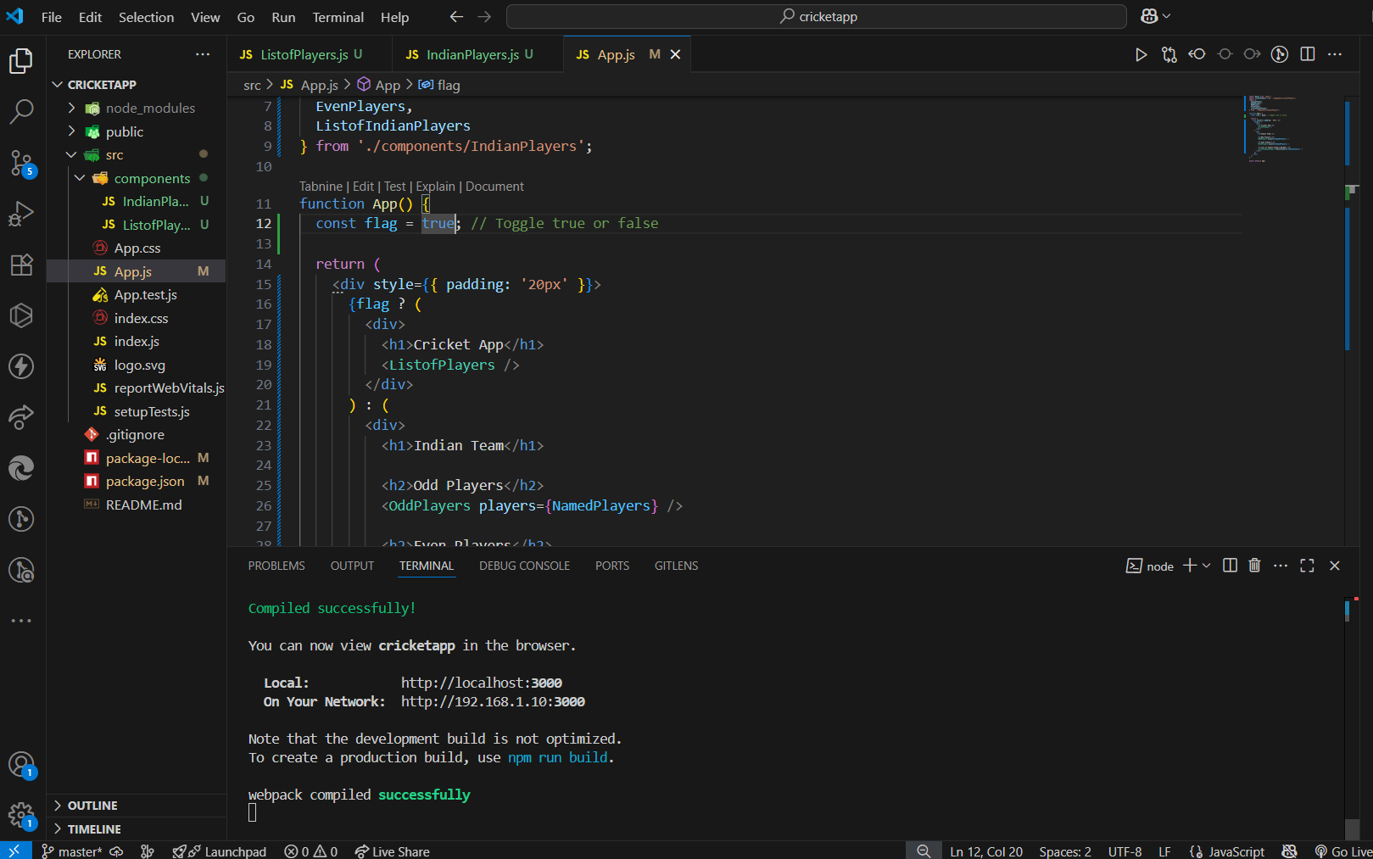

**App.js**

import React from 'react';

import ListofPlayers from './components/ListofPlayers';

import {

  IndianPlayers,

  NamedPlayers,

  OddPlayers,

  EvenPlayers,

  ListofIndianPlayers

} from './components/IndianPlayers';

function App() {

  const flag = true; // Toggle true or false

  return (

    <div style={{ padding: '20px' }}>

      {flag ? (

        <div>

          <h1>Cricket App</h1>

          <ListofPlayers />

        </div>

      ) : (

        <div>

          <h1>Indian Team</h1>

          <h2>Odd Players</h2>

          <OddPlayers players={NamedPlayers} />

          <h2>Even Players</h2>

          <EvenPlayers players={NamedPlayers} />

          <h2>List of Indian Players Merged:</h2>

          <ListofIndianPlayers IndianPlayers={IndianPlayers} />

        </div>

      )}

    </div>

  );

}

export default App;

**IndianPlayers.js**

import React from 'react';

const NamedPlayers = ["Rohit", "Gill", "Kohli", "Pujara", "Jadeja", "Ashwin"];

const T20Players = ["First Player", "Second Player", "Third Player"];

const RanjiTrophyPlayers = ["Fourth Player", "Fifth Player", "Sixth Player"];

const IndianPlayers = [...T20Players, ...RanjiTrophyPlayers];

function OddPlayers({ players }) {

  const positions = ["First", "Third", "Fifth"];

  const oddPlayers = players.filter((_, index) => index % 2 === 0);

  return (

    <ul>

      {oddPlayers.map((player, index) => (

        <li key={index}>{positions[index]}: {player}</li>

      ))}

    </ul>

  );

}

function EvenPlayers({ players }) {

  const positions = ["Second", "Fourth", "Sixth"];

  const evenPlayers = players.filter((_, index) => index % 2 !== 0);

  return (

    <ul>

      {evenPlayers.map((player, index) => (

        <li key={index}>{positions[index]}: {player}</li>

      ))}

    </ul>

  );

}

function ListofIndianPlayers({ IndianPlayers }) {

  return (

    <ul>

      {IndianPlayers.map((player, index) => (

        <li key={index}>Mr. {player}</li>

      ))}

    </ul>

  );

}

export {

  IndianPlayers,

  NamedPlayers,

  OddPlayers,

  EvenPlayers,

  ListofIndianPlayers

};

**ListofPlayers.js**

import React from 'react';

function ListofPlayers() {

    const players = [

        { name: "Rohit", score: 78 },

        { name: "Kohli", score: 34 },

        { name: "Gill", score: 56 },

        { name: "Iyer", score: 98 },

        { name: "Rahul", score: 23 },

        { name: "Hardik", score: 88 },

        { name: "Jadeja", score: 67 },

        { name: "Ashwin", score: 55 },

        { name: "Shami", score: 26 },

        { name: "Bumrah", score: 91 },

        { name: "Siraj", score: 77 }

    ];

    const players70 = players.filter(player => player.score <= 70);

    return (

        <div>

            <h1>List of Players</h1>

            <ul>

                {players.map((item, index) => (

                    <li key={index}>Mr. {item.name} - {item.score}</li>

                ))}

            </ul>

            <h1>List of Players having Scores Less than 70</h1>

            <ul>

                {players70.map((item, index) => (

                    <li key={index}>Mr. {item.name} - {item.score}</li>

                ))}

            </ul>

        </div>

    );

}

export default ListofPlayers;

flag=true

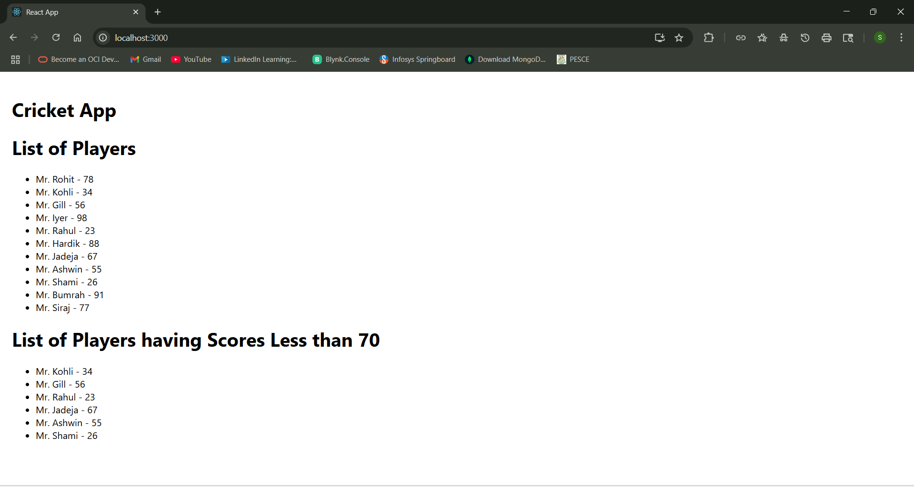

Flag=false

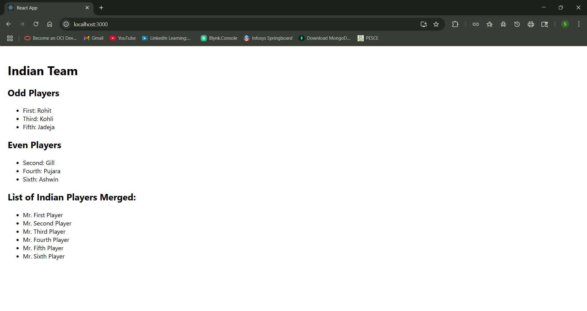

**Problem 10**

Create a React Application named “officespacerentalapp” which uses React JSX to create elements, attributes and renders DOM to display the page.

Create an element to display the heading of the page.

Attribute to display the image of the office space

Create an object of office to display the details like Name, Rent and Address.

Create a list of Object and loop through the office space item to display more data.

To apply Css, Display the color of the Rent in Red if it’s below 60000 and in Green if it’s above 60000.

**App.js**

import React from 'react';

import './App.css';

import officeImg from './office.jpg';

function App() {

  const heading = <h1>Office Space , at Affordable Range</h1>;

  const officeImage = <img src={officeImg} alt="Office Space" width="25%" height="25%" />;

  const officeList = [

    { Name: "DBS", Rent: 50000, Address: "Chennai" },

    { Name: "Regus", Rent: 75000, Address: "Bangalore" },

    { Name: "WeWork", Rent: 58000, Address: "Hyderabad" }

  ];

  const getRentClass = (rent) => {

    return rent <= 60000 ? 'textRed' : 'textGreen';

  };

  return (

    <div className="App">

      {heading}

      {officeImage}

      <br /><br />

      {officeList.map((item, index) => (

        <div key={index} style={{ marginBottom: '30px' }}>

          <h2>Name: {item.Name}</h2>

          <h3 className={getRentClass(item.Rent)}>Rent: Rs. {item.Rent}</h3>

          <h3>Address: {item.Address}</h3>

        </div>

      ))}

    </div>

  );

}

export default App;

**App.css**

.textRed {

  color: red;

  font-weight: bold;

}

.textGreen {

  color: green;

  font-weight: bold;

}

.App {

  padding: 30px;

  font-family: Arial, sans-serif;

}

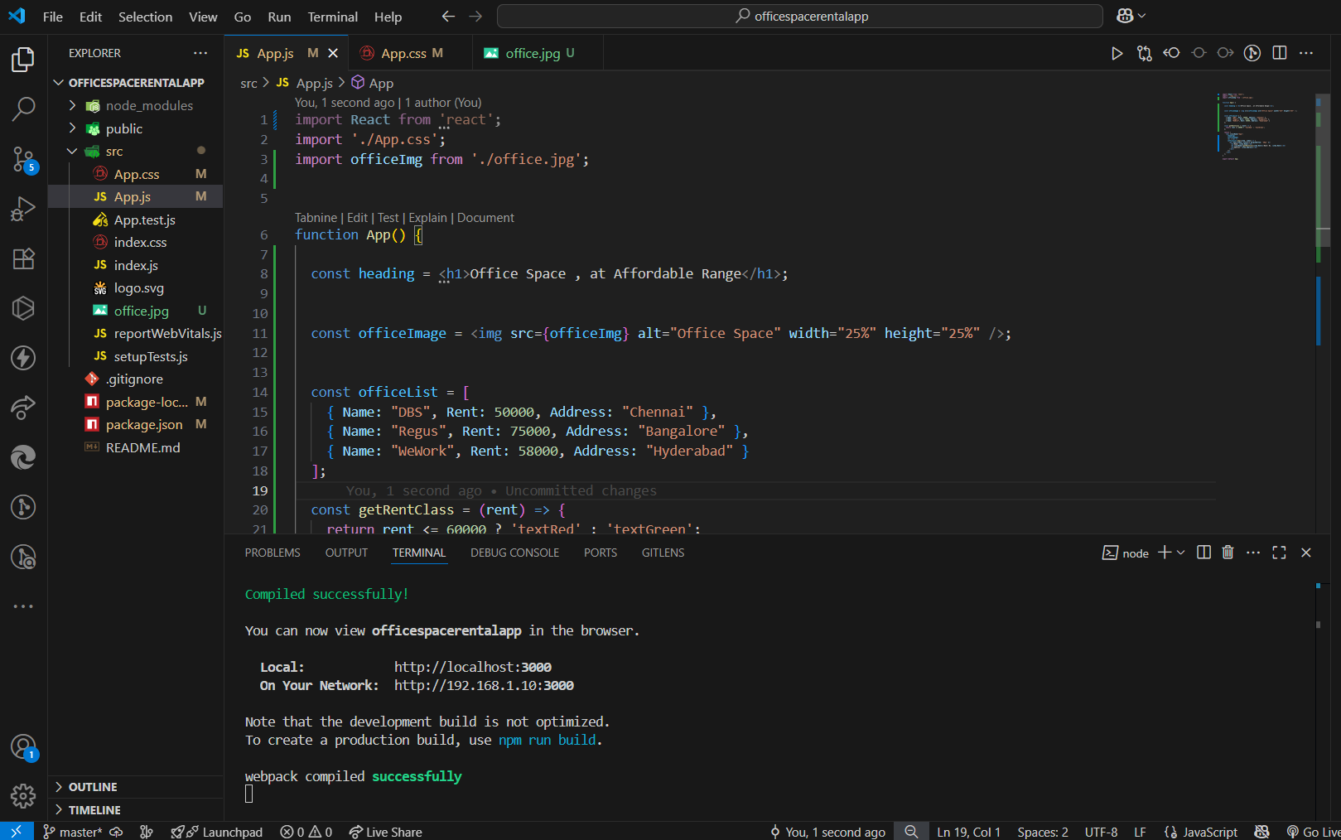

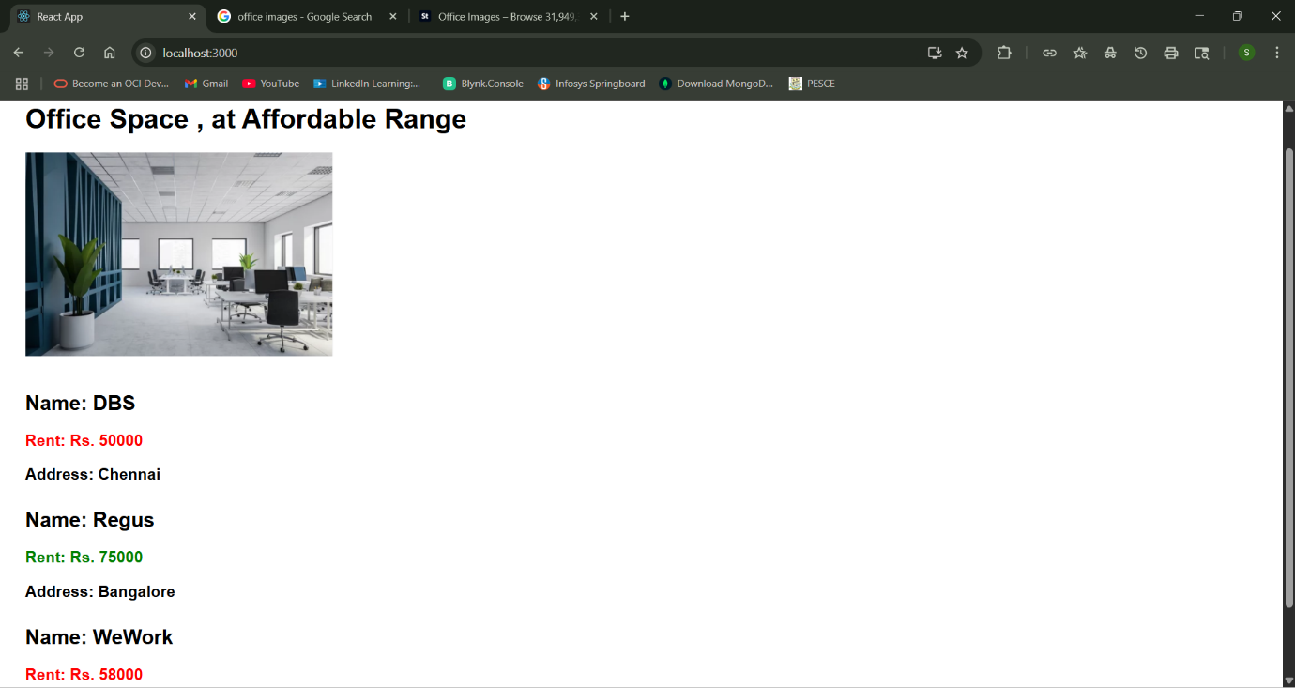

**Problem 11**

Create a React Application “eventexamplesapp” to handle various events of the form elements in HTML.

1. Create “Increment” button to increase the value of the counter and “Decrement” button to decrease the value of the counter. The “Increase” button should invoke multiple methods.

a. To increment the value

b. Say Hello followed by a static message.

2. Create a button “Say Welcome” which invokes the function which takes “welcome” as an argument.

3. Create a button which invokes synthetic event “OnPress” which display “I was clicked”

Create a “CurrencyConvertor” component which will convert the Indian Rupees to Euro when the Convert button is clicked.

Handle the Click event of the button to invoke the handleSubmit event and handle the conversion of the euro to rupees.

**Solution:**

**CurrencyConvertor.js**

import React, { useState } from 'react';

function CurrencyConvertor() {

  const [amount, setAmount] = useState('');

  const [currency, setCurrency] = useState('');

  const handleSubmit = (e) => {

    e.preventDefault();

    const result = parseFloat(amount) * 80;

    setCurrency("Euro");

    alert(`Converting to ${currency} Amount is ${result}`);

  };

  return (

    <div style={{ marginTop: '40px' }}>

      <h2 style={{ color: 'green' }}>Currency Convertor!!!</h2>

      <form onSubmit={handleSubmit}>

        <label>Amount: </label>

        <input

          type="number"

          value={amount}

          onChange={(e) => setAmount(e.target.value)}

        /><br /><br />

        <label>Currency: </label>

        <input

          type="text"

          value={currency}

          readOnly

        /><br /><br />

        <button type="submit">Submit</button>

      </form>

    </div>

  );

}

export default CurrencyConvertor;

**App.js**

import React, { useState } from 'react';

import CurrencyConvertor from './CurrencyConvertor';

import './App.css';

function App() {

  const [count, setCount] = useState(0);

  const handleIncrement = () => {

    setCount(prev => prev + 1);

    sayHello();

  };

  const sayHello = () => {

    alert("Hello! Member1");

  };

  const handleDecrement = () => {

    setCount(prev => prev - 1);

  };

  const sayWelcome = (msg) => {

    alert(`Welcome ${msg}`);

  };

  const handleClick = (e) => {

    alert("I was clicked");

  };

  return (

    <div className="App">

      <p>{count}</p>

      <button onClick={handleIncrement}>Increment</button><br />

      <button onClick={handleDecrement}>Decrement</button><br />

      <button onClick={() => sayWelcome("Member1")}>Say welcome</button><br />

      <button onClick={handleClick}>Click on me</button>

      <CurrencyConvertor />

    </div>

  );

}

export default App;

**App.css**

.App {

  padding: 20px;

  font-family: Arial, sans-serif;

}

button {

  margin: 5px 0;

  padding: 5px 10px;

}

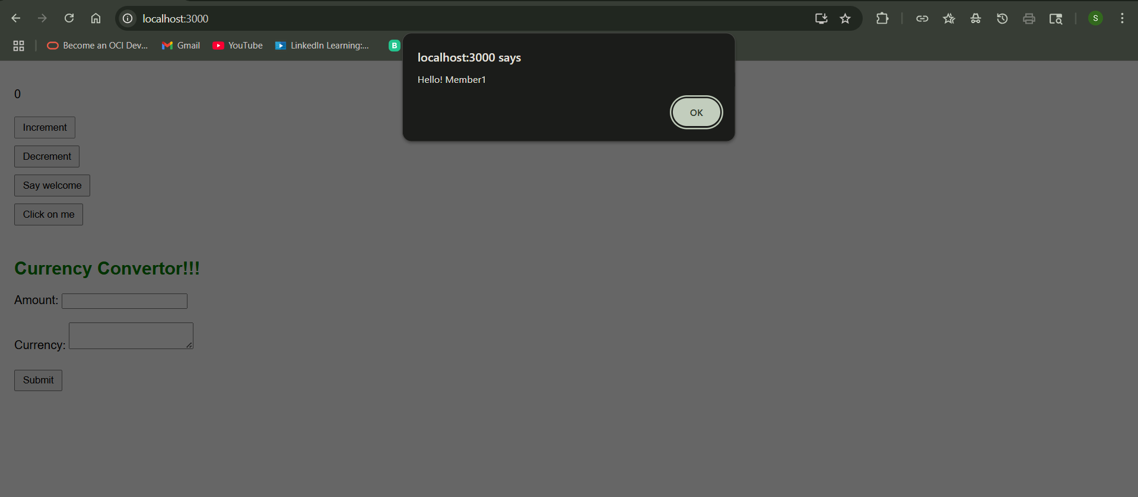

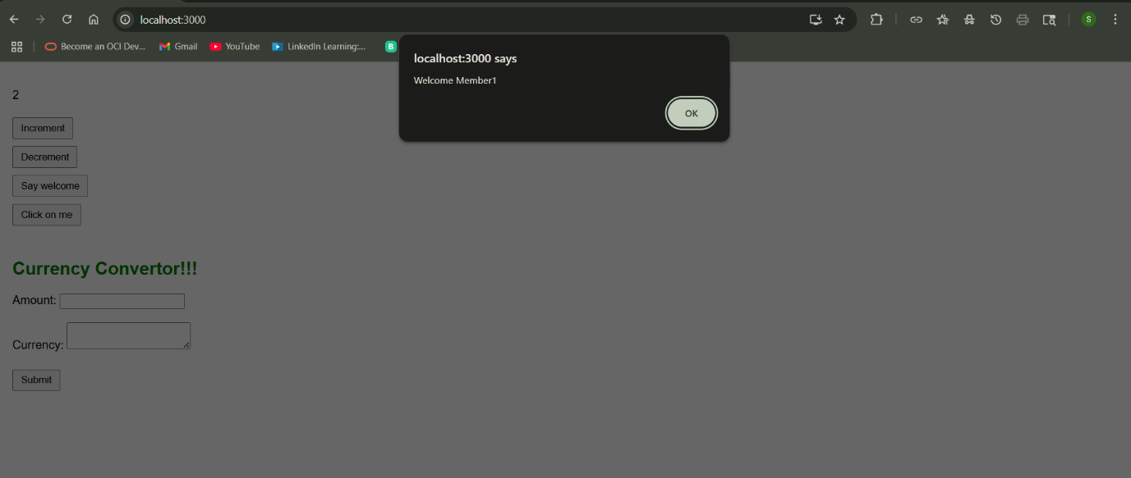

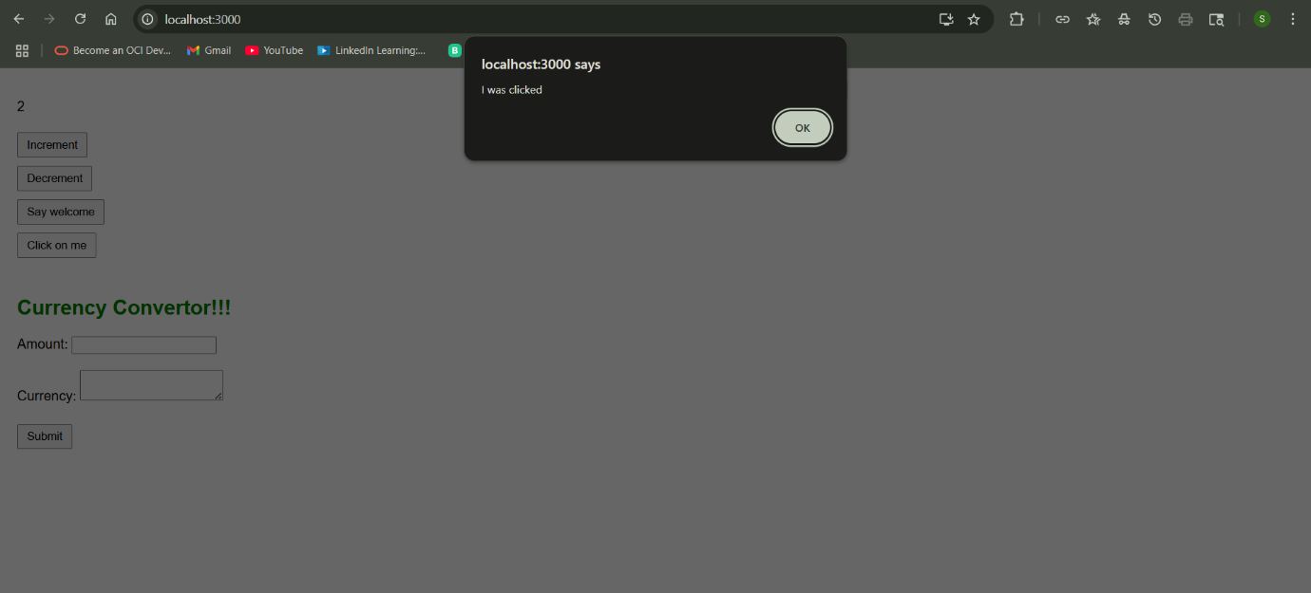

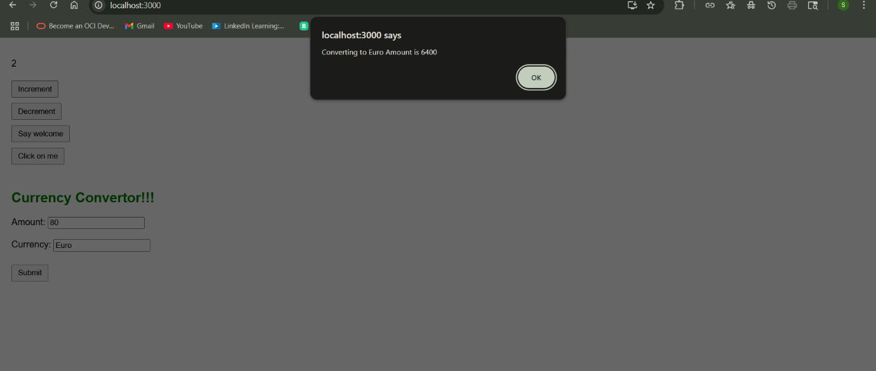

**Problem 12**

Create a React Application named “ticketbookingapp” where the guest user can browse the page where the flight details are displayed whereas the logged in user only can book tickets.

The Login and Logout buttons should accordingly display different pages. Once the user is logged in the User page should be displayed. When the user clicks on Logout, the Guest page should be displayed.

**App.js**

import React, { useState } from 'react';

function LoginButton(props) {

  return <button onClick={props.onClick}>Login</button>;

}

function LogoutButton(props) {

  return <button onClick={props.onClick}>Logout</button>;

}

function UserGreeting() {

  return <h2>Welcome back</h2>;

}

function GuestGreeting() {

  return <h2>Please sign up.</h2>;

}

function Greeting(props) {

  const isLoggedIn = props.isLoggedIn;

  if (isLoggedIn) {

    return <UserGreeting />;

  }

  return <GuestGreeting />;

}

function App() {

  const [isLoggedIn, setIsLoggedIn] = useState(false);

  const handleLoginClick = () => {

    setIsLoggedIn(true);

  };

  const handleLogoutClick = () => {

    setIsLoggedIn(false);

  };

  let button;

  if (isLoggedIn) {

    button = <LogoutButton onClick={handleLogoutClick} />;

  } else {

    button = <LoginButton onClick={handleLoginClick} />;

  }

  return (

    <div style={{ padding: '20px', fontFamily: 'Arial' }}>

      <Greeting isLoggedIn={isLoggedIn} />

      {button}

    </div>

  );

}

export default App;

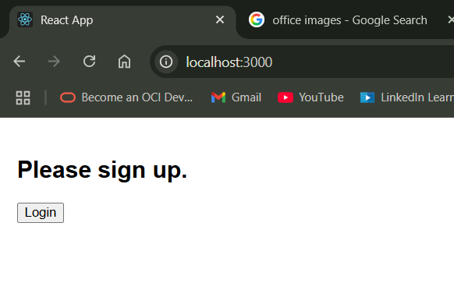

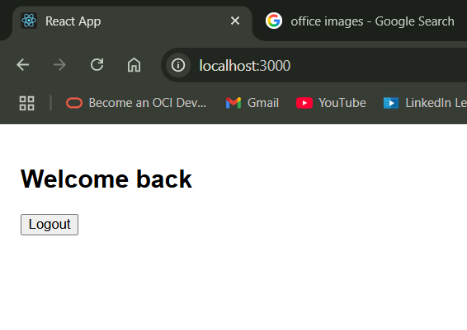

**Problem 13:**

Create a React App named “bloggerapp” in with 3 components.

1. Book Details

2. Blog Details

3. Course Details

Implement this with as many ways possible of Conditional Rendering.

**Solution:**

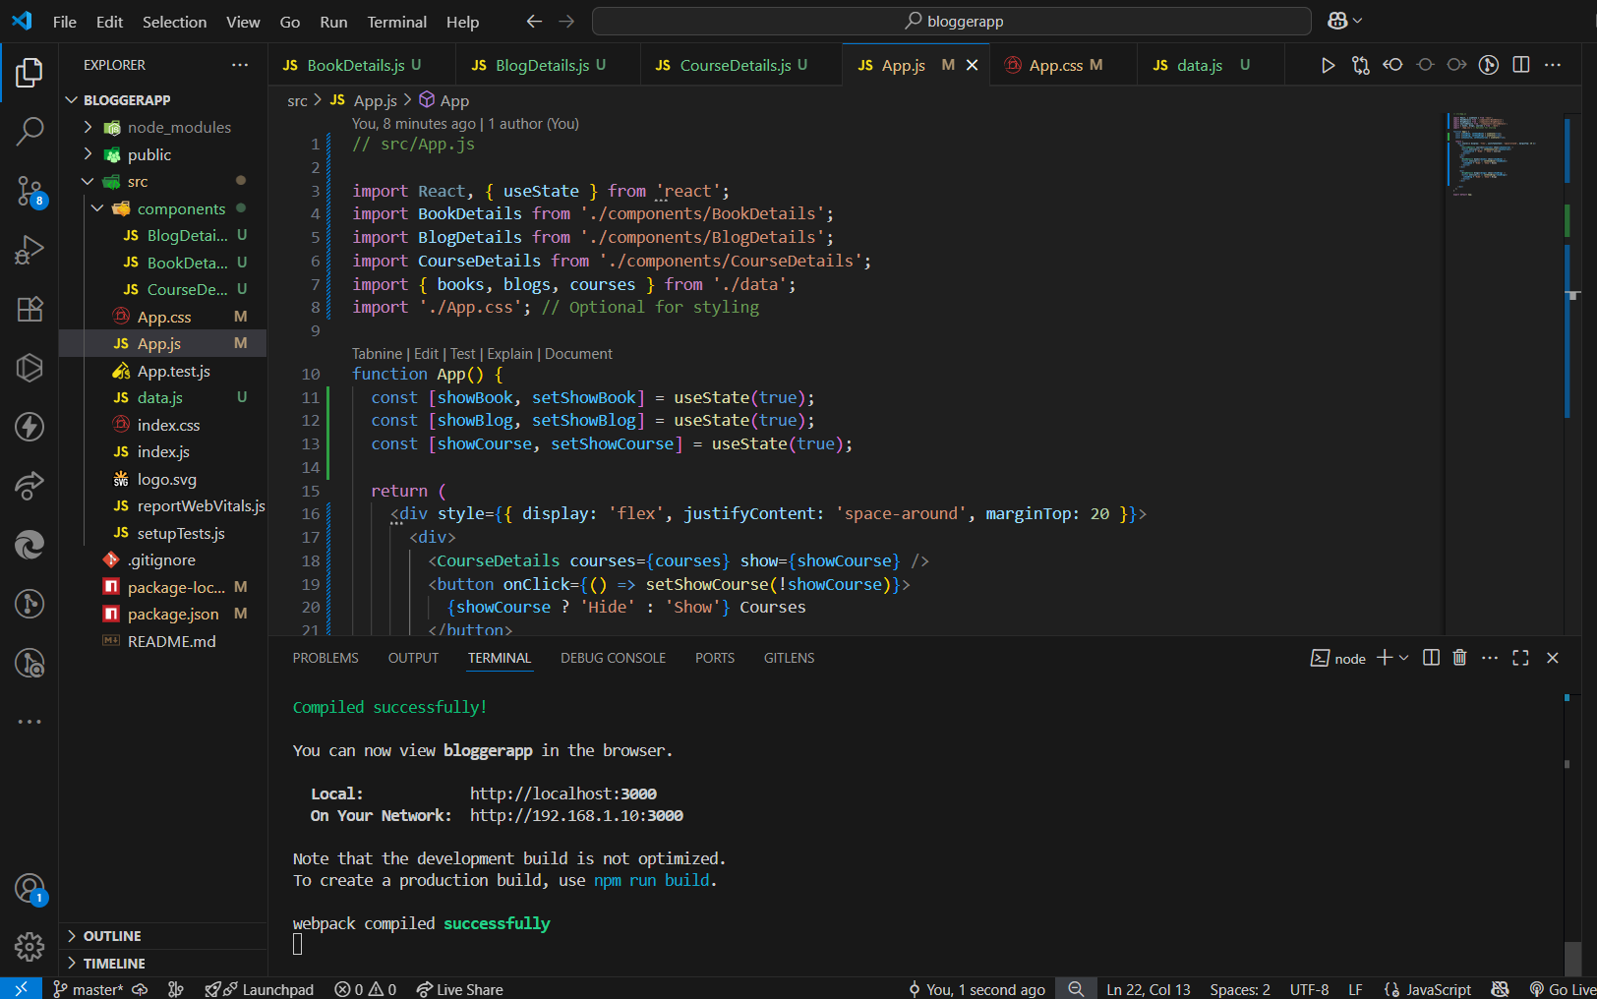

**App.js**

import React, { useState } from 'react';

import BookDetails from './components/BookDetails';

import BlogDetails from './components/BlogDetails';

import CourseDetails from './components/CourseDetails';

import { books, blogs, courses } from './data';

import './App.css';

function App() {

  const [showBook, setShowBook] = useState(true);

  const [showBlog, setShowBlog] = useState(true);

  const [showCourse, setShowCourse] = useState(true);

  return (

    <div style={{ display: 'flex', justifyContent: 'space-around', marginTop: 20 }}>

      <div>

        <CourseDetails courses={courses} show={showCourse} />

        <button onClick={() => setShowCourse(!showCourse)}>

          {showCourse ? 'Hide' : 'Show'} Courses

        </button>

      </div>

      <div>

        <BookDetails books={books} show={showBook} />

        <button onClick={() => setShowBook(!showBook)}>

          {showBook ? 'Hide' : 'Show'} Books

        </button>

      </div>

      <div>

        <BlogDetails blogs={blogs} show={showBlog} />

        <button onClick={() => setShowBlog(!showBlog)}>

          {showBlog ? 'Hide' : 'Show'} Blogs

        </button>

      </div>

    </div>

  );

}

export default App;

**App.css**

.st2, .v1, .mystyle1 {

  border-left: 3px solid green;

  padding-left: 20px;

}

**Data.js**

export const books = [

  { id: 101, bname: 'Master React', price: 670 },

  { id: 102, bname: 'Deep Dive into Angular 11', price: 800 },

  { id: 103, bname: 'Mongo Essentials', price: 450 }

];

export const blogs = [

  {

    title: 'React Learning',

    author: 'Stephen Biz',

    content: 'Welcome to learning React!'

  },

  {

    title: 'Installation',

    author: 'Schewzdenier',

    content: 'You can install React from npm.'

  }

];

export const courses = [

  { name: 'Angular', date: '4/5/2021' },

  { name: 'React', date: '6/3/2020' }

];

**BlogDetails.js**

import React from 'react';

const BlogDetails = ({ blogs, show }) => {

  return (

    show && (

      <div className="v1">

        <h1>Blog Details</h1>

        {blogs.map((blog, index) => (

          <div key={index}>

            <h2>{blog.title}</h2>

            <h4>{blog.author}</h4>

            <p>{blog.content}</p>

          </div>

        ))}

      </div>

    )

  );

};

export default BlogDetails;

**BookDetails.js**

import React from 'react';

const BookDetails = ({ books, show }) => {

  return show ? (

    <div className="st2">

      <h1>Book Details</h1>

      {books.map((book) => (

        <div key={book.id}>

          <h3>{book.bname}</h3>

          <h4>{book.price}</h4>

        </div>

      ))}

    </div>

  ) : null;

};

export default BookDetails;

**CourseDetails.js**

import React from 'react';

const CourseDetails = ({ courses, show }) => {

  if (!show) return null;

  return (

    <div className="mystyle1">

      <h1>Course Details</h1>

      {courses.map((course, index) => (

        <div key={index}>

          <h3>{course.name}</h3>

          <p>{course.date}</p>

        </div>

      ))}

    </div>

  );

};

export default CourseDetails;

