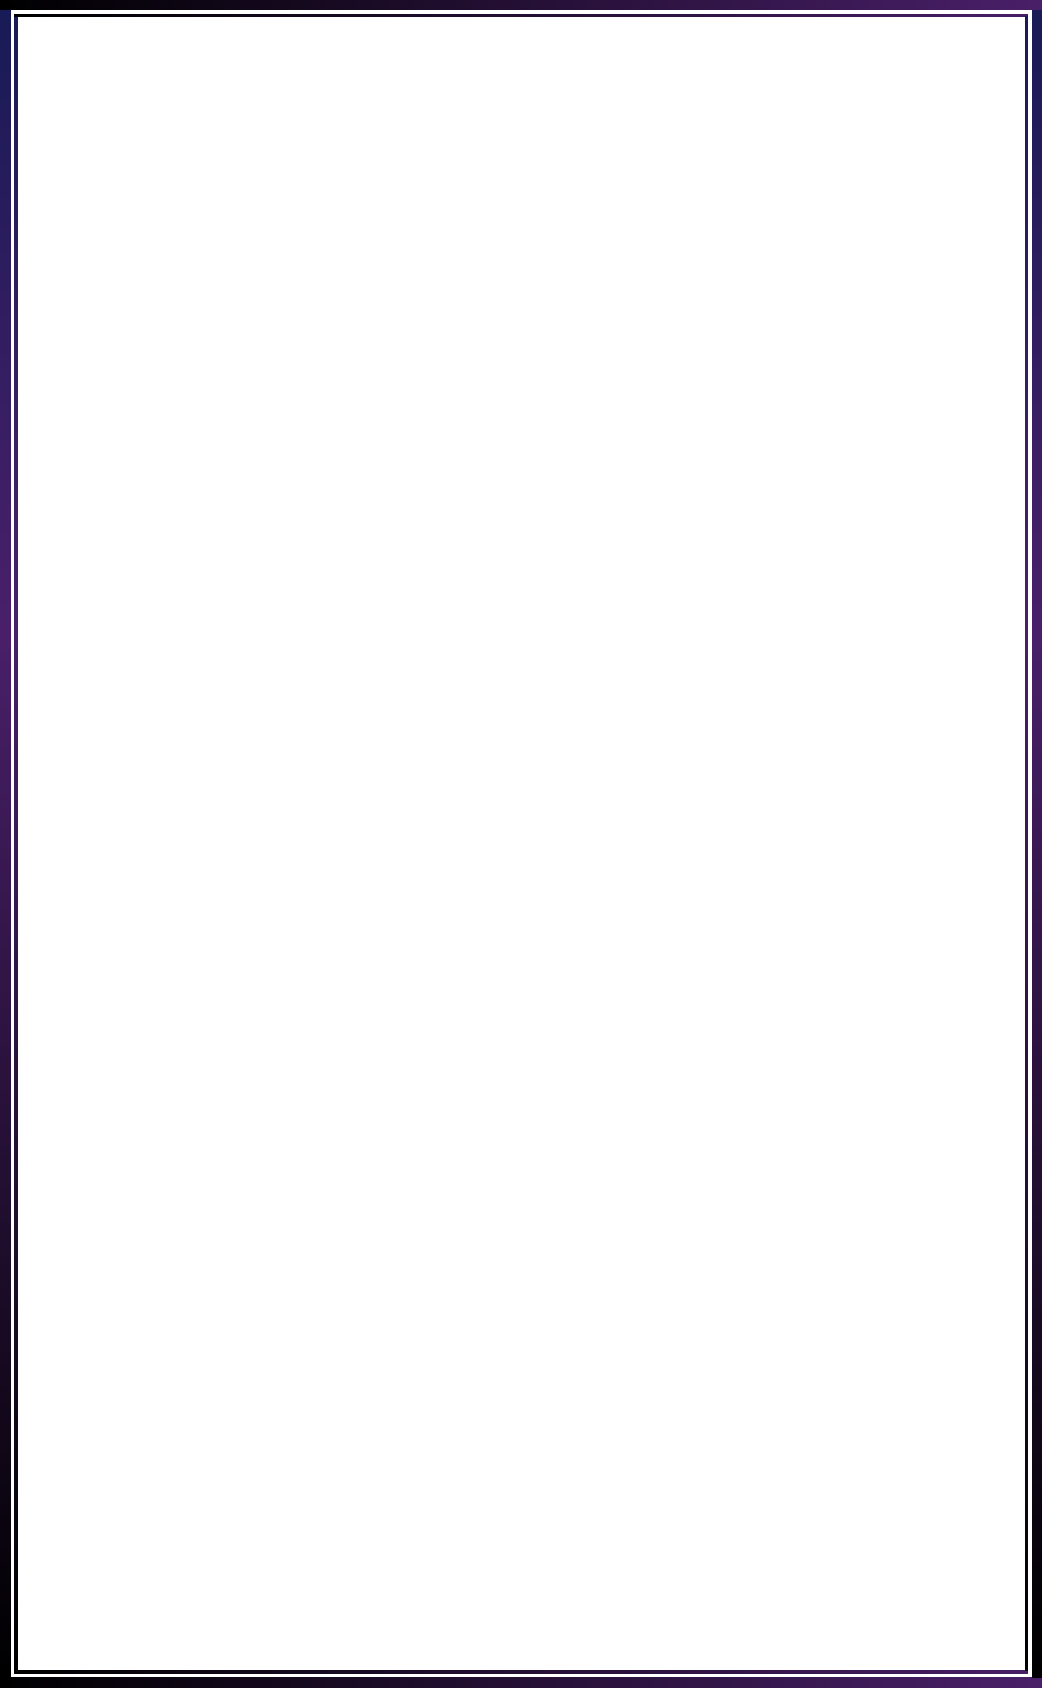

Compsoft Technologies



AN INTERNSHIP REPORT

ON

“AURKOISAWAL”

#### Bachelor of Engineering

#### In

#### Computer Science and Engineering

#### 

#### Submitted by: MEGHANA RABBA (1JS20CS091)

#### 

#### JSSATE COLLEGE OF ENGINEERING ENGALURU,2022

#### 

#### 

#### C:\Users\Nikhil\Desktop\download.png

#### 

## ABOUT THE COMPANY

The race for digital transformation is on. In this globally connected on-demand world with rapid advancements in internet technologies, businesses worldwide are under constant pressure to add innovative real-time capabilities to their applications to respond to market opportunities.

​

Every business worldwide is building event-driven, real-time applications - from financial services, transportation, and energy, to retail, healthcare, and Gaming companies.

Our endeavour is to make it easy to develop innovative real-time applications and efficient to operate them in production.

​

We have a proven record of building highly scalable, world-class consulting processes that offer tremendous business advantages to our clients in the form of huge cost-benefits, definitive results and consistent project deliveries across the globe.

​

We prominently strive to improve your business by delivering the full range of competencies including operational performance, developing and applying business strategies to improve financial reports, defining strategic goals and measure and manage those goals along with measuring and managing them.

​

**TABLE OF CONTENTS**

Table of contents i

Overview of the Project 1

About **AURKOISAWAL** 2

Tools Used 4

Implementation 5

Snapshots 21

Bibliography 25

## OVERVIEW OF THE PROJECT

## Project Name: AURKOISAWAL

**Team Members:**

1. **PANKAJ SHARMA**
2. **SHWETHA N**
3. **MEGHANA RABBA**
4. **FAISAL**

## This project is based on Web Development And its Applications. The main objective of this project is to learn the implementation of HTML, CSS and JavaScript. The basic webpage of this project is created using HTML and styling of the webpage is done using CSS.

## This webpage is about AURKOISAWAL is a question and answer website for Engineering students. AURKOISAWAL features questions and answers on a wide range of topics in Engineering. Our notion of a better-connected engineering community to tackle all kinds of academic and non Academical questions and problems would make the engineering community better. Establishing a community-based platform like this would help bypass the location barrier for Engineering students.

## ABOUT AURKOISAWAL

. **AURKOISAWAL** is a question-and-answer platform that allows users to engage in dialogue with their experts in their field and it has become a go-to source for information on a wide range of topics.

We have created a platform where anyone could ask and answer questions about anything.

As you might imagine, **AURKOISAWAL** is a great resource for learning about new things, finding answers to your questions, and building relationships with other people who share your interests. It's also a great way to stay up-to-date on the latest trends and developments in your field.

**AURKOISAWAL** mission is to share and grow the world’s knowledge. Not all knowledge can be written down, but much of that which can be, still isn't. It remains in people’s heads or only accessible if you know the right people. We want to connect the people who have knowledge to the people who need it, to bring together people with different perspectives so they can understand each other better, and to empower everyone to share their knowledge for the benefit of the rest of the world

# TOOLS USED

### Software Requirements

* Visual Studio Code 20.
* Google Chrome or Microsoft Edge of latest version.
* Front End: HTML, CSS, JS
* Linux 7.1 or Windows XP/7/8/10/11 OS or Mac OS

### Hardware Requirements

* Pentium 200-MHz computer with a minimum of 64 MB of RAM (128 MB of RAM recommended).
* Monitor with a refresh rate of at least 40Hz for a smooth GUI experience (optional).

# IMPLEMENTATION

# Source Code (base.html):

{% load static %}

<!DOCTYPE html>

<html lang="en">

<head>

    <meta charset="UTF-8">

    <meta name="viewport" content="width=device-width, initial-scale=1.0">

    <title>{% block title %}Detail Page{% endblock %}</title>

    <!-- Animate 4 -->

    <link rel="stylesheet" href="{% static 'animate.min.css' %}" />

    <!-- Bootstrap 4 -->

    <link rel="stylesheet" href="{% static 'bootstrap.min.css' %}" />

    <!-- Font Awesome 4 -->

    <link rel="stylesheet" href="{% static 'fa4/css/font-awesome.min.css' %}" />

    <!-- Tailwind -->

    <link href="https://unpkg.com/tailwindcss@^1.0/dist/tailwind.min.css" rel="stylesheet">

    <!-- Jquery -->

    <script src="{% static 'jquery-3.5.1.min.js' %}"></script>

    <!-- Bootstrap 4 Js -->

    <script src="{% static 'bootstrap.min.js' %}"></script>

</head>

<body style="background-color: #353535;">

    <nav class="navbar navbar-expand-lg navbar-dark" style="background-color: #353535">

        <div class="container">

            <svg xmlns="http://www.w3.org/2000/svg" fill="none" stroke="currentColor" stroke-linecap="round" stroke-linejoin="round" stroke-width="2" class="w-20 h-20 text-white p-2  rounded-full" viewBox="0 0 24 24">

                <path d="M12 2L2 7l10 5 10-5-10-5zM2 17l10 5 10-5M2 12l10 5 10-5"></path>

            </svg>

            <a class="navbar-brand" href="/"><p style="color: white; font-size: 40px; margin: 10px;font-weight:bold; font-family: 'Times New Roman', serif;">Aur Koi Sawal<p></a>

            <button class="navbar-toggler" type="button" data-toggle="collapse" data-target="#navbarNav" aria-controls="navbarNav" aria-expanded="false" aria-label="Toggle navigation">

                <span class="navbar-toggler-icon"></span>

            </button>

            <div class="collapse navbar-collapse" id="navbarNav">

                <form class="ml-auto" action="/">

                    <div class="input-group">

                        <input type="text" name="q" class="form-control" placeholder="Search here...!" style="border-radius: 0px 0px 0px 20px;border-color: #202124;"/>

                        <div class="input-group-append">

                        <button class="btn btn-dark" type="submit" id="button-addon2" style="background-color:#202124;border-radius:0px 20px 0px 0px; margin-left:10px;">Search</button>

                        </div>

                    </div>

                </form>

                <ul class="navbar-nav ml-auto">

                    <li class="nav-item " >

                        <a class="nav-link " href="/" style="font-size:30px;">Home</a>

                    </li>

                    <li class="nav-item {% block activeTags %}{% endblock %}">

                        <a class="nav-link" href="/tags" style="font-size:30px;">Tags</a>

                    </li>

                    <li class="nav-item {% block activeAsk %}{% endblock %}">

                        <a class="nav-link" href="{% url 'ask-question' %}" style="font-size:30px;">Ask</a>

                    </li>

                    {% if user.is_authenticated %}

                    <li class="nav-item {% block activeProfile %}{% endblock %}">

                        <a class="nav-link" href="/accounts/profile" style="font-size:30px;">Profile</a>

                    </li>

                    <li class="nav-item ">

                        <a class="nav-link" href="{% url 'logout' %}" style="font-size:30px;">Logout</a>

                    </li>

                    {% else %}

                  <li class="nav-item {% block activeLogin %}{% endblock %}">

                        <a class="nav-link" href="/accounts/login" style="font-size:30px;">Login</a>

                    </li>

                    <li class="nav-item {% block activeRegister %}{% endblock %}">

                        <a class="nav-link" href="/accounts/register" style="font-size:30px;">Register</a>

                    </li>

                    {% endif %}

                </ul>

            </div>

        </div>

    </nav>

    <hr style="background-color:gray">

    {% block content %}

    {% endblock %}

</body>

</html>

# IMPLEMENTATION

# Snapshots :

# 

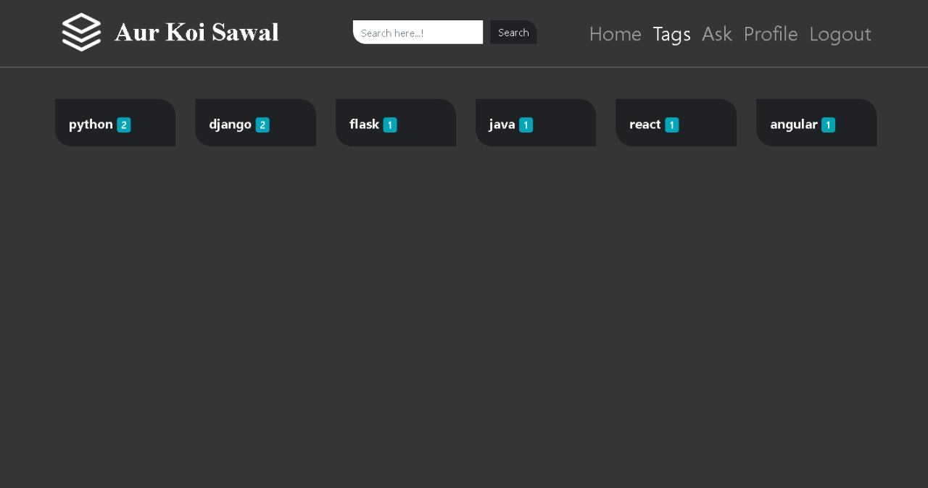

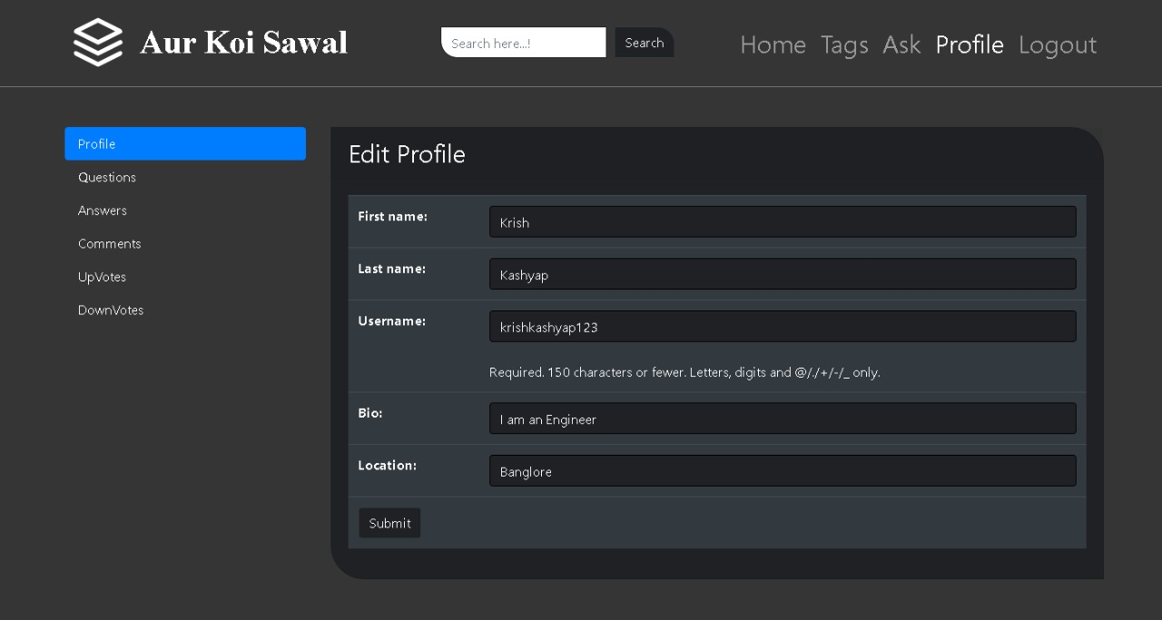

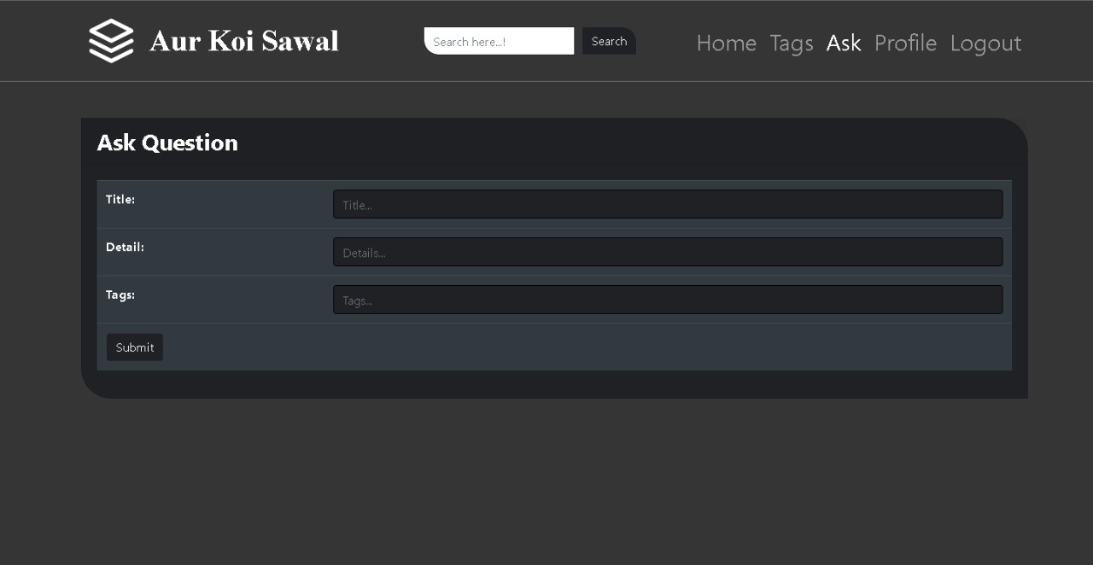

**BIBLIOGRAPHY**

* https://getbootstrap.com/
* https://www.w3schools.com/
* https://www.youtube.com/

## About my TEAM

Team Mates:

1. **PANKAJ SHARMA**

* Front-End Design and Development

1. **SHWETHA N**

* Front-End Design and Development

1. **Meghana Rabba**

* Back-end Development

1. **Faisal**

* Back-end Development