Handwritten Mathematical symbol recognition and classification using Neural Networks in MATLAB

ACKNOWLEDGEMENT

This project consumed huge amount of work, research and dedication. Still, implementation would not have been possible if we did not have a support of many individuals. Therefore we would like to extend our sincere gratitude to all of them.

First of all we are thankful to Dr. Ganga Holi for their help, guidance and for providing provision of expertise, and technical support in the implementation. Without their superior knowledge and experience, the Project would like in quality of outcomes, and thus their support has been essential.

We are also grateful to Dr. Shylaja. S.S. for providing support for the implementation of the project and for the opportunity of learning a new language along with the gaining of knowledge in the field of image processing.

We would like to express our sincere thanks towards the various resources who devoted their time and knowledge understanding the concepts used in this project and for documenting it. Without their help it would have been tough to use certain concepts in the implementation of this project.

Nevertheless, we express our gratitude toward our families and colleagues for their kind co-operation and encouragement which help us in completion of this project.

ABSTRACT

With the advancement of technology, the world is entering a state where every activity is automated, from cooking to cleaning to shopping. Man looks to make his work simple in all ways possible and this has led to the need of a new subject, machine learning. Being a vast subject, machine learning has many vast subcategories it deals with one of them being image processing. As man finds easier ways to solve his problems, one area where he can work on in support to the previous statement is handwriting recognition. Every handwriting the world has seen is unique. No two handwritings are the same. This makes it harder for the handwriting to be interpreted. But with machine learning as the backbone, we come closer to creating a unit that recognizes handwriting, interprets their meaning and classifies them. Mathematics is a subject that has been studied a thousand years before and will be studied well in the future. Man has changed, math has remained the same. To develop with the times, automated calculations are being looked into. This brings mathematical symbol recognition into picture. This deals with recognizing the parts of a mathematical equation extracted from a handwriting, classifying and categorizing the extracted elements and performing the necessary operations to compute the result. The aim is to input a handwritten expression to calculate the result of the input expression. Mathematical symbol recognition is a process with a number of steps involved. An input image must first undergo preprocessing followed by segmentation. Then it undergoes feature extraction, classification and recognition. All these steps are explained in detail in the report, further.

.
Table of Contents

1. INTRODUCTION 1
2.MOTIVATION AND AIM 3
3.LITERATURE REVIEW 5
4.DESIGN 9
4.1.PURPOSE 10
4.2.SCOPE 10
4.3.BLOCK DIAGRAM 10
4.4.STEPS 11
4.4.1.PRE PROCESSING 11
4.4.2.SEGMENTATION 14
4.4.3.FEATURE EXTRACTION 15
4.4.4.CLASSIFICATION 15

4.5.USE OF TOOLS FOR DESIGN 17
4.5.1.IMAGE PROCESSING TOOLBOX 17
4.5.2.NEURAL NETWORK TOOLBOX 17

5.IMPLEMENTATION 18
5.1.SOFTWARE AND HARDWARE USED 19
5.2.SOFTWARE DEVELOPMENT PLATFORM ENVIRONMENT FRAMEWORK 19
5.2.1.THE MATLAB LANGUAGE 19
5.2.2.THE MATLAB WORKING ENVIRONMENT 20
5.2.3.MATLAB IMAGE PROCESSING TOOLBOX 20
5.2.4.MATLAB NEURAL NETWORK TOOLBOX 21
5.2.5.NEURAL NETWORK TRAINING 21

6.RESULTS 22
6.1.RESULTS OF TRAINING AND TESTING 23
6.2.PERFORMANCE PLOT 24

CONCLUSION 25
7.FUTURE WORK AND ENHANCEMENTS 27
7.1.PROPOSAL FOR ENHANCEMENT OR REDESIGN 28

8.SNAPSHOTS 29
9.REFERENCES 39
Table of Images

Figure 4.1: Block diagram of proposed method 10
Figure 4.2- Input image 11
Figure 4.3- Binarized Image 12
Figure 4.4 – Noise free image 12
Figure 4.5 – image after edge detection 13
Figure 4.6 – Image with only edges 13
Figure 4.7 – Image after dilation with bounding box 14
Figure 4.8 – Images after segmentation 14
Figure 4.9 – Implemented neural network 16
Figure 5.1 - Software and Hardware Used 19
Figure 6.1- result of training 2774 samples 23
Figure 6.2 – Performance plot 24
Figure 6.3 – Error histogram 24

CHAPTER 1
INTRODUCTION

- INTRODUCTION

Handwriting recognition is defined as the ability of a computer to receive and interpret intelligible handwritten input from sources such as paper documents, photographs, touch-screens and other devices. The image of the written text may be sensed off line from a piece of paper by optical scanning (optical character recognition) or intelligent word recognition. Alternatively, the movements of the pen tip may be sensed on line, for example by a pen-based computer screen surface. Handwriting recognition principally entails optical character recognition. However, a complete handwriting recognition system also handles formatting, performs correct segmentation into characters and finds the most plausible words. In this project we have focused on offline implementation. As mentioned earlier, mathematical symbol recognition employs a number of steps, which are preprocessing, segmentation, feature extraction, classification and recognition. The handwriting sample is first input as an image. This image undergoes various processes to make the image more suited for the extraction of information like noise reduction, etc. Then, the data is extracted from the image in the form of segments. A number of such images are used. For the successful classification and categorization, a dataset is used. This dataset is structured as a database. A part of this forms the training data and the remaining part of this forms the testing data. The learning rate is shown. As the output, we can view the graph of mean squared error against the epochs. Also, we can view the graphs like confusion matrix graph, etc.

CHAPTER 2
MOTIVATION AND AIM

- MOTIVATION AND AIM

There is a growing interest in the subject of applied machine learning and every category of it offers methods good and unique methods to be implemented. One of the biggest subdomain in applied machine learning is image processing. With the implementation of image processing the world is now able to carry out many activities in a simple method.

With mathematical symbol recognition, we can, at one touch, recognize what category a symbol belongs to. The recognition of numbers and operations become plausible and this paves way to automatic result computation. With one click of the expression, we will be able to find the numerical answer of the expression. This makes math easier. According to surveys, school going children find the most fearful subject to be mathematics. With the recognition of mathematical symbols, children, who are getting more tech savvy every generation, will be able to overcome their fear for math and will be able to learn it the fun way. Also, apart from children, this application can be of use to adults also. Though knowing simple mathematics is necessary for survival in daily life, some people don’t possess the skills to carry out basic computations, also a percentage of people struggle with basic mathematics. This application is aimed at people of all walks of life and all professions.

As the field of machine learning is a growing one, and it is growing at rapid speeds, it generates interest for exploration of the sub lying ideas. The thought that a simple application can solve handwritten mathematical expressions generates a lot of interest and curiosity among us. This field is a relatively new one that lets us explore our imagination without any restrictions and where imagination start, inventions start, technology starts.

CHAPTER 3
LITERATURE REVIEW

- LITERATURE REVIEW

Mathematical expressions are often part of a document, especially for documents in scientific and engineering disciplines. Hence, on-line mathematical expression recognition must be achieved before realistic document processing systems can be built for such disciplines.

Patel et al [1] often emphasized that recognition of a wide variety of mathematical expressions can be done by using only the layout structures of symbols without actually parsing them. The system first applies recursive projection profile cutting to segment the characters and symbols and at the same time build a relation tree. Afterwards, a traditional template matching method is used for the recognition of symbols.

Vaidya et al [8] proposed a system for recognizing printed mathematical expressions. First, the system uses a traditional statistical approach to recognize individual characters and symbols. It then applies a procedure-oriented method to translate the expressions from two-dimensional structures into one-dimensional character strings. Ha defined an expression tree as the abstraction of a mathematical expression. After applying the X-Y cut to segment the characters and symbols, the individual objects are recognized using a neural network approach. The construction of the expression tree can be done through top-down (finding all primitive objects) and bottom-up (resolving spatial relationships among objects) processes.

Faaborg et al [7] developed a prototype system that can properly translate noise-free typeset mathematical expressions into Lisp expressions. For the symbol recognition part, different methods are used, such as calculating the Hausdorff distance and computing the gray-value of the scaled character. For the structural analysis part, a simple recursive descent parser is employed. Experiments show that the original bottom-up design is of limited use in the face of noisy data. Hence, a more semantic top-down approach may later replace it for achieving higher levels of performance.

Dutt et al [4] presented a system for segmenting and understanding text as well as mathematical expressions in a document. In understanding the expressions, some feature extraction techniques and a nearest-neighbor algorithm are used to recognize the characters and symbols. A symbol relation tree is then built for representing an expression. In addition, some heuristics are used to correct recognition errors.

Kala et al [5] have worked on mathematical character recognition. Given a binary image which contains the representation of a mathematical expression, the first step is to segment this image into groups. The goal is that each of these groups form exactly one symbol. In their work, the method chosen to solve the segmentation problem is to compute the connected components of the input image. It can be easily carried out by considering the black pixels to be 8-connected. In other words, pixels are neighbors to every pixel that touches one of their edges or corners. In pattern recognition, the representation of the problem is important to the classifier performance. In this case, given a region of an image that could contain a mathematical symbol, it was normalized to a fixed size of n × m. After that, a vector of n·m components was formed by concatenating the rows of the normalized region, and this vector was the representation used for each symbol in the classification task. The HMM models has a difference in the representation of the symbols. The HMM expects a sequence of vectors as input, for that reason the image was transformed into a sequence of fixed-dimension feature vectors. In other words, the image was adequately normalized to a fixed size rows, keeping the aspect ratio, and then a sequence of vectors was obtained.

Prasad et al [2] states that recognition of handwritten text has been one of the active and challenging areas of research in the field of image processing and pattern recognition. It has numerous applications which include, reading aid for blind, bank cheques and conversion of any hand written document into structural text form. In this paper we focus on recognition of English alphabet in a given scanned text document with the help of Neural Networks. Using Mat lab Neural Network toolbox, we tried to recognize handwritten characters by projecting them on different sized grids. The first step is image acquisition which acquires the scanned image followed by noise filtering, smoothing and normalization of scanned image, rendering image suitable for segmentation where image is decomposed into sub images. Feature Extraction improves recognition rate and

misclassification. We use character extraction and edge detection algorithm for training the neural network to classify and recognize the handwritten characters.

Sheng Wang[9] states that in computer vision research, object detection based on image processing is the task of identifying a designated object on a static image or a sequence of video frames. Projects based on such research works have been widely adapted to various industrial and social applications. The field to which those applications apply includes but not limited to, security surveillance, intelligent transportation system, automated manufacturing, and quality control and supply chain management. In this paper, we are going to review a few most popular computer vision methods based on image processing and pattern recognition. Those methods have been extensively studied in various research papers and their significance to computer vision research has been proven by subsequent research works. In general, we categorize those methods into to gradient-based and edge based feature extraction methods, depending on the low level features they use. In this paper, the definitions for gradient and edge are extended. Because an image can also be considered as a grid of image patches, it is therefore reasonable to incorporate the concept of granules to gradient for a review.

CHAPTER 4
DESIGN

- DESIGN

  - Purpose

The purpose of this design document is to explore the logical view of architecture design, sequence diagram, data flow diagram, user interface design of the software for performing the operations such as pre-processing, extracting features and displaying the text present in the images.

  - Scope
The scope of this design document is to achieve the features of the system such as pre-process the images, feature extraction, segmentation and display the text present in the image.

  - Block Diagram
The block schematic diagram of the proposed model is given in Fig.5.1.1
Pre Processing

Segmentation

Feature Extraction

Classification

Recognition

Figure 4.1: Block diagram of proposed method

  - Steps

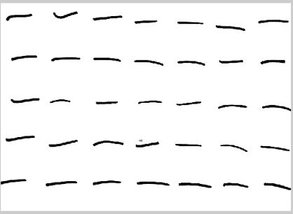

Figure 4.2- Input image

    - Pre-processing

The pre-processing is a series of operations performed on scanned input image. It essentially enhances the image rendering it suitable for segmentation. The role of pre-processing is to segment the interesting pattern from the background. Generally, noise filtering, smoothing and normalization should be done in this step. The pre-processing also defines a compact representation of the pattern. Binarization process converts a gray scale image into a binary image. Dilation of edges in the binarized image is done using sobel technique.

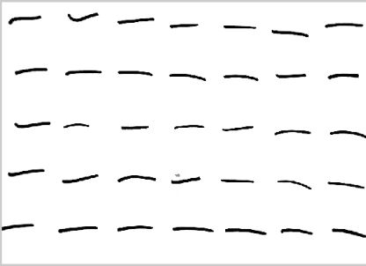

Figure 4.3- Binarized Image

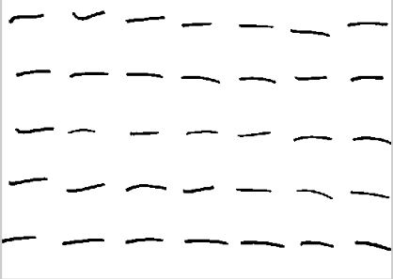

Figure 4.4 – Noise free image

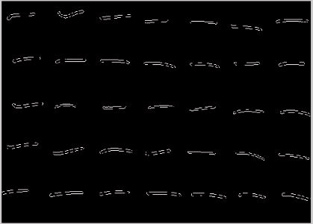

Figure 4.5 – image after edge detection

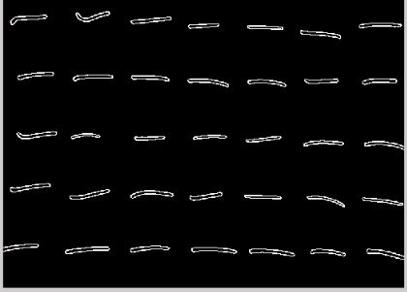

Figure 4.6 – Image with only edges

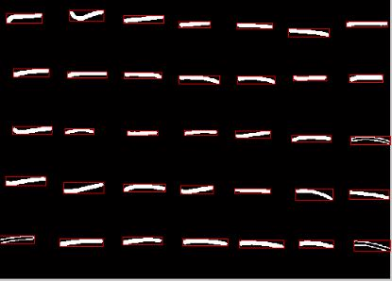

Figure 4.7 – Image after dilation with bounding box

    - Segmentation

In the segmentation stage, an image of sequence of characters is decomposed into sub-images of individual character. The pre-processed input image is segmented into isolated characters by assigning a number to each character using a labelling process. This labelling provides information about number of characters in the image. Each individual character is uniformly resized into pixels





Figure 4.8 – Images after segmentation

Edge Detection Algorithm

BW = edge(I) takes a grayscale or a binary image I as its input, and returns a binary image BW of the same size as I, with 1's where the function finds edges in I and 0's elsewhere.

By default, edge uses the Sobel method to detect edges but the following provides a complete list of all the edge-finding methods supported by this function:
The Sobel method finds edges using the Sobel approximation to the derivative. It returns edges at those points where the gradient of I is maximum.

4.4.3 Feature Extraction

The sub-images have to be cropped sharp to the border of the character in order to standardize the sub-images. The image standardization is done by finding the maximum row and column with 1s and with the peak point, increase and decrease the counter until meeting the white space, or the line with all 0s. The image pre-processing is then followed by the image resize again to meet the network input requirement, 10 by 10 matrices, where the value of 1 will be assign to all pixel where all 10 by 10 box are filled with 1s. Finally, the 10 by 10 matrices is concatenated into a stream so that it can be feed into network 100 input neurons. The input of the network is actually the negative image of the figure, where the input range is 0 to 1, with 0 equal to black and 1 indicate white, while the value in between show the intensity of the relevant pixel.

By this, we are able to extract the character and pass to another stage for future "classification" or “training" purpose of the neural network.

4.4.4 Classification

In Neural Network, each node perform some simple computation and each connection conveys a signal from one node to another labelled by a number called the “connection strength” or weight indicating the extent to which signal is amplified or diminished by the connection.

Different choices for weight results in different functions are being evaluated by the network. If in a given network whose weight are initial random and given that we know the task to be accomplished by the network , a learning algorithm must be used to determine the values of the weight that will achieve the desired task. Learning Algorithm qualifies the computing system to be called Artificial Neural Network. The node function was predetermined to apply specific function on inputs imposing a fundamental limitation on the capabilities of the network. Typical pattern recognition systems are designed using two pass.
The first pass is a feature extractor that finds features within the data which are specific to the task being solved (e.g. finding bars of pixels within an image for character recognition).
The second pass is the classifier, which is more general purpose and can be trained using a neural network and sample data sets Back propagation was created by generalizing the Widrow-Hoff learning rule to multiple-layer networks and nonlinear differentiable transfer functions.
Input vectors and the corresponding target vectors are used to train a network until it can approximate a function, associate input vectors with specific output vectors, or classify input vectors in an appropriate way as defined by you. Networks with biases, a sigmoid layer, and a linear output layer are capable of approximating any function with a finite number of discontinuities.

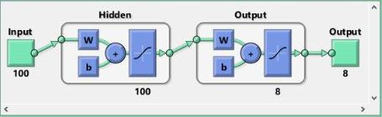

Figure 4.9 – Implemented neural network

4.5 Use of tools for design

4.5.1 Image Processing Toolbox
Image Processing Toolbox™ provides a comprehensive set of reference-standard algorithms, functions, and apps for image processing, analysis, visualization, and algorithm development. You can perform image enhancement, image deblurring, feature detection, noise reduction, image segmentation, geometric transformations, and image registration. Many toolbox functions are multithreaded to take advantage of multi core and multiprocessor computers.
Image Processing Toolbox supports a diverse set of image types, including high dynamic range, giga pixel resolution, embedded ICC profile and tomography. Visualization functions let you explore an image, examine a region of pixels, adjust the contrast, create contours or histograms, and manipulate regions of interest (ROIs). With toolbox algorithms you can restore degraded images, detect and measure features, analyze shapes and textures, and adjust color balance. Image Processing Toolbox is included in MATLAB and Simulink Student Version.

4.5.2 Neural Network Toolbox
Neural Network Toolbox™ provides functions and apps for modeling complex nonlinear systems that are not easily modeled with a closed-form equation. Neural Network Toolbox supports supervised learning with feedforward, radial basis, and dynamic networks. It also supports unsupervised learning with self-organizing maps and competitive layers. With the toolbox you can design, train, visualize, and simulate neural networks. You can use Neural Network Toolbox for applications such as data fitting, pattern recognition, clustering, time-series prediction, and dynamic system modeling and control.

CHAPTER 5
IMPLEMENTATION

- IMPLEMENTATION

  - Software and Hardware Used

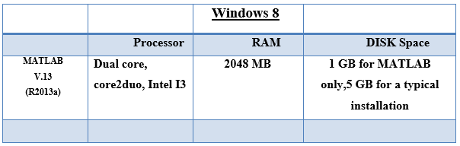

Figure 5.1 - Software and Hardware Used

5.2 Software Development Platform/Environment/framework

MATLAB is a high-performance language for technical computing. It integrates computation, visualization, and programming in an easy-to-use environment where problems and solutions are expressed in familiar mathematical notation.

The name MATLAB stands for matrix laboratory. MATLAB was originally written to provide easy access to matrix software developed by the LINPACK and EISPACK projects, which together represent the state-of-the-art in software for matrix computation.

5.2.1 The MATLAB language

This is a high-level matrix/array language with control flow statements, functions, data structures, input/output, and object-oriented programming features. It allows both "programming in the small" to rapidly create quick and dirty throw-away programs, and "programming in the large" to create complete large and complex application programs.

5.2.2 The MATLAB working environment

This is the set of tools and facilities that you work with as the MATLAB user or programmer. It includes facilities for managing the variables in your workspace and importing and exporting data. It also includes tools for developing, managing, debugging, and profiling M-files, MATLAB's applications.

5.2.3 MATLAB Image Processing Toolbox

We have used MATLAB Image Processing Toolbox for the development of this software. Image processing involves changing the nature of an image in order to improve pictorial information of the image for human interpretation for autonomous human perception. The Image Processing Toolbox is a collection of functions that extend the capability of the MATLAB numeric computing environment. The toolbox supports a wide range of operations on the image.

Key Features

• Image enhancement, including filtering, filters design, deblurring and contrast enhancement.
• Image analysis including features detection, morphology, segmentation, and measurement.
• Spatial transformations and image registration.
• Support for multidimensional image processing.
• Support for ICC version 4 color management system.
• Modular interactive tools including ROI selection, histograms and distance measurements.
• Interactive image and video display.
• DICOM import and export.

5.2.4 MATLAB Neural Network Toolbox

Key Features
• Supervised networks, including multilayer, radial basis, learning vector quantization (LVQ), time-delay, nonlinear autoregressive (NARX), and layer-recurrent
• Unsupervised networks, including self-organizing maps and competitive layers
• Apps for data-fitting, pattern recognition, and clustering
• Parallel computing and GPU support for accelerating training (using Parallel Computing Toolbox)
• Preprocessing and post processing for improving the efficiency of network training and assessing network performance
• Modular network representation for managing and visualizing networks of arbitrary size
• Simulink® blocks for building and evaluating neural networks and for control systems applications

5.2.5 Neural network training

The implemented neural network is trained using scaled conjugate gradient backpropagation (trainscg).

Training automatically stops when generalization stops improving, as indicated by an increase in the mean square error of the validation samples.

CHAPTER 6
RESULTS

- RESULTS
  - Results of training and testing
We have used a data set of 2774 where each symbol has approximately 300 samples in the data set. We are classifying samples as one of 8 symbols that include plus, minus, multiplication, division, lesser than, greater than, square opening bracket and square closing bracket.

Three kinds of samples that are used.
- Training
These are presented to the network during training, and the network is adjusted according to its error. Among the dataset of 2774 samples, 75% of the dataset was used for training, approximately 2080 samples are used for training.
- Validation
These are used to measure network generalization, and to halt training when generalization stops improving. 10% of the dataset is used for validation ie approximately 280 samples from the dataset are used for validation.
- Testing
These have no effect on training and so provide an independent measure of network performance during and after training. 15% of the dataset is used for testing, approximately 415 samples were used for testing.

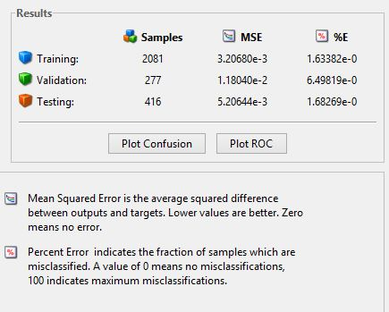

Figure 6.1- result of training 2774 samples.

  - Performance plot

The performance plot the training, validation, and test performances given the training record TR returned by the function train.
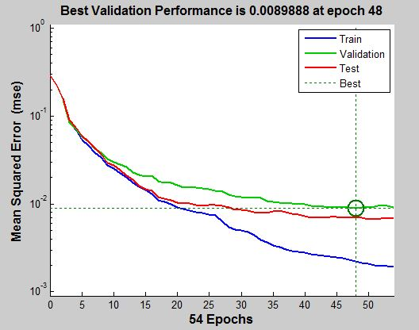
Figure 6.2 – Performance plot
6.3 Error histogram
Error histogram is a plot of error values e and names n as a pair.

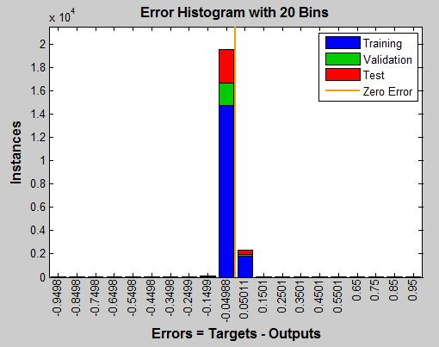
Figure 6.3 – Error histogram.

CHAPTER 7
CONCLUSION

- CONCLUSION

Handwritten character recognition is a complex problem, which is not easily solvable. The main arguing which I had at the beginning was around dataset and database. We put a lot of energy into finding already pre-prepared datasets, which could be useful for our neural network, but at the end we end up with no training data and no neural network. The main problem lies in pre-processing of data. Datasets from the internet were quite large, they contained a lot of data (a lot of data is excellent for training, validation and testing), but too little information on attributes and image extractions (which were used by them-authors of datasets). We decided to make our own dataset, which we did by get people to write the sample data on plain white A4 size sheets with marker pens. The bad side of own application is that, we did not have a lot of training data, therefore output from the neural network would be questionable. We then scanned the sheets into the computer, snipped it. This dataset was further preprocessed to remove noise, extract edges. Then we segment each sheet of data into samples of symbols. This is used for training to generate results. The effectiveness of the method that uses feature extraction using intensity of pixel technique from scanned images containing handwritten characters is presented. The feature extraction technique performed well in classification when fed to the neural network and preprocessing of image using edge detection and normalization are the ideal choice for degraded noisy images. The method of training neural network with extracted features from sample images of each character has detection accuracy to a greater extent. The proposed methodology has produced good results for images containing handwritten text written in different styles, different size and alignment with varying background. The system is developed in MATLAB and evaluated for a set of sample images containing handwritten text on Intel i3 computer.

CHAPTER 8
FUTURE WORK / ENHANCEMENT

- FUTURE WORK/ ENHANCEMENT

As the feature extraction method intensity does not classify characters of different thickness, the method can be extended for thickness independent classification from the images of other characters with little modifications. The performance of the method has been tested for classifying only a few mathematical characters, but needs further exploration. Refinement of the segmented characters can be done in order to achieve higher accuracy rate. The performance of the neural network can be increased by adding some more features other than the existing ones. More sophisticated efficient feature extraction methods can be used. The classification rate can be increased by training the neural network with more number of test images. The main aim of doing this project was to successfully recognize handwriting. This aids in solving mathematical expressions.

CHAPTER 9
SNAPSHOTS

- SNAPSHOTS

Open MATLAB R2011a
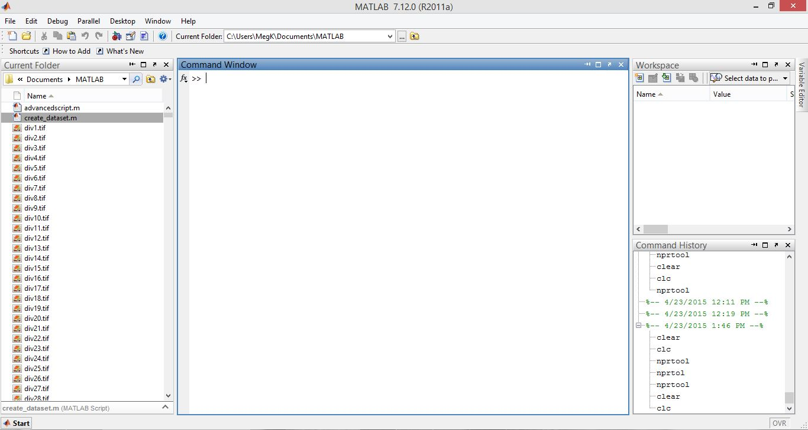

Press on the script icon on top. The editor will open start your code for preprocessing, segmentation and dataset creation. After that click run button.
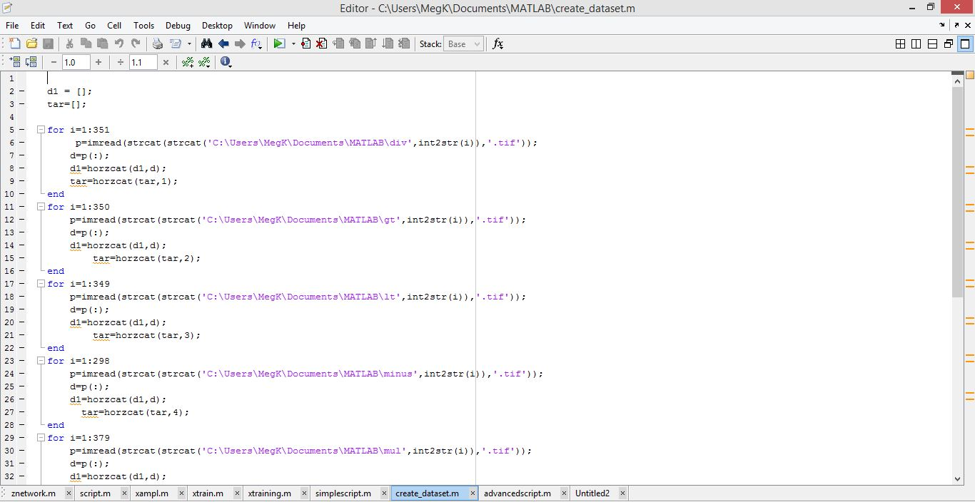

Check for the changes in the workspace. In the main MATLAB window.
Type nprtool in the command window. A new window will open.

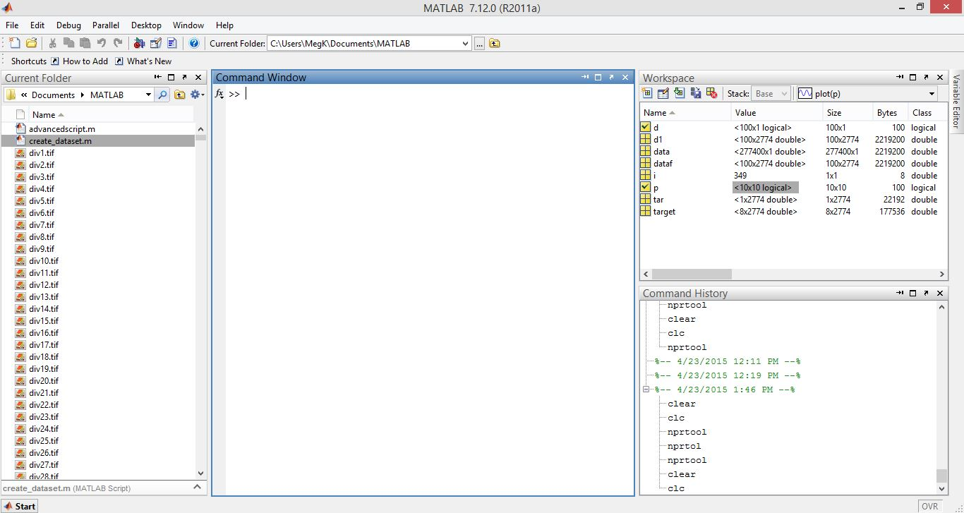
The nprtool will be triggered. Click next.
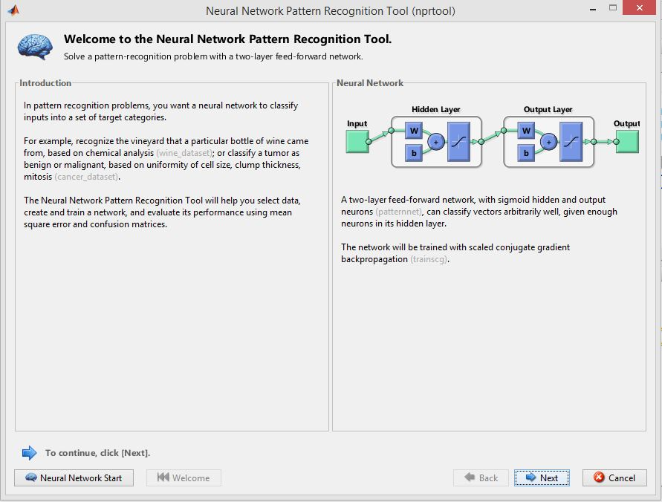

Select input and targets and the column option and click next.
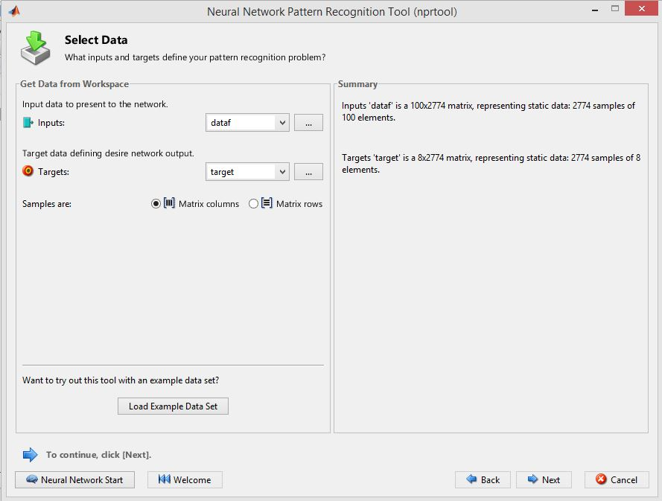
Divide the dataset into training, validating and testing set and click next. 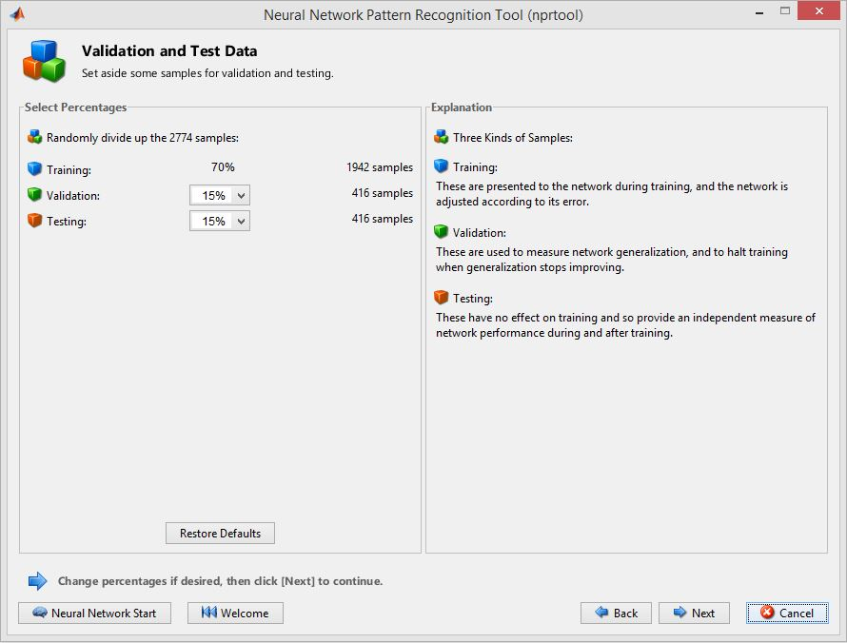

Set the network architechture by giving the number of neurons and click next.
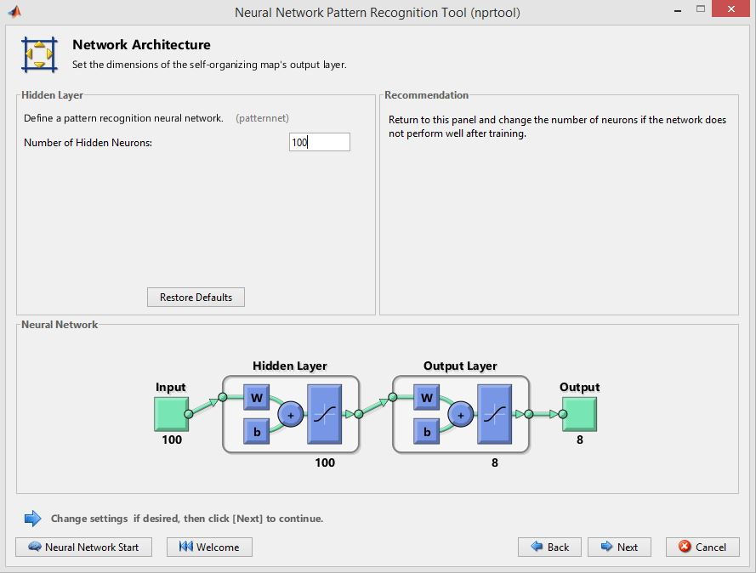

See that the results are not yet generated. Click on train.
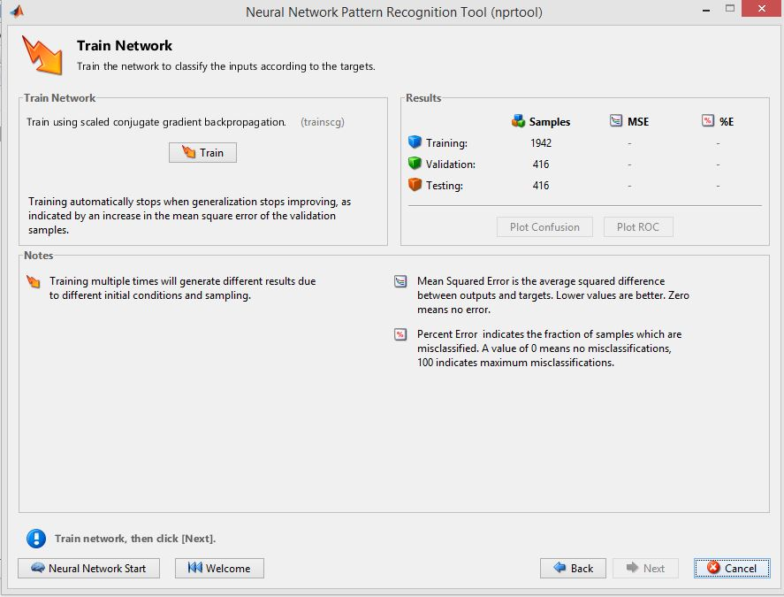

Now see that the results are generated. Another window opens up.

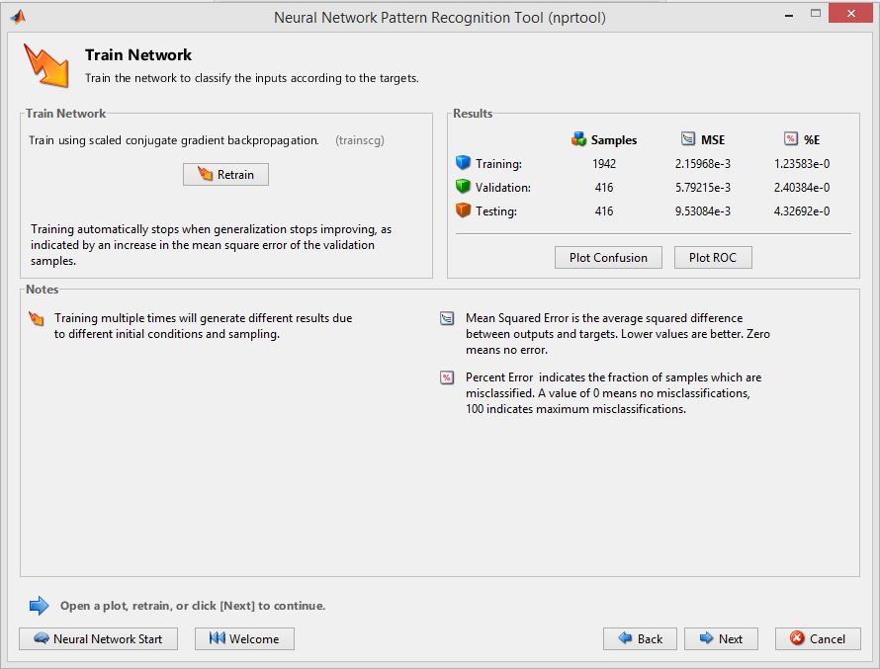

This window shows that the neural network has been trained.

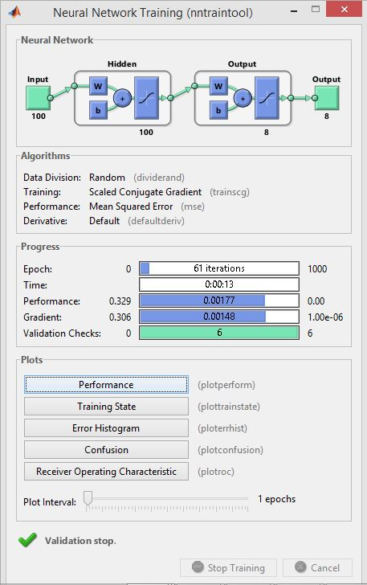
This plot is obtained by the plot per form function. or on the click of performance button in the previous window.
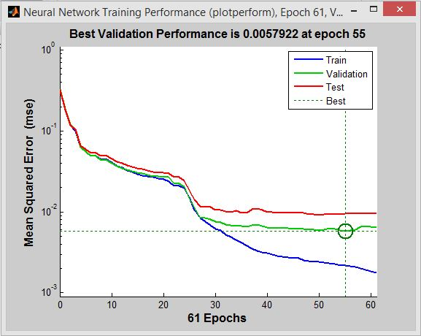

This plot is obtained by clicking on the confusion button
.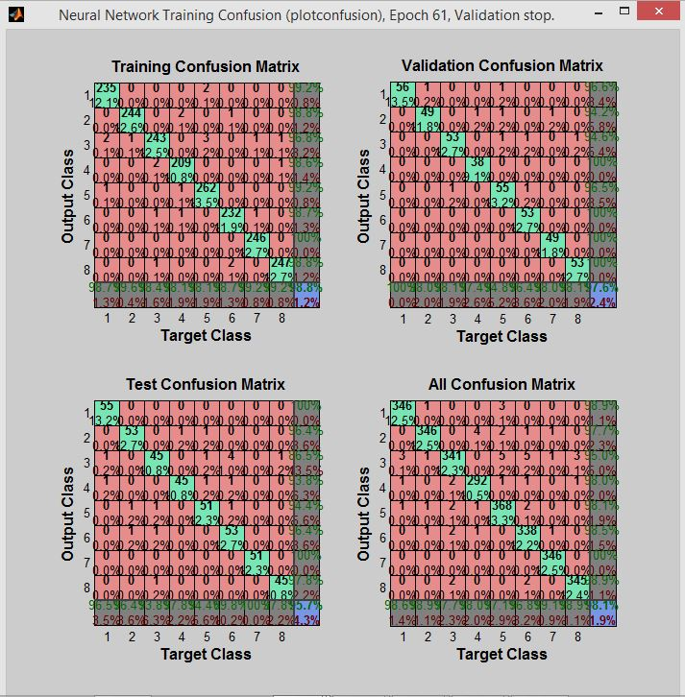
This plot is obtained by clicking on the Error histogram button.
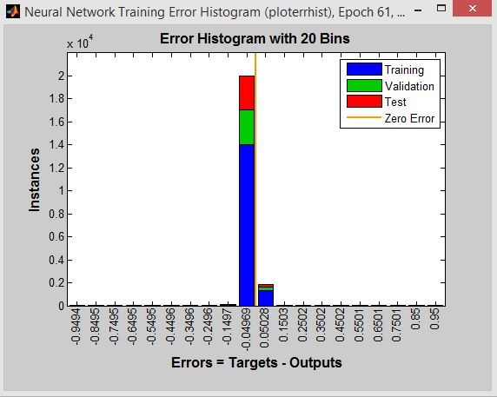
This plot is obtained by clicking on the training state button.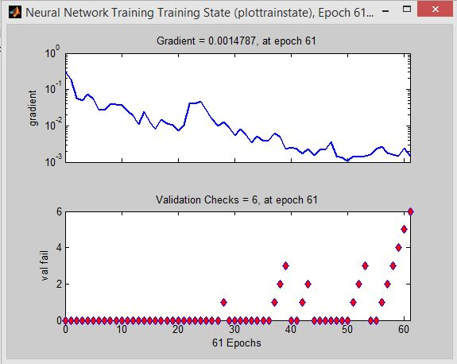Finally save all required outputs and click on the finish button to finish.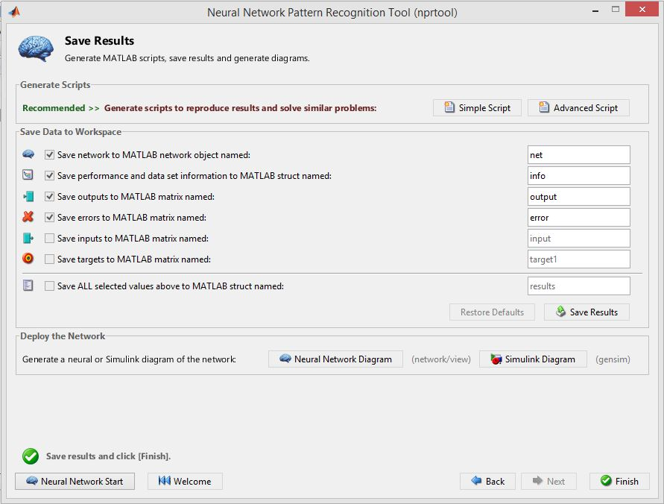

REFERENCES

REFERENCES

- Chirag I Patel, Ripal Patel, Palak Patel, “Handwritten Character Recognition Using Neural Networks”, International Journal of Scientific & Engineering Research Volume 2, Issue 5, May-2011.
- Kauleshwar Prasad, Devvrat C Nigam, Ashmika Lakhotiya, Dheeren Umre, “Character Recognition Using Matlab’s Neural Toolbox”, International Journal of u- and e- Service, Science and Technology Vol. 6, No. 1, February, 2013.
- Ashutosh Aggarwal, Rajneesh Rani, Renu Dhir,”Handwritten Character Recognition Using Gradient Features”, International Journal of Advanced Research in Computer Science and Software Engineering, Volume 2, Issue 5, May 2012.
- Vinita Dutt, Sunil Dutt, “Handwritten Character Recognition Using Artificial Neural Network”, Advances in Computing: 2011; 1(1): 18-23.
- Rahul Kala, Harsh Vazirani, Anupam Shukla, Ritu Tiwari, “Offline Handwriting Recognition”, International Journal of Computer Science issues, volume 7, March-2010.
- Dinesh Dileep, “A Feature Extraction Technique Based on Character Geometry for Character Recognition”.
- Alexander J. Faaborg, “Using Neural Networks to Create an Adaptive Character Recognition System”, Cornell University, Ithaca NY, (May 14, 2002)
- Swapnil A. Vaidya, Balaji R. Bombade “A Novel Approach of Handwritten Character Recognition using Positional Feature Extraction”, IJCSMC, Vol. 2, Issue. 6, June 2013.
- Sheng Wang “A Review of Gradient-Based and Edge-Based Feature Extraction Methods for Object Detection”, Computer and Information Technology (CIT), 2011 IEEE 11th International Conference.

