Contents
Others 1
Process 1
Threads 4
SIGNALS 7
IPC 9
Scheduling 9
File systems 9
File System 10
Memory management 13
Memory management images 14
Images – C related 15
How a C program starts and terminates 15
Memory layout of a C program 16
File System images 18
C 24
The role of _libc_start_main() function 25

Others
- gcc –nostartfile
- gcc -lpthreads

Process
- int main(int argc, char *argv[ ] )
- int main(int argc, char *argv[ ] , char *envip[ ])
- Process termination :
  - #include <stdlib.h> void exit(int status)
  - #include <stdlib.h> void _Exit(int status)
  - #include <unistd.h> void _exit(int status)
  - abort()

- Exit handler for cleanup after main function
  - #include <stdlib.h> void atexit( void (*func)(void) );
  - Returns zero on success
- Environmental variables => extern char **environ
- To compile without shared libraries=> gcc –o a.out a.c –static
  - size a.out => will increase now
- Memory allocation
  - #include <stdlib.h>
  - void *malloc(size_t size);
  - void *calloc(size_t nobjs, size_t size);
  - void *realloc(void *ptr, size_t new_size);
  - void free(void *ptr);
  - #include <alloc.h> void *alloca(size_t size);
- Environmental variables
  - #include <stdlib.h>
  - Char *getenv(const char *name)
    - Exmp : char *data = getenv( “PATH” );
    - PATH , HOME, DIR, SHELL, USER, SUDO_USER, TERM, USERNAME , MAIL , LOGNAME, PWD etc…
  - int putenv(char *str);
  - int setenv(const char * name, const char *value, int rewrite);
  - int unsetenv(const char *name);
  - clearenv
- NON LOCAL JUMPS :jmp works only with the same function, To jump across functions :
  - #include <setjmp.h>
  - jmp_buffer var_jmp;
  - int setjmp( jmp_buffer env) => returns the value passed by longjmp in its function argument
  - void longjmp(jmp_buffer env, int val)
  - Example :
    - if (setjmp(var_jmp) == ret_value)
    - longjmp(var_jmp, ret_value)
  - Without compiler optimization => auto,register, static, extern, volatile are stored and accessed directly from memory. Register storage class name is ignored
  - With compiler optimization => auto,register are stored and accessed directly from CPU registers
- Main PID’s
  - PID 0 – swapper or scheduler has process ID 0(kernel level process) and is responsible for paging, and is actually part of the kernel rather than a normal user-mode process
  - PID 1 – the init process primarily runs in user space with root privileges responsible for starting and shutting down the system. “init” process script file => /etc/init.d, /etc/rc*.d, /etc/inittab
  - PID 2 – page daemon
- Process identifiers
  - pid_t getpid(void);
  - pid_t getppid(void);
  - uid_t getuid(void);
  - uid_t geteuid(void);
  - gid_t getgid(void);
  - gid_t getegid(void);
  - pid_t getsid(pid_t);
- Fork
  - CHILD PROCESS INHERITS THE FILE-DESCRIPTORS from PARENT PROCESS.
  - #include <sys/types.h>
  - #include <unistd.h>
  - pid_t fork(void); (COW technique)==>
    - Sharing of open files between parent and child after fork
    - BASICALLY PARENT AND CHILD SHARE THE SAME PHYSICAL PAGES
  - pid_t vfork(void); => parent process is suspended till child calls exec/exit it will work in the same address-space as tht of parent, but the local variables from main are not used by the child.
    - BASICALLY PARENT AND CHILD SHARE THE SAME VIRTUAL ADDRESS SPACE
  - wait
    - wait3
    - wait4
    - #include <sys/types.h>
    - #include <sys/wait.h>
    - pid_t wait(int *status);
      - parent process blocks until any of its child changes the state( termination, child wakes due to signal etc.)
      - notes : is always blocking unless any child terminates
    - pid_t waitpid(pid_t pid, int *status, int options);
      - parents process waits for the specific child till its terminated but this behaviour can be changed using “options” field => WNOHANG : Return immediately if no child has exited.
WUNTRACED : Also return if a child has stopped. Status for traced children which have stopped is provided even if this option is not specified.
WCONTINUED : Also return if a stopped child has been resumed by delivery of SIGCONT.
      - exmp : printf("Child exit code: %d\n", WEXITSTATUS(status));
      - pid < -1 : Wait for any child process whose process group ID is equal to the absolute value of pid.
      - pid = -1 : Wait for any child process.
      - pid = 0 : Wait for any child process whose process group ID is equal to that of the calling process.
      - pid > 0 : Wait for the child whose process ID is equal to the value of pid.
      - Wiatpid is also blocking but it can be told not to block using the option WNOHANG
    - http://www.masterraghu.com/subjects/np/introduction/unix_network_programming_v1.3/ch05lev1sec10.html (IMP)
    - int waitid(idtype_t idtype, id_t id, siginfo_t * infop , int options );

  - exit
    - exit
    - registering exit function : int atexit(void(*func)void)
  - exec
    - execl
    - execv
    - execle
    - execve
    - execlp
    - execvp
  - TELL_WAIT
- Sharing of open files between parent and child after fork
  - Other option : filelocks
- Chmod command has 777 => first 7 for user, second 7 for group, third 7 for others permissions

Threads
- Posix threads
  - #include <pthread.h>
  - Pthread functions
    - int pthread_create(pthread_t *, const pthread_attr_t *, void *(*)(void *), void *);
    - void pthread_exit(void *);
    - int pthread_join(pthread_t, void **);
    - pthread_self(void);
    - int pthread_cancel(pthread_t);
    - int pthread_detach(pthread_t);
    - void pthread_cleanup_push(void*), void *);
    - void pthread_cleanup_pop(int);
    - int pthread_equal(pthread_t, pthread_t);
  - thread sync

    - int pthread_attr_destroy(pthread_attr_t *);
    - int pthread_attr_getdetachstate(const pthread_attr_t *, int *);
    - int pthread_attr_getguardsize(const pthread_attr_t *, size_t *);
    - int pthread_attr_getinheritsched(const pthread_attr_t *, int *);
    - int pthread_attr_getschedparam(const pthread_attr_t *,
    - struct sched_param *);
    - int pthread_attr_getschedpolicy(const pthread_attr_t *, int *);
    - int pthread_attr_getscope(const pthread_attr_t *, int *);
    - int pthread_attr_getstackaddr(const pthread_attr_t *, void **);
    - int pthread_attr_getstacksize(const pthread_attr_t *, size_t *);
    - int pthread_attr_init(pthread_attr_t *);
    - int pthread_attr_setdetachstate(pthread_attr_t *, int);
    - int pthread_attr_setguardsize(pthread_attr_t *, size_t);
    - int pthread_attr_setinheritsched(pthread_attr_t *, int);
    - int pthread_attr_setschedparam(pthread_attr_t *,
    - const struct sched_param *);
    - int pthread_attr_setschedpolicy(pthread_attr_t *, int);
    - int pthread_attr_setscope(pthread_attr_t *, int);
    - int pthread_attr_setstackaddr(pthread_attr_t *, void *);
    - int pthread_attr_setstacksize(pthread_attr_t *, size_t);

    - int pthread_cond_broadcast(pthread_cond_t *);
    - int pthread_cond_destroy(pthread_cond_t *);
    - int pthread_cond_init(pthread_cond_t *, const pthread_condattr_t *);
    - int pthread_cond_signal(pthread_cond_t *);
    - int pthread_cond_timedwait(pthread_cond_t *,
    - pthread_mutex_t *, const struct timespec *);
    - int pthread_cond_wait(pthread_cond_t *, pthread_mutex_t *);
    - int pthread_condattr_destroy(pthread_condattr_t *);
    - int pthread_condattr_getpshared(const pthread_condattr_t *, int *);
    - int pthread_condattr_init(pthread_condattr_t *);
    - int pthread_condattr_setpshared(pthread_condattr_t *, int);

    - int pthread_getconcurrency(void);
    - int pthread_getschedparam(pthread_t, int *, struct sched_param *);
    - void *pthread_getspecific(pthread_key_t);

    - int pthread_key_create(pthread_key_t *, void (*)(void *));
    - int pthread_key_delete(pthread_key_t);

    - int pthread_mutex_destroy(pthread_mutex_t *);
    - int pthread_mutex_getprioceiling(const pthread_mutex_t *, int *);
    - int pthread_mutex_init(pthread_mutex_t *, const pthread_mutexattr_t *);
    - int pthread_mutex_lock(pthread_mutex_t *);
    - int pthread_mutex_setprioceiling(pthread_mutex_t *, int, int *);
    - int pthread_mutex_trylock(pthread_mutex_t *);
    - int pthread_mutex_unlock(pthread_mutex_t *);
    - int pthread_mutexattr_destroy(pthread_mutexattr_t *);
    - int pthread_mutexattr_getprioceiling(const pthread_mutexattr_t *,
    - int *);
    - int pthread_mutexattr_getprotocol(const pthread_mutexattr_t *, int *);
    - int pthread_mutexattr_getpshared(const pthread_mutexattr_t *, int *);
    - int pthread_mutexattr_gettype(const pthread_mutexattr_t *, int *);
    - int pthread_mutexattr_init(pthread_mutexattr_t *);
    - int pthread_mutexattr_setprioceiling(pthread_mutexattr_t *, int);
    - int pthread_mutexattr_setprotocol(pthread_mutexattr_t *, int);
    - int pthread_mutexattr_setpshared(pthread_mutexattr_t *, int);
    - int pthread_mutexattr_settype(pthread_mutexattr_t *, int);

    - int pthread_once(pthread_once_t *, void (*)(void));
    - int pthread_rwlock_destroy(pthread_rwlock_t *);
    - int pthread_rwlock_init(pthread_rwlock_t *,
    - const pthread_rwlockattr_t *);
    - int pthread_rwlock_rdlock(pthread_rwlock_t *);
    - int pthread_rwlock_tryrdlock(pthread_rwlock_t *);
    - int pthread_rwlock_trywrlock(pthread_rwlock_t *);
    - int pthread_rwlock_unlock(pthread_rwlock_t *);
    - int pthread_rwlock_wrlock(pthread_rwlock_t *);
    - int pthread_rwlockattr_destroy(pthread_rwlockattr_t *);
    - int pthread_rwlockattr_getpshared(const pthread_rwlockattr_t *,
    - int *);
    - int pthread_rwlockattr_init(pthread_rwlockattr_t *);
    - int pthread_rwlockattr_setpshared(pthread_rwlockattr_t *, int);
    - pthread_t
  - Thread cancellation
    - int pthread_setcancelstate(int, int *);
    - int pthread_setcanceltype(int, int *);
    - int pthread_setconcurrency(int);
    - int pthread_setschedparam(pthread_t, int ,
    - const struct sched_param *);
    - int pthread_setspecific(pthread_key_t, const void *);
    - void pthread_testcancel(void);

SIGNALS
- #include <signal.h> => asynchronous event
  - SIGALRM: Alarm timer time-out. Generated by alarm( ) API.
  - SIGABRT: Abort process execution. Generated by abort( ) API.
  - SIGFPE: Illegal mathematical operation.
  - SIGHUP: Controlling terminal hang-up.
  - SIGILL: Execution of an illegal machine instruction.
  - SIGINT: Process interruption. Can be generated by <Delete> or <ctrl_C> keys.
  - SIGKILL: Sure kill a process. Can be generated by – “kill -9 <process_id>“ command.
  - SIGPIPE: Illegal write to a pipe.
  - SIGQUIT: Process quit. Generated by <crtl_> keys.
  - SIGSEGV: Segmentation fault. generated by de-referencing a NULL pointer.
  - SIGTERM: process termination. Can be generated by – “kill <process_id>” command
  - SIGUSR1: Reserved to be defined by user
  - SIGUSR2: Reserved to be defined by user
  - SIGCHLD: Sent to a parent process when its child process has terminated
    - Whenever a process terminates or stops, the SIGCHLD signal is sent to the parent. By default, this signal is ignored, so the parent must catch this signal if it wants to be notified whenever a child's status changes. The normal action in the signal-catching function is to call one of the wait functions to fetch the child's process ID and termination status.
  - SIGCONT: Resume execution of a stopped process
  - SIGSTOP: Stop a process execution.
  - SIGTTIN: Stop a background process when it tries to read from from its controlling terminal
  - SIGTSTP: Stop a process execution by the control_Z keys. •
  - SIGTTOUT: Stop a background process when it tries to write to its controlling terminal
- Creating a signal handler (cnat be done for SIGKILL, SIGSTOP)
  - void (*signal ( int sig_num, void(*sig_handler(int))) (int)
    - handler function shld be => void func_handler (int sig_num)
    - in case of registering like this ,while processing the signal-handler, if the same signal occurs again then it gets invoked in between itself.
    - Return type is pointer to the previous signal handler
    - This function automatically restarts the slow system calls
    - #define SIG_ERR (void (*)())-1
    - #define SIG_DFL (void (*)())0
    - #define SIG_IGN (void (*)())1
    - The three values used for these constants need not be -1, 0, and 1. they must be three values that can never be the address of any declarable function.
  - Other way of programming :
    - typedef void *sighandler(int)
    - sighandler signal(int , sighandler)
  - Signal sets:
    - Signal _mask

    - sigprocmask
    - sigpending
    - sigsuspend
  - Other method :
    - Struct sigaction act;
    - act.sa_hanler = func_handler ;
    - sigemptyset( &act.sa_mask);
    - act.sa_flags = 0
    - sigaction( SIG_USR1, &act);
  - jumping out of the signal handler fucntiont o main, instead of returning frm the signal handler properly
    - sigsetjmp
    - siglongjmp
  - Signal occurs while running a System call => slow process
- Kill : int kill(pid_t pid, int sig_num)
- Raise : int raise(int sig_num)
- Int kill(getpid(),int sig_num) becomes same as raise
- alarm
- pause
- sleep
- abort

IPC
- PIPES :
  - Processes must have a common parent
  - By default Linux when a pipe is created 4096bytes of memory is assigned(1 page).
- FIFO
- <sys/ipc.h>

Scheduling

File systems
- Disk buffering, Buffer Cache, Write-back buffer cache, Write through buffer cache, sync command
- Superblocks, inodes, dentry
- How a single file is shared between two different process?
- Open
- Close
- Read
- Write
- Ioctk
- Sysfs
- Procfs => /proc

File System
- LRU algorithm for maintaining buffer caches.
- Size of memory allocated for buffer cache varies depending on the amount of free RAM available at a given point of time
- File operations : FILE *fp => for c-library calls, int fd => system calls
- For any process
  - fd = 0 ==> STDIN_FILENO
  - fd = 1 ==> STDOUT_FILENO
  - fd = 2 ==> STDERR_FILENO
- #include <fcntl.h>
- Open
  - int fd = open(const char *file_name, int flags, mode_t mode);
O_RDONLY
O_WRONLY
O_RDWR
O_APPEND
O_TRUNC : if the file exists and it is successfully opened for either readwrite or write-only ,truncate its length to 0
O_CREAT : if the file is not present a new file is created, else if the file already exists it just opens , This option requires a third argument to the open function, the mode, which specifies the access permission bits of the new file.
O_EXCL : If O_CREAT and O_EXCL are set, open() shall fail if the file exists. The check for the existence of the file and the creation of the file if it does not exist shall be atomic with respect to other threads executing open() naming the same filename in the same directory with O_EXCL and O_CREAT set. If O_EXCL and O_CREAT are set, and path names a symbolic link,open() shall fail and set errno to [EEXIST], regardless of the contents of the symbolic link. If O_EXCL is set and O_CREAT is not set, the result is undefined.
O_NONBLOCK
O_SYNC : each write wait for physical I/O to complete and also including IO necessary to update file attributes modified as a result of write. These 2 operations happen in atomic mode
O_DSYNC : each write wait for physical I/O to complete but don’t wait for file attributes to be updated if they don’t affect the ability to read the data just written.
O_RSYNC : Have each read operation on the file descriptor wait until any pending writes for the same portion of the file are complete.

- creat function
  - int creat(const char *filename, mode_t mode);
  - New file creation :
    - int fd = open( “/tmp/a.c”, O_WRONLY|O_CREAT|O_TRUNC, mode);
  - int fd = creat(“/tmp/a.c”, mode); When a file is created using creat function, file is opened for only writing, if we want to read frm the file then again we have to do => close the opened file , open file with O_RDWR and then perform read operations.
- close
  - int close(int file_descriptor)
- Read
  - int read(int fd, char *buf, int no_of_bytes);
  - returns no of bytes read on success, 1 on error , 0 if EOF
- Write
  - int write(int fd, const char *buf, int no_of_bytes);
  - If the O_APPEND option was specified when the file was opened, the file's offset is set to the current end of file before each write operation. After a successful write, the file's offset is incremented by the number of bytes actually written.
- lseek : #include <unistd.h>
  - By default, this offset is initialized to 0 when a file is opened, unless the O_APPEND option is specified.
  - int lseek(int fd, off_t offset, int whence)
  - For exmp: Assume 2 file’s : file_wth_nohole.c and file_wth_hole.c both with the same size, if we check their physical size on the hard-disk file_wth_hole.c with use more no of data blocks on hard disk
  - TO get current fd position in file => int current_position = lseek( fd, 0, SEEK_CUR);
  - SEEK_SET
  - SEEK_CUR
  - SEEK_END
  - SEEK_HOLE
  - SEEK_DATA
- Hole in a file
  - Open fd, lseek(fd, 100,SEEK_END), write(fd, buf, 10);
  - Another way to create holes In a file is using dd command
- pread and pwrite functions (used instead of lseek and write (OR) lseek and read , as these are not atomic operations)
  - #include <unistd.h>
  - ssize_t pread(int fd, void *buf, size_t count, off_t offset);
pread() reads up to count bytes from file descriptor fd at offset offset (from the start of the file) into the buffer starting at buf.
The file offset is not changed.
  - ssize_t pwrite(int fd, const void *buf, size_t count, off_t offset);
pwrite() writes up to count bytes from the buffer starting at buf to the file descriptor fd at offset offset
The file offset is not changed.
- Dup/dup2
  - int dup(int filedes );
    - The new file descriptor returned by dup is guaranteed to be the lowest-numbered available file descriptor.
  - int dup2(int filedes, int filedes2);
    - With dup2, we specify the value of the new descriptor with the filedes2 argument. If filedes2 is already open, it is first closed. If filedes equals filedes2, then dup2 returns filedes2 without closing it.
- sync/fsync/fsyncdata =>returns 0 on success and 1 on error
  - When we write data to a file, the data is normally copied into the kernel into one of its buffers(i.e.buffer cache) and queued for writing to disk at sometime later this is called as DELAYED WRITE. Kernel eventually writes all the delayed-write blocks at a later point of time,normally when it needs to reuse the buffer at a later point of time
  - #include <unistd.h>
  - void sync(void) => this is asynchronous operation
    - The sync function simply queues all the modified block buffers for writing and returns; it does not wait for the disk writes to take place. The function sync is normally called periodically (usually every 30 seconds) from a system daemon, often called update. This guarantees regular flushing of the kernel's block buffers.
  - int fsync(int filedes); => this is synchronous operation both file attributes+data portions of the file
    - The function fsync refers only to a single file, specified by the file descriptor filedes, and waits for the disk writes to complete before returning. With fsync, the file's attributes are also updated synchronously. The intended use of fsync is for an application, such as a database, that needs to be sure that the modified blocks have been written to the disk.
  - int fdatasync(int filedes);
    - The fdatasync function is similar to fsync, but it affects only the data portions of a file.
- Linux commands :
  - cat /proc/fd
  - od –c file_name => prints the file contents as characters
  - dd command
  - cat /proc/meminfo
  - free –m
  - df –h
  - sync, fsync, fdatasync
  - od –c file_name
  - dd
  - cat /dev/fd
  - mount
  - mkfs
  - ln –s => to create symbolic link
  - /etc/fstab
  - ls command – list directory contents.
  - du command – estimate file space usage.
  - stat command – display file or file system status.
- Buffer cache
- Synchronous/asynchronous read/write operations
- /etc/fstab => during linux boot-up contains info about all file systems

Memory management

- Linux commands :

- Virtual memory is Memory management technique of the computer.
- SWAP SPACE : this is a space which is actually present on SECONDARY STORAGE => HARD DISK, in linux OS swap space must be ≥ 2×RAM size. Swap space can be assumed like any other file being stored on the hard-disk following file system rules, Difference is that for SWAP-SPACE there is no “METADATA” maintained, so accessing swap space is faster than any other normal files. Other difference is that “BUFFER CACHE” concept doesn’t apply for SWAP-SPACE
- TLB is actually a part of hardware – on SOC
- UMA vs NUMA => uniform memory access ; non-uniform memory access

Memory management images

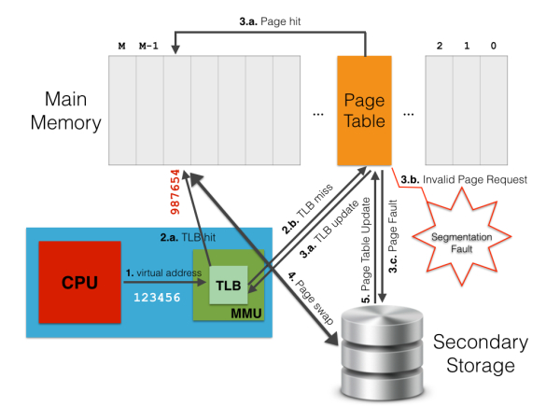
1TLB-Page fault understanding

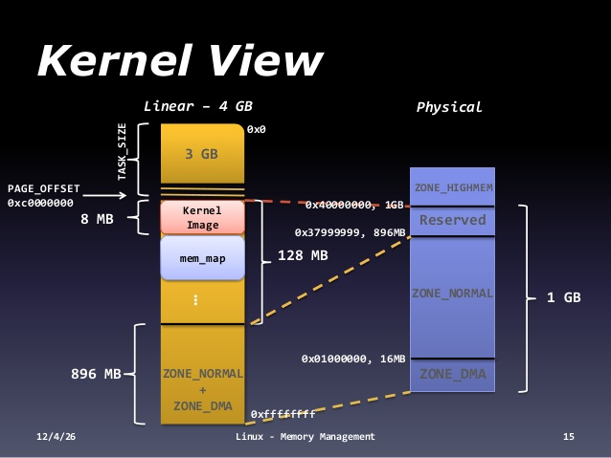

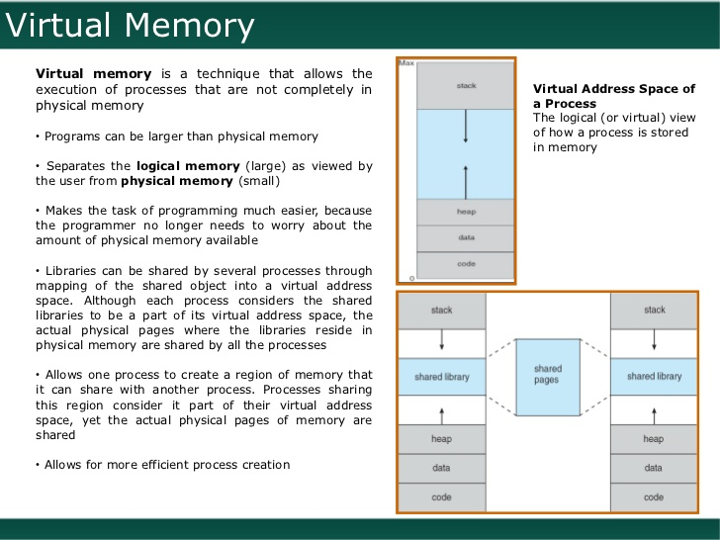
2virtual memory and sharing of a code between 2 different processes

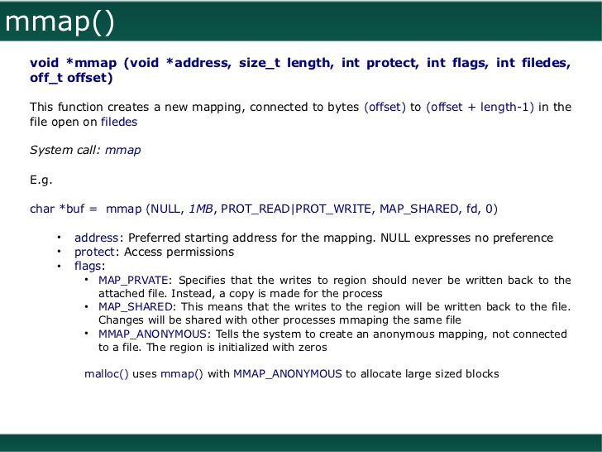
3mmap function which is invoked by malloc()

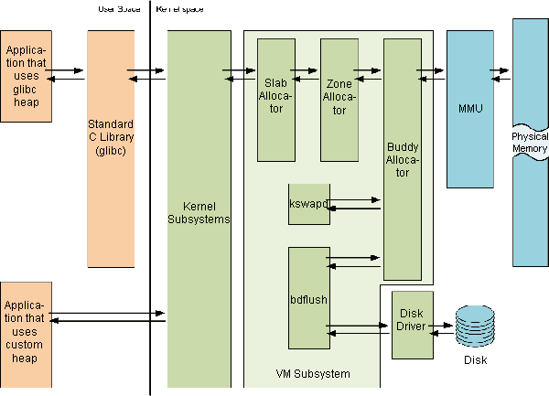

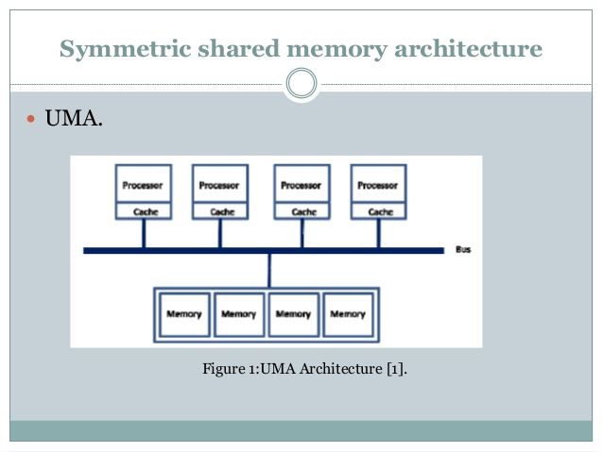
4UMA architecture

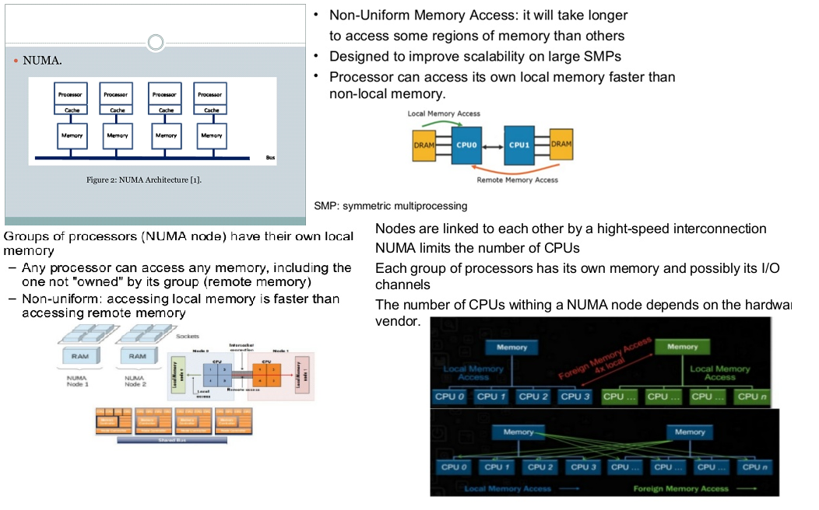
5NUMA architecture

Images – C related

How a C program starts and terminates

Memory layout of a C program
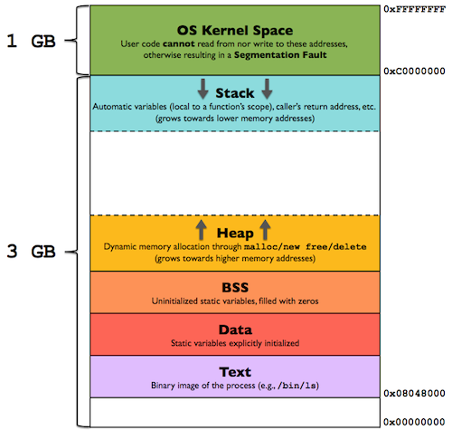

The dynamically allocated data (ie. the data created using malloc in C) as well as the static data without a fixed size (such as arrays of variable size) are created and kept in the heap.

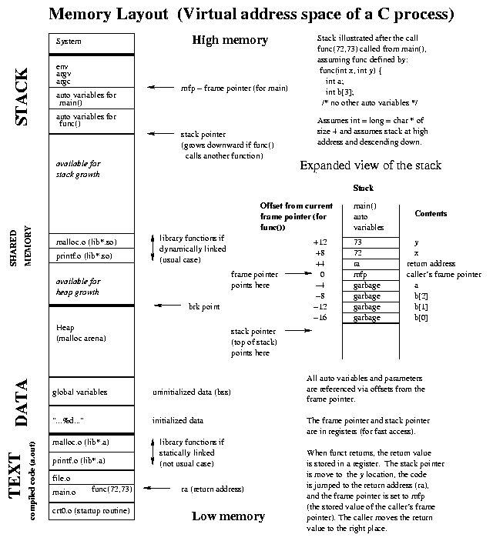

File System images
- How a single file is shared between two different process?

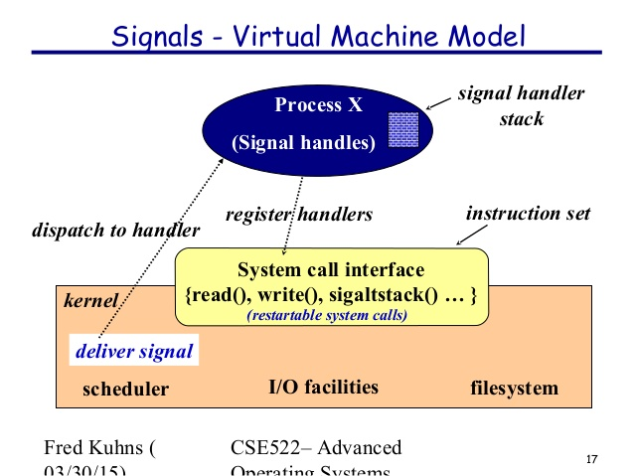

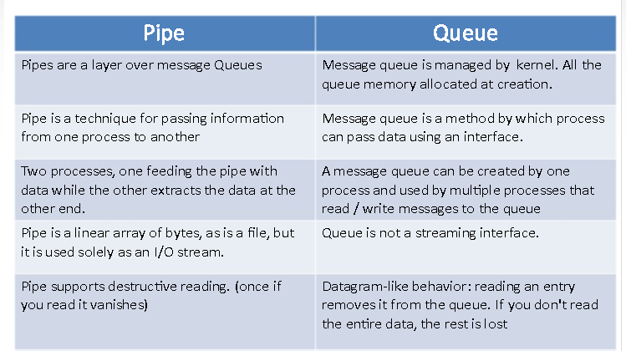

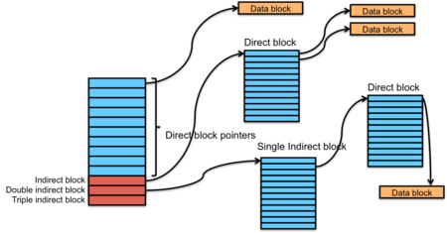

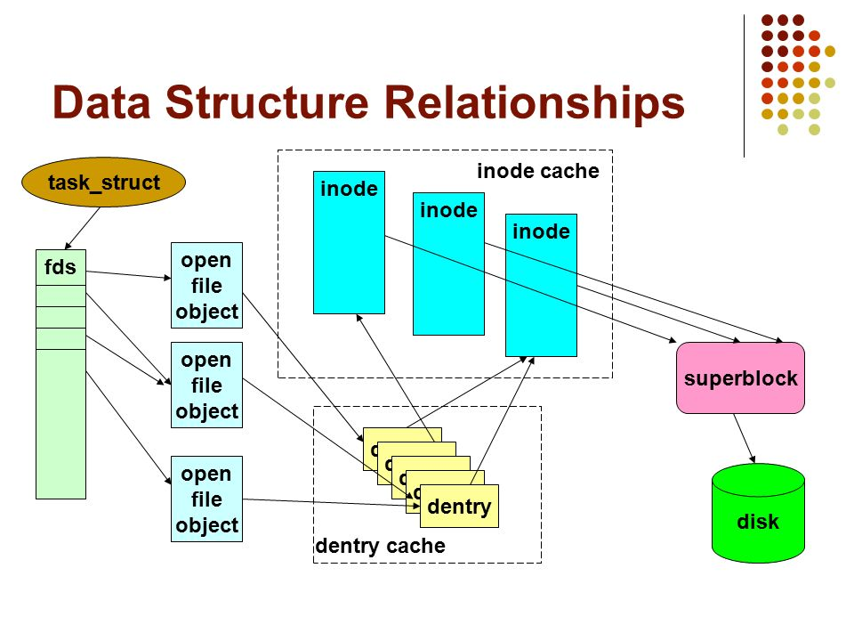

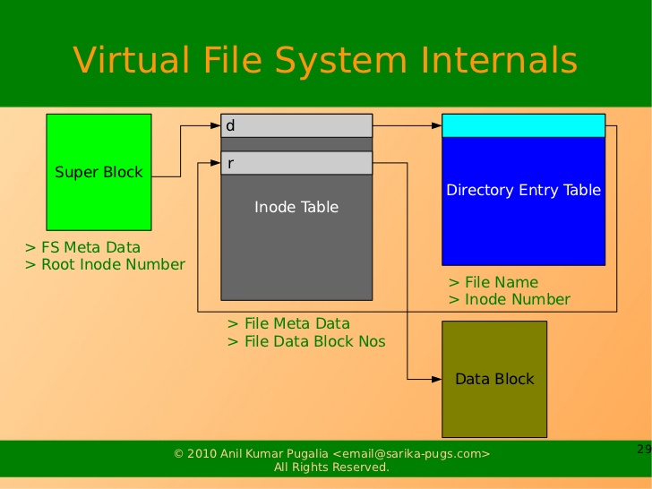

C
- Before and after main() :
#include<stdio.h>

/* Apply the constructor attribute to myStartupFun() so that it
is executed before main() */
void myStartupFun (void) __attribute__ ((constructor));

/* Apply the destructor attribute to myCleanupFun() so that it
is executed after main() */
void myCleanupFun (void) __attribute__ ((destructor));

  - ELF file => e_entry field contain address of => _start function => _libc_start_main function => main function
  - gcc –nostartfiles
The _start() function prepare the input arguments for another function _libc_start_main() which will be called next. This is prototype of _libc_start_main() function. Here we can see the arguments which were prepared by _start() function.
int __libc_start_main(int (*main) (int, char * *, char * *), /* address of main function*/
int argc, /* number of command line args*/
char ** ubp_av, /* command line arg array*/
void (*init) (void), /* address of init function*/
void (*fini) (void), /* address of fini function*/
void (*rtld_fini) (void), /* address of dynamic linker fini function */
void (* stack_end) /* end of the stack address*/
);

The role of _libc_start_main() function
The role of _libs_start_main() function is following –
- Preparing environment variables for program execution
- Calls _init() function which performs initialization before the main() function start.
- Register _fini() and _rtld_fini() functions to perform cleanup after program terminates
After all the prerequisite actions has been completed, _libc_start_main() calls the main() function.

