1)Test the impact of imputation and missing data by running the above analyses on the original vcf file 5.n190_moreSNPS_gwas_thinned.recode.vcf. How does it differ from imputation and removing the missing data?

FIRST METHOD :

To test the impact of imputation and missing data I can run the follow code:
- We run the same code as given in the module practice page for installing conda packages and downloading the data.

- The extra code I have used is:

mkdir gwas_test
cd gwas_test
cp ../pheno_bin .
plink --make-bed --vcf ../5.n190_moreSNPS_gwas_thinned.recode.vcf --chr-set 95 --allow-extra-chr
awk 'FNR==NR{a[NR]=$1;next}{$6=a[FNR]}1' pheno_bin plink.fam > test.fam
mv test.fam plink.fam
gemma -gk -bfile plink -p pheno_bin -o kinship

Output of below command is:
GEMMA 0.98.3 (2020-11-28) by Xiang Zhou and team (C) 2012-2020
Reading Files ...
## number of total individuals = 76
## number of analyzed individuals = 76
## number of covariates = 1
## number of phenotypes = 1
## number of total SNPs/var = 29821
## number of analyzed SNPs = 39
Calculating Relatedness Matrix ...
================================================== 100%
**** INFO: Done.

gemma -bfile plink -k output/kinship.cXX.txt -lmm 4 -o gwas_kinship

We can’t analyze further using the above command because only few SNPs are analyzed and because the plink.fam file has missing values in the phenotype column. GEMMA won’t run if few values are missing in the phenotype column (it throws an error).

SECOND METHOD:

We can run the analysis without using phenotype information (pheno_bin):

- We can do the similar workflow but change few lines of code.
- In the generated plink.fam, we can keep a placeholder value in the place of missing values(-9).Gemma can handle placeholder values and uses phenotype information present in the plink.fam’s sixth column. Placeholder values don’t mean anything important to GEMMA according to the phenotype.
awk '{if ($6 == "") $6 = -9; print}' plink.fam > test.fam
3)We can do few other steps that are similar like :
mv test.fam plink.fam
gemma -gk -bfile plink -o kinship
gemma -bfile plink -k output/kinship.cXX.txt -lmm 4 -o gwas_kinship
Output screenshot:

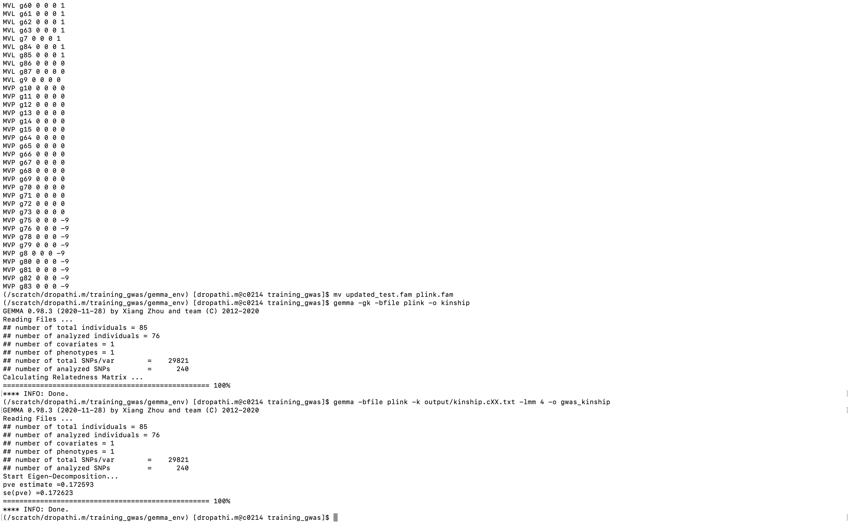

In this case as well, the number of SNP’s analyzed is just 240, it’s better if we don’t consider this case.

The Manhattan plot looks like this:
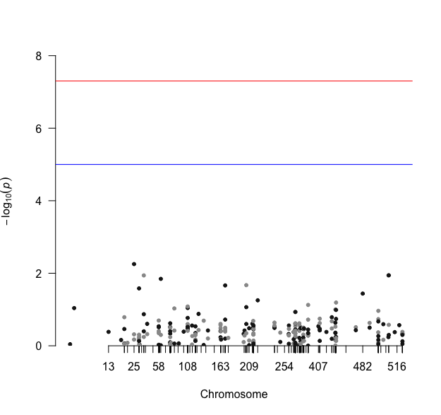
When we do imputation and remove missing data:

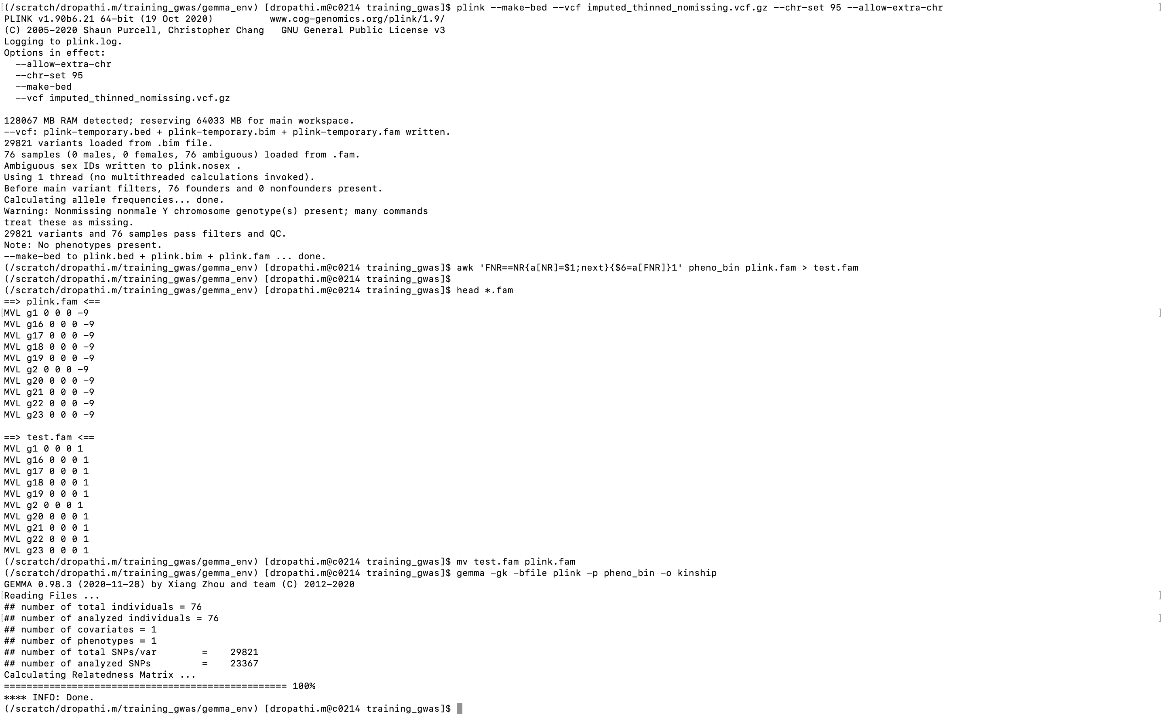

Gist:

In the first method we couldn’t analyze further as only 39 SNPs were analyzed and GEMMA output file couldn’t be created.
In the second method only few SNP’s were created and the plots clearly show the difference and the impact. It is always better and preferred to do imputation and remove missing data for GWAS analysis. Imputation is done as GWAS is sensitive to missing data. Missing data greater than 50% is removed.

But in the case of imputing and removing missing data we see that many SNPs were analyzed. Out of 29821,23367 of them were analyzed whereas if we use original file only 240 SNPs and 39 SNPs were analyzed using different logics. This shows us that by imputing and removing missing data we get more accuracy in results and looking at the Manhattan plot and qq plot we can say imputing and removing missing data has a huge difference. This process can lead to a more complete dataset for analysis.
On the other hand, when you don't perform imputation and don't remove missing data, GEMMA may only analyze SNPs that have phenotype. As SNPs have missing data, this resulted in a much smaller set of SNPs that were being analyzed.

