Assignment

1. a. No

b. No

c. Yes

1. This distribution can be considered normal as most points lie on the line.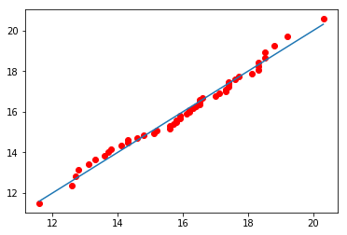
2. This distribution cannot be considered normal as barely any points fall on the line.

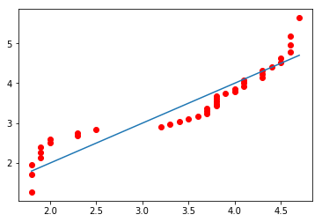

1. This distribution cannot be considered normal as most points don’t lie on the line.

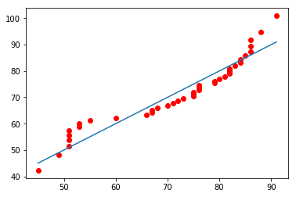

1. This distribution cannot be considered normal as a very few points only lie on the line. A lot of outliers exist.

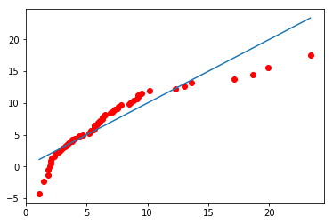

1. This distribution can be approximated to a normal distribution as most points seem to fall on the line

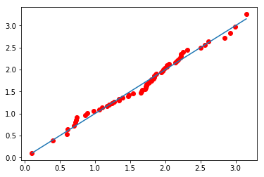

1. Yes .If the logs of the PM data come from a normal population, the PM data come from a lognormal population, and vice versa.
2. No, it cannot be said that the distribution is well-modeled as lognormal as quite a few points do not lie on the line

