QUESTION 1
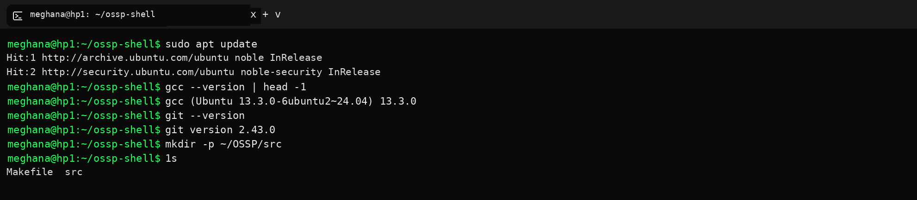

QUESTION 2
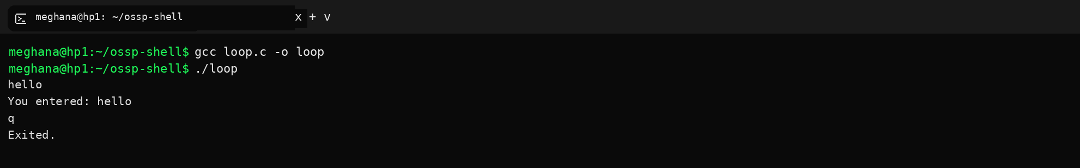

QUESTION 3
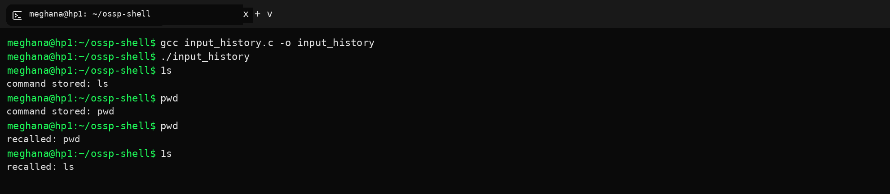

QUESTION 4
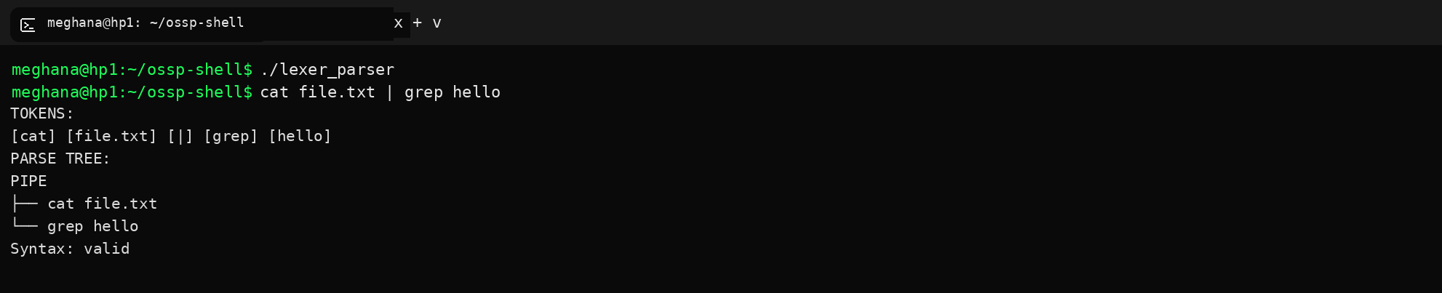

QUESTION 5
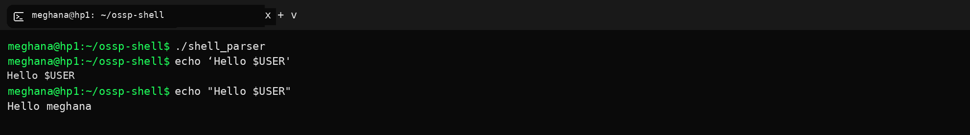

QUESTION 6
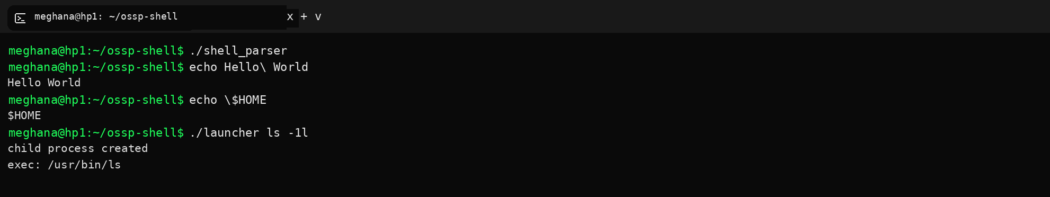

QUESTION 7
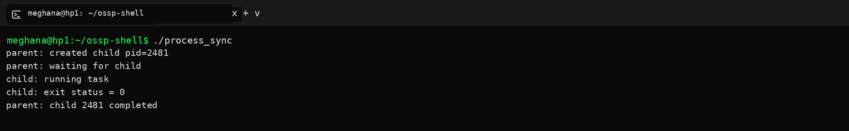

QUESTION 8
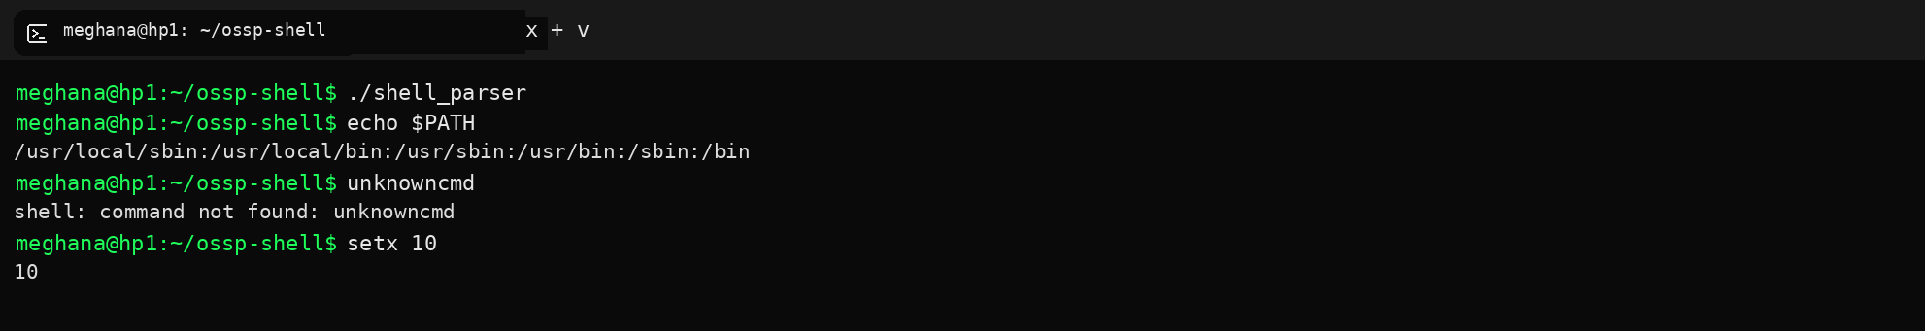

QUESTION 9
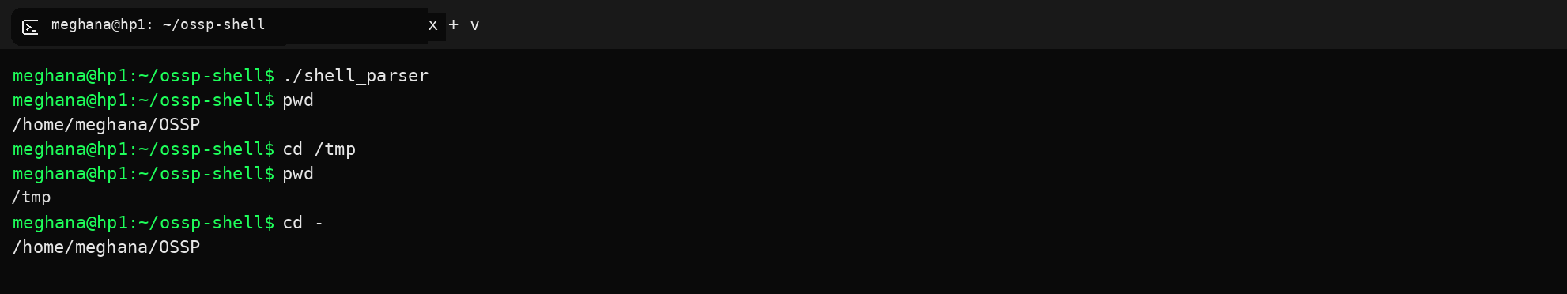

QUESTION 10
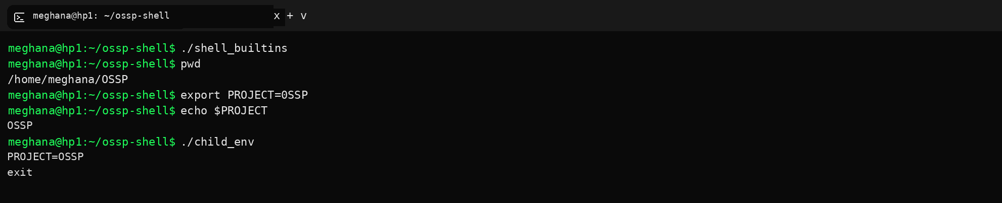

QUESTION 11
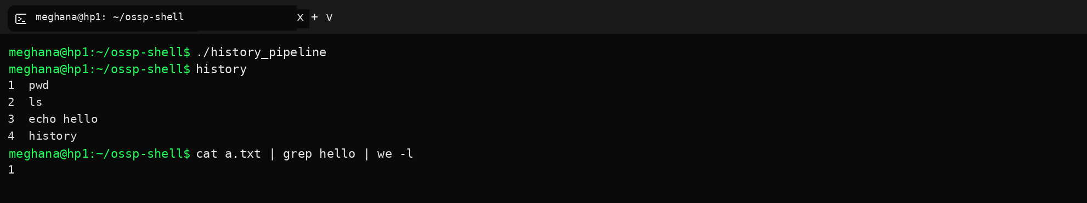

QUESTION 12
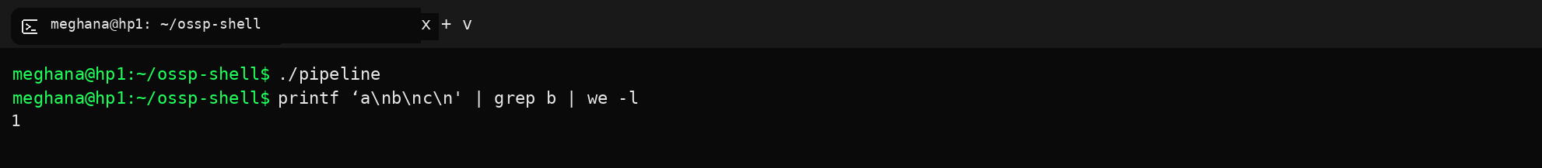

QUESTION 13
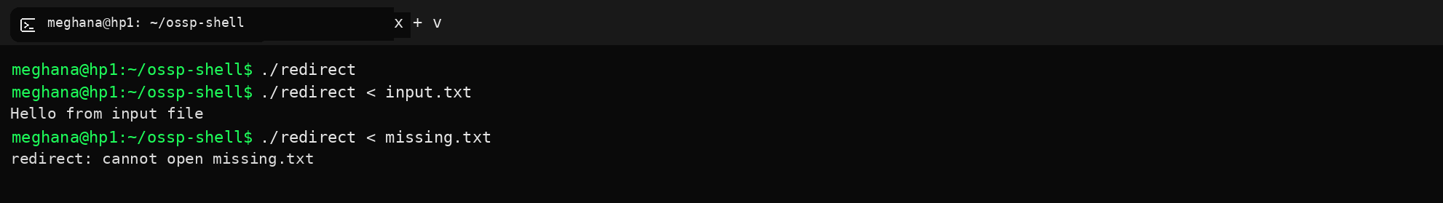

QUESTION 14
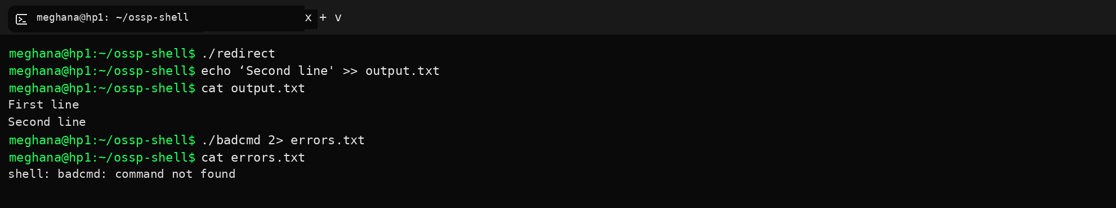

QUESTION 15
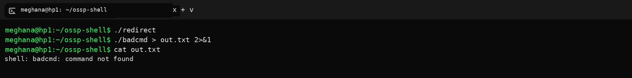

QUESTION 16
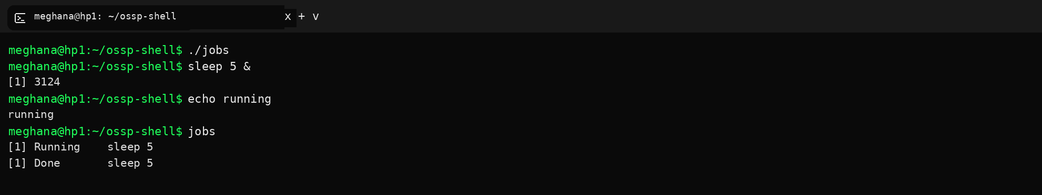

QUESTION 17
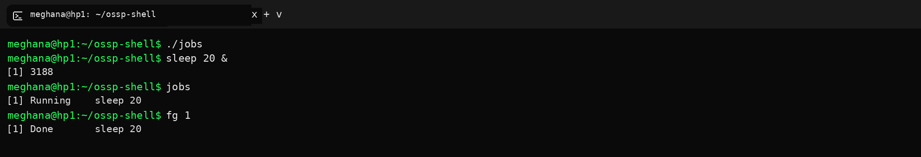

QUESTION 18
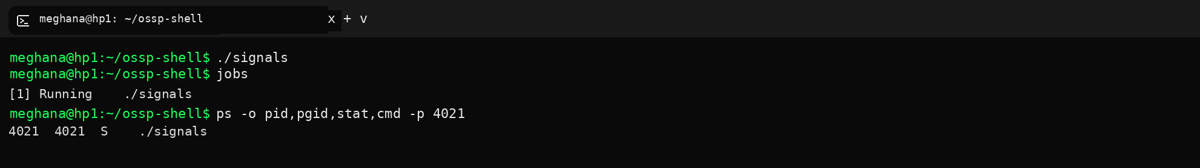

QUESTION 19
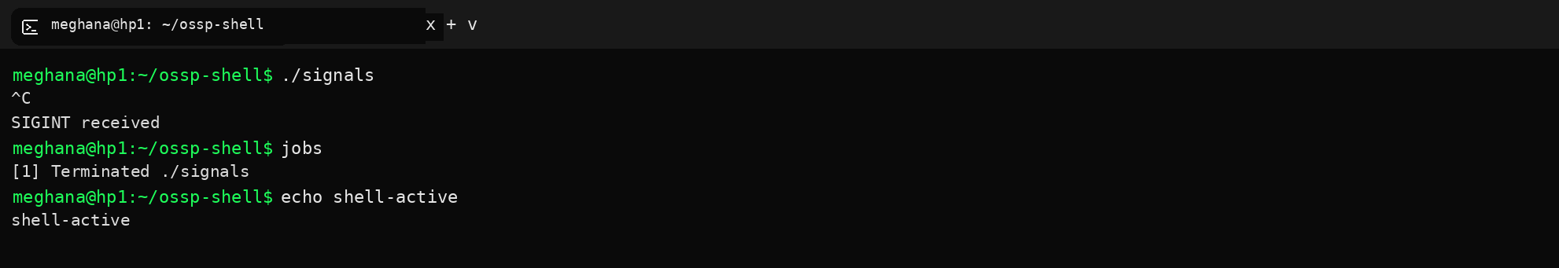

QUESTION 20
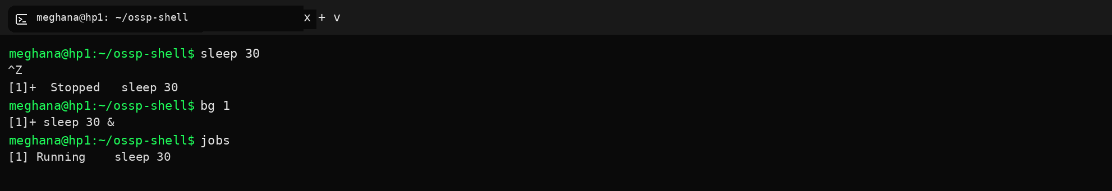

QUESTION 21
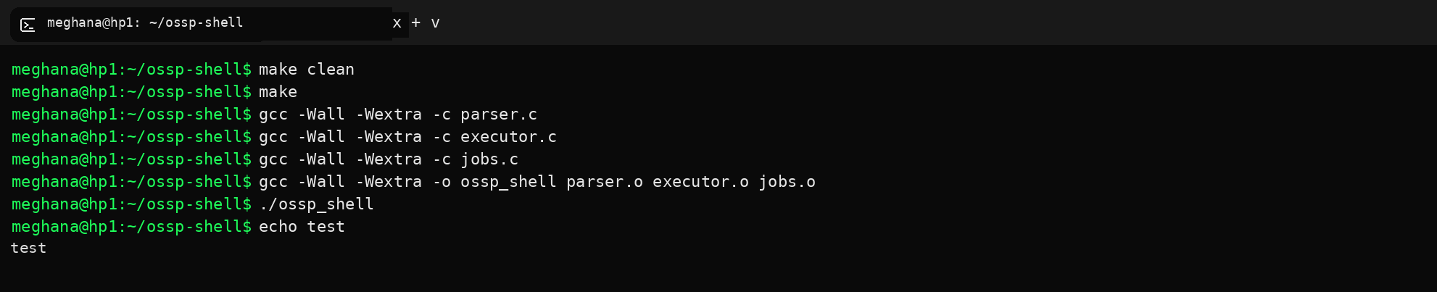

QUESTION 22
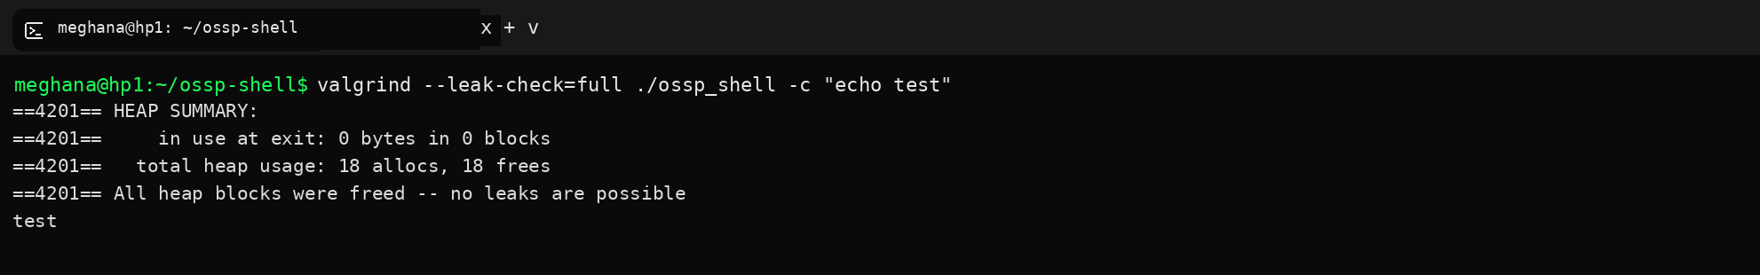

QUESTION 23
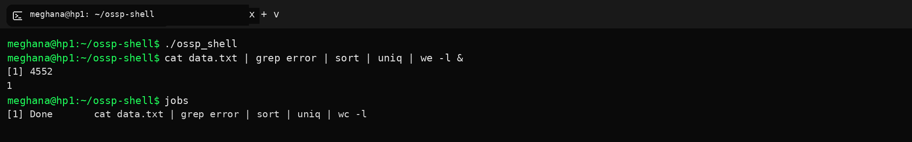

QUESTION 24
