Step 1: Open PowerShell as Administrator
- Press Windows.
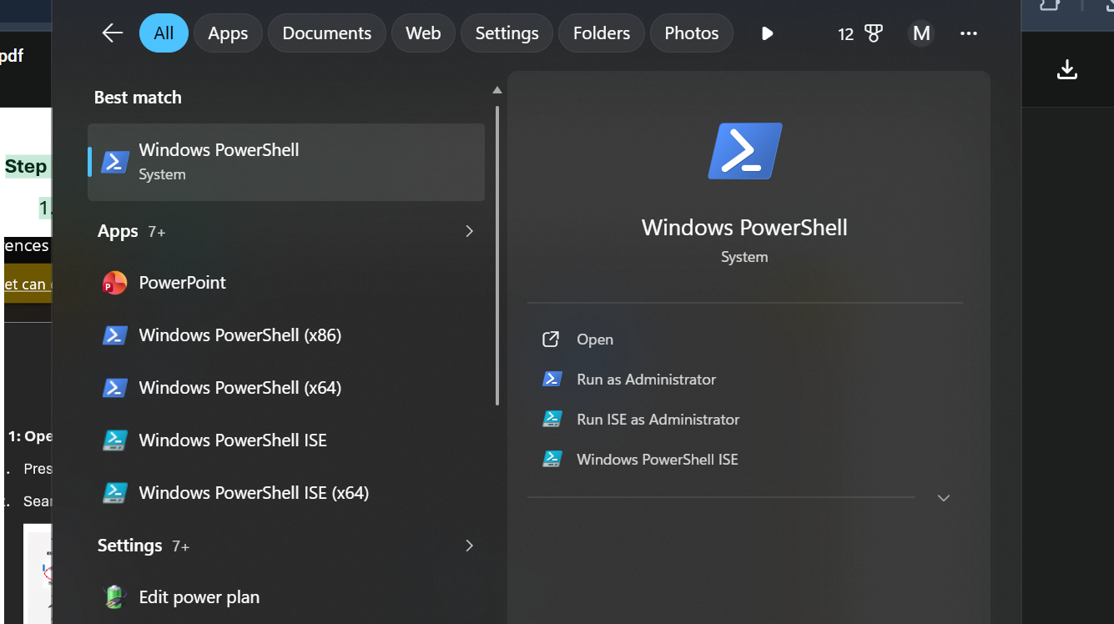

2.Search for PowerShell.
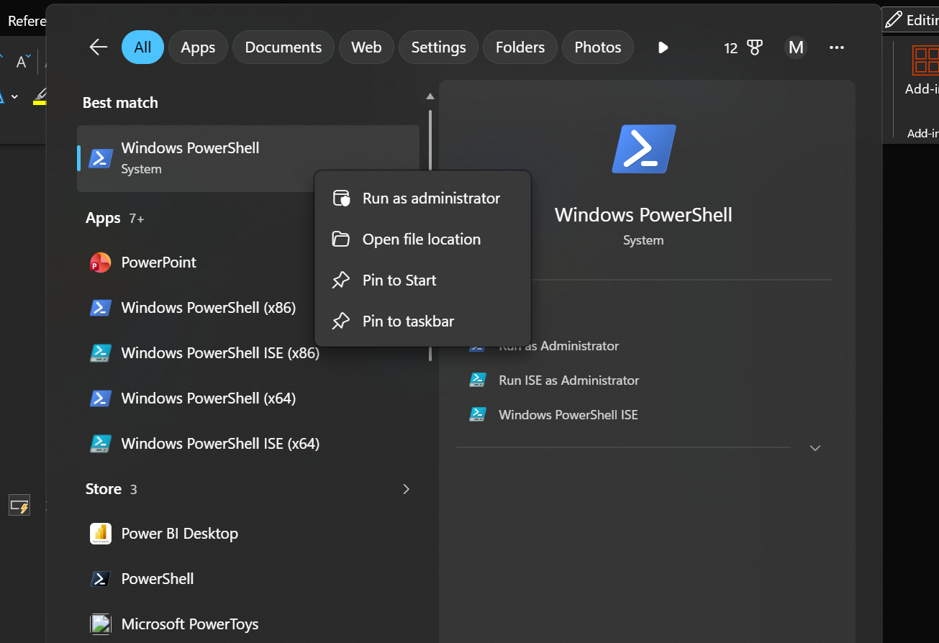
3.Right-click Windows PowerShell.
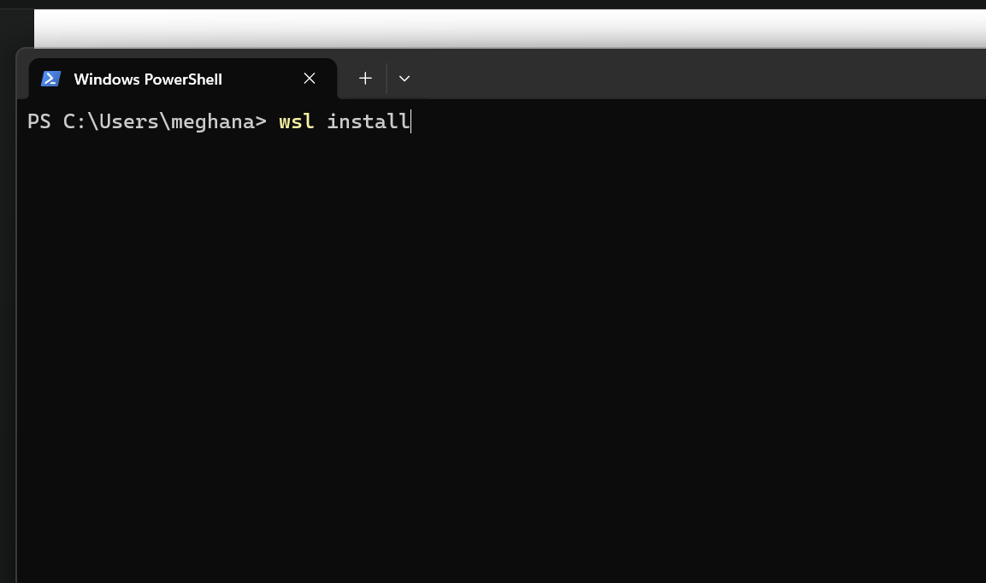
Step 4: Restart Your Computer After installation, restart your PC when prompted.

Step 5: Complete Ubuntu Setup

After restarting:

1. Ubuntu opens automatically (or search for Ubuntu in the Start menu).
2. Wait for the installation to finish.
3. Create a Linux username.

Example: Enter new UNIX username: anusha

Step 5: Create a Password You'll then be prompted to create a password.

New password: ****
Retype new password:****

Step 6: Update Ubuntu
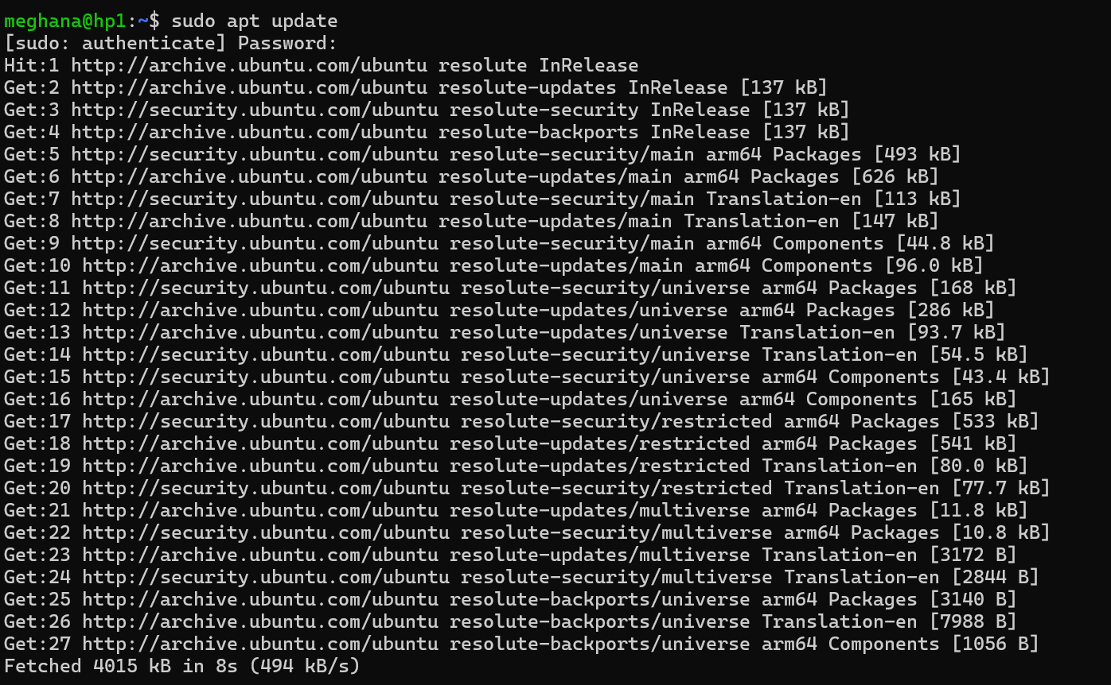

Step 7:Install GCC (C complier)
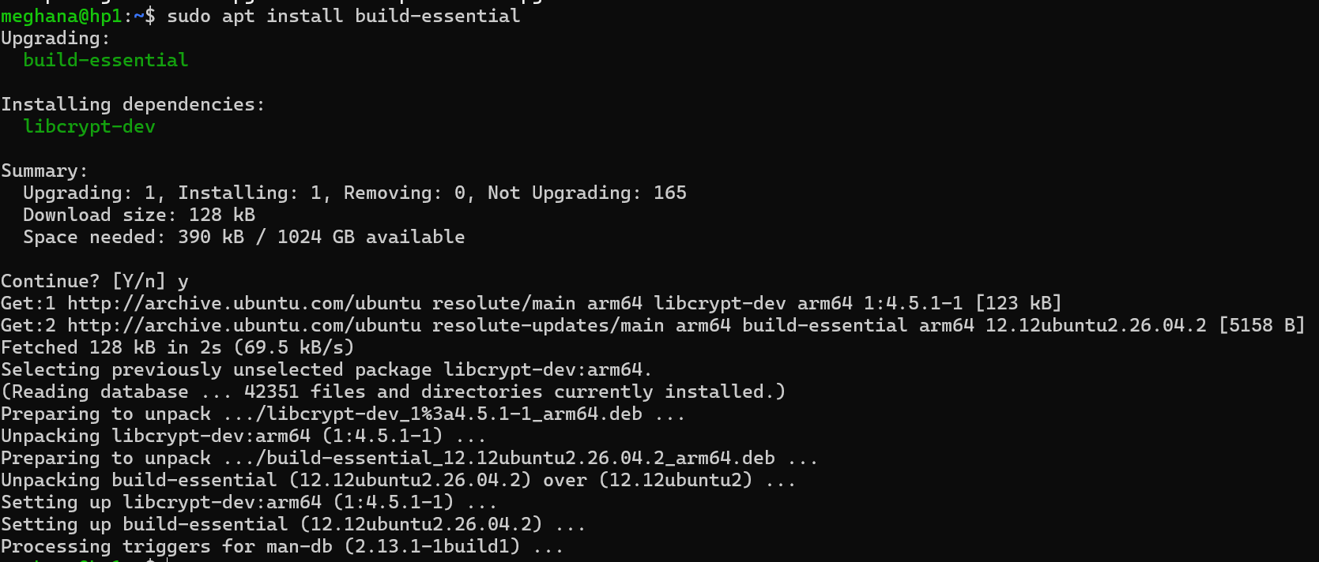

Step 8:Verify the installation

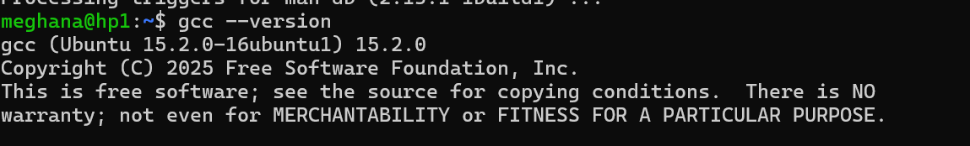
Step 9:Create your C program
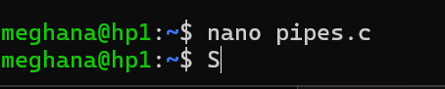
Step 10:Complie the program
