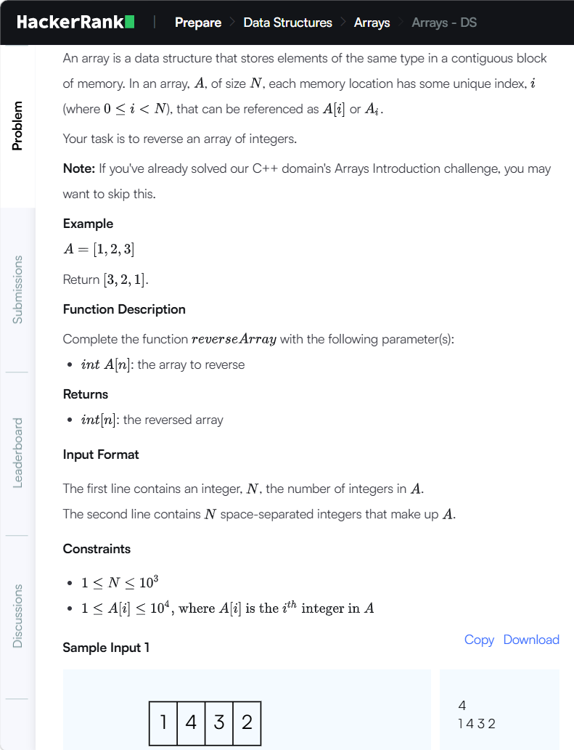
RAW CODE
#include <assert.h>
#include <ctype.h>
#include <limits.h>
#include <math.h>
#include <stdbool.h>
#include <stddef.h>
#include <stdint.h>
#include <stdio.h>
#include <stdlib.h>
#include <string.h>
char* readline();
char* ltrim(char*);
char* rtrim(char*);
char** split_string(char*);
int parse_int(char*);
/*
* Complete the 'reverseArray' function below.
*
* The function is expected to return an INTEGER_ARRAY.
* The function accepts INTEGER_ARRAY a as parameter.
*/
int* reverseArray(int a_count, int* a, int* result_count) {
// Write your code here
int main()
{
FILE* fptr = fopen(getenv("OUTPUT_PATH"), "w");
int arr_count = parse_int(ltrim(rtrim(readline())));
char** arr_temp = split_string(rtrim(readline()));
int* arr = malloc(arr_count * sizeof(int));
for (int i = 0; i < arr_count; i++) {
int arr_item = parse_int(*(arr_temp + i));
*(arr + i) = arr_item;
}
int res_count;
int* res = reverseArray(arr_count, arr, &res_count);
for (int i = 0; i < res_count; i++) {
fprintf(fptr, "%d", *(res + i));
if (i != res_count - 1) {
fprintf(fptr, " ");
}
}
fprintf(fptr, "\n");
fclose(fptr);
return 0;
}
char* readline() {
size_t alloc_length = 1024;
size_t data_length = 0;
char* data = malloc(alloc_length);
while (true) {
char* cursor = data + data_length;
char* line = fgets(cursor, alloc_length - data_length, stdin);
if (!line) {
break;
}
data_length += strlen(cursor);
if (data_length < alloc_length - 1 || data[data_length - 1] == '\n') {
break;
}
alloc_length *= 2;
data = realloc(data, alloc_length);
if (!data) {
break;
}
}
if (data[data_length - 1] == '\n') {
data[data_length - 1] = '\0';
}
data = realloc(data, data_length);
return data;
}
char* ltrim(char* str) {
if (!str) {
return '\0';
}
if (!*str) {
return str;
}
while (*str != '\0' && isspace(*str)) {
str++;
}
return str;
}
char* rtrim(char* str) {
if (!str) {
return '\0';
}
if (!*str) {
return str;
}
char* end = str + strlen(str) - 1;
while (end >= str && isspace(*end)) {
end--;
}
*(end + 1) = '\0';
return str;
}
char** split_string(char* str) {
char** splits = NULL;
char* token = strtok(str, " ");
int spaces = 0;
while (token) {
splits = realloc(splits, sizeof(char*) * ++spaces);
if (!splits) {
return splits;
}
splits[spaces - 1] = token;
token = strtok(NULL, " ");
}
return splits;
}
int parse_int(char* str) {
char* endptr;
int value = strtol(str, &endptr, 10);
if (endptr == str || *endptr != '\0') {
exit(EXIT_FAILURE);
}
return value;
}

MODIFIED CODE
#include <assert.h>
#include <ctype.h>
#include <limits.h>
#include <math.h>
#include <stdbool.h>
#include <stddef.h>
#include <stdint.h>
#include <stdio.h>
#include <stdlib.h>
#include <string.h>
char* readline();
char* ltrim(char*);
char* rtrim(char*);
char** split_string(char*);
int parse_int(char*);
int* reverseArray(int a_count, int* a, int* result_count)
{
int i;
int temp;
*result_count = a_count;
for (i = 0; i < a_count / 2; i++)
{
temp = a[i];
a[i] = a[a_count - 1 - i];
a[a_count - 1 - i] = temp;
}
return a;
}
int main()
{
FILE* fptr = fopen(getenv("OUTPUT_PATH"), "w");
int arr_count = parse_int(ltrim(rtrim(readline())));
char** arr_temp = split_string(rtrim(readline()));
int* arr = malloc(arr_count * sizeof(int));
for (int i = 0; i < arr_count; i++)
{
int arr_item = parse_int(*(arr_temp + i));
*(arr + i) = arr_item;
}
int res_count;
int* res = reverseArray(arr_count, arr, &res_count);
for (int i = 0; i < res_count; i++)
{
fprintf(fptr, "%d", *(res + i));
if (i != res_count - 1)
{
fprintf(fptr, " ");
}
}
fprintf(fptr, "\n");
fclose(fptr);
return 0;
}
char* readline()
{
size_t alloc_length = 1024;
size_t data_length = 0;

char* data = malloc(alloc_length);
while (true)
{
char* cursor = data + data_length;
char* line = fgets(cursor, alloc_length - data_length, stdin);
if (!line)
{
break;
}
data_length += strlen(cursor);
if (data_length < alloc_length - 1 || data[data_length - 1] == '\n')
{
break;
}
alloc_length *= 2;
data = realloc(data, alloc_length);
if (!data)
{
break;
}
}
if (data_length > 0 && data[data_length - 1] == '\n')
{
data[data_length - 1] = '\0';
}
data = realloc(data, data_length + 1);
return data;
}
char* ltrim(char* str)
{
if (!str)
{
return '\0';
}

if (!*str)
{
return str;
}
while (*str != '\0' && isspace(*str))
{
str++;
}
return str;
}
char* rtrim(char* str)
{
if (!str)
{
return '\0';
}
if (!*str)
{
return str;
}
char* end = str + strlen(str) - 1;
while (end >= str && isspace(*end))
{
end--;
}
*(end + 1) = '\0';
return str;
}
char** split_string(char* str)
{
char** splits = NULL;
char* token = strtok(str, " ");
int spaces = 0;
while (token)
{
splits = realloc(splits, sizeof(char*) * ++spaces);
if (!splits)
{
return splits;
}
splits[spaces - 1] = token;
token = strtok(NULL, " ");
}
return splits;
}
int parse_int(char* str)
{
char* endptr;
int value = strtol(str, &endptr, 10);
if (endptr == str || *endptr != '\0')
{
exit(EXIT_FAILURE);
}
return value;
}
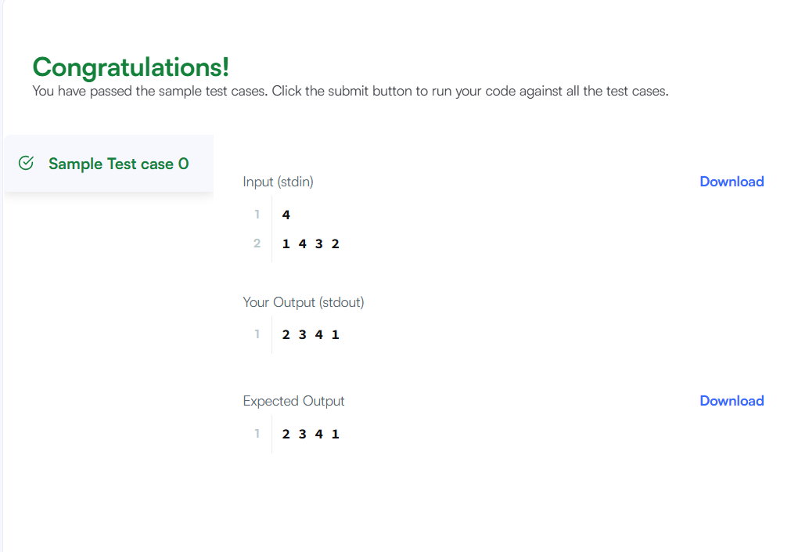

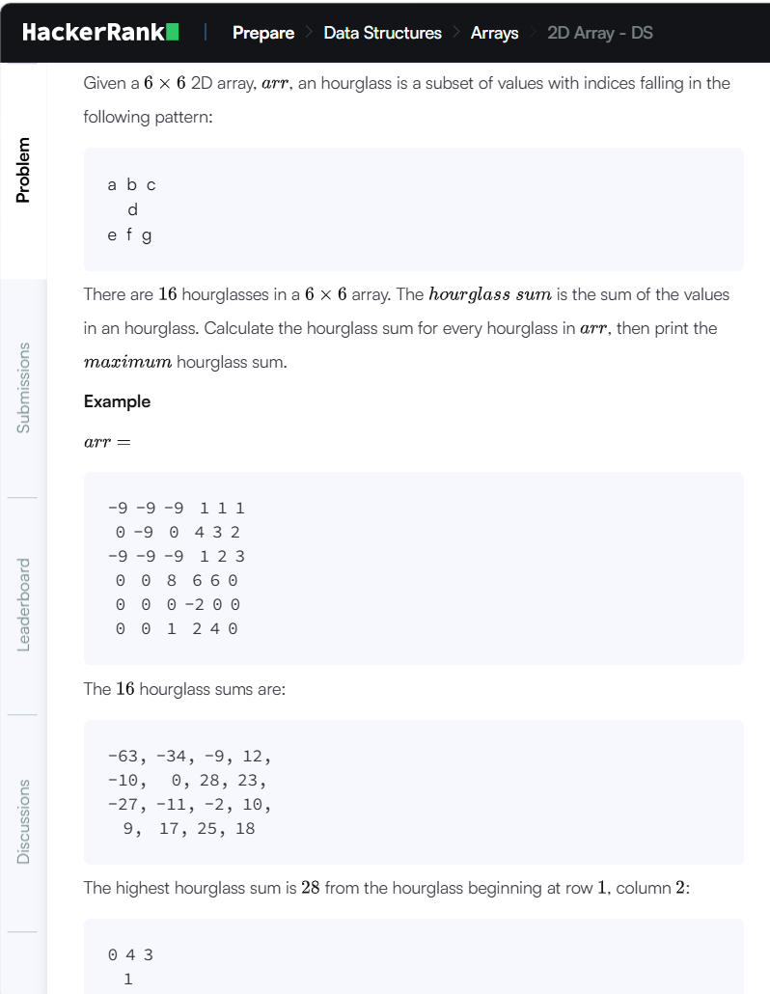

RAW CODE
#include <assert.h>
#include <ctype.h>
#include <limits.h>
#include <math.h>
#include <stdbool.h>
#include <stddef.h>
#include <stdint.h>
#include <stdio.h>
#include <stdlib.h>
#include <string.h>
char* readline();
char* ltrim(char*);
char* rtrim(char*);
char** split_string(char*);
int parse_int(char*);
/*
* Complete the 'hourglassSum' function below.
*
* The function is expected to return an INTEGER.
* The function accepts 2D_INTEGER_ARRAY arr as parameter.
*/
int hourglassSum(int arr_rows, int arr_columns, int** arr) {
}
int main()
{
FILE* fptr = fopen(getenv("OUTPUT_PATH"), "w");
int** arr = malloc(6 * sizeof(int*));
for (int i = 0; i < 6; i++) {
*(arr + i) = malloc(6 * (sizeof(int)));
char** arr_item_temp = split_string(rtrim(readline()));
for (int j = 0; j < 6; j++) {
int arr_item = parse_int(*(arr_item_temp + j));
*(*(arr + i) + j) = arr_item;
}
}
int result = hourglassSum(6, 6, arr);
fprintf(fptr, "%d\n", result);
fclose(fptr);
return 0;
}
char* readline() {
size_t alloc_length = 1024;
size_t data_length = 0;
char* data = malloc(alloc_length);
while (true) {
char* cursor = data + data_length;
char* line = fgets(cursor, alloc_length - data_length, stdin);
if (!line) {
break;
}
data_length += strlen(cursor);
if (data_length < alloc_length - 1 || data[data_length - 1] == '\n') {
break;
}
alloc_length <<= 1;
data = realloc(data, alloc_length);
if (!data) {
data = '\0';
break;
}
}
if (data[data_length - 1] == '\n') {
data[data_length - 1] = '\0';
data = realloc(data, data_length);
if (!data) {
data = '\0';
}
} else {
data = realloc(data, data_length + 1); if (!data) {
data = '\0';
} else {
data[data_length] = '\0';
}
}
return data

char* ltrim(char* str) {
if (!str) {
return '\0';
} if (!*str) {
return str;
}
while (*str != '\0' && isspace(*str)) {
str++;
} return str;
}
char* rtrim(char* str) {
if (!str) {
return '\0';
}
if (!*str) {
return str;
}
char* end = str + strlen(str) - 1;
while (end >= str && isspace(*end)) {
end--;
}
*(end + 1) = '\0';
return str;
}
char** split_string(char* str) {
char** splits = NULL;
char* token = strtok(str, " ");
int spaces = 0;
while (token) {
splits = realloc(splits, sizeof(char*) * ++spaces);
if (!splits) {
return splits;
splits[spaces - 1] = token;
token = strtok(NULL, " ");
}
return splits;
}
int parse_int(char* str) {
char* endptr;
int value = strtol(str, &endptr, 10);
if (endptr == str || *endptr != '\0') {
exit(EXIT_FAILURE);
}
return value;
}
MODIFIED CODE
#include <stdio.h>
#include <stdlib.h>
int hourglassSum(int arr_rows, int arr_columns, int** arr) {
int max = -1000000;
int sum;
for (int i = 0; i < 4; i++) {
for (int j = 0; j < 4; j++) {
sum = arr[i][j] + arr[i][j+1] + arr[i][j+2]
+ arr[i+1][j+1]
+ arr[i+2][j] + arr[i+2][j+1] + arr[i+2][j+2];
if (sum > max)
max = sum;
}
}
return max;
}
int main() {
int** arr;
arr = malloc(6 * sizeof(int*));
for (int i = 0; i < 6; i++) {
arr[i] = malloc(6 * sizeof(int));
for (int j = 0; j < 6; j++) {
scanf("%d", &arr[i][j]);
}
}
int result = hourglassSum(6, 6, arr);
printf("%d\n", result);
for (int i = 0; i < 6; i++) {
free(arr[i]);
}
free(arr);

return 0;
}
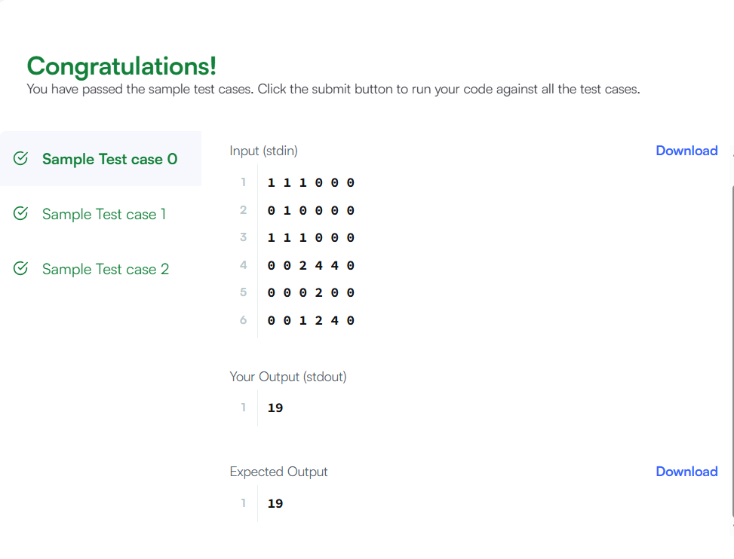

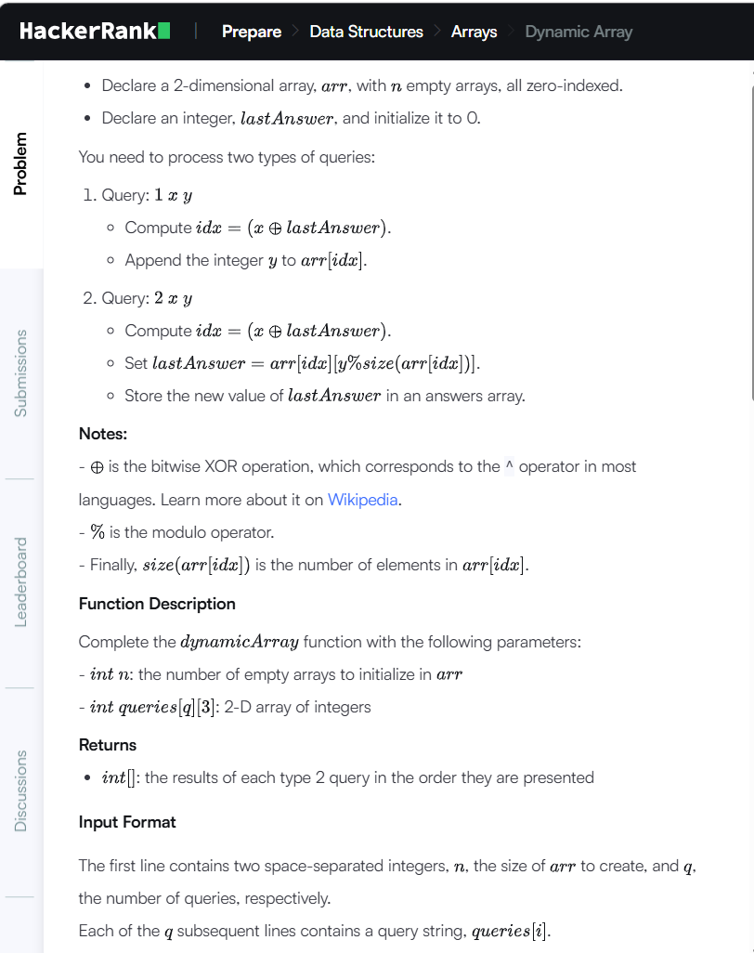

RAW CODE
#include <assert.h>
#include <ctype.h>
#include <limits.h>
#include <math.h>
#include <stdbool.h>
#include <stddef.h>
#include <stdint.h>
#include <stdio.h>
#include <stdlib.h>
#include <string.h>
char* readline();
char* ltrim(char*);
char* rtrim(char*);
char** split_string(char*);
int parse_int(char*);
/*
* Complete the 'dynamicArray' function below.
*
* The function is expected to return an INTEGER_ARRAY.
* The function accepts following parameters:
* 1. INTEGER n
* 2. 2D_INTEGER_ARRAY queries
*/
/*
* To return the integer array from the function, you should:
* - Store the size of the array to be returned in the result_count variable
* - Allocate the array statically or dynamically
*
* For example,
* int* return_integer_array_using_static_allocation(int* result_count) {
* *result_count = 5;
*
* static int a[5] = {1, 2, 3, 4, 5};
*
* return a;
* }
*
* int* return_integer_array_using_dynamic_allocation(int* result_count) {
* *result_count = 5;
*
* int *a = malloc(5 * sizeof(int));
*
* for (int i = 0; i < 5; i++) {
* *(a + i) = i + 1;
* }
*
* return a;
* }
*
*/
int* dynamicArray(int n, int queries_rows, int queries_columns, int** queries, int* result_count) {
}
int main()
{
FILE* fptr = fopen(getenv("OUTPUT_PATH"), "w");
char** first_multiple_input = split_string(rtrim(readline()));
int n = parse_int(*(first_multiple_input + 0));
int q = parse_int(*(first_multiple_input + 1));
int** queries = malloc(q * sizeof(int*));
for (int i = 0; i < q; i++) {
*(queries + i) = malloc(3 * (sizeof(int)));
char** queries_item_temp = split_string(rtrim(readline()));
for (int j = 0; j < 3; j++) {
int queries_item = parse_int(*(queries_item_temp + j));
*(*(queries + i) + j) = queries_item;
}
}
int result_count;
int* result = dynamicArray(n, q, 3, queries, &result_count);
for (int i = 0; i < result_count; i++) {
fprintf(fptr, "%d", *(result + i));
if (i != result_count - 1) {
fprintf(fptr, "\n");
}
}
fprintf(fptr, "\n");
fclose(fptr);
return 0;
}
char* readline() {
size_t alloc_length = 1024;
size_t data_length = 0;
char* data = malloc(alloc_length);
while (true) {
char* cursor = data + data_length;
char* line = fgets(cursor, alloc_length - data_length, stdin);
if (!line) {
break;
}
data_length += strlen(cursor);
if (data_length < alloc_length - 1 || data[data_length - 1] == '\n') {
break;
}
alloc_length <<= 1;
data = realloc(data, alloc_length);
if (!data) {
data = '\0';
break;
}
}
if (data[data_length - 1] == '\n') {
data[data_length - 1] = '\0';
data = realloc(data, data_length);
if (!data) {
data = '\0';
}
} else {
data = realloc(data, data_length + 1);
if (!data) {
data = '\0';
} else {
data[data_length] = '\0';
}
}
return data;
}
char* ltrim(char* str) {
if (!str) {
return '\0';
}
if (!*str) {
return str;
}
while (*str != '\0' && isspace(*str)) {
str++;
}
return str;
}
char* rtrim(char* str) {
if (!str) {
return '\0';
}
if (!*str) {
return str;
}

char* end = str + strlen(str) - 1;
while (end >= str && isspace(*end)) {
end--;
}
*(end + 1) = '\0';
return str;
}
char** split_string(char* str) {
char** splits = NULL;
char* token = strtok(str, " ");
int spaces = 0;
while (token) {
splits = realloc(splits, sizeof(char*) * ++spaces);
if (!splits) {
return splits;
}
splits[spaces - 1] = token;
token = strtok(NULL, " ");
}
return splits;
}
int parse_int(char* str) {
char* endptr;
int value = strtol(str, &endptr, 10);
if (endptr == str || *endptr != '\0') {
exit(EXIT_FAILURE);
}
return value;
}
MODIFIED CODE
#include <stdio.h>
#include <stdlib.h>
int* dynamicArray(int n, int queries_rows, int queries_columns,
int** queries, int* result_count) {
int **arr = malloc(n * sizeof(int *));
int *size = calloc(n, sizeof(int));
int *answer = malloc(queries_rows * sizeof(int));
for (int i = 0; i < n; i++)
arr[i] = NULL;
int lastAnswer = 0;
int count = 0;
for (int i = 0; i < queries_rows; i++) {
int type = queries[i][0];
int x = queries[i][1];
int y = queries[i][2];
int index = (x ^ lastAnswer) % n;
if (type == 1) {
arr[index] = realloc(arr[index],
(size[index] + 1) * sizeof(int));
arr[index][size[index]] = y;
size[index]++;
}
else {
lastAnswer = arr[index][y % size[index]];
answer[count] = lastAnswer;
count++;
}
}
*result_count = count;
for (int i = 0; i < n; i++)
free(arr[i]);
free(arr);
free(size);
return answer;
}
int main() {
int n, q;
scanf("%d %d", &n, &q);
int **queries = malloc(q * sizeof(int *));
for (int i = 0; i < q; i++) {
queries[i] = malloc(3 * sizeof(int));
scanf("%d %d %d",
&queries[i][0],
&queries[i][1],
&queries[i][2]);
}
int result_count;
int *result = dynamicArray(n, q, 3,
queries, &result_count);
for (int i = 0; i < result_count; i++)
printf("%d\n", result[i]);
free(result);
for (int i = 0; i < q; i++)
free(queries[i]);
free(queries);
return 0;
}