**Logging using SLF4J**

**Exercise 1: Logging Error Messages and Warning Levels Task: Write a Java application that demonstrates logging error messages and warning levels using SLF4J.**

**Code Snippets:**

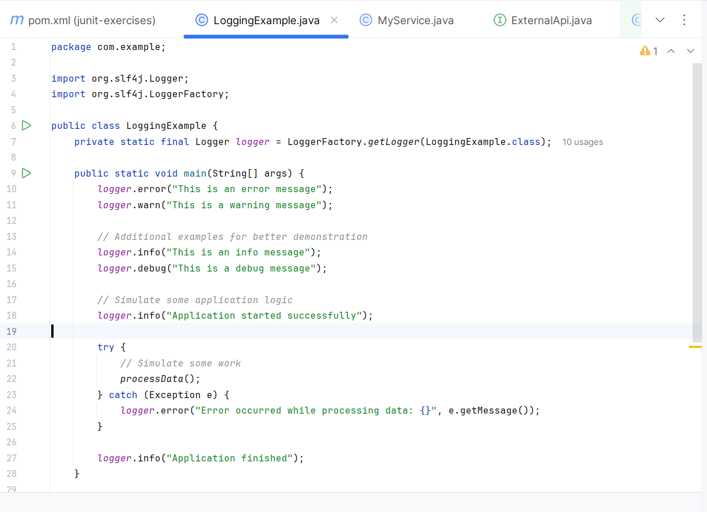

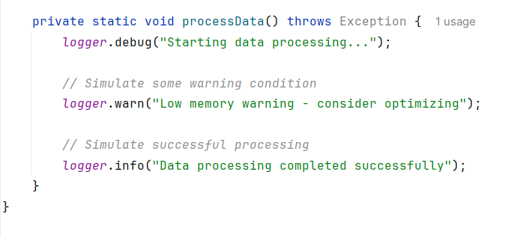

**Output:**

