**JUnit Testing Exercises:**

**Exercise 1: Setting Up JUnit Scenario: You need to set up JUnit in your Java project to start writing unit tests.**

**Steps:**

**1. Create a new Java project in your IDE (e.g., IntelliJ IDEA, Eclipse).**

**2. Add JUnit dependency to your project. If you are using Maven, add the following to your pom.xml**

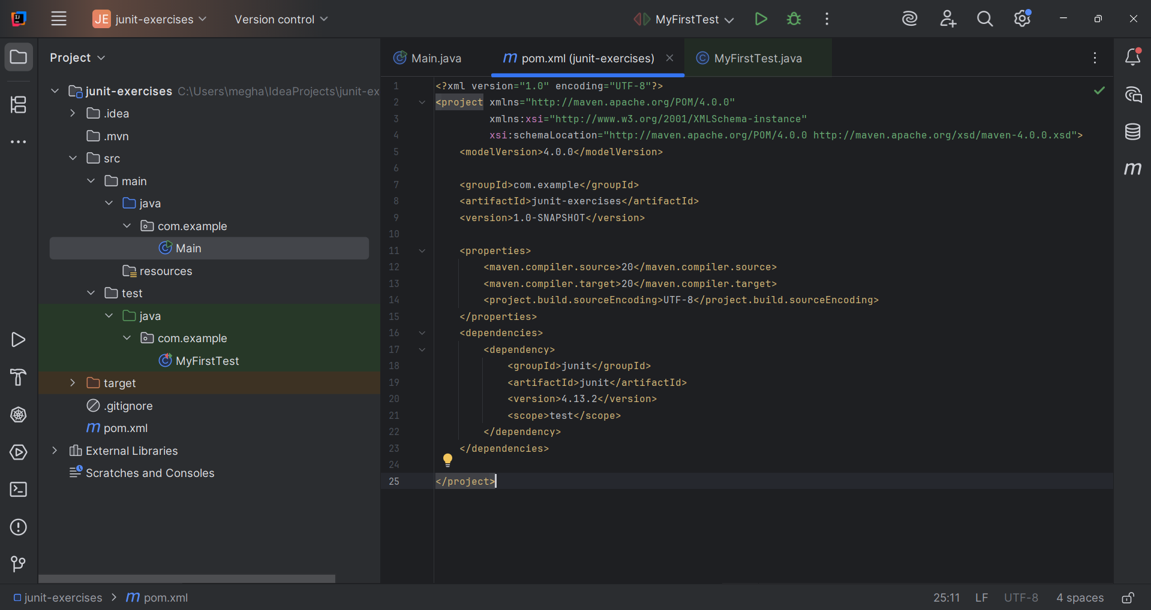

**3. Create a new test class in your project.**

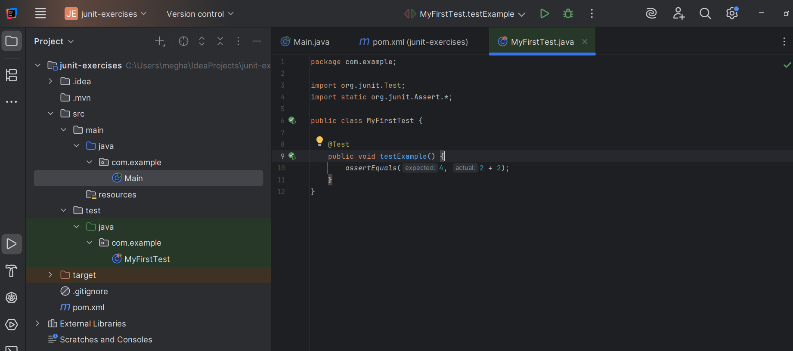

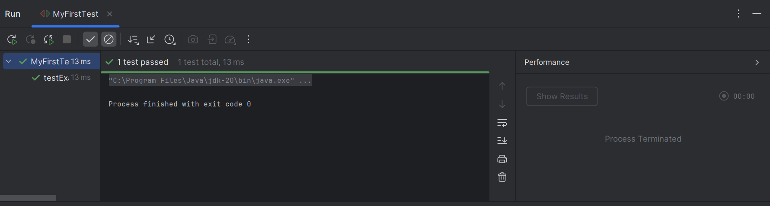

--------------------------------------------------------------------------------------------------------------------------------------

--------------------------------------------------------------------------------------------------------------------------------------

**Exercise 3: Assertions in JUnit Scenario: You need to use different assertions in JUnit to validate your test results.**

**Steps: 1. Write tests using various JUnit assertions.**

