**Exercise 1: Configuring a Basic Spring Application**

**Scenario:**

Your company is developing a web application for managing a library. You need to use the Spring Framework to handle the backend operations.

**Steps:**

1. **Set Up a Spring Project:**
   * Create a Maven project named **LibraryManagement**.
   * Add Spring Core dependencies in the **pom.xml** file.

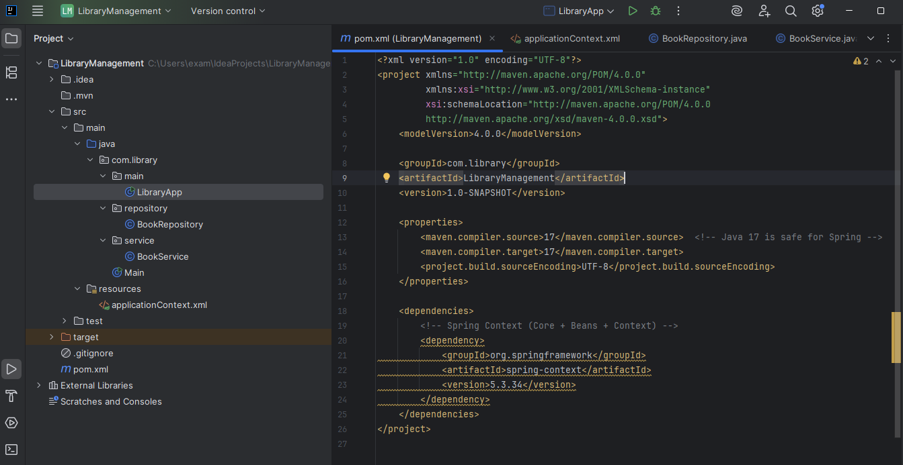

1. **Configure the Application Context:**
   * Create an XML configuration file named **applicationContext.xml** in the **src/main/resources** directory.
   * Define beans for **BookService** and **BookRepository** in the XML file.

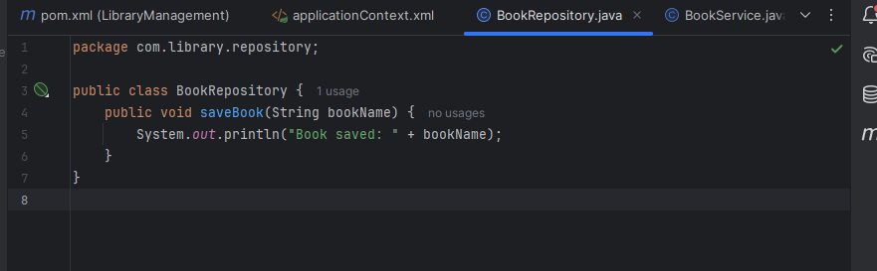

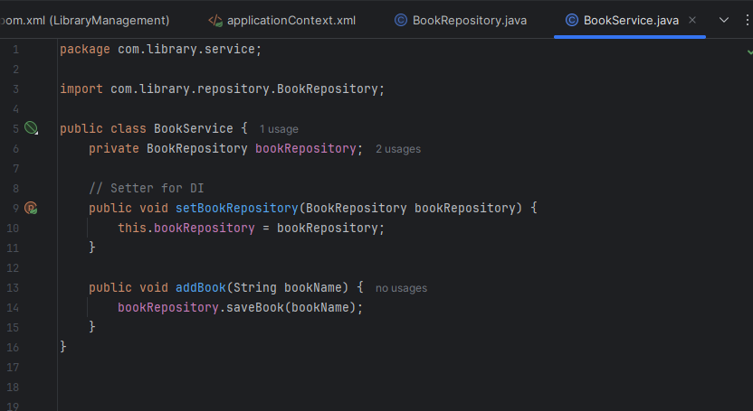

1. **Define Service and Repository Classes:**
   * Create a package **com.library.service** and add a class **BookService**.
   * Create a package **com.library.repository** and add a class **BookRepository**.
2. **Run the Application:**
   * Create a main class to load the Spring context and test the configuration.

Output:

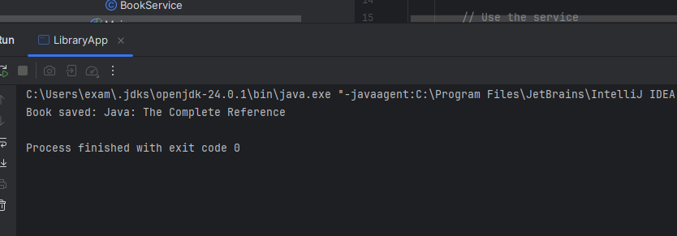

**Exercise 2: Implementing Dependency Injection**

**Scenario:**

In the library management application, you need to manage the dependencies between the BookService and BookRepository classes using Spring's IoC and DI.

**Steps:**

1. **Modify the XML Configuration:**
   * Update **applicationContext.xml** to wire **BookRepository** into **BookService**.

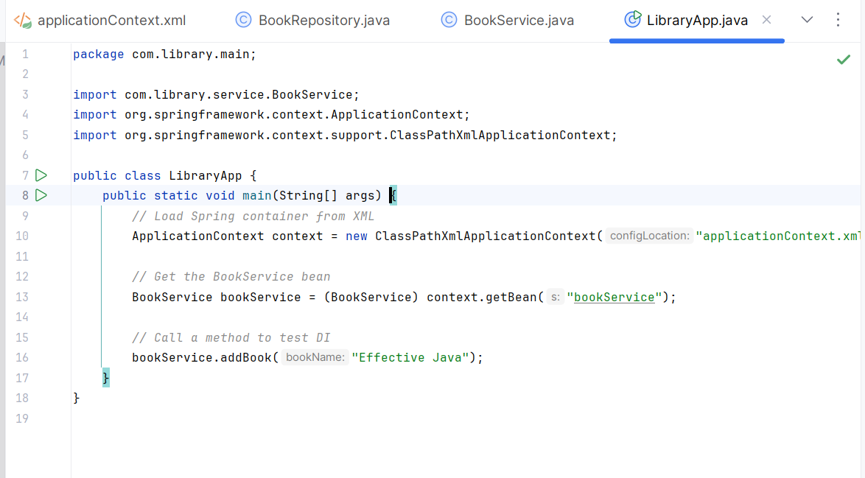

1. **Update the BookService Class:**
   * Ensure that **BookService** class has a setter method for **BookRepository**.

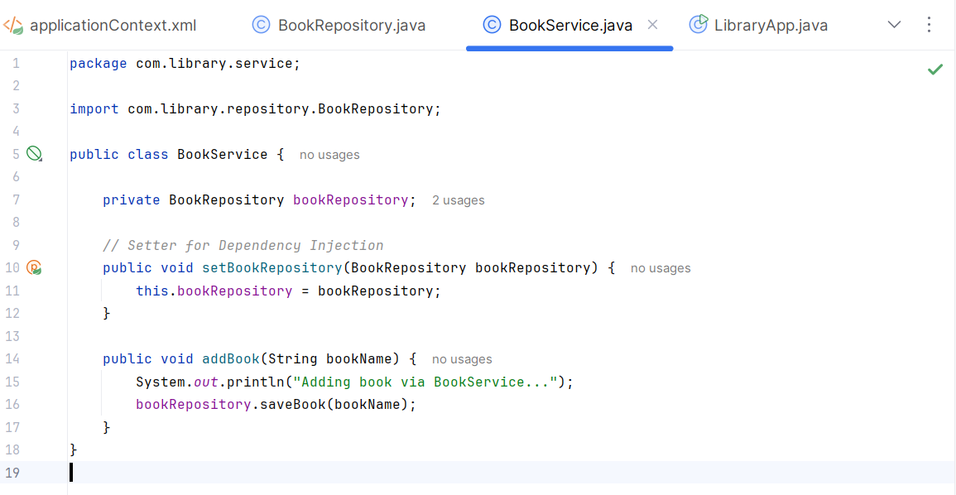

1. **Test the Configuration:**

Run the **LibraryManagementApplication** main class to verify the dependency injection.

Output:

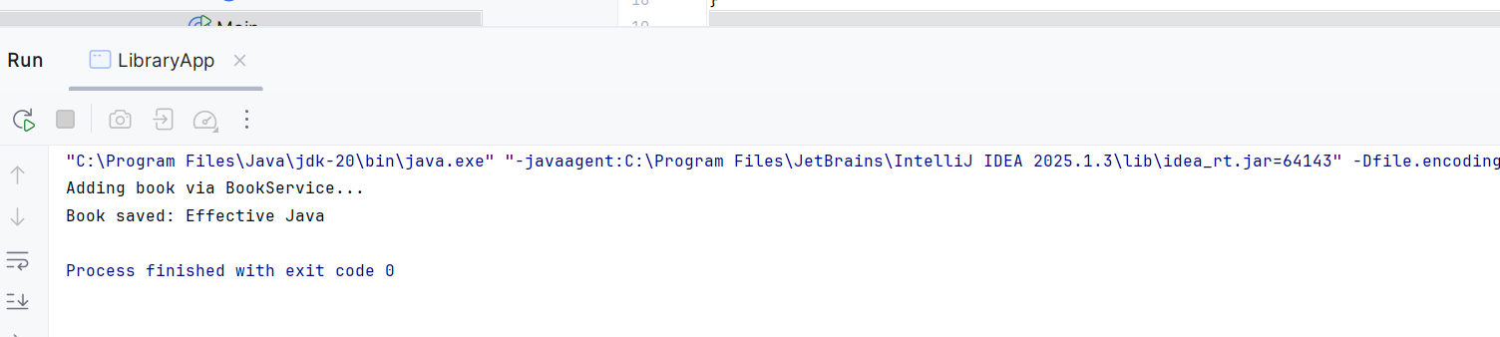

**Exercise 4: Creating and Configuring a Maven Project**

**Scenario:**

You need to set up a new Maven project for the library management application and add Spring dependencies.

**Steps:**

1. **Create a New Maven Project:**
   * Create a new Maven project named **LibraryManagement**.
2. **Add Spring Dependencies in pom.xml:**
   * Include dependencies for Spring Context, Spring AOP, and Spring WebMVC.
3. **Configure Maven Plugins:**
   * Configure the Maven Compiler Plugin for Java version 1.8 in the pom.xml file.

Pom.xml

<project xmlns="http://maven.apache.org/POM/4.0.0"  
 xmlns:xsi="http://www.w3.org/2001/XMLSchema-instance"  
 xsi:schemaLocation="http://maven.apache.org/POM/4.0.0  
 http://maven.apache.org/xsd/maven-4.0.0.xsd">  
 <modelVersion>4.0.0</modelVersion>  
  
 <groupId>com.library</groupId>  
 <artifactId>LibraryManagement</artifactId>  
 <version>1.0-SNAPSHOT</version>  
  
 <properties>  
 <maven.compiler.source>1.8</maven.compiler.source>  
 <maven.compiler.target>1.8</maven.compiler.target>  
 <project.build.sourceEncoding>UTF-8</project.build.sourceEncoding>  
 </properties>  
  
 <dependencies>  
 *<!-- Spring Context -->* <dependency>  
 <groupId>org.springframework</groupId>  
 <artifactId>spring-context</artifactId>  
 <version>5.3.34</version>  
 </dependency>  
  
 *<!-- Spring AOP -->* <dependency>  
 <groupId>org.springframework</groupId>  
 <artifactId>spring-aop</artifactId>  
 <version>5.3.34</version>  
 </dependency>  
  
 *<!-- Spring WebMVC -->* <dependency>  
 <groupId>org.springframework</groupId>  
 <artifactId>spring-webmvc</artifactId>  
 <version>5.3.34</version>  
 </dependency>  
  
 *<!-- Servlet API (required for Spring MVC) -->* <dependency>  
 <groupId>javax.servlet</groupId>  
 <artifactId>javax.servlet-api</artifactId>  
 <version>4.0.1</version>  
 <scope>provided</scope>  
 </dependency>  
 </dependencies>  
  
 <build>  
 <plugins>  
 *<!-- Maven Compiler Plugin -->* <plugin>  
 <artifactId>maven-compiler-plugin</artifactId>  
 <version>3.10.1</version>  
 <configuration>  
 <source>1.8</source>  
 <target>1.8</target>  
 </configuration>  
 </plugin>  
 </plugins>  
 </build>  
</project>