**PL/SQL EXCERSICES :**

**Exercise 1: Control Structures  
  
INITIAL TABLES AND VALUES INSERTED INTO THEM TO PERFORM THE REQUIRED OPERATIONS**

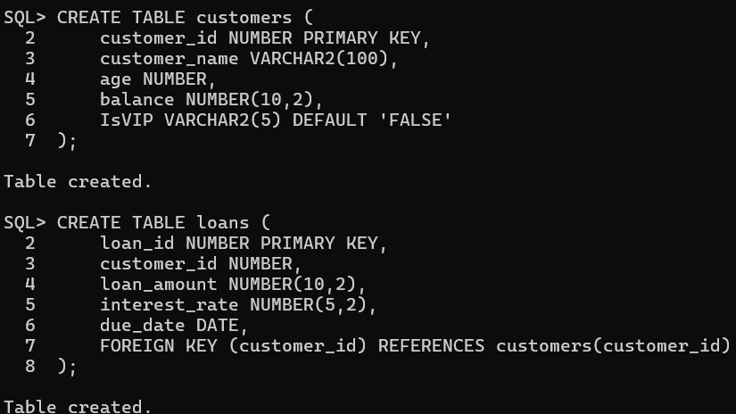

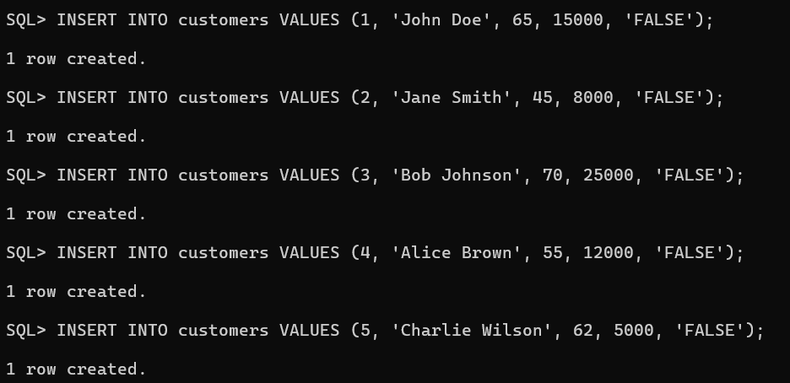

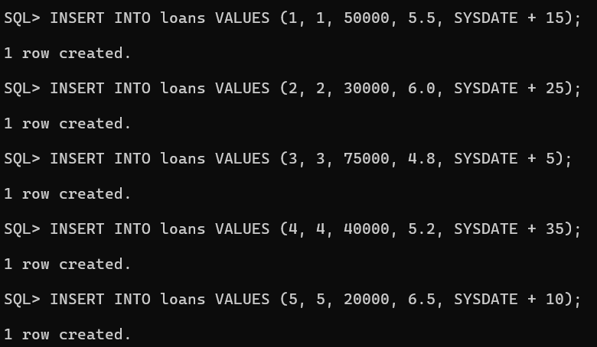

**Scenario 1:** The bank wants to apply a discount to loan interest rates for customers above 60 years old.

**Question:** Write a PL/SQL block that loops through all customers, checks their age, and if they are above 60, apply a 1% discount to their current loan interest rates.

**Solution:**

DECLARE

CURSOR customer_cursor IS

SELECT customer_id, customer_name, age

FROM customers

WHERE age > 60;

v_customer_id customers.customer_id%TYPE;

v_customer_name customers.customer_name%TYPE;

v_age customers.age%TYPE;

v_discount_count NUMBER := 0;

BEGIN

DBMS_OUTPUT.PUT_LINE('Applying 1% discount to customers above 60 ');

FOR customer_rec IN customer_cursor LOOP

UPDATE loans

SET interest_rate = interest_rate - 1

WHERE customer_id = customer_rec.customer_id

AND interest_rate > 1;

IF SQL%ROWCOUNT > 0 THEN

v_discount_count := v_discount_count + 1;

DBMS_OUTPUT.PUT_LINE('Discount applied to customer: ' || customer_rec.customer_name ||

' (Age: ' || customer_rec.age || ')');

END IF;

END LOOP;

DBMS_OUTPUT.PUT_LINE('Total customers who received discount: ' || v_discount_count);

COMMIT;

EXCEPTION

WHEN OTHERS THEN

DBMS_OUTPUT.PUT_LINE('Error: ' || SQLERRM);

ROLLBACK;

END;

**Output:**

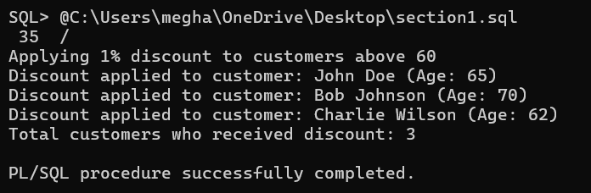

**Scenario 2:** A customer can be promoted to VIP status based on their balance.

**Question:** Write a PL/SQL block that iterates through all customers and sets a flag IsVIP to TRUE for those with a balance over $10,000.

**Solution:**

DECLARE

CURSOR customer_cursor IS

SELECT customer_id, customer_name, balance

FROM customers;

v_vip_count NUMBER := 0;

BEGIN

DBMS_OUTPUT.PUT_LINE(' Setting VIP status for high-balance customers ');

FOR customer_rec IN customer_cursor LOOP

IF customer_rec.balance > 10000 THEN

UPDATE customers

SET IsVIP = 'TRUE'

WHERE customer_id = customer_rec.customer_id;

v_vip_count := v_vip_count + 1;

DBMS_OUTPUT.PUT_LINE('VIP status granted to: ' || customer_rec.customer_name ||

' (Balance: $' || customer_rec.balance || ')');

ELSE

UPDATE customers

SET IsVIP = 'FALSE'

WHERE customer_id = customer_rec.customer_id;

END IF;

END LOOP;

DBMS_OUTPUT.PUT_LINE('Total VIP customers: ' || v_vip_count);

COMMIT;

EXCEPTION

WHEN OTHERS THEN

DBMS_OUTPUT.PUT_LINE('Error: ' || SQLERRM);

ROLLBACK;

END;

**Output:**

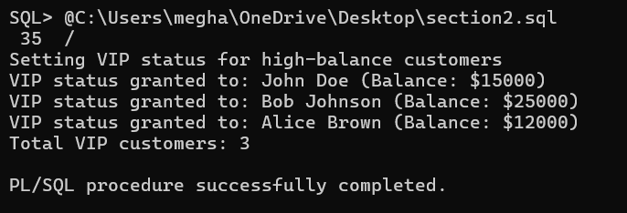

**Scenario 3:** The bank wants to send reminders to customers whose loans are due within the next 30 days.

**Question:** Write a PL/SQL block that fetches all loans due in the next 30 days and prints a reminder message for each customer.

**Solution:**

DECLARE

CURSOR loan_cursor IS

SELECT l.loan_id, l.customer_id, c.customer_name, l.loan_amount, l.due_date

FROM loans l

JOIN customers c ON l.customer_id = c.customer_id

WHERE l.due_date BETWEEN SYSDATE AND SYSDATE + 30

ORDER BY l.due_date;

v_reminder_count NUMBER := 0;

v_days_remaining NUMBER;

BEGIN

DBMS_OUTPUT.PUT_LINE('Loan Due Reminders (Next 30 Days) ');

DBMS_OUTPUT.PUT_LINE('Current Date: ' || TO_CHAR(SYSDATE, 'DD-MON-YYYY'));

DBMS_OUTPUT.PUT_LINE('---------------------------------------------------');

FOR loan_rec IN loan_cursor LOOP

v_days_remaining := TRUNC(loan_rec.due_date - SYSDATE);

v_reminder_count := v_reminder_count + 1;

DBMS_OUTPUT.PUT_LINE('REMINDER #' || v_reminder_count);

DBMS_OUTPUT.PUT_LINE('Customer: ' || loan_rec.customer_name);

DBMS_OUTPUT.PUT_LINE('Loan ID: ' || loan_rec.loan_id);

DBMS_OUTPUT.PUT_LINE('Loan Amount: $' || loan_rec.loan_amount);

DBMS_OUTPUT.PUT_LINE('Due Date: ' || TO_CHAR(loan_rec.due_date, 'DD-MON-YYYY'));

DBMS_OUTPUT.PUT_LINE('Days Remaining: ' || v_days_remaining);

IF v_days_remaining <= 7 THEN

DBMS_OUTPUT.PUT_LINE('*** URGENT: Payment due within a week! ***');

ELSIF v_days_remaining <= 15 THEN

DBMS_OUTPUT.PUT_LINE('** IMPORTANT: Payment due soon **');

END IF;

DBMS_OUTPUT.PUT_LINE('---------------------------------------------------');

END LOOP;

IF v_reminder_count = 0 THEN

DBMS_OUTPUT.PUT_LINE('No loans due within the next 30 days.');

ELSE

DBMS_OUTPUT.PUT_LINE('Total reminders sent: ' || v_reminder_count);

END IF;

EXCEPTION

WHEN OTHERS THEN

DBMS_OUTPUT.PUT_LINE('Error: ' || SQLERRM);

END;

**OUTPUT:**

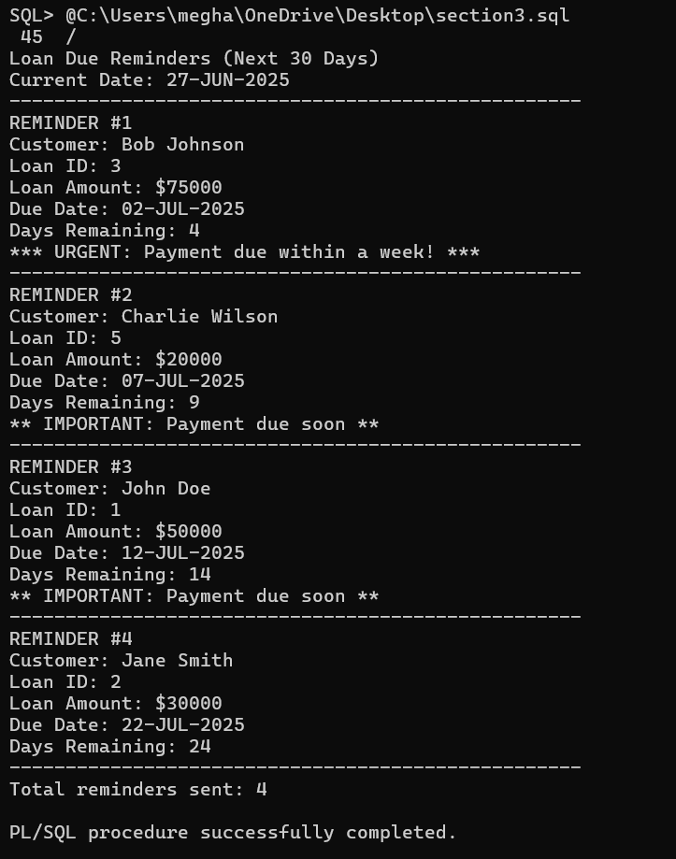

**Exercise 3: Stored Procedures**

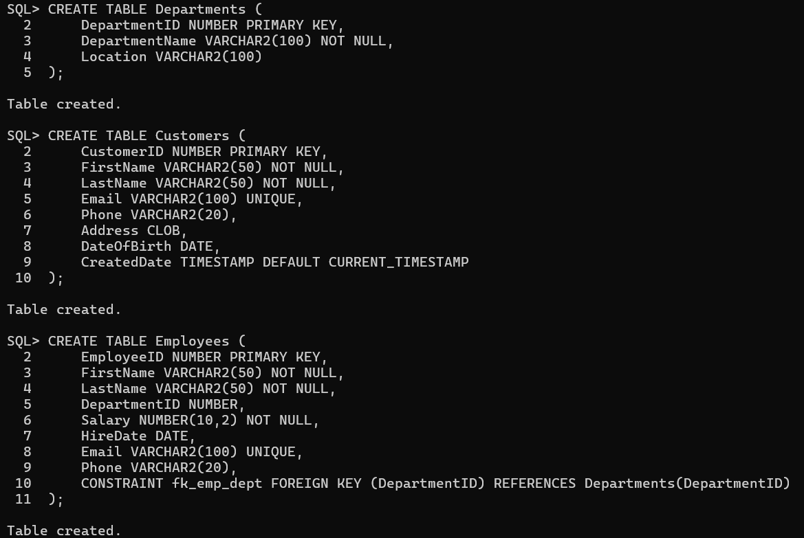

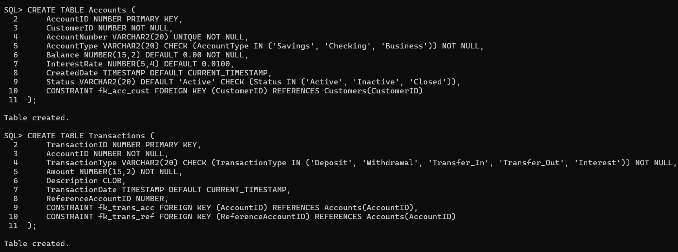

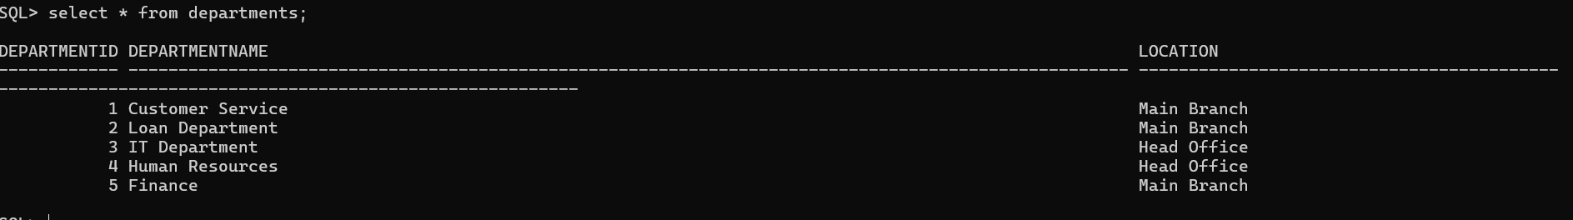

**Scenario 1:** The bank needs to process monthly interest for all savings accounts.

**Question:** Write a stored procedure **ProcessMonthlyInterest** that calculates and updates the balance of all savings accounts by applying an interest rate of 1% to the current balance.

**Solution:**

CREATE OR REPLACE PROCEDURE ProcessMonthlyInterest

IS

v_accounts_processed NUMBER := 0;

v_interest_amount NUMBER(15,2);

v_new_balance NUMBER(15,2);

CURSOR savings_cursor IS

SELECT AccountID, Balance, InterestRate

FROM Accounts

WHERE AccountType = 'Savings' AND Status = 'Active';

BEGIN

FOR rec IN savings_cursor LOOP

v_interest_amount := rec.Balance * rec.InterestRate;

v_new_balance := rec.Balance + v_interest_amount;

UPDATE Accounts

SET Balance = v_new_balance

WHERE AccountID = rec.AccountID;

INSERT INTO Transactions (AccountID, TransactionType, Amount, Description)

VALUES (rec.AccountID, 'Interest', v_interest_amount,

'Monthly interest applied at ' || (rec.InterestRate * 100) || '% rate');

v_accounts_processed := v_accounts_processed + 1;

END LOOP;

DBMS_OUTPUT.PUT_LINE('Monthly interest processed for ' || v_accounts_processed || ' savings accounts');

EXCEPTION

WHEN OTHERS THEN

ROLLBACK;

RAISE_APPLICATION_ERROR(-20001, 'Error processing monthly interest: ' || SQLERRM);

END ProcessMonthlyInterest;

**Output:**

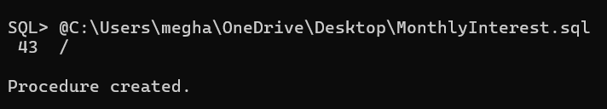

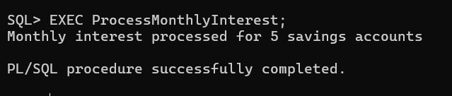

**Scenario 2:** The bank wants to implement a bonus scheme for employees based on their performance.

**Question:** Write a stored procedure **UpdateEmployeeBonus** that updates the salary of employees in a given department by adding a bonus percentage passed as a parameter.

**Solution:**

CREATE OR REPLACE PROCEDURE UpdateEmployeeBonus(

p_department_id IN NUMBER,

p_bonus_percentage IN NUMBER

)

IS

v_employees_updated NUMBER := 0;

v_department_name VARCHAR2(100);

BEGIN

IF p_department_id IS NULL OR p_bonus_percentage IS NULL THEN

RAISE_APPLICATION_ERROR(-20002, 'Department ID and bonus percentage are required');

END IF;

IF p_bonus_percentage < 0 OR p_bonus_percentage > 100 THEN

RAISE_APPLICATION_ERROR(-20003, 'Bonus percentage must be between 0 and 100');

END IF;

-- Check if department exists

BEGIN

SELECT DepartmentName INTO v_department_name

FROM Departments

WHERE DepartmentID = p_department_id;

EXCEPTION

WHEN NO_DATA_FOUND THEN

RAISE_APPLICATION_ERROR(-20004, 'Department does not exist');

END;

-- Update employee salaries with bonus

UPDATE Employees

SET Salary = Salary + (Salary * p_bonus_percentage / 100)

WHERE DepartmentID = p_department_id;

v_employees_updated := SQL%ROWCOUNT;

DBMS_OUTPUT.PUT_LINE('Department: ' || v_department_name);

DBMS_OUTPUT.PUT_LINE('Employees Updated: ' || v_employees_updated);

DBMS_OUTPUT.PUT_LINE('Bonus Percentage: ' || p_bonus_percentage || '%');

DBMS_OUTPUT.PUT_LINE('Bonus of ' || p_bonus_percentage || '% applied to ' ||

v_employees_updated || ' employees in ' || v_department_name);

EXCEPTION

WHEN OTHERS THEN

ROLLBACK;

RAISE_APPLICATION_ERROR(-20005, 'Error updating employee bonus: ' || SQLERRM);

END UpdateEmployeeBonus;

**Output:**

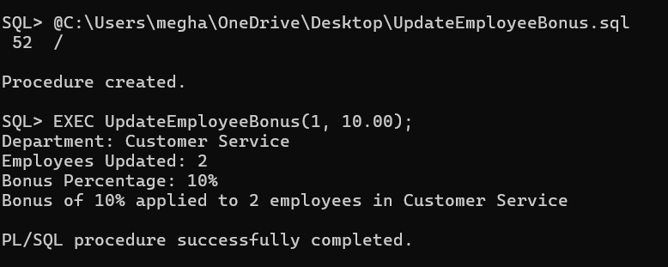

**Scenario 3:** Customers should be able to transfer funds between their accounts.

**Question:** Write a stored procedure **TransferFunds** that transfers a specified amount from one account to another, checking that the source account has sufficient balance before making the transfer.

**Solution:**

CREATE OR REPLACE PROCEDURE TransferFunds(

p_from_account_id IN NUMBER,

p_to_account_id IN NUMBER,

p_amount IN NUMBER,

p_description IN VARCHAR2 DEFAULT NULL

)

IS

v_from_balance NUMBER(15,2);

v_to_balance NUMBER(15,2);

v_from_account_number VARCHAR2(20);

v_to_account_number VARCHAR2(20);

v_transfer_description VARCHAR2(4000);

BEGIN

IF p_from_account_id IS NULL OR p_to_account_id IS NULL OR p_amount IS NULL THEN

RAISE_APPLICATION_ERROR(-20006, 'From Account ID, To Account ID, and Amount are required');

END IF;

IF p_amount <= 0 THEN

RAISE_APPLICATION_ERROR(-20007, 'Transfer amount must be greater than zero');

END IF;

IF p_from_account_id = p_to_account_id THEN

RAISE_APPLICATION_ERROR(-20008, 'Cannot transfer to the same account');

END IF;

BEGIN

SELECT Balance, AccountNumber INTO v_from_balance, v_from_account_number

FROM Accounts

WHERE AccountID = p_from_account_id AND Status = 'Active';

EXCEPTION

WHEN NO_DATA_FOUND THEN

RAISE_APPLICATION_ERROR(-20009, 'Source account does not exist or is not active');

END;

BEGIN

SELECT Balance, AccountNumber INTO v_to_balance, v_to_account_number

FROM Accounts

WHERE AccountID = p_to_account_id AND Status = 'Active';

EXCEPTION

WHEN NO_DATA_FOUND THEN

RAISE_APPLICATION_ERROR(-20010, 'Destination account does not exist or is not active');

END;

-- Check sufficient balance

IF v_from_balance < p_amount THEN

RAISE_APPLICATION_ERROR(-20011, 'Insufficient balance in source account');

END IF;

IF p_description IS NOT NULL THEN

v_transfer_description := p_description;

ELSE

v_transfer_description := 'Transfer from ' || v_from_account_number || ' to ' || v_to_account_number;

END IF;

-- Debit from source account

UPDATE Accounts

SET Balance = Balance - p_amount

WHERE AccountID = p_from_account_id;

-- Credit to destination account

UPDATE Accounts

SET Balance = Balance + p_amount

WHERE AccountID = p_to_account_id;

-- Insert transaction records

INSERT INTO Transactions (AccountID, TransactionType, Amount, Description, ReferenceAccountID)

VALUES (p_from_account_id, 'Transfer_Out', p_amount, v_transfer_description, p_to_account_id);

INSERT INTO Transactions (AccountID, TransactionType, Amount, Description, ReferenceAccountID)

VALUES (p_to_account_id, 'Transfer_In', p_amount, v_transfer_description, p_from_account_id);

-- Commit the transaction

COMMIT;

DBMS_OUTPUT.PUT_LINE('Transfer Successful');

DBMS_OUTPUT.PUT_LINE('From Account: ' || v_from_account_number);

DBMS_OUTPUT.PUT_LINE('To Account: ' || v_to_account_number);

DBMS_OUTPUT.PUT_LINE('Amount Transferred: ' || p_amount);

DBMS_OUTPUT.PUT_LINE('Description: ' || v_transfer_description);

DBMS_OUTPUT.PUT_LINE('Transfer Date: ' || TO_CHAR(SYSDATE, 'DD-MON-YYYY HH24:MI:SS'));

EXCEPTION

WHEN OTHERS THEN

ROLLBACK;

RAISE_APPLICATION_ERROR(-20012, 'Error during funds transfer: ' || SQLERRM);

END TransferFunds;

**Output:**

