Meghana(A25248100)

1.Determine the optimal linear hypothesis using linear regression to predict if a student passes or not based on the number hours studied.

Source code:

clc;

close all;

%training data

x=[0.5 0.75 1 1.25 1.5 1.75 1.75 2 2.25 2.5 2.75 3 3.25 3.5 4 4.25 4.50 4.75 5 5.50];

y=[0 0 0 0 0 0 1 0 1 0 1 0 1 0 1 1 1 1 1 1];

%initial values

a=0.0015; %learning rate

m=20;

i=1:20;

t0=0;

t1=1;

j=zeros(1500,1);

for num=1:1500

h=t0+t1\*x(i);

j(num)=(0.5\*m).\*sum((h(i)-y(i)).^2); %cost function

jt0=sum(h(i)-y(i));

jt1=sum((h(i)-y(i)).\*x(i));

t0=t0-a\*jt0;

t1=t1-a\*jt1;

plot(0:49,j(1:50))

end

%hypothesis plot

figure('Name','hypothesis')

scatter (x,y)

hold on

plot(x,h)

axis([0 6 -0.5 1.5])

xlabel('hours studied')

ylabel('pass/fail')

hold off;

t0

t1

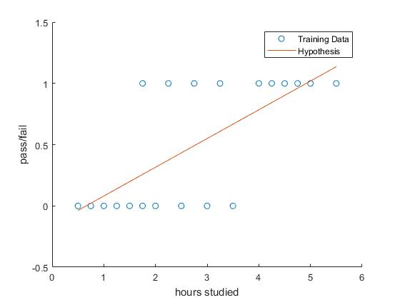

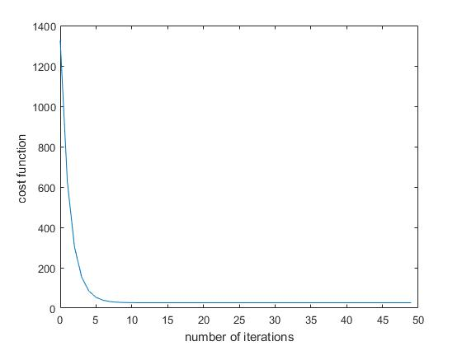

2.Determine the optimal logistic hypothesis using logistic regression to predict if a student passes or not based on the number hours studied.

Source code

clc;

close all;

%training data

x=[0.5 0.75 1 1.25 1.5 1.75 1.75 2 2.25 2.5 2.75 3 3.25 3.5 4 4.25 4.50 4.75 5 5.50]';

y=[0 0 0 0 0 0 1 0 1 0 1 0 1 0 1 1 1 1 1 1]';

x = [ones(20,1) ,x];

a=0.1; %learning rate

m=20;

t = zeros(2,1);

j=zeros(5000,1);

for num=1:5000

hyp = x \* t;

h = 1./(1+exp(-hyp));

j(num)=-(1/m) \* sum(y.\*log(h) + (1-y) .\*log(1-h)); %cost function

grad = (1/m) .\* x' \*(h-y);

t = t - a\*grad;

plot(0:4999,j(1:5000))

end

%hypothesis plot

figure('Name','hypothesis')

scatter (x(:,2),y)

hold on

plot(x(:,2),h)

axis([0 6 -0.5 1.5])

xlabel('hours studied')

ylabel('pass/fail')

xlabel('Number of iterations')

ylabel('Cost J')

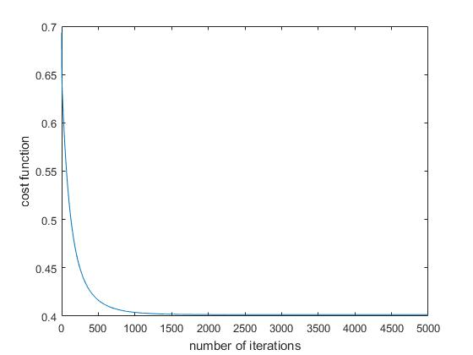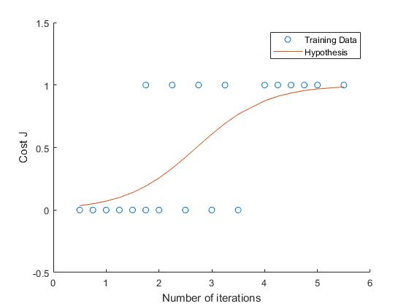

3.Plot both hypothesis function 0 < x < 6. Compare and explain the two results obtained.

Source code

clc;

close all;

%training data

x=[0.5 0.75 1 1.25 1.5 1.75 1.75 2 2.25 2.5 2.75 3 3.25 3.5 4 4.25 4.50 4.75 5 5.50];

y=[0 0 0 0 0 0 1 0 1 0 1 0 1 0 1 1 1 1 1 1];

%initial values

a=0.0015; %learning rate

m=20;

i=1:20;

t0=0;

t1=1;

j=zeros(1500,1);

for num=1:1500

h=t0+t1\*x(i);

j(num)=(0.5\*m).\*sum((h(i)-y(i)).^2); %cost function

%grad

jt0=sum(h(i)-y(i));

jt1=sum((h(i)-y(i)).\*x(i));

t0=t0-a\*jt0;

t1=t1-a\*jt1;

end

x=[0.5 0.75 1 1.25 1.5 1.75 1.75 2 2.25 2.5 2.75 3 3.25 3.5 4 4.25 4.50 4.75 5 5.50]';

y=[0 0 0 0 0 0 1 0 1 0 1 0 1 0 1 1 1 1 1 1]';

x = [ones(20,1) ,x];

a1=0.1; %learning rate

m=20;

t1 = zeros(2,1);

j1=zeros(5000,1);

for num1=1:5000

hyp1 = x \* t1;

h1 = 1./(1+exp(-hyp1));

j1(num1)=-(1/m) \* sum(y.\*log(h1) + (1-y) .\*log(1-h1)); %cost function

grad1 = (1/m) .\* x' \*(h1-y);

t1 = t1 - a1\*grad1;

end

%hypothesis plot

figure('Name','hypothesis1')

scatter (x(:,2),y)

hold on

plot(x(:,2),h)

hold on

plot(x(:,2),h1)

axis([0 6 -0.5 1.5])

xlabel('hours studied')

ylabel('pass/fail')

hold off

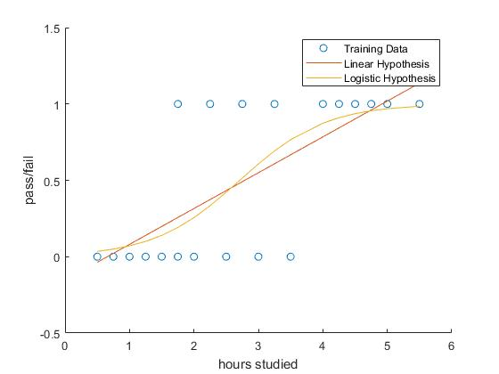

4.Develop a logistic regression-like algorithm for the following cost function.

-Y = 1 - Cost function goes from 100 to 0 linearly as hypothesis function goes from 0 to 1

-Y = 0 - Cost function goes from 0 to 100 linearly as hypothesis function goes from 0 to 1Compare results with those of the standard logistic algorithm.

clc;

close all;

%training data

x=[0.5 0.75 1 1.25 1.5 1.75 1.75 2 2.25 2.5 2.75 3 3.25 3.5 4 4.25 4.50 4.75 5 5.50];

y=[0 0 0 0 0 0 1 0 1 0 1 0 1 0 1 1 1 1 1 1];

%initial values

a=0.0015; %learning rate

m=20;

i=1:20;

t0=0;

t1=1;

j=zeros(20,1);

j1=zeros(20,1);

for num=1:20;

if y(i)==1

h=t0+t1\*x(i);

j1=-100.\*h+100;

jt10=sum(h(i)-y(i));

jt11=sum((h(i)-y(i)).\*x(i));

t10=t10-a\*jt10;

t11=t11-a\*jt11;

else

h=t0+t1\*x(i);

j=100.\*h;

jt0=sum(h(i)-y(i));

jt1=sum((h(i)-y(i)).\*x(i));

t0=t0-a\*jt0;

t1=t1-a\*jt1;

plot(h,j1(1:20),'r',h,j(1:20),'b')

end

end

A screenshot of a cell phone

Description generated with very high confidence