 

**SAVEETHA SCHOOL OF ENGINEERING**

**SAVEETHA INSTITUTE OF MEDICAL AND TECHNICAL**

**SCIENCES**

**CAPSTONE PROJECT REPORT**

**PROJECT TITLE:**

SOLAR POWER GENERATION FORECAST

**CSA1356 -THEORY OF COMPUTATION**

**Submitted**

**By**

**Girija (192211932)**

**Supriya (192211351)**

**Meghana (192211562)**

**Guided by**

**Mounika (Professor)**

**ABSTRACT:**

The Solar Power Generation Forecaster is a crucial tool in optimising renewable energy utilisation. This abstract introduces a novel forecasting model designed to predict solar power generation with high accuracy. Incorporating machine learning algorithms and meteorological data, the system offers reliable predictions for various timeframes, aiding energy grid management and operational planning. By analysing historical solar irradiance patterns and weather conditions, the forecaster enhances decision-making processes for stakeholders in the renewable energy sector. Its versatility allows adaptation to different geographical locations and scales of operation, making it an indispensable asset for advancing sustainable energy transitions. With its precision and adaptability, the Solar Power Generation Forecaster stands as a key solution for maximising the efficiency and reliability of solar energy integration into power systems.

**INTRODUCTION:**

In an era of escalating energy demands and growing environmental concerns, the significance of solar power generation forecasting cannot be overstated. As humanity strives towards a sustainable future, the ability to accurately predict solar power generation holds immense promise in optimising energy distribution, reducing reliance on fossil fuels, and mitigating climate change impacts.

The Solar Power Generation Forecaster represents a pioneering solution at the intersection of technology and sustainability. By leveraging advanced algorithms and real-time data analytics, this innovative tool empowers energy stakeholders with invaluable insights into solar power output fluctuations. From utility companies seeking to balance grid demand to policymakers crafting resilient energy policies, the forecaster serves as a cornerstone for informed decision-making.

Through its precise predictions, the Solar Power Generation Forecaster not only enhances the efficiency and reliability of solar energy integration but also fosters a more resilient and adaptable energy landscape. By harnessing the potential of the sun, we illuminate a path towards a cleaner, brighter future for generations to come.

**DATA PROCESSING:**

Data processing for a solar power generation forecaster involves aggregating historical solar irradiance data, weather forecasts, and solar panel characteristics. Through algorithms like machine learning, this data is analysed to predict future solar power output accurately. Factors such as cloud cover, atmospheric conditions, and time of day are considered to enhance forecasting precision. Additionally, real-time data feeds continually update predictions, ensuring accuracy. The processed data aids in optimising energy distribution, scheduling maintenance, and informing grid management decisions. Advanced techniques like neural networks or statistical models refine predictions, enabling efficient utilisation of solar energy resources for sustainable power generation.

**MODEL\ALGORITHM:**

**Time Series Forecasting:**

**Autoregressive Integrated Moving Average (ARIMA):** Suitable for modelling time series data with trends and seasonality. It can capture patterns in historical solar power generation data and forecast future values.

**Seasonal Decomposition of Time Series (STL):** Decomposes the time series into seasonal, trend, and residual components, enabling better understanding and forecasting of solar power generation patterns.

**Exponential Smoothing (ETS):** Models time series data using exponential smoothing methods, which are particularly useful for short-term forecasting of solar power generation.

**Machine Learning Algorithms:**

**Random Forest:** Effective for regression tasks, random forests can capture complex relationships between weather variables (such as temperature, humidity, cloud cover) and solar power generation.

**Gradient Boosting Machines (GBM):** Ensemble learning technique that builds multiple decision trees sequentially, each one correcting errors of its predecessor, which can provide accurate predictions for solar power generation.

**Long Short-Term Memory (LSTM) Networks:** A type of recurrent neural network (RNN) capable of learning long-term dependencies in time series data, making it suitable for forecasting solar power generation with sequential patterns.

**Hybrid Approaches:**

**ARIMA with Exogenous Variables (ARIMAX):** Integrates external factors like weather forecasts (temperature, humidity, cloud cover) into the ARIMA model to improve accuracy by capturing the impact of weather on solar power generation.

**Neural Network Autoregression (NNAR):** Combines the capabilities of neural networks and autoregressive models to capture complex nonlinear relationships and temporal dependencies in solar power generation data.

**GRAPH:**

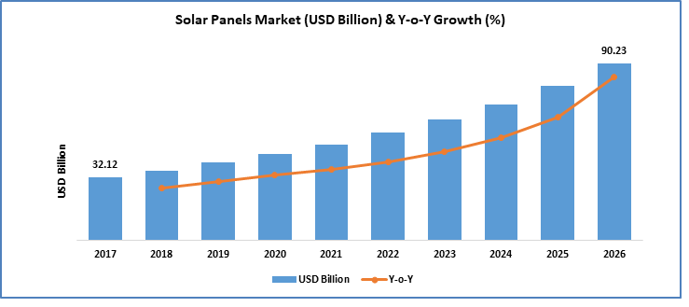

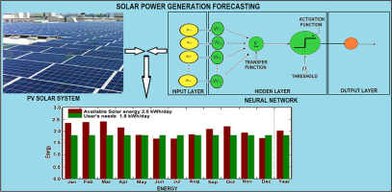

**CONCLUSION:**

In conclusion, developing a reliable solar power generation forecaster is pivotal for optimising energy management and promoting sustainable practices. By leveraging advanced predictive models and real-time data analytics, stakeholders can anticipate fluctuations in solar output, enabling efficient grid integration and resource allocation. Additionally, accurate forecasting facilitates informed decision-making for investors, policymakers, and energy operators, fostering a smoother transition towards renewable energy adoption. With continuous refinement and collaboration across interdisciplinary fields, solar power generation forecasting holds the promise of bolstering resilience in energy systems while mitigating environmental impact, thereby shaping a brighter, more sustainable future.

**CODE:**

# Importing necessary libraries

import pandas as pd

from sklearn.model_selection import train_test_split

from sklearn.ensemble import RandomForestRegressor

from fbprophet import Prophet

# Assuming you have a CSV file with historical solar power generation data

# Load the data

data = pd.read_csv('solar_generation_data.csv')

# Preprocessing data

data['datetime'] = pd.to_datetime(data['datetime'])

data = data.set_index('datetime')

# Assuming the data has features like temperature, humidity, etc.

# Splitting data into features and target variable

X = data[['temperature', 'humidity']] # Add more features if available

y = data['solar_power_generation']

# Splitting data into training and testing sets

X_train, X_test, y_train, y_test = train_test_split(X, y, test_size=0.2, random_state=42)

# Training a Random Forest Regressor model

model = RandomForestRegressor(n_estimators=100, random_state=42)

model.fit(X_train, y_train)

# Making predictions

predictions = model.predict(X_test)

# Prophet Forecasting

# Prepare data for Prophet

prophet_data = data.reset_index()

prophet_data.columns = ['ds', 'y']

# Initialize and fit Prophet model

prophet_model = Prophet()

prophet_model.fit(prophet_data)

# Make future dataframe for forecasting

future = prophet_model.make_future_dataframe(periods=365) # Forecasting for next 365 days

# Forecasting

forecast = prophet_model.predict(future)

# Plotting forecasts

fig = prophet_model.plot(forecast)

# Displaying the plot

fig.show()

**SCRIPTSHEET :**

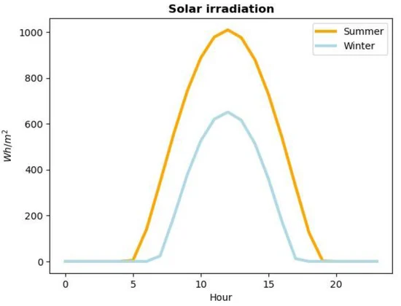

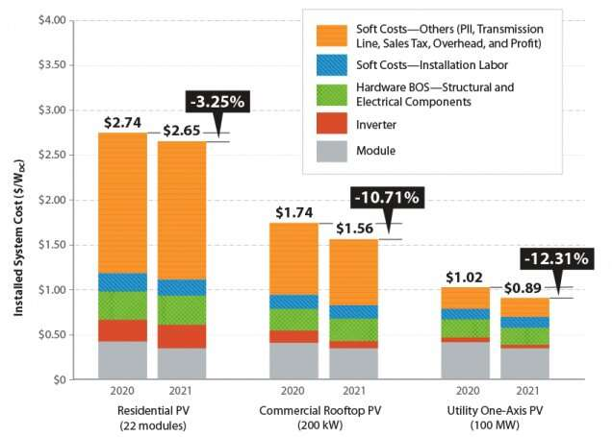

**REFERENCE:**

1.Zhang, J., Chi, Y. and Xiao, L., 2018, November. Solar power generation forecast based on LSTM. In *2018 IEEE 9th International Conference on Software Engineering and Service Science (ICSESS)* (pp. 869-872). IEEE.<https://ieeexplore.ieee.org/abstract/document/8663788/>.

2.AlKandari, M. and Ahmad, I., 2020. Solar power generation forecasting using ensemble approach based on deep learning and statistical methods. *Applied Computing and Informatics*.[https://www.emerald.com/insight/content/doi/10.1016/j.aci.2019.11.002/full/htm](https://www.emerald.com/insight/content/doi/10.1016/j.aci.2019.11.002/full/html).

3.Tang, N., Mao, S., Wang, Y. and Nelms, R.M., 2018. Solar power generation forecasting with a LASSO-based approach. *IEEE Internet of Things Journal*, *5*(2), pp.1090-1099.<https://ieeexplore.ieee.org/abstract/document/8306874/>.

4.Kim, J.G., Kim, D.H., Yoo, W.S., Lee, J.Y. and Kim, Y.B., 2017. Daily prediction of solar power generation based on weather forecast information in Korea. *IET Renewable Power Generation*, *11*(10),pp.1268-1273.<https://ietresearch.onlinelibrary.wiley.com/doi/abs/10.1049/iet-rpg.2016.0698>.

5.Maciel, J.N., Ledesma, J.J.G. and Junior, O.H.A., 2021. Forecasting Solar Power Output Generation: A Systematic Review with the Proknow-C. *IEEE Latin America Transactions*, *19*(4), pp.612-624.<https://ieeexplore.ieee.org/abstract/document/9448544/>.

6.Kumar, K.R. and Kalavathi, M.S., 2018. Artificial intelligence based forecast models for predicting solar power generation. *Materials today: proceedings*, *5*(1), pp.796-802.<https://www.sciencedirect.com/science/article/pii/S2214785317323957>.

7.Prema, V., Bhaskar, M.S., Almakhles, D., Gowtham, N. and Rao, K.U., 2021. Critical review of data, models and performance metrics for wind and solar power forecast. *IEEE Access*, *10*, pp.667-688.<https://www.sciencedirect.com/science/article/pii/S0306261920303354?casa_token=ygJCfGmi5uAAAAAA:TLCkpWIeyzn-A9T6pSx6m_Rl5yOPY1gd7gIYacHh6fPoNKXKajqfa6J7-ECR_rq2pWKeep35llGZ>.

8.Yang, Z., Mourshed, M., Liu, K., Xu, X. and Feng, S., 2020. A novel competitive swarm optimised RBF neural network model for short-term solar power generation forecasting. *Neurocomputing*, *397*, pp.415-421.<https://www.sciencedirect.com/science/article/pii/S0925231220304094?casa_token=NO-di56Idl0AAAAA:L5m9uNW1ejDpi5-_YsNrKtbzTBYLerbgLCDakiWvaMV4kCCavAmtwJDBOjk4HynsFVTQocaN8ael>

9.Sobri, S., Koohi-Kamali, S. and Rahim, N.A., 2018. Solar photovoltaic generation forecasting methods: A review. *Energy conversion and management*, *156*, pp.459-497.<https://www.sciencedirect.com/science/article/pii/S0196890417310622?casa_token=ehQM9DxOhnQAAAAA:JkfCJH6V_N8G3CRsEMOGE9caopK7xBCEmWvn6BDtraJoEYIxCY03ft1_-Y_0WAptAojkACda8As7>.

10.Kumar, K.R. and Kalavathi, M.S., 2018. Artificial intelligence based forecast models for predicting solar power generation. *Materials today: proceedings*, *5*(1), pp.796-802.

<https://www.sciencedirect.com/science/article/pii/S2214785317323957>.