**JAVA FSE WEEK 5**

**Microservices**

**Mandatory Hands-on Excercises**

**Creating Microservices for account and loan**

In this hands-on exercises, we will create two microservices for a bank. One microservice for handing accounts and one for handling loans**.**

**SOLUTION:**

**PART- I :Account Microservice using Spring Boot**

To implement a simple RESTful microservice named Account Service using Spring Boot and Maven, which returns dummy account details based on account number.

**Step-by-Step Implementation:**

1. Project Setup Using Spring Initializr 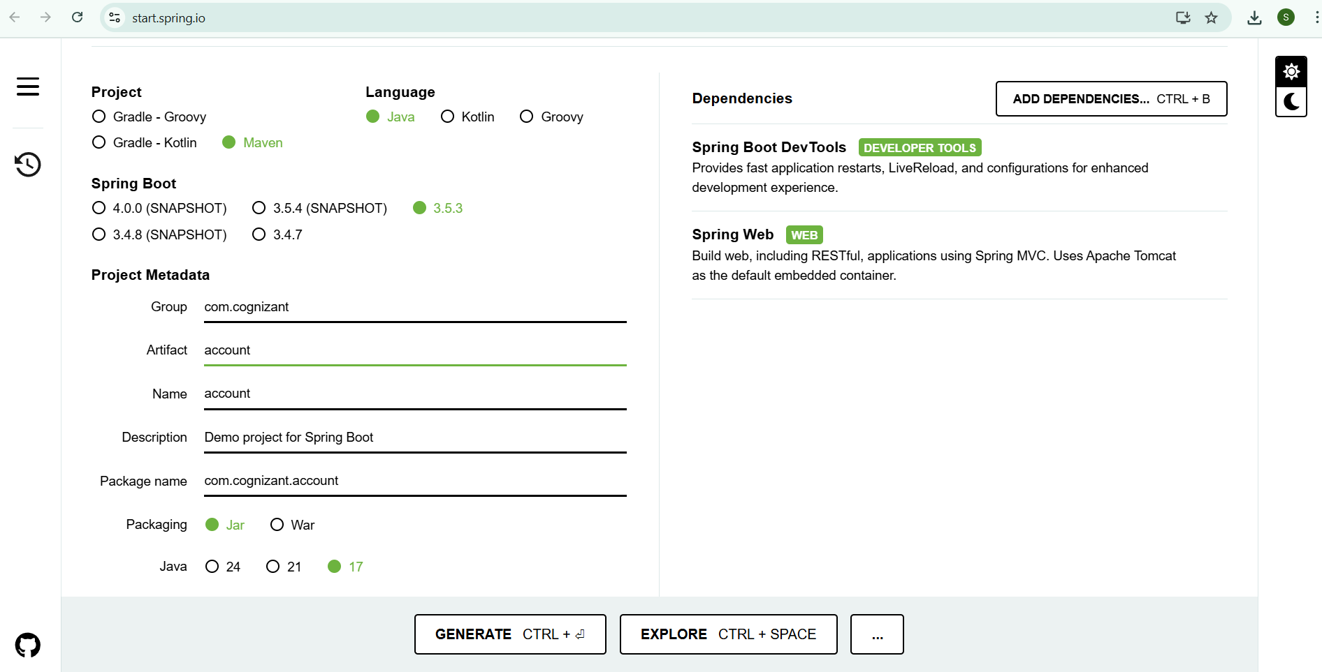
2. Extract & Open in VS Code
3. Build the Project
4. Created REST Controller

Code:

package com.cognizant.account.controller;

import org.springframework.web.bind.annotation.*;

@RestController

@RequestMapping("/accounts")

public class AccountController {

@GetMapping("/{number}")

public Account getAccount(@PathVariable String number) {

return new Account(number, "savings", 234343);

}

record Account(String number, String type, double balance) {}

}

1. Run the Application
2. Tested the API

**OUTPUT:**

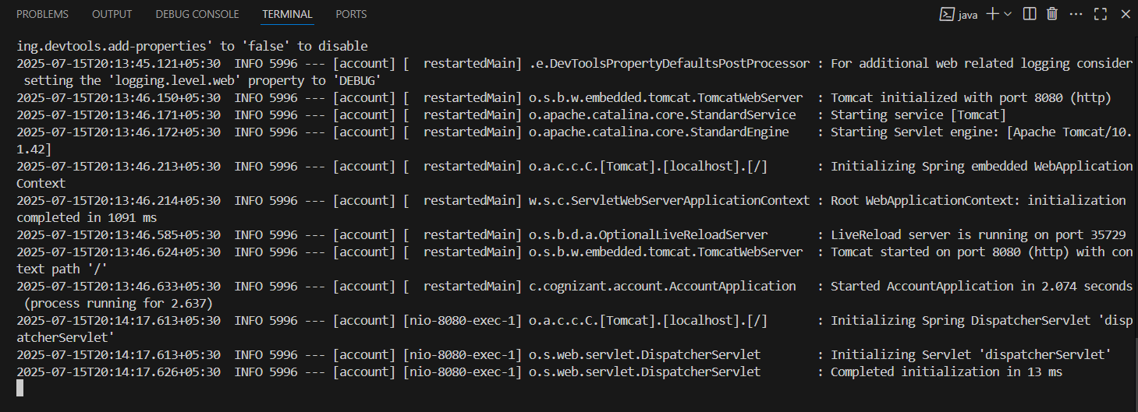

Console showed: Tomcat started on port(s): 8080

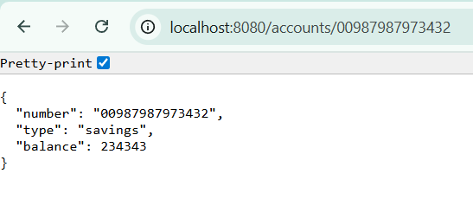

**PART – II :Loan Microservice using Spring Boot**

To develop an independent **Loan Service** microservice using **Spring Boot** and **Maven**, which returns dummy loan details for a given loan account number.

**Step-by-Step Implementation:**

1. Project Setup Using Spring Initializr 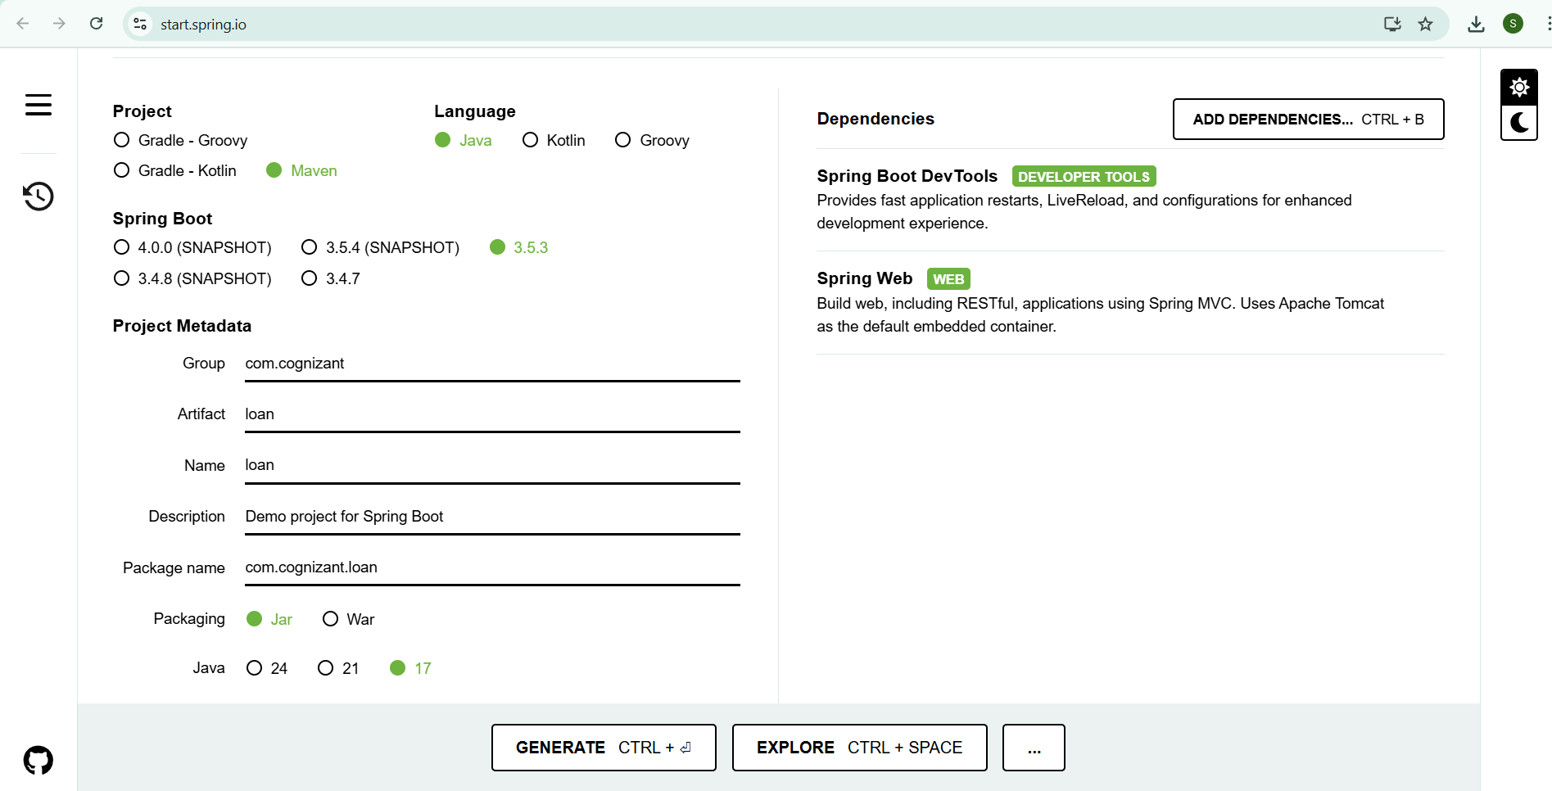
2. Extract & Open in VS Code
3. Build the Project
4. Set Application Port to 8081
5. Created REST Controller

Code:

package com.cognizant.loan.controller;

import org.springframework.web.bind.annotation.*;

@RestController

@RequestMapping("/loans")

public class LoanController {

@GetMapping("/{number}")

public Loan getLoan(@PathVariable String number) {

return new Loan(number, "car", 400000, 3258, 18);

}

record Loan(String number, String type, double loan, double emi, int tenure) {}

}

1. Run the Application
2. Tested the API

**OUTPUT:**

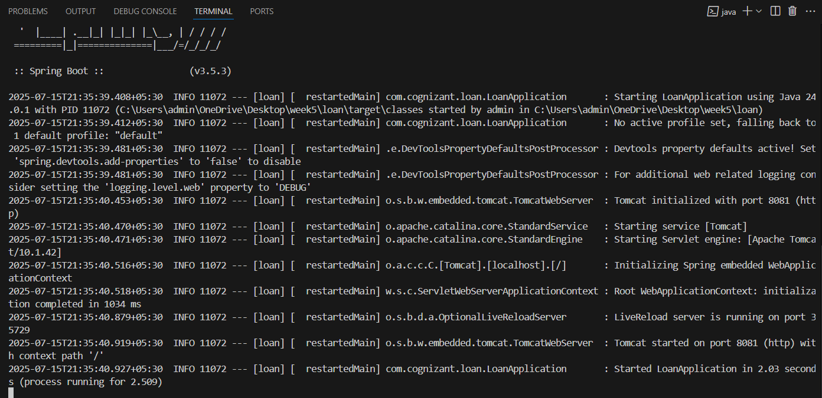

Tomcat started on port(s): 8081

