**ANALYSIS-3**

**1.The memory usage of the data is around 6.1 mb. How can we reduce the memory usage of the data set?**

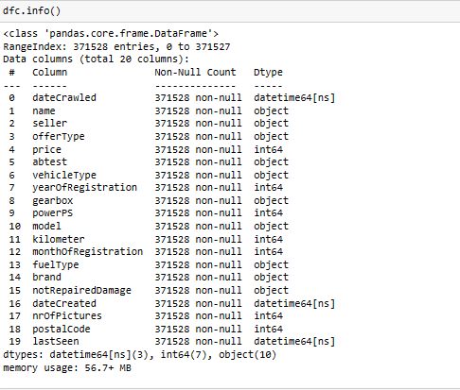

The memory usage of the data set is as you can see 59.5+ MB.

By using the below code I dropped some columns which are not use full and I changed the data type of some columns.

After dropping those columns and changing the data types of some columns the memory usage of the data set is decreased to 41.8+MB.

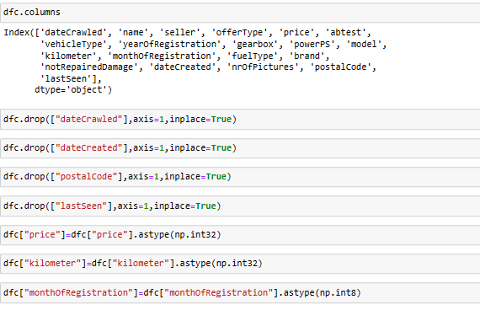

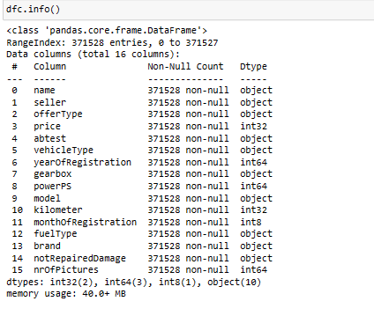

**C.2.what is the average price of vehicle by fuel type and gearbox type And give a plot.**

With the help of below code we got the below plot.

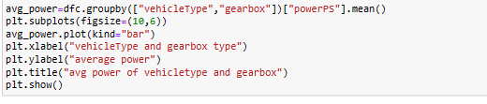

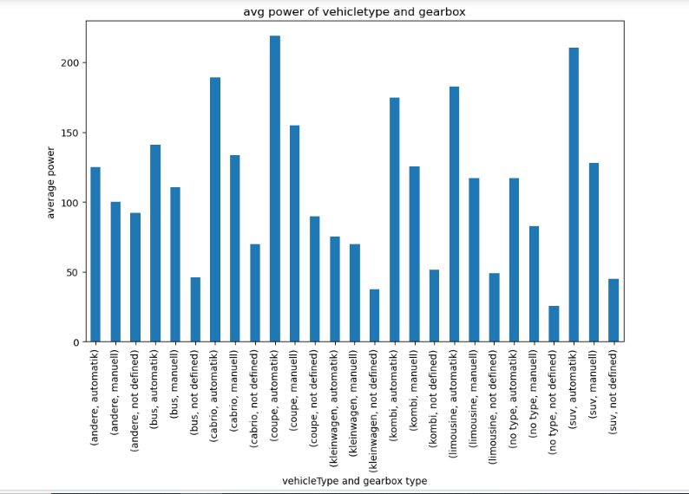

From the above plot I can tell that andere fuel type in manuell gearbox type has more average price when compared to all others.

**C.3.What is the Average power of a vehicle by vehicle type and gearbox type Give a plot.**

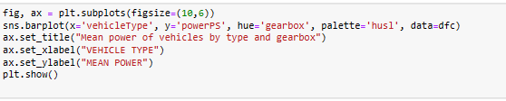

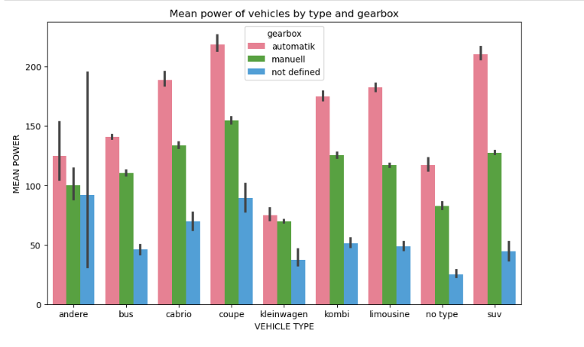

From the above plot we can see that coupe vehicle type has more average price when compared to other vehicle types. And in that coupe vehicle type automatic gear box type has more average price than other two gear box types.

**C.4.What is the Average price of a vehicle by brand as well as vehicle type.Use heatmap to explain this.**

Box

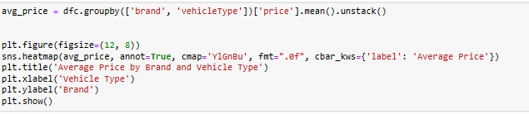

With the help of above data we can plot a heap map.



