AI Website Copy Generator for Local Businesses
Project Report
Project Title
AI Website Copy Generator for Local Businesses
Business Chosen
MK Cafe, Warangal
Submitted By
Meghana Ankam

1. Introduction
This project focuses on creating professional website content for a local business using Artificial Intelligence and Prompt Engineering techniques. The selected business for this project is MK Cafe, located in Warangal. The objective was to generate engaging website copy and develop a simple website prototype using HTML and CSS.

2. Objective
The main objectives of this project are:
- To understand the basics of Prompt Engineering.
- To generate professional website content using AI tools.
- To create customer-focused and conversion-oriented website copy.
- To develop a simple and responsive website prototype.
- To improve content creation and web development skills.

3. Tools Used
The following tools were used during the project:
ChatGPT
Used for generating website content, service descriptions, and call-to-action sections through well-designed prompts.
HTML
Used to create the structure of the website.
CSS
Used to style the website and make it visually appealing and responsive.

4. Project Methodology
Step 1: Business Selection
A local cafe named MK Cafe, Warangal was selected for the project.
Step 2: Understanding Business Requirements
The services, target audience, and offerings of the cafe were identified.
Step 3: Prompt Creation
Different prompts were created to generate:
- Homepage content
- About Us content
- Service descriptions
- Why Choose Us section
- Call-to-Action content
Step 4: Content Generation
The prompts were provided to ChatGPT to generate professional and customer-friendly website copy.
Step 5: Website Development
The generated content was integrated into a website using HTML and CSS.
Step 6: Testing
The website layout and content were reviewed to ensure readability and responsiveness.

5. Prompt Logic
The prompts were designed to achieve the following goals:
- Create a strong first impression through homepage content.
- Highlight the services offered by the cafe.
- Build trust through business information and benefits.
- Encourage customer engagement using Call-to-Action sections.
- Maintain a professional and friendly tone throughout the website.

6. Website Features
The website includes the following sections:
Homepage
Provides an introduction to MK Cafe and its offerings.
About Us
Describes the cafe's mission and customer experience.
Services
Highlights coffee, snacks, desserts, and beverages.
Why Choose Us
Explains the advantages of visiting MK Cafe.
Call-to-Action Section
Encourages visitors to visit the cafe or contact the business.
Responsive Design
Ensures the website works properly on different screen sizes.

7. Business Description
MK Cafe is a modern cafe located in Warangal. It offers premium coffee, delicious snacks, desserts, and refreshing beverages in a comfortable and welcoming environment. The cafe aims to provide customers with quality food, excellent service, and a relaxing atmosphere.

8. Deliverables
The following deliverables were completed:
- Homepage Copy
- Services Page Content
- CTA Content
- HTML Website Prototype
- CSS Styling
- README Documentation
- Project Report

9. Learning Outcomes
Through this project, I learned:
- Basics of Prompt Engineering
- AI-assisted content creation
- Website content planning
- HTML and CSS development
- Local business website design
- Effective use of AI tools in digital marketing

10. Conclusion
The AI Website Copy Generator project successfully demonstrated how Prompt Engineering and AI tools can be used to create professional website content for local businesses. The project improved my understanding of content generation, web development, and AI-assisted workflows. The final website provides a professional online presence for MK Cafe and showcases the practical application of AI in website content creation.

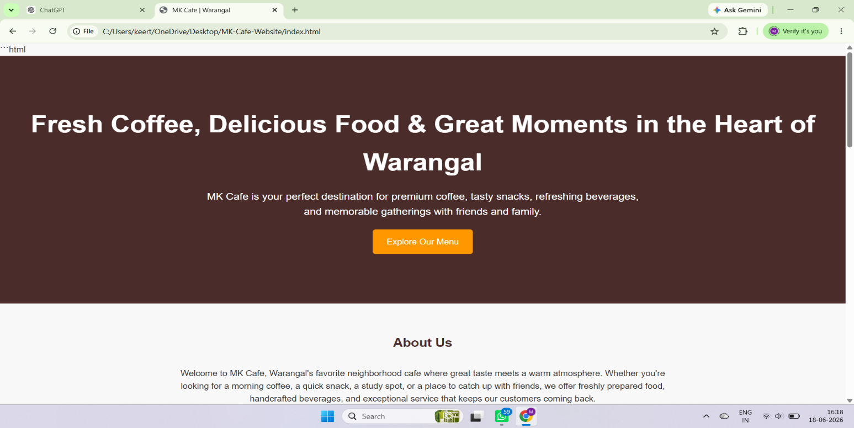
Outputs:

