1. ARTICLE:

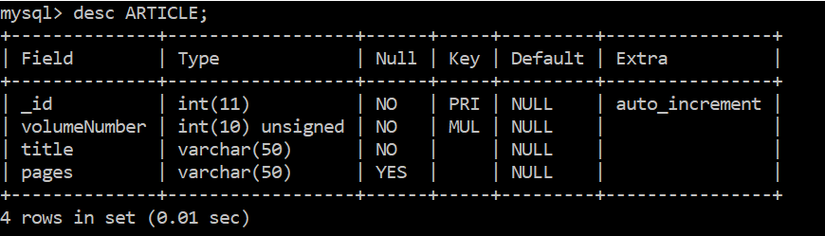

1. AUTHOR:

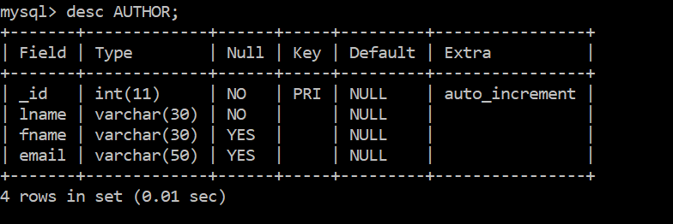

1. ARTICLE AUTHOR

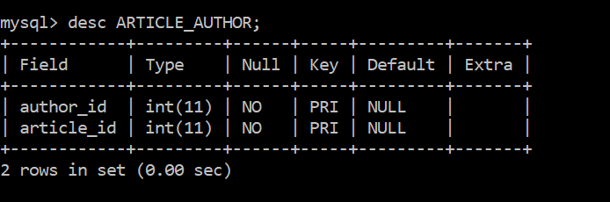

1. MAGAZINE:

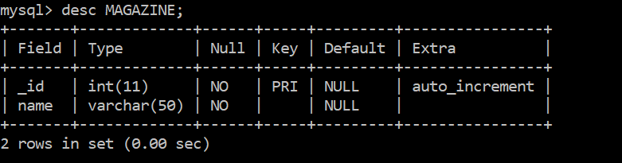

1. MAGAZINEVOLUME:

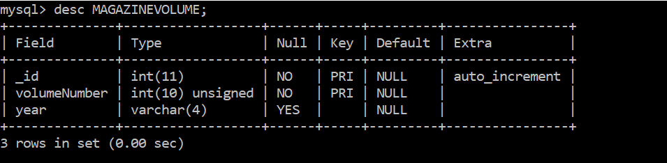

1. CUSTOMER :

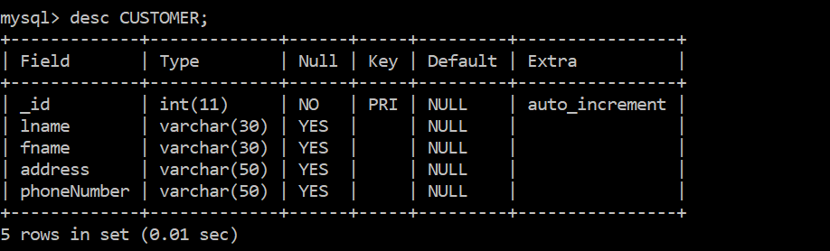

1. EMPLOYEE:

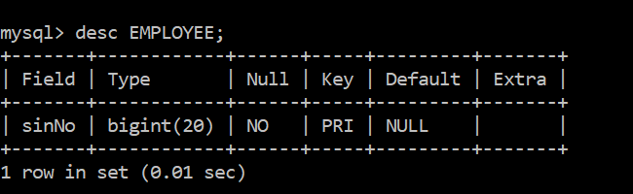

1. ITEM :

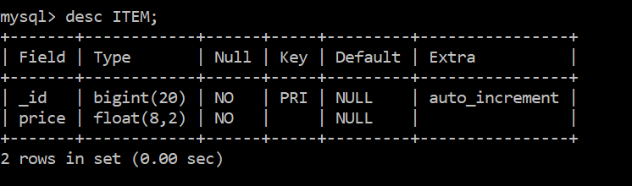

1. TRANSACTION

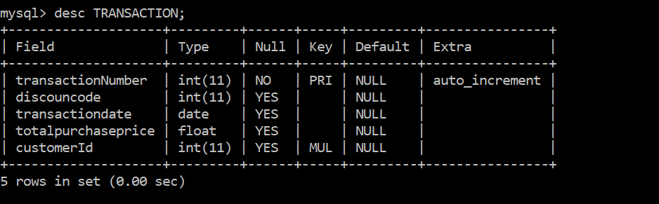

1. TRANSACTIONDETAILS

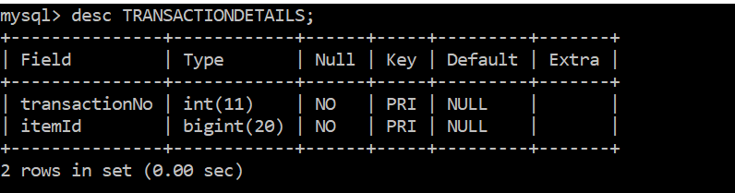

1. WORKHOURS

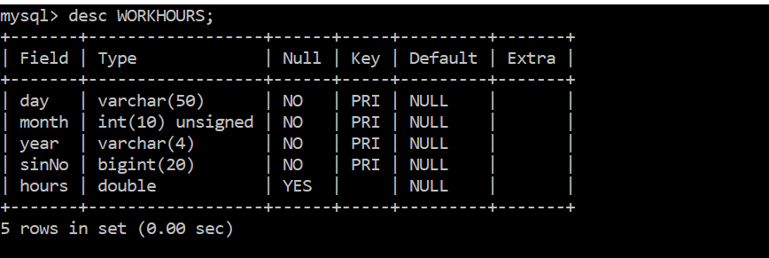

1. YEARLYRENT

