WEEK 2 TASK REPORT
Advanced Data Visualization and Storytelling with Python
Global CO₂ Emissions: Trends, Country Differences and Energy Patterns

Table of Contents
1. Introduction
2. Objective
3. Dataset Description
4. Data Acquisition
5. Data Preparation and Cleaning
6. Visualization and Data Storytelling
6.1 Visualization 1 – Global CO₂ Emissions Over Time
6.2 Visualization 2 – Top 10 Countries by CO₂ Emissions in 2024
6.3 Visualization 3 – Top 10 Countries by CO₂ Emissions Per Capita in 2024
6.4 Visualization 4 – GDP Per Capita vs CO₂ Emissions Per Capita in 2024
6.5 Visualization 5 – CO₂ Emissions: 2000 vs 2024
7. Key Insights
8. Business and Scientific Implications
9. Limitations
10. Tools and Technologies
11. Conclusion
12. Appendix – Main Python Workflow

1. Introduction
Data visualization converts numerical information into patterns that can be understood quickly. This project develops a visual narrative about global CO₂ emissions using publicly accessible Our World in Data datasets. The analysis examines long-term trends, country differences, population-adjusted emissions, the relationship between GDP per capita and emissions per capita, and country-level changes between 2000 and 2024. The narrative is designed for a non-technical audience using clear chart titles, readable labels, appropriate units, and short explanations.

2. Objective
The objectives of this task are to:
- Explore long-term and recent patterns in global CO₂ emissions.
- Compare countries by total annual CO₂ emissions.
- Compare countries using CO₂ emissions per person.
- Explore the relationship between GDP per capita and CO₂ emissions per capita.
- Compare emissions for selected major countries between 2000 and 2024.
- Explain the reasoning behind each visualization and its contribution to the overall narrative.

3. Dataset Description
The primary dataset is the Our World in Data indicator for annual CO₂ emissions including land-use change. It contains entity, code, year, and annual emissions values and covers 1850–2024. For the per-capita analysis, the corresponding Our World in Data per-capita indicator was used. For the economic comparison, 2024 GDP per capita data was merged with 2024 CO₂-per-capita data.
Primary source: Our World in Data – Annual CO₂ emissions including land-use change
Per-capita source: Our World in Data – CO₂ emissions per capita including land-use change
GDP source: Our World in Data – GDP per capita

4. Data Acquisition
The datasets were downloaded directly from publicly accessible Our World in Data Grapher CSV endpoints using Pandas. An Our World in Data User-Agent was supplied through Pandas storage_options so the CSV files could be read successfully in Google Colab.
df = pd.read_csv(url, storage_options={"User-Agent": "Our World in Data data fetch/1.0"})

5. Data Preparation and Cleaning
The primary DataFrame contained 23,796 rows and 4 columns. The data was checked for structure, data types, missing values, duplicate rows, year range, and available entities.
- Dataset size: 23,796 rows and 4 columns.
- Year range: 1850–2024.
- Unique entities: 211.
- Duplicate rows: 0.
- Missing values occurred in the Code field; unavailable codes were filled with 'N/A' in the working copy.
- The World aggregate was used for the global time-series chart.
- Aggregate regions were excluded where country-only comparisons were required.
- 2024 GDP-per-capita data was merged with 2024 CO₂-per-capita data for the scatter plot.

6. Visualization and Data Storytelling
The five visualizations use different chart types and answer different questions. The narrative progresses from a broad global trend to country rankings, a per-capita comparison, an economic relationship, and country-level change over time.

6.1 Visualization 1 – Global CO₂ Emissions Over Time
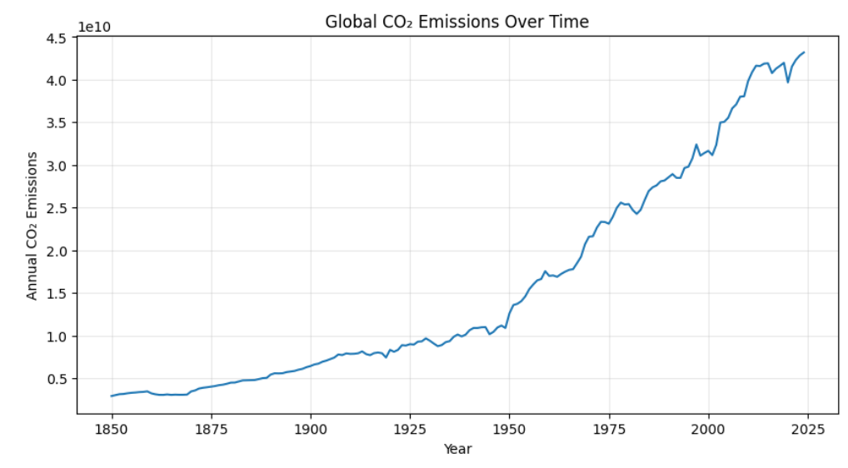
Figure 1. Global annual CO₂ emissions including land-use change from 1850 to 2024.
Why this chart was selected: A line chart was selected because annual observations form a time series. Lines make long-term direction and fluctuations easy to follow.
Observation: The chart shows a strong long-term increase in global CO₂ emissions, with shorter-term fluctuations and declines within the overall upward pattern.
Storytelling contribution: This establishes the global context before the analysis moves to individual countries.

6.2 Visualization 2 – Top 10 Countries by CO₂ Emissions in 2024
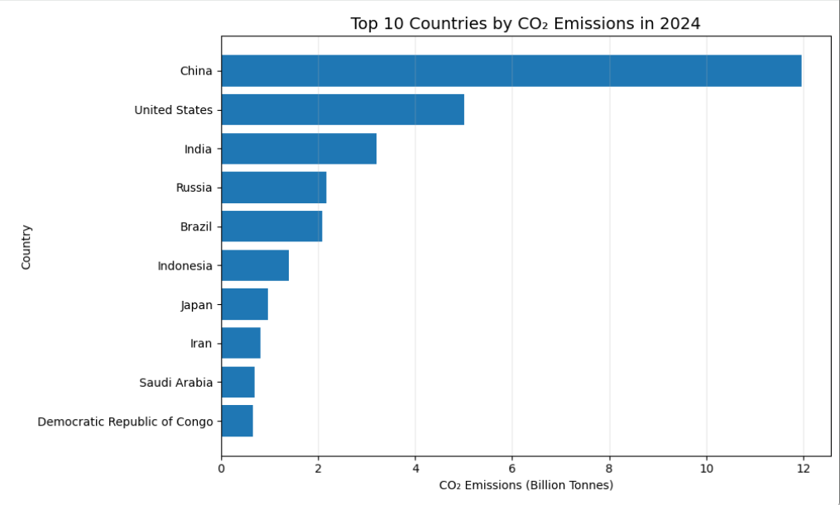
Figure 2. Top 10 countries ranked by annual CO₂ emissions including land-use change in 2024.
Why this chart was selected: A horizontal bar chart was selected because it is effective for ranking categories and keeps country names readable.
Observation: The chart shows substantial differences in total annual emissions. China has the highest value in the selected 2024 data, followed by the United States and India.
Storytelling contribution: This moves the story from the global trend to where total emissions are concentrated.

6.3 Visualization 3 – Top 10 Countries by CO₂ Emissions Per Capita in 2024
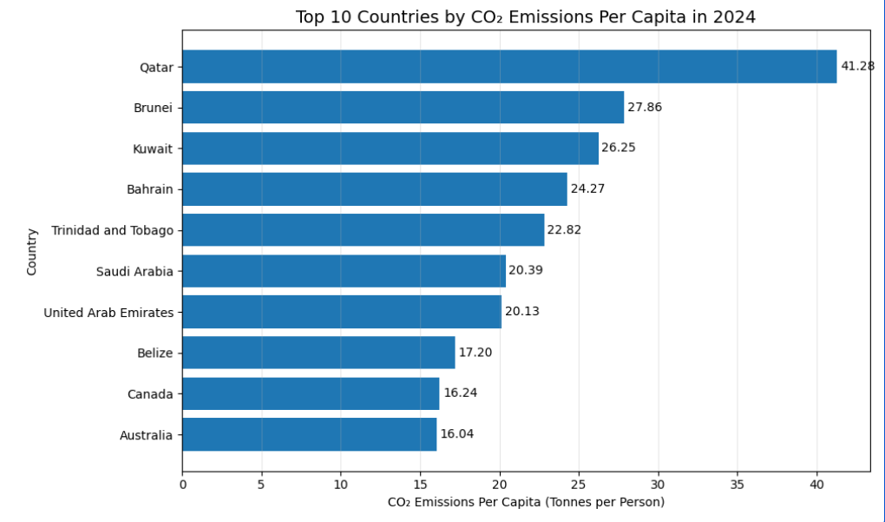
Figure 3. Top 10 countries ranked by annual CO₂ emissions including land-use change per person in 2024.
Why this chart was selected: A horizontal bar chart was selected to compare emissions per person and provide a population-adjusted perspective.
Observation: The ranking differs from total emissions: Qatar, Brunei, Kuwait and other countries appear prominently in the per-capita comparison.
Storytelling contribution: This demonstrates that total emissions and emissions per person can produce very different country-level patterns.

6.4 Visualization 4 – GDP Per Capita vs CO₂ Emissions Per Capita in 2024
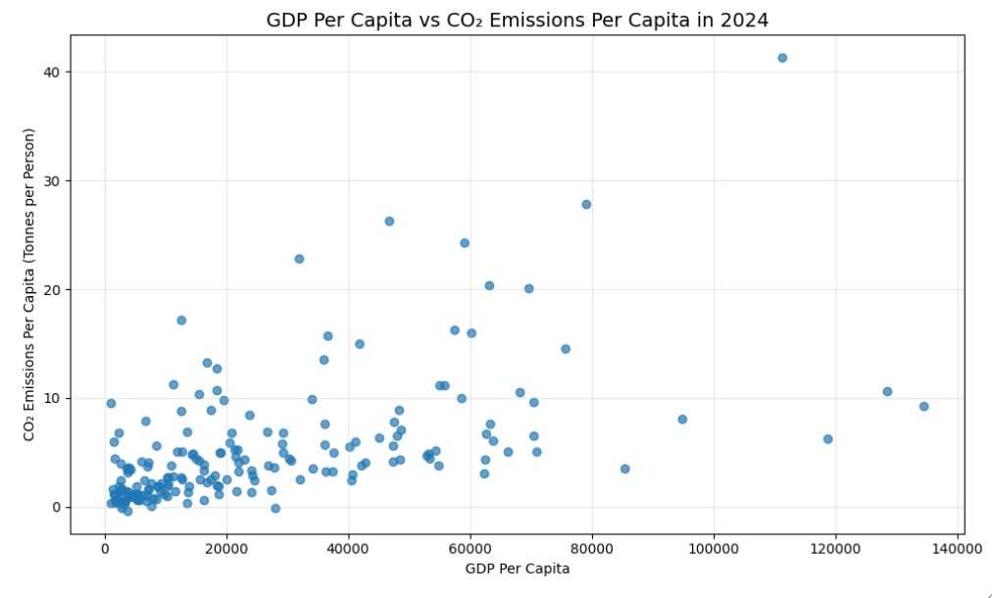
Figure 4. Relationship between GDP per capita and CO₂ emissions per capita across entities in 2024.
Why this chart was selected: A scatter plot was selected to explore a relationship between two numerical variables. Each point represents an entity.
Observation: The points are widely distributed. Some entities with high GDP per capita also have high per-capita emissions, while others have comparatively lower emissions.
Storytelling contribution: This introduces an economic dimension to the narrative. The chart is descriptive and does not establish causation.

6.5 Visualization 5 – CO₂ Emissions: 2000 vs 2024
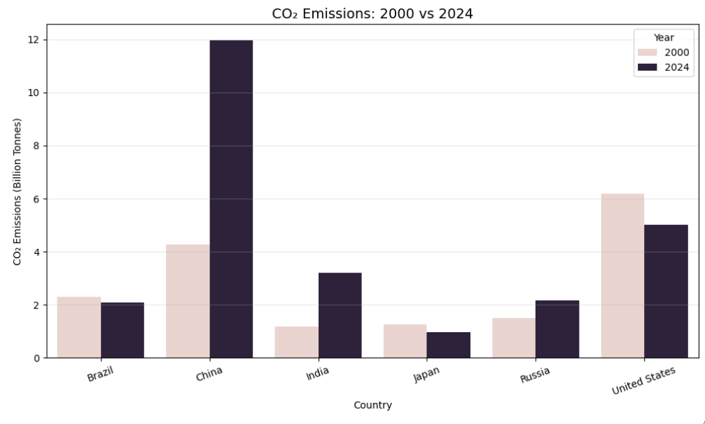
Figure 5. Comparison of annual CO₂ emissions including land-use change for selected major emitting countries in 2000 and 2024.
Why this chart was selected: A grouped bar chart was selected to compare the same countries across two years, making changes easy to identify.
Observation: China and India show substantial increases, while Russia also increases. Brazil, Japan and the United States show lower 2024 values than 2000 within this dataset.
Storytelling contribution: This connects the global trend with country-level changes and shows that countries follow different trajectories.

7. Key Insights
- Global CO₂ emissions show a strong long-term upward trend from 1850 to 2024, with shorter-term fluctuations.
- Total emissions are concentrated among a relatively small group of countries, with China, the United States and India prominent in the 2024 comparison.
- The per-capita ranking differs substantially from the total-emissions ranking, showing why population-adjusted measures are useful.
- GDP per capita and CO₂ emissions per capita vary across a wide range; the scatter plot does not show one uniform pattern for every entity.
- Country-level changes between 2000 and 2024 differ, with some selected countries increasing and others decreasing.
- Using several chart types creates a more complete narrative than relying on a single measure.

8. Business and Scientific Implications
From a scientific perspective, the visualizations provide an accessible starting point for examining long-term emission trends, country differences and population-adjusted patterns. They can support exploratory analysis before more detailed statistical or causal research.
From a business and planning perspective, the analysis demonstrates why total emissions alone may not provide a complete picture. Organizations working with energy, transportation, manufacturing, sustainability reporting or environmental analytics may need total and per-capita measures together. Economic indicators can also be used to explore differences in emissions patterns. These charts are descriptive and should not be interpreted as proof of causation.

9. Limitations
- The analysis is descriptive and does not establish causal relationships.
- The GDP comparison does not include every factor that can influence emissions, such as energy mix, industrial structure, technology and trade.
- The selected emissions indicator includes land-use change.
- Aggregate entities and individual countries are different types of observations, so aggregates were excluded where country-only comparisons were needed.
- The final 2000-versus-2024 comparison uses selected major countries rather than every country.
- The analysis should be updated when newer data releases become available.

10. Tools and Technologies
Tool / Library | Purpose
Python | Programming language for analysis
Pandas | Data loading, cleaning, filtering, transformation and merging
NumPy | Numerical support
Matplotlib | Line, bar and scatter visualizations
Seaborn | Grouped comparison visualization
Plotly | Interactive visualization capability
Google Colab | Cloud environment for the notebook
Our World in Data | Public data source

11. Conclusion
This project developed a five-visualization narrative about global CO₂ emissions using Python. The analysis began with the long-term global trend, then examined total emissions by country, emissions per person, the relationship with GDP per capita, and changes between 2000 and 2024.
The main lesson is that a single measure cannot fully describe global emissions. Total emissions, per-capita emissions, economic indicators and changes over time reveal different aspects of the same dataset. Combining different chart types with clear explanations turns a large dataset into a structured narrative that can be communicated to a non-technical audience.

12. Appendix – Main Python Workflow
# Import libraries
import pandas as pd
import numpy as np
import matplotlib.pyplot as plt
import seaborn as sns
import plotly.express as px
# Load CO₂ data
df = pd.read_csv(
url,
storage_options={"User-Agent": "Our World in Data data fetch/1.0"}
)
# Clean working copy
df_clean = df.copy()
df_clean["Code"] = df_clean["Code"].fillna("N/A")
# Global trend
world = df_clean[df_clean["Entity"] == "World"].copy()
# Load 2024 per-capita CO₂ data
df_per_capita = pd.read_csv(
per_capita_url,
storage_options={"User-Agent": "Our World in Data data fetch/1.0"}
)
per_capita_2024 = df_per_capita[df_per_capita["Year"] == 2024].copy()
# Load 2024 GDP-per-capita data
df_gdp = pd.read_csv(
gdp_url,
storage_options={"User-Agent": "Our World in Data data fetch/1.0"}
)
gdp_2024 = df_gdp[df_gdp["Year"] == 2024].copy()
# Merge GDP and CO₂ per-capita data
gdp_co2 = pd.merge(
gdp_selected,
co2_selected,
on=["Entity", "Code", "Year"],
how="inner"
)
# Visualizations:
# 1. Global CO₂ emissions over time
# 2. Top 10 countries by total CO₂ emissions
# 3. Top 10 countries by CO₂ emissions per capita
# 4. GDP per capita vs CO₂ emissions per capita
# 5. CO₂ emissions: 2000 vs 2024

Submission Description (200+ words)
This Week 2 project focuses on advanced data visualization and storytelling with Python. The project analyzes global CO₂ emissions using publicly accessible Our World in Data datasets and presents the results through five visualizations designed for a non-technical audience. The analysis begins with a line chart showing the long-term trend of global CO₂ emissions from 1850 to 2024. A horizontal bar chart compares the top 10 countries by total CO₂ emissions in 2024. The third visualization changes the perspective to emissions per person, showing why population-adjusted measures can reveal different patterns from total emissions. The fourth visualization uses a scatter plot to explore the relationship between GDP per capita and CO₂ emissions per capita in 2024. The fifth visualization compares emissions for selected major countries between 2000 and 2024. Pandas was used for data acquisition, cleaning, filtering and merging, while Matplotlib and Seaborn were used for visualization. Plotly was included in the analysis environment for interactive visualization capability. The dataset was checked for missing values, duplicate rows, data types, year coverage and geographic aggregates before visualization. Each figure includes a reason for the chosen chart type, an observation and an explanation of its contribution to the overall story. The narrative progresses from the global trend to country rankings, population-adjusted emissions, an economic relationship and country-level change over time. The project demonstrates how multiple visualization techniques can transform a large dataset into clear and connected insights while also emphasizing that descriptive charts do not by themselves establish causation.

