WEEK 1 – DATA SCIENCE WITH PYTHON
Data Acquisition, Cleaning and Exploratory Data Analysis (EDA)
Titanic Passenger Survival Dataset
Internship Task Report
Prepared using Python, Pandas, Matplotlib and Seaborn

1. Introduction
This report presents the work completed for Week 1 of the Data Science with Python internship task. The task focuses on acquiring a publicly available dataset, cleaning the data, performing exploratory data analysis (EDA), generating visualizations, and extracting meaningful observations from the data. The Titanic passenger dataset was selected because it contains numerical, categorical and missing-value information, making it suitable for demonstrating the complete basic data-analysis workflow.

2. Objective
- Acquire a publicly available dataset using Python.
- Inspect the structure, columns, data types and quality of the dataset.
- Identify and handle missing values and duplicate records.
- Perform summary statistical analysis.
- Create visualizations to understand important patterns.
- Identify relationships between passenger characteristics and survival.
- Document the methodology, cleaning decisions and EDA findings.

3. Dataset Acquisition
The Titanic dataset was obtained from a publicly available GitHub repository and loaded directly into Google Colab using Pandas. The dataset was accessed through the following raw public CSV resource:
https://raw.githubusercontent.com/datasciencedojo/datasets/master/titanic.csv
The dataset contains information about passengers on the Titanic, including passenger class, sex, age, ticket information, fare, family-related variables, embarkation point and survival status.

Dataset dimensions
Property | Value
Rows before cleaning | 891
Columns before cleaning | 12
Columns after cleaning | 11
Rows after cleaning | 891
Duplicate rows | 0

4. Dataset Variables
Column | Description | Data Type
PassengerId | Unique passenger identifier | int64
Survived | Survival status: 0 = did not survive, 1 = survived | int64
Pclass | Passenger class: 1, 2 or 3 | int64
Name | Passenger name | object
Sex | Passenger gender | object
Age | Passenger age | float64
SibSp | Number of siblings/spouses aboard | int64
Parch | Number of parents/children aboard | int64
Ticket | Ticket information | object
Fare | Passenger fare | float64
Cabin | Cabin information | object
Embarked | Port of embarkation | object

5. Data Cleaning
The dataset was inspected for missing values, duplicate records and data types. Cleaning decisions were made based on the amount of missing data and the nature of each variable.

5.1 Missing Value Analysis
Column | Missing Values | Missing % | Action
Age | 177 | 19.87% | Filled with median
Cabin | 687 | 77.10% | Column removed
Embarked | 2 | 0.22% | Filled with mode
Age had 177 missing values. Since Age is numerical and can be affected by extreme values, the median was used to fill the missing observations. Cabin had 687 missing values, representing approximately 77.10% of the records, so the column was removed rather than making a large number of assumptions. Embarked had only two missing values, so the mode was used to fill them.

5.2 Duplicate Records
The dataset contained 0 completely duplicated rows. Therefore, no records were removed for duplication.

5.3 Data Type Verification
The final data types were checked using Pandas. Numerical variables were stored as integers or floating-point values, while text and categorical variables were stored as object values. These data types were appropriate for the planned analysis, so no further data-type conversion was required.

5.4 Cleaning Code
import pandas as pd
url = "https://raw.githubusercontent.com/datasciencedojo/datasets/master/titanic.csv"
df = pd.read_csv(url)
df_clean = df.copy()
df_clean["Age"] = df_clean["Age"].fillna(df_clean["Age"].median())
df_clean = df_clean.drop("Cabin", axis=1)
df_clean["Embarked"] = df_clean["Embarked"].fillna(df_clean["Embarked"].mode()[0])

6. Summary Statistics
Descriptive statistics were generated using the Pandas describe() function. The most relevant numerical statistics are summarized below.
Variable | Mean | Minimum | Maximum
Age | 29.36 | 0.42 | 80
Fare | 32.20 | 0 | 512.33
SibSp | 0.52 | 0 | 8
Parch | 0.38 | 0 | 6
Survived | 0.3838 | 0 | 1
The cleaned dataset contains 891 passenger records. The average age was 29.36 years, and the average fare was 32.20. The mean value of Survived was 0.3838, indicating that approximately 38.38% of passengers in the dataset survived.

7. Exploratory Data Analysis (EDA)

7.1 Overall Passenger Survival
The first visualization compares the number of passengers who survived with those who did not survive. Approximately 38.38% survived, while approximately 61.62% did not survive.
Observation: The number of non-surviving passengers was considerably higher than the number of surviving passengers.

7.2 Survival by Passenger Class
Survival rates were calculated separately for each passenger class.
Passenger Class | Survival Rate
1st Class | 62.96%
2nd Class | 47.28%
3rd Class | 24.24%
Observation: The survival rate decreased from first class to third class. First-class passengers had a survival rate of 62.96%, compared with 47.28% for second class and 24.24% for third class.

7.3 Survival by Gender
Gender | Survival Rate
Female | 74.20%
Male | 18.89%
Observation: Female passengers had a survival rate of 74.20%, while male passengers had a survival rate of 18.89%. This represents a substantial difference in survival outcomes between the two groups in this dataset.

7.4 Age Distribution
The age histogram shows that passengers were concentrated mainly in the young and middle-aged groups. A large proportion of observations were between approximately 20 and 40 years, with fewer passengers at older ages. The dataset includes ages ranging from 0.42 to 80 years.

8. Key EDA Insights
- Overall survival was approximately 38.38%, while approximately 61.62% of passengers did not survive.
- Gender was strongly associated with survival in the dataset: the female survival rate was 74.20%, compared with 18.89% for males.
- Passenger class was associated with survival: survival rates were 62.96% in first class, 47.28% in second class and 24.24% in third class.
- Passenger ages were concentrated mainly around young and middle adulthood, with relatively fewer older passengers.
- The dataset contained substantial missingness in Cabin, while Age and Embarked had smaller amounts of missing data that could be handled through imputation.
These observations describe associations in the dataset. They do not by themselves establish causal relationships between the variables and survival.

9. Methodology and Rationale
The analysis followed a simple data-science workflow. First, the public dataset was loaded into Google Colab using Pandas. Next, the dataset dimensions, columns and data types were inspected. Missing values and duplicate records were then identified. Numerical missing values in Age were handled using the median because the median is less sensitive to extreme values. The Cabin column was removed because more than three-quarters of its values were missing. The two missing Embarked values were replaced with the mode because the variable is categorical and the number of missing records was very small. Duplicate checking showed no complete duplicate rows. Finally, descriptive statistics and visualizations were generated to explore survival, passenger class, gender and age.

10. Main Python Code Used for EDA
# Check shape and columns
df_clean.shape
df_clean.columns
# Missing values
df_clean.isnull().sum()
# Duplicate records
df_clean.duplicated().sum()
# Summary statistics
df_clean.describe()
# Survival distribution
df_clean["Survived"].value_counts()
# Survival percentage
df_clean["Survived"].value_counts(normalize=True) * 100
# Survival rate by gender
df_clean.groupby("Sex")["Survived"].mean() * 100
# Survival rate by passenger class
df_clean.groupby("Pclass")["Survived"].mean() * 100
# Visualizations
import matplotlib.pyplot as plt
import seaborn as sns
sns.countplot(data=df_clean, x="Survived")
sns.countplot(data=df_clean, x="Pclass", hue="Survived")
sns.countplot(data=df_clean, x="Sex", hue="Survived")
plt.hist(df_clean["Age"], bins=20, edgecolor="black")

11. Conclusion
This analysis successfully completed the basic data acquisition, cleaning and exploratory data analysis workflow using the Titanic passenger dataset. Missing values were handled using appropriate statistical methods, the highly incomplete Cabin column was removed, and no duplicate rows were found. Summary statistics and four visualizations were used to understand the data. The EDA identified clear differences in survival outcomes across gender and passenger class, while the age distribution showed that many passengers were young or middle-aged adults. The project demonstrates how Python and Pandas can be used to transform a raw dataset into a cleaned dataset and then extract useful descriptive insights through visualization and statistical analysis.

12. Visualization Evidence
The four visualizations generated in Google Colab should be inserted in this section before submission. Suggested captions are provided below.
- Figure 1. Passenger Survival Distribution
- Figure 2. Survival Distribution by Passenger Class
- Figure 3. Survival Distribution by Gender
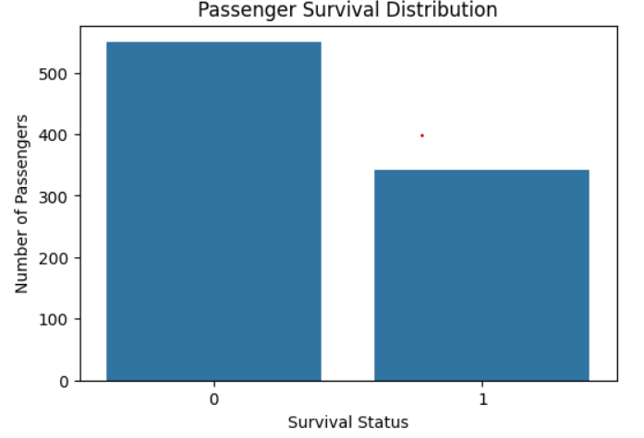
- Figure 4. Age Distribution of Passengers

Figure 1

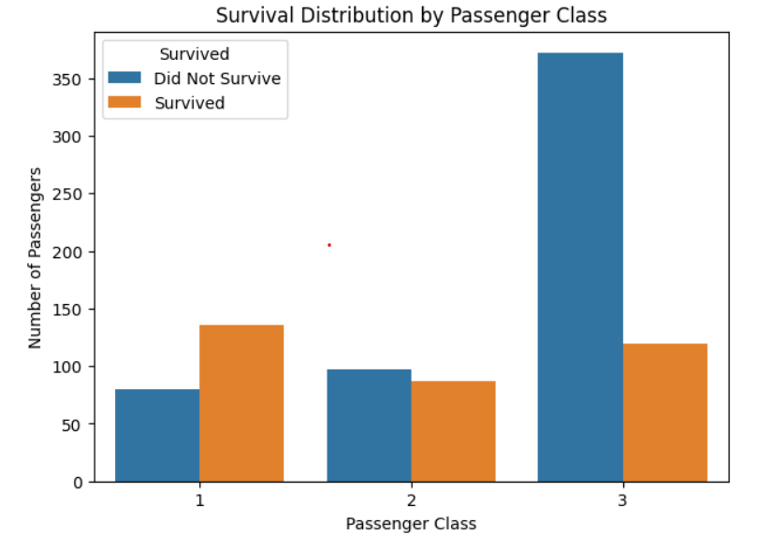

Figure 2
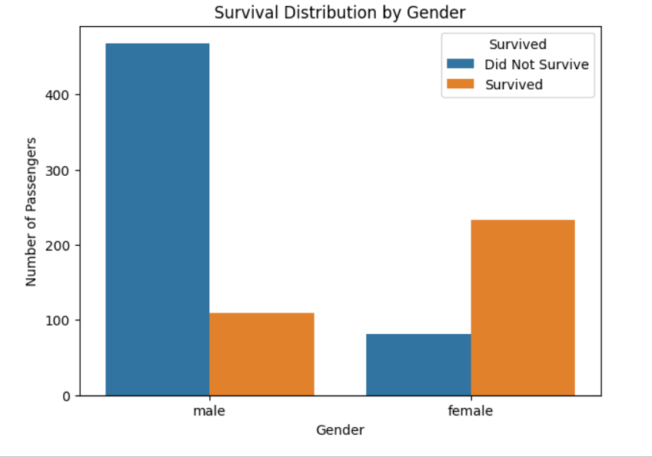
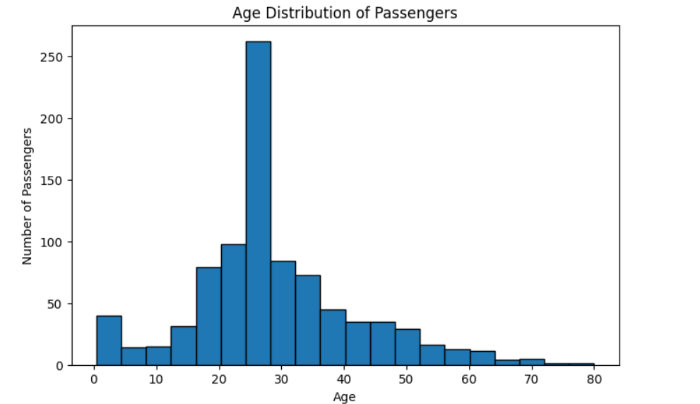
Figure 3
Figure 4

