WEEK 5
Comprehensive Data Science Project Report
Project Synthesis, Findings, and Strategic Recommendations

Executive Summary
This report synthesizes four stages of a Data Science with Python internship: Titanic passenger exploratory analysis, global CO₂ emissions visualization, statistical analysis of student performance, and a student pass/fail classification model. These activities used different datasets and answer different questions; they are integrated as a coherent account of the analytical workflow rather than treated as one combined dataset. Across the projects, data inspection and cleaning supported reliable analysis, visualizations made patterns easier to communicate, statistical tests quantified selected group differences, and machine learning demonstrated both predictive potential and the importance of class-specific evaluation.
Key findings include a 38.38% survival rate in the Titanic dataset, with notable differences by sex and passenger class; global CO₂ analysis showing that total and per-capita emissions tell different stories; statistically significant differences in student grades across gender and study-time groups in the observed sample; and a Logistic Regression model with 79.23% test accuracy but only 25% recall for students classified as failing. Recommendations emphasize using context-appropriate metrics, validating findings before operational decisions, communicating uncertainty, and prioritizing targeted follow-up analysis rather than treating observational associations as causal evidence.

1. Introduction and Project Objectives
The final project consolidates skills practiced throughout the internship: acquiring public data, inspecting and cleaning datasets, conducting exploratory data analysis, creating explanatory visualizations, applying statistical tests, training a basic machine learning model, and communicating findings to stakeholders. The objective is to show how each method contributes a different type of evidence and how results can be translated into cautious, actionable recommendations.
The report addresses four project strands:
- Titanic: explore passenger data quality and patterns associated with survival.
- CO₂ emissions: communicate global trends, country comparisons, per-capita differences, and an economic comparison.
- Student statistics: test selected differences in final grades and an association involving internet access and higher-education intention.
- Student classification: build and evaluate a binary Logistic Regression model for pass/fail outcomes.

2. Data Sources and Project Scope
Project | Data source and scope | Main methods
Week 1 – Titanic | Public Titanic passenger CSV; 891 rows, 12 original columns | Cleaning, descriptive statistics, grouped survival rates, charts
Week 2 – CO₂ | Our World in Data emissions, per-capita emissions, and GDP-per-capita indicators; main series spans 1850–2024 | Filtering, merging, trend and comparison visualizations
Week 3 – Student statistics | UCI Student Performance; 649 records; selected variables sex, studytime, internet, higher, G3 | Welch t-test, ANOVA, Tukey HSD, chi-square, effect size
Week 4 – Student model | Portuguese Student Performance file; 649 records, 33 original columns | Preprocessing pipeline, Logistic Regression, test-set metrics, confusion matrix, ROC-AUC
The datasets are not merged because they describe unrelated populations and outcomes. Instead, the synthesis compares the analytical process, evidence types, communication choices, and lessons learned across projects.

3. Methodology

3.1 Data acquisition and quality checks
Data was obtained from public sources and loaded in Python using Pandas. The workflow included checking dataframe dimensions, column names, data types, missing values, duplicate records, ranges, and category frequencies. Cleaning decisions were guided by variable type and missingness rather than applying one rule to every dataset.

3.2 Exploratory analysis and visualization
Descriptive summaries and charts were used to examine distributions and comparisons. Chart types were selected to match the question: line charts for time trends, bar charts for comparisons, histograms for distributions, boxplots for grouped grade distributions, and scatter plots for relationships between numeric indicators. Captions and annotations are important because charts communicate patterns but do not by themselves establish causation.

3.3 Statistical inference
The student analysis used α = 0.05. Welch’s t-test compared mean final grades by gender; one-way ANOVA tested differences among study-time groups, followed by Tukey HSD pairwise comparisons; and a chi-square test examined internet access versus higher-education intention. Confidence intervals and Cramér’s V added context beyond p-values.

3.4 Machine learning
For the Week 4 model, G3 was converted to a binary outcome: Pass for G3 ≥ 10 and Fail for G3 < 10. G1 and G2 were excluded from predictors to avoid using earlier grades as direct grade-related signals. The remaining 30 features included 17 categorical and 13 numerical variables. An 80:20 stratified split produced 519 training and 130 testing records. Numerical variables were imputed and standardized; categorical variables were imputed and one-hot encoded within a preprocessing pipeline. Logistic Regression was fitted on the training data.

4. Results and Key Findings

4.1 Titanic exploratory analysis
The cleaned Titanic dataset retained 891 passenger records. Age had 177 missing values (19.87%) and was imputed with the median; Cabin had 687 missing values (77.10%) and was removed; the two missing Embarked values were filled with the mode. No complete duplicate rows were found. The mean age was 29.36 years and mean fare was 32.20.
Overall survival was 38.38%. The reported survival rates were 74.20% for female passengers and 18.89% for male passengers. Rates by passenger class were 62.96% in first class, 47.28% in second class, and 24.24% in third class. These are descriptive associations in this dataset and do not isolate the effect of any one factor.
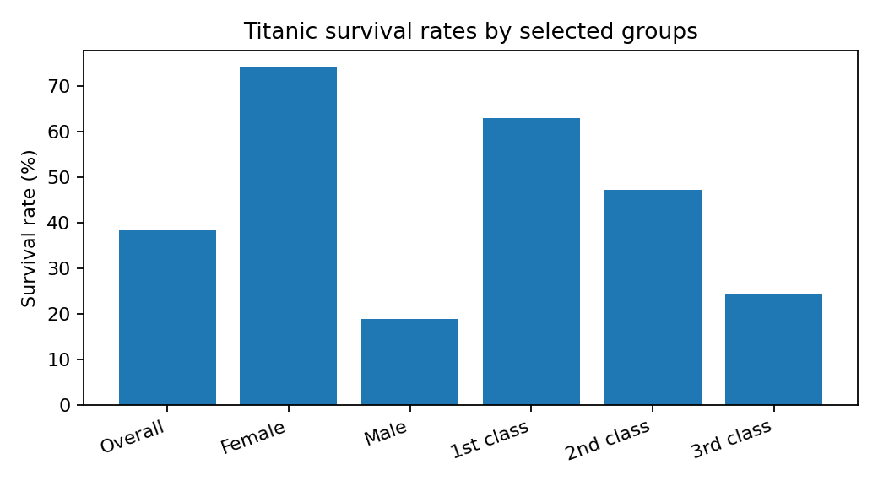
Figure 1. Overall and subgroup survival rates reported in the Week 1 analysis.

4.2 Global CO₂ emissions visualization
The Week 2 report developed a five-chart narrative: global annual emissions over time; the top 10 countries by total emissions in 2024; the top 10 by emissions per capita; GDP per capita versus CO₂ emissions per capita; and selected-country emissions in 2000 compared with 2024. The analysis found that total emissions are concentrated among a relatively small group of countries, with China, the United States, and India prominent in the total-emissions comparison. Per-capita rankings differ from total rankings, demonstrating that population-adjusted measures answer a different question. GDP and per-capita emissions varied across entities, without one uniform pattern. Country changes from 2000 to 2024 also differed.
Strategic interpretation: emissions reporting should present total and per-capita measures together. Total values help describe aggregate scale, while per-capita values provide population context. Economic comparisons can guide further investigation, but the scatter plot does not establish that income causes emissions differences.

4.3 Student statistical analysis
Female students had mean G3 = 12.25 (SD = 3.12), while male students had mean G3 = 11.41 (SD = 3.32). The female-minus-male mean difference was 0.85 points (95% CI: 0.34 to 1.36); Welch’s t = 3.275, p = 0.0011. This provides evidence of a difference in sample means, not a causal explanation.
Mean grades by weekly study-time group were 10.84 (<2 hours), 12.09 (2–5 hours), 13.23 (5–10 hours), and 13.06 (>10 hours). ANOVA returned F = 15.876, p = 5.71 × 10⁻¹⁰. Tukey HSD found significant differences for groups 1–2, 1–3, 1–4, and 2–3; comparisons 2–4 and 3–4 were not significant. The pattern is consistent with higher average grades in several higher study-time groups, but the observational design cannot show that study time caused the grade differences.
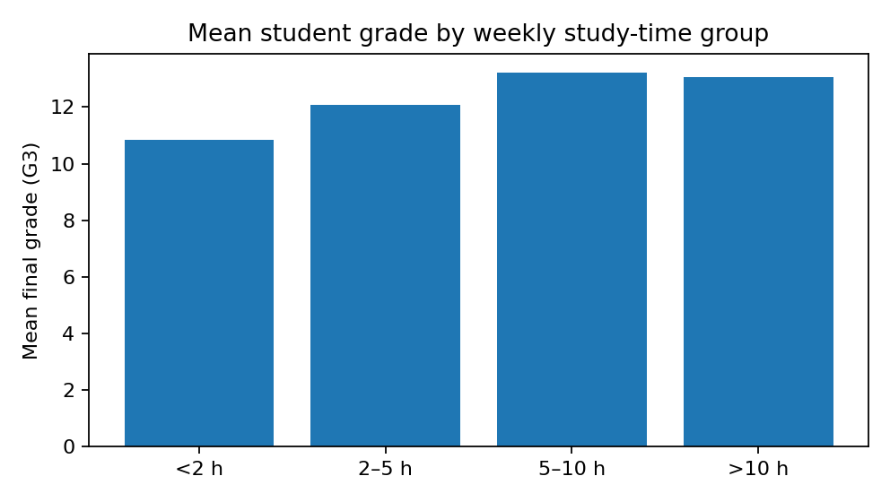
Figure 2. Mean G3 by reported weekly study-time category.
For internet access and higher-education intention, the chi-square test gave χ² = 2.694, df = 1, p = 0.1007, and Cramér’s V = 0.064. At α = 0.05, the analysis did not detect a statistically significant association. This result does not prove that no association exists; it indicates insufficient evidence in this analysis.

4.4 Student pass/fail classification
The target contained 549 passing students (84.59%) and 100 failing students (15.41%). On the 130-record test set, the model achieved 79.23% accuracy and ROC-AUC 0.6227. Pass precision, recall, and F1 were 0.87, 0.89, and 0.88. Fail precision, recall, and F1 were 0.29, 0.25, and 0.27.
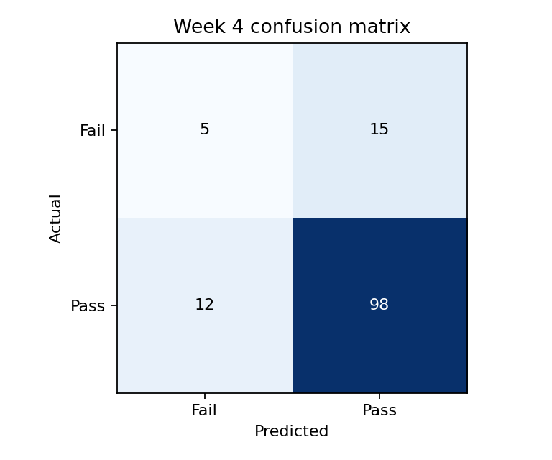
Figure 3. Week 4 confusion matrix: rows are actual classes and columns are predicted classes.
The model correctly identified 5 of 20 failing students and missed 15; it correctly identified 98 of 110 passing students and classified 12 as fail. Thus, overall accuracy hides weak detection of the minority Fail class. The ROC-AUC indicates limited discrimination. The model should be treated as an educational exercise, not a validated student-risk tool.

5. Cross-Project Synthesis
- Data quality decisions affect every later step. Week 1 illustrated how missingness can influence the usable variables; later projects reinforced the need to inspect ranges, categories, and merges.
- Visualization is most useful when the measure matches the question. CO₂ totals and per-capita values produced different country comparisons; grouped survival and grade charts revealed patterns that overall averages would hide.
- Statistical significance and practical meaning are different. The student tests found group differences, but effect sizes, confidence intervals, group sizes, and the observational design are needed for interpretation.
- Predictive accuracy is not enough for imbalanced classification. Week 4 showed that a model can have near-80% accuracy while missing three-quarters of failing students.
- Communication should include uncertainty. Descriptive associations, hypothesis tests, and model predictions provide different kinds of evidence and should not be presented as interchangeable.

6. Strategic Recommendations
For data and analytics teams: Use a documented, repeatable workflow for data loading, cleaning, validation, analysis, and reporting. Record assumptions and cleaning decisions so results can be reproduced.
For sustainability and emissions reporting: Report total emissions alongside per-capita measures and time trends. Use economic comparisons as exploratory context, and examine energy mix, industrial structure, trade, and technology before drawing policy or investment conclusions.
For educational research and support planning: Use the observed study-time and grade patterns to motivate further investigation of learning supports. Do not infer that changing study hours alone will cause grade improvement; test interventions with appropriate study designs.
For responsible use of student prediction models: Do not deploy the current classifier to make consequential decisions. Its 25% recall for the Fail class means many failing students were missed. If a risk-screening tool is explored, evaluate class weighting, thresholds, calibration, subgroup performance, and false-negative costs with validation data and human oversight.
For decision-makers: Pair every headline metric with context: population, time period, sample size, uncertainty, and limitations. Use findings to prioritize questions and follow-up analysis rather than treating them as definitive causal conclusions.

7. Potential Business Impact and Research Outcomes
The projects demonstrate how data science can support different stakeholder needs. In sustainability, clear emissions dashboards can help organizations monitor trends and identify where deeper analysis is warranted. In education, descriptive and inferential analysis can help researchers formulate questions about student experiences and learning conditions. A carefully validated predictive model might eventually support early outreach, but only if it performs reliably across groups and is used with safeguards. The immediate outcome of this internship work is a documented analytical workflow and a set of evidence-based observations, not a proven operational intervention or causal model.

8. Limitations and Future Improvements
- The projects use different datasets, periods, definitions, and populations; their results cannot be pooled into one statistical estimate.
- The Titanic and student analyses are observational and do not establish causality. The Titanic data is a historical passenger sample and should not be generalized to modern travel settings.
- The CO₂ analysis is descriptive; GDP per capita alone omits important structural and policy factors. The 2000–2024 comparison uses selected countries, and results depend on indicator definitions and data releases.
- The student study-time groups are unequal in size; the group reporting more than 10 hours contains only 35 records. Outliers and zero grades may affect parametric-test assumptions.
- The Week 4 test set contains only 20 failing cases, so class-specific estimates are uncertain. Overfitting and underfitting were not formally assessed with training metrics or cross-validation.
- Future work should add reproducible data-version documentation, sensitivity checks, confidence intervals where appropriate, stratified cross-validation, threshold analysis, model comparisons, and subgroup fairness checks before any consequential use.

9. Conclusion
Across five weeks of work, the project progressed from data acquisition and cleaning to visualization, statistical inference, machine learning, and stakeholder-oriented reporting. The Titanic analysis showed substantial survival-rate differences across passenger groups; the CO₂ project demonstrated why multiple measures are needed to tell a balanced environmental story; the student statistical tests identified differences in grade means across selected groups while finding no statistically significant internet-access association with higher-education intention; and the pass/fail classifier illustrated the limitations of accuracy under class imbalance. The central lesson is that sound data science requires more than producing charts or fitting a model: it requires appropriate methods, transparent assumptions, careful interpretation, and recommendations proportionate to the strength of the evidence.

