WEEK 3

Statistical Analysis
of Student Performance
Hypothesis Testing, Group Comparisons, and Data Visualization

Data Science with Python Internship
Dataset: UCI Student Performance

Executive Summary
This report analyzes student final grades (G3) in relation to gender and weekly study time, and examines whether home internet access is associated with students’ intention to pursue higher education. The analysis uses descriptive statistics, a Welch independent-samples t-test, one-way ANOVA with Tukey HSD post-hoc comparisons, and a chi-square test of independence.
Question | Statistical result | Interpretation
Gender and final grade | Welch t = 3.275; p = 0.0011 | Evidence of a difference in mean G3 between the two gender groups in this sample.
Study time and final grade | ANOVA F = 15.876; p < 0.001 | At least one study-time group mean differs; Tukey comparisons identify which pairs differ.
Internet access and higher-education intention | χ² = 2.694; p = 0.1007; V = 0.064 | No statistically significant association detected at α = 0.05.

1. Introduction and Objectives
The objective of this week’s work is to apply statistical methods to a real student-performance dataset and communicate the findings using both numerical summaries and visualizations. The analysis focuses on relationships between selected student characteristics and outcomes. The results describe associations in the observed data and should not be interpreted as proof of causation.

2. Dataset and Preparation
The UCI Student Performance dataset was accessed using the ucimlrepo Python package. The working dataframe contained 649 student records and 33 columns after combining the selected feature and target data. Variables used here were sex, studytime, internet, higher, and G3 (final grade). The G3 scale in this dataset ranges from 0 to 20.
Measure | Summary
Number of records | 649
Gender counts | Female: 383; Male: 266
Study-time group counts | Group 1: 212; Group 2: 305; Group 3: 97; Group 4: 35
Internet access | Yes: 498; No: 151
Higher-education intention | Yes: 580; No: 69
G3 overall | Mean: 11.91; SD: 3.23; median: 12; range: 0–19

3. Methods
- Descriptive statistics summarized the distribution of G3 and the sample sizes for each category.
- Welch’s independent-samples t-test compared mean G3 by gender without assuming equal variances. A 95% confidence interval was calculated for the female-minus-male mean difference.
- One-way ANOVA tested whether mean G3 differed across the four study-time groups. Tukey HSD was used for pairwise follow-up comparisons.
- A chi-square test of independence examined the relationship between home internet access and higher-education intention. Cramér’s V was reported as an effect-size measure.
- The significance threshold was α = 0.05.

4. Results and Visualizations

4.1 Final Grade by Gender
Female students had a sample mean G3 of 12.25 (SD = 3.12), while male students had a mean of 11.41 (SD = 3.32). The estimated female-minus-male difference was 0.85 grade points, with a 95% confidence interval from 0.34 to 1.36. Welch’s t-test returned t = 3.275 and p = 0.0011. At the 0.05 level, the null hypothesis of equal group means is rejected for this sample.
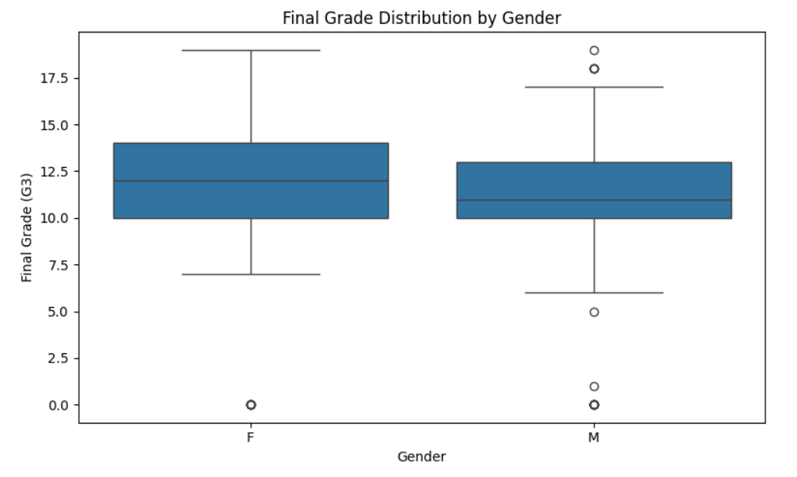
Figure 1. Boxplot of final grade (G3) by gender.
The boxplot shows a slightly higher median for the female group. The distributions overlap substantially, and both groups contain low-grade outliers. The figure provides a visual comparison; the t-test supplies the formal test of the difference in means.

4.2 Final Grade by Weekly Study Time
Mean G3 generally increased from the lowest study-time category to the middle categories. The group means were 10.84 (less than 2 hours), 12.09 (2–5 hours), 13.23 (5–10 hours), and 13.06 (more than 10 hours). The one-way ANOVA was statistically significant, F = 15.876, p = 5.71 × 10⁻¹⁰.
Study-time category | n | Mean G3 | SD
< 2 hours | 212 | 10.84 | 3.22
2–5 hours | 305 | 12.09 | 3.24
5–10 hours | 97 | 13.23 | 2.50
> 10 hours | 35 | 13.06 | 3.04

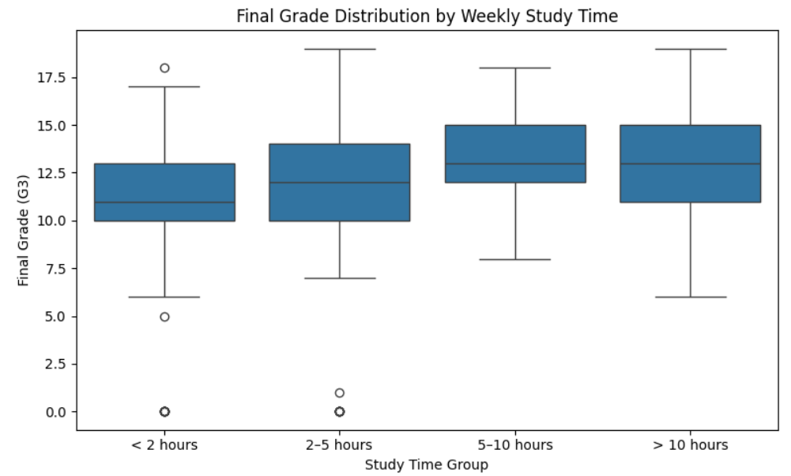
Figure 2. Boxplot of final grade by weekly study-time category.
Tukey HSD found significant differences for groups 1 vs. 2 (adjusted p = 0.0001), 1 vs. 3 (p < 0.0001), 1 vs. 4 (p = 0.0007), and 2 vs. 3 (p = 0.0103). The comparisons 2 vs. 4 (p = 0.3084) and 3 vs. 4 (p = 0.9927) were not statistically significant. The pattern is consistent with higher average grades among students reporting more study time up to the 5–10 hour group, but the observational analysis cannot establish that study time caused the differences.

4.3 Internet Access and Higher-Education Intention
The chi-square test returned χ² = 2.694 with 1 degree of freedom and p = 0.1007. Because p exceeds 0.05, the analysis does not reject the null hypothesis of independence. Cramér’s V was 0.064, indicating a small association in magnitude in this sample.
Home internet access | Higher: No | Higher: Yes | Total
No | 22 | 129 | 151
Yes | 47 | 451 | 498
Total | 69 | 580 | 649

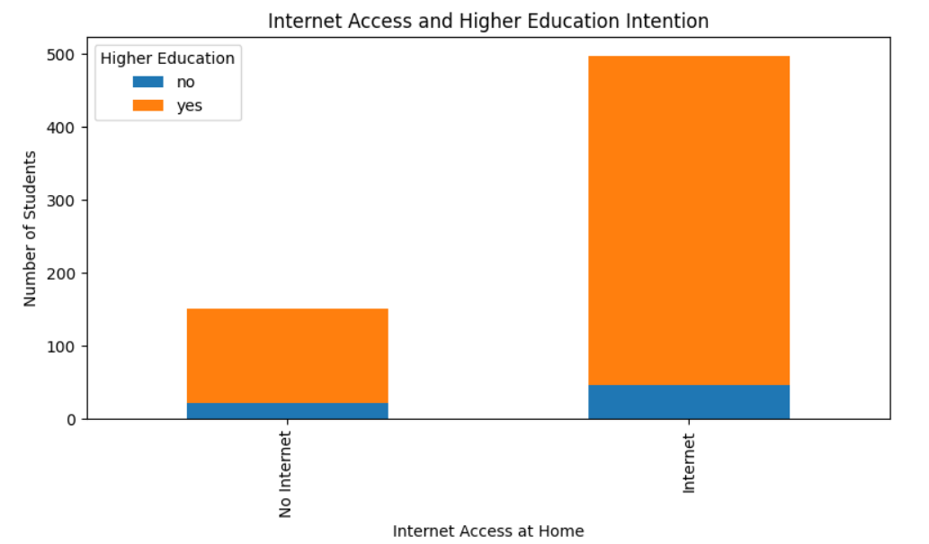
Figure 3. Stacked bar chart of higher-education intention by home internet access.
The chart shows that students with and without home internet access mostly reported an intention to pursue higher education. The internet-access group is much larger, so raw bar heights should be read with group sizes in mind. The chi-square test evaluates the association rather than the difference in totals.

5. Consolidated Hypothesis-Test Results
Analysis | Test statistic | p-value | Decision at α = 0.05
Gender vs. G3 | Welch t = 3.275 | 0.0011 | Reject equal-means null
Study time vs. G3 | ANOVA F = 15.876 | 5.71 × 10⁻¹⁰ | Reject equal-means null
Internet vs. higher intention | χ² = 2.694 | 0.1007 | Do not reject independence null

6. Limitations
- The dataset is observational; results show associations and do not establish causal effects.
- The study-time categories have unequal sample sizes, and the group reporting more than 10 hours contains only 35 students.
- Outliers and the concentration of some grades at zero may affect summaries and assumptions of parametric tests.
- The analysis is limited to the selected variables and records in this dataset; findings may not generalize to all students or educational settings.
- A non-significant result does not prove that no association exists; it means the analysis did not detect sufficient evidence at the chosen threshold.

7. Conclusion
In this sample, mean final grades differed by gender, and final grades also differed across weekly study-time categories. Pairwise comparisons showed that the lower study-time groups tended to have lower means than several higher study-time groups, while the two highest categories were not significantly different from each other. The analysis did not find statistically significant evidence of an association between home internet access and intention to pursue higher education. Together, the statistical tests and visualizations demonstrate how descriptive and inferential methods can be used to investigate student data while keeping interpretations appropriately cautious.

8. Tools and Resources
Python; pandas; NumPy; SciPy; statsmodels; Matplotlib; Seaborn; ucimlrepo; Jupyter/Google Colab.
Dataset: Cortez, P. & Silva, A. (2008). Student Performance. UCI Machine Learning Repository. https://doi.org/10.24432/C5TG7T
Internship work summary: During Week 3, statistical analysis was performed on student-performance data. The work included data preparation, descriptive summaries, hypothesis formulation, t-testing, ANOVA, post-hoc testing, chi-square analysis, effect-size interpretation, and visualization. Results were documented with attention to statistical significance, uncertainty, and the limitations of observational data.

