WEEK 4 TASK
Machine Learning Model Development and Evaluation
Student Performance Classification using Python and Scikit-learn

1. Introduction and Objective
The objective of this task was to develop and evaluate a basic machine learning model in Python. Using student information, the project predicts whether a student passes or fails based on the final-grade threshold. The workflow covers dataset preparation, feature preprocessing, model selection, training, evaluation, visualization, and critical discussion of the results.

2. Dataset Description
The project uses the Portuguese-language version of the UCI Student Performance dataset. It contains 649 student records and 33 original columns. The target was derived from the final grade (G3): a grade of 10 or higher is labeled Pass (1), while a grade below 10 is labeled Fail (0).
Dataset detail | Value
Records | 649
Original columns | 33
Passing students | 549 (84.59%)
Failing students | 100 (15.41%)
Target | Binary pass/fail

3. Data Preparation and Preprocessing
The data was loaded from the semicolon-separated student-por.csv file. The binary target was created from G3. The columns G1 and G2 were excluded from the predictors to avoid using earlier grades as direct grade-related signals for predicting the final outcome. G3 and the derived target column were also excluded from the input features.
The remaining 30 predictors consisted of 17 categorical and 13 numerical features. The data was divided into training and testing subsets using an 80:20 split, with random_state=42 and stratify=y. This produced 519 training records and 130 test records. A preprocessing pipeline applied median imputation and standardization to numerical columns, and most-frequent imputation and one-hot encoding to categorical columns. Fitting the preprocessing steps within the pipeline helps prevent information from the test set influencing preprocessing.

4. Model Selection and Training
Logistic Regression was selected because it is a common, relatively simple and interpretable baseline for binary classification. It estimates the probability of the positive class and supports probability-based evaluation such as an ROC curve. The classifier was configured with max_iter=1000 and random_state=42, then fitted on the training data using the preprocessing pipeline.
Core model pipeline (abridged):
model = Pipeline(steps=[
("preprocessor", preprocessor),
("classifier", LogisticRegression(max_iter=1000, random_state=42))
])
model.fit(X_train, y_train)
y_pred = model.predict(X_test)
y_prob = model.predict_proba(X_test)[:, 1]

5. Evaluation Metrics and Results
The model was evaluated on the held-out test set using accuracy, precision, recall, F1-score, ROC-AUC, the classification report, and a confusion matrix. Because the classes are imbalanced, class-specific results are important alongside overall accuracy.
Metric | Fail (class 0) | Pass (class 1)
Precision | 0.29 | 0.87
Recall | 0.25 | 0.89
F1-score | 0.27 | 0.88
Support | 20 | 110
Overall accuracy: 0.7923 (79.23%). ROC-AUC: 0.6227.

6. Visualizations

6.1 Confusion Matrix
The confusion matrix shows 5 failing students correctly classified as Fail and 15 failing students incorrectly classified as Pass. It also shows 12 passing students predicted as Fail and 98 passing students correctly classified as Pass. Thus, 103 of 130 test predictions were correct.
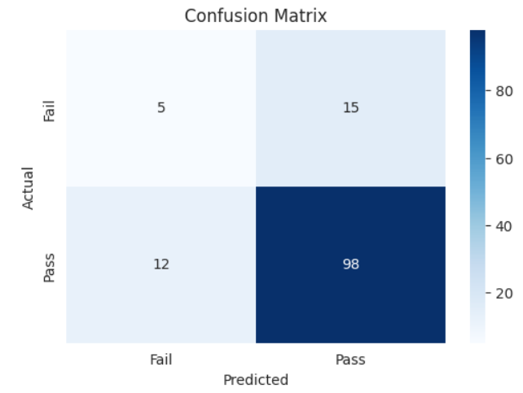

6.2 ROC Curve
The ROC curve plots the true-positive rate against the false-positive rate at different probability thresholds. The measured ROC-AUC is 0.6227. This suggests limited discrimination between the two classes; it is above the 0.5 reference for random ranking but is not evidence of strong separation.
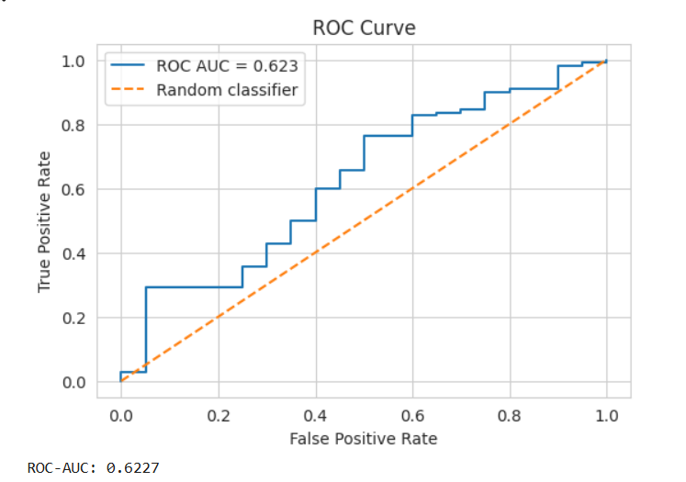

7. Error Analysis and Critical Discussion
The main weakness is the model's low recall for the Fail class: it identified 5 of the 20 students who actually failed and missed 15. The model therefore fails to flag many students who may need support. The test set also contains substantially more passing than failing students (110 versus 20), reflecting the class imbalance in the full dataset. As a result, accuracy of 79.23% alone gives an incomplete picture of performance.
Potential sources of error include overlap in the patterns of student characteristics across the two outcome classes, the limited number of failing examples in the test set, the use of a single train-test split, and the information captured by the available features. The model's performance should not be interpreted as proof that the selected features cause academic success or failure.

8. Overfitting, Underfitting, and Improvements
Overfitting and underfitting were not formally assessed because training-set metrics or cross-validation results were not included in this evaluation. A train-versus-test comparison and cross-validation would help determine whether the model generalizes consistently. The current results alone do not establish that either condition is occurring.
Possible improvements include using class_weight='balanced' and comparing the resulting class-specific metrics; tuning the decision threshold based on the cost of missed failing students; evaluating alternative classifiers such as decision trees; and using stratified cross-validation. Any changes should be assessed on validation data, with the test set reserved for final evaluation. Additional metrics such as balanced accuracy and precision-recall curves may also be useful for the imbalanced target.

9. Conclusion
This project implemented a complete basic classification workflow using Python and Scikit-learn. Logistic Regression achieved 79.23% test accuracy, but the ROC-AUC of 0.6227 and Fail-class recall of 25% show that its ability to distinguish and identify failing students is limited. The results demonstrate why evaluation must consider class-specific errors and class imbalance rather than relying on accuracy alone. Future work should compare model and threshold alternatives, use cross-validation, and assess whether performance improves for the minority Fail class.

