Update contributing.md
# Contributing guidelines

To start contributing to [Whatsapp-Play](https://github.com/rpotter12/whatsapp-play) project, please first discuss the change you wish to make via creating a issue
in the issue section or any other method with the owners of this repository before making a change.<br />
We have a code of conduct, please follow it in all your interactions with the project.<br />

## Steps for creating your first pull request

1.Ensure any install or build dependencies are checked and verified before the end when releasing a build.<br />
2.Update the README.md with details of changes including environment variables, various file parameters and container details **if needed**.<br />
3.Try adding screenshots in your pull request of the changes you made.
4.You may be able to merge the pull request in once you have the sign-off of two other developers, or if you do not have permission to do that, you may request the maintainer or reviewer to merge it for you.
##how to clone a repository
1.on main page of the repository that you want to be downloaded.
2.under the repository name, click Clone or Download.
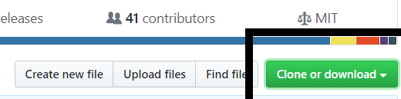
3.to clone the repository, click Download Zip
4.if you want to clone using SSH key then, click “Use SSH” then click on the copy link symbol which is side of the link
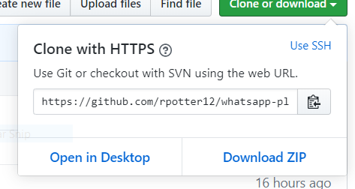
5.open git bash
6.type “git clone” and then paste then paste the url copied in before step
$git clone <URL copied>
7.press “enter”. Your local cone will be created.

##adding reference to the original repository
1.create a new repo on github
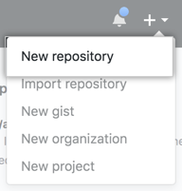
2.open github and change the current wirking directory to your local project
3.initialize the local directory as a git repository
$git init
4. add files
$git add <file name>
5.commit the changes in your local repository
$git commit -m “my first commit”
6.at top of your github repo quick setup page, copy the remote repository url
7.$git remote add origin <url of remote repository>
8.next push the changes in your local repository on github

##updating local copy of repository
$git pull origin master
if your default branch is not master then
$git pull origin <default_branch_name>

##creating a new branch
1.open the repo in which you want to create a new branch
2.now click on branch
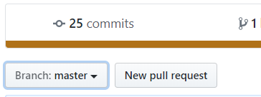
3.enter the name of the which you want to create
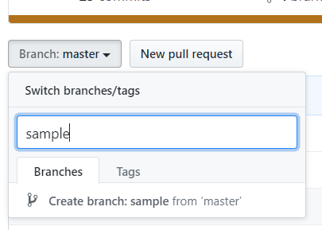
4.click on create “branch:sample from master”
5.new branch is created.
##pushing commits
1.open git bash terminal
2.git push <REMOTE NAME> <BRANCH NAME>
3.to rename the branch we use the same git push command
git push <REMOTE NAME> <LOCALBRANCH NAME>:<REMOTEBRANCH NAME>
this command helps to push the LOCALBRACNAME to your REMOTENAME but it is renamed to REMOTEBRANCHNAME

