PROJECT REPORT
ON

SMARTCITY INTELLIGENT TRAFFIC CONTROL SYSTEM

Submitted in partial fulfillment of the requirements for
the award of the degree of
Bachelor of Engineering / Master of Computer Applications

Submitted by

Department of
Academic Year: 2025 – 2026

1. Abstract
The rapid increase in urban vehicle density has created unprecedented challenges in traffic management, leading to congestion, increased accident rates, fuel wastage, and environmental pollution. Traditional traffic control systems rely on fixed-time signal switching, which fails to adapt to real-time road conditions. This inadequacy demands the development of an intelligent, data-driven traffic control system capable of dynamically responding to live traffic patterns.
The SmartCity Intelligent Traffic Control System addresses this challenge by integrating state-of-the-art computer vision technologies with real-time web-based visualization and control. The system employs YOLOv8 (You Only Look Once, version 8), a deep learning-based object detection model, combined with the VisDrone dataset-trained weights to detect and classify various vehicle types — including cars, motorcycles, trucks, buses, and pedestrians — in live or recorded video feeds.
Upon detection, vehicles are tracked across frames using ByteTrack, a robust multi-object tracking algorithm. A perspective view transformer converts the camera's 2D projection into a top-down real-world coordinate system, allowing accurate speed estimation in km/h. A configurable speed limit threshold enables automatic flagging and alerting of over-speeding vehicles in real time.
The system is built on a Flask-based web server with a responsive, dark-themed dashboard offering live MJPEG video streaming, vehicle data tables, overspeed alert logs, and per-class breakdown charts. A separate OpenStreetMap-based traffic simulation module allows placement of 4-way, T-junction, or roundabout intersections at any real-world geographic coordinate, with signal phase control, emergency override for ambulance/priority vehicles, and road rotation alignment.
Authentication is enforced through a secure login and signup system using SHA-256 hashed passwords stored in a JSON user store. The complete application runs on a standard Python environment, making deployment straightforward on any machine with a compatible GPU or CPU. Experimental results demonstrate that the YOLOv8 model achieves high detection accuracy at near-real-time inference speeds, validating the system's suitability for practical smart city deployment.
This report documents the complete design, implementation, and evaluation of the SmartCity system, covering objectives, methodology, system architecture, module descriptions, algorithms, and future enhancement possibilities. The project demonstrates a practical convergence of deep learning, web technologies, and geographic information systems in solving a critical urban infrastructure problem.
Keywords: YOLOv8, Traffic Detection, ByteTrack, Speed Estimation, Flask, OpenStreetMap, Smart City, Signal Control, Emergency Override, Vehicle Classification.

2. Introduction
Urban traffic management is one of the most critical components of modern smart city infrastructure. With the exponential growth in the number of privately owned vehicles, two-wheelers, and commercial transport in tier-1 and tier-2 cities, existing traffic management mechanisms have become inadequate. Fixed-duration signal cycles fail to account for asymmetric traffic flow, resulting in long vehicle queues at one direction while the opposing lane is empty. The absence of real-time monitoring means traffic violations, over-speeding, and congestion go undetected until accidents occur.
Intelligent Transportation Systems (ITS) have emerged as a promising solution to these problems. By combining embedded hardware, computer vision, and cloud-based analytics, ITS enables dynamic signal adaptation, automated violation detection, and informed infrastructure planning. However, large-scale ITS deployments are expensive and require proprietary hardware. The SmartCity project proposes a cost-effective, software-only alternative that can be deployed on any standard machine with a camera feed.
The project uses YOLOv8, which stands for You Only Look Once version 8, a single-stage real-time object detection neural network developed by Ultralytics. YOLOv8 provides significant improvements in detection speed and accuracy over its predecessors, supporting multiple tasks including detection, segmentation, and classification. When trained on the VisDrone dataset — a large-scale dataset of aerial footage containing dense vehicle scenes — it achieves high precision in identifying vehicles in traffic scenarios.
Vehicle tracking is achieved through ByteTrack, which maintains consistent track IDs across frames using a byte-level matching strategy that handles both high-confidence and low-confidence detections. This ensures that vehicles are not lost during partial occlusions or brief frame exits. Speed estimation is computed by mapping 2D pixel trajectories to real-world coordinates using a perspective transformation matrix derived from known source and target point correspondences.
The web interface, built with Flask and vanilla JavaScript, provides a full-featured control dashboard. Operators can upload video feeds, set speed limits, view live detection data, and manage overspeed alerts without requiring technical expertise. The simulation module, built with Leaflet.js and the OpenStreetMap tile server, enables visualization of traffic signal behavior at any real road intersection worldwide. Signal timings are adjustable per direction, and an emergency override feature allows instant green signal allocation for ambulances or priority vehicles.
This report is organized as follows: Section 3 states the objectives. Section 4 provides a system overview. Section 5 surveys related literature. Section 6 compares existing and proposed systems. Sections 7 through 12 describe the methodology, configuration, implementation, modules, architecture, and flow. Sections 13 through 16 cover algorithms, future work, conclusions, and references.
The SmartCity system represents a significant step toward making intelligent traffic management accessible and deployable at the community level, requiring only a standard server, a network-connected camera, and a web browser to operate.

3. Objectives
The primary objective of the SmartCity Intelligent Traffic Control System is to design and implement a comprehensive, real-time, web-based platform that automates the detection, classification, tracking, and speed monitoring of vehicles using deep learning techniques, while also providing an interactive simulation environment for traffic signal management.
The first specific objective is to integrate the YOLOv8 deep learning model — trained on the VisDrone aerial dataset — with the Flask web framework to enable real-time vehicle detection and classification from video feeds uploaded through the browser interface. Detection categories include cars, motorcycles, vans, trucks, buses, and pedestrians.
The second objective is to implement ByteTrack multi-object tracking to assign persistent IDs to detected vehicles across video frames. This enables trajectory analysis, residence time computation, and accurate counting of vehicles crossing a predefined line zone in both the inward and outward directions.
The third objective is to develop a speed estimation module using perspective transformation that maps 2D camera-space coordinates to real-world metric space. This allows the computation of vehicle speed in km/h, enabling automated detection and logging of vehicles that exceed a user-defined speed limit.
The fourth objective is to build a secure user authentication system with login, signup, and session management capabilities. Passwords are stored as SHA-256 hashes, and all analytical routes are protected by a login-required decorator, ensuring that only authorized users can access the traffic data.
The fifth objective is to develop an OpenStreetMap-based traffic simulation module that allows operators to place intersection overlays at any real-world coordinate, configure signal phases and durations for each direction, simulate vehicle arrival and departure, and trigger emergency signal overrides for priority vehicle passage.
The sixth objective is to provide road rotation alignment controls so that the simulated intersection overlay aligns accurately with the real road geometry visible on the map, regardless of the road's bearing angle. The seventh objective is to ensure that the entire system is deployable on a standard Python environment without specialized hardware, making it accessible to municipalities, research institutions, and urban planners.
The final overarching objective is to deliver a production-grade, maintainable codebase with a modular architecture — separating detection, tracking, speed estimation, authentication, dashboard, and simulation concerns — so that any individual component can be upgraded or replaced independently as technology evolves.

4. System Overview
The SmartCity Intelligent Traffic Control System is a full-stack web application that operates in two primary modes: live YOLO-powered video analysis and interactive map-based traffic simulation. The system is structured around a central Flask server that handles routing, session management, video streaming, and data APIs, with all user interaction occurring through a browser-based interface styled with a dark, professional dashboard aesthetic.
When a user accesses the application, they are greeted by a landing page that provides a product overview and links to the login and signup pages. After authentication, users are directed to the main dashboard, which is divided into two primary areas. The left-dominant area contains a live MJPEG video feed panel where uploaded traffic videos are analyzed frame-by-frame using the YOLO pipeline. A vehicle data table below the feed displays all currently tracked vehicles, their classes, speeds, and over-speed status.
The right panel of the dashboard contains the speed limit control, where operators set the threshold in km/h. Overspeed alerts are logged with timestamps. A vehicle class breakdown section shows a proportional bar chart of the detected vehicle types. Quick action buttons provide navigation shortcuts including a direct link to the simulation module.
The simulation module occupies a full-height layout with the map taking the majority of the screen width, and a scrollable sidebar on the left containing all control panels. The map is rendered using Leaflet.js with OpenStreetMap tiles. Users can search for any geographic location using the Nominatim geocoding API, and the map will navigate and zoom to the matched coordinates. Clicking anywhere on the map places an intersection marker at that precise latitude and longitude.
The intersection overlay — rendered on a transparent HTML5 canvas overlaid on the map — draws road arms, stop-line boxes, signal light indicators, and animated vehicle rectangles, all rotated by a user-specified angle to align with the real road geometry. Three intersection types are supported: 4-way cross, T-junction, and roundabout, each with distinct road rendering geometry.
Signal control panels display four lane cards (or three for T-junction), each with a miniature three-bulb traffic light that updates in real time. A cycle engine advances phases in pairs — North/South then East/West — with configurable green durations and a fixed 4-second yellow transition. The emergency override feature allows operators to instantly force a green signal for any single direction with one button click, with the remaining directions turning red.
The road rotation panel provides a slider from 0 to 359 degrees, plus fine-nudge buttons at plus/minus 1 and 5 degrees, allowing the intersection overlay to be precisely aligned with map roads regardless of their compass bearing. The entire system, from authentication to simulation, is designed to run on a single server with no external dependencies beyond the Python packages in requirements.txt.
Overall, the SmartCity system provides a comprehensive operational tool for traffic engineers and urban planners, combining real-time detection intelligence with simulation-based signal optimization in a single unified interface accessible from any modern web browser.

5. Literature Survey
Intelligent traffic management has been a subject of active research for more than two decades. Early works in the 1990s focused on inductive loop detectors and fixed-time signal controllers. The SCOOT (Split Cycle Offset Optimization Technique) and SCATS (Sydney Coordinated Adaptive Traffic System) systems represented the first generation of adaptive signal control, adjusting green phase durations based on upstream detector counts. However, these systems required expensive road infrastructure and could not provide vehicle-level classification or speed data.
The introduction of vision-based detection changed the landscape significantly. Viola and Jones (2001) proposed the use of Haar cascades for real-time object detection, which was later adapted for vehicle detection in traffic scenes. Dalal and Triggs (2005) introduced Histogram of Oriented Gradients (HOG) features with Support Vector Machine classifiers, which became the dominant approach for pedestrian and vehicle detection for nearly a decade. These methods suffered from poor performance in varying lighting conditions and could not classify vehicle types reliably.
Deep learning transformed object detection with the introduction of convolutional neural network-based architectures. Girshick et al. (2014) proposed R-CNN, which applied CNNs to region proposals, achieving high accuracy but at very low inference speeds. Faster R-CNN (Ren et al., 2015) introduced Region Proposal Networks, improving speed to around 5 FPS. These two-stage detectors remained too slow for real-time traffic monitoring applications requiring 25–30 FPS processing.
The YOLO (You Only Look Once) family of models, introduced by Redmon et al. (2016), fundamentally changed real-time detection by framing it as a single regression problem over the full image. YOLO unified detection and classification in one pass through the network, achieving 45 FPS on standard hardware. Subsequent versions — YOLOv2 through YOLOv8 — progressively improved accuracy, anchor-free detection, multi-scale feature extraction, and training data augmentation. YOLOv8, released by Ultralytics in 2023, introduced anchor-free architecture, improved neck design using C2f modules, and superior small-object detection, making it particularly suitable for aerial and dense traffic scenes.
The VisDrone dataset (Zhu et al., 2018) was specifically designed for drone-captured aerial imagery and contains over 10,000 annotated images with 10 object categories including pedestrians, cars, vans, trucks, buses, and motor vehicles. Training YOLOv8 on VisDrone has been shown to significantly outperform generic COCO-pretrained models for traffic surveillance, particularly for small and occluded vehicles common in overhead camera views.
Multi-object tracking has advanced considerably with the introduction of deep association methods. SORT (Bewley et al., 2016) combined Kalman filtering with the Hungarian algorithm for efficient frame-to-frame association. DeepSORT (Wojke et al., 2017) added appearance descriptors to improve track persistence through occlusions. ByteTrack (Zhang et al., 2022) proposed a novel strategy of using all detected bounding boxes — including low-confidence ones — for association, achieving state-of-the-art MOTA scores on standard benchmarks while maintaining real-time speed.
Speed estimation from video has been studied using optical flow, background subtraction, and homography-based perspective transformation. Luvizon et al. (2014) and Llorca et al. (2016) demonstrated that calibrated perspective transforms mapping image plane coordinates to ground plane coordinates provide accurate speed estimates without requiring dedicated radar hardware. The Supervision library (Dwyer, 2023) builds on these principles by providing ready-to-use ViewTransformer and SpeedEstimator components, which have been adopted in this project.
Web-based traffic dashboards have been proposed in several works. Flask and Django have been widely used as lightweight back-ends for real-time data visualization. Leaflet.js combined with OpenStreetMap has emerged as the standard open-source mapping stack for traffic simulation prototypes, enabling researchers to build geographic-aware applications without proprietary map API costs. The combination of these technologies in a unified application, as implemented in this project, represents an integration of best practices from multiple fields of research.

6. Existing System and Proposed System

6.1 Existing System
Current traffic management systems in most Indian cities and many developing urban centers rely on fixed-time signal controllers. These systems operate on pre-programmed timing plans that do not change based on actual traffic volume. The green phase for each direction is determined by historical average counts collected periodically, meaning that during unexpected surges — such as school dismissal, hospital emergency influx, or public events — signal timings remain unchanged, creating bottlenecks.
Even in cities with partial adaptive control, the systems typically use magnetic inductive loop detectors embedded in the road surface. These detectors provide only vehicle count and occupancy data — they cannot distinguish vehicle types, measure individual vehicle speeds, or provide visual evidence of violations. Installation requires road cutting, which is expensive, disruptive, and difficult to maintain. Faults are hard to diagnose without specialized equipment.
Closed Circuit Television cameras are widely deployed at intersections but are typically used for post-incident review rather than real-time analysis. Their footage is not processed automatically; human operators must manually review recordings to identify violations. This creates significant manpower requirements and introduces substantial delays between incident occurrence and response. Over-speeding on arterial roads between intersections remains largely undetected by CCTV-only systems.
Emergency vehicle preemption — the process of clearing signal phases to allow ambulances or fire trucks to pass without delay — is handled in most cities by radio-based preemption systems tied to the vehicle's siren. These systems require expensive transponders in each emergency vehicle and compatible receivers at each intersection. In cities without this infrastructure, emergency vehicles rely on manual signal override by traffic police officers, which is slow and unreliable.
Disadvantages of the existing system include: inability to adapt to real-time traffic conditions; no automated vehicle classification or speed measurement; high hardware installation and maintenance cost; lack of centralized web-based monitoring and control; no accessible simulation environment for testing timing optimizations before deployment; and no emergency override capability without dedicated hardware transponders.

6.2 Proposed System
The SmartCity Intelligent Traffic Control System proposes a software-defined replacement and augmentation for these existing approaches. By deploying standard network cameras and running the YOLOv8 detection pipeline on a central server, the system provides real-time vehicle detection, classification, tracking, and speed measurement without any road-embedded hardware. The web dashboard gives operators instant visibility into intersection conditions from any browser.
The simulation module allows traffic engineers to model signal timing strategies at any real-world intersection using the actual map geometry. Signal phase durations can be optimized manually or automatically based on the simulated congestion levels. The emergency override feature directly addresses the preemption problem: with a single button click in the web interface, a specific direction receives an immediate green signal, providing a software-based preemption capability that requires no vehicle transponders.
Advantages of the proposed system include: real-time adaptive monitoring without road infrastructure changes; automatic overspeed detection and logging; multi-vehicle class classification; secure web-based access from any device; geographic simulation aligned with real map data; emergency signal override with single-click activation; road rotation control for accurate overlay alignment; and a modular architecture that allows future integration with live camera streams, IoT sensors, and predictive AI models.

7. Methodology
The development of the SmartCity system followed an iterative, module-driven methodology organized into five phases: requirements analysis, backend pipeline development, frontend interface design, integration and testing, and deployment preparation. Each phase produced a testable deliverable, and feedback from one phase informed adjustments in the next.
In the requirements analysis phase, the functional requirements were identified: user authentication, video upload and streaming, YOLO-based detection, multi-object tracking, speed estimation, overspeed alerting, and map-based simulation. Non-functional requirements included real-time performance at 25–30 FPS on modern hardware, browser compatibility, and maintainable modular code structure. The technology stack was selected based on these requirements: Python with Flask for the backend, OpenCV for video processing, Ultralytics YOLOv8 for detection, Supervision for tracking and annotation utilities, and Leaflet.js with OpenStreetMap for geographic simulation.
Backend pipeline development proceeded by first establishing the video frame generation loop using OpenCV's VideoCapture and Supervision's get_video_frames_generator. YOLOv8 inference was applied to each frame, and Supervision's Detections class was used to parse and manipulate results. ByteTrack was integrated through the Supervision ByteTrack wrapper. The LineZone counter was configured to count vehicles crossing a horizontal line at a fixed Y-coordinate. The ViewTransformer was initialized with SOURCE and TARGET point arrays encoding the perspective correction coefficients.
The Flask application was designed with a lazy pipeline initialization strategy. The YOLO model, tracker, and speed estimator are not loaded at server startup — they are instantiated the first time a video is uploaded. This prevents startup failures when no video file exists and keeps memory usage low when the detection module is not in use. Route protection is enforced by a login_required decorator that checks the Flask session on every protected endpoint.
Frontend interface design followed a dark, neon-accented aesthetic using CSS custom properties for theming consistency. The simulation page uses Leaflet.js for the map layer, a transparent HTML5 canvas for the intersection overlay, and vanilla JavaScript for the signal cycle engine and vehicle animation loop. The canvas rendering context is rotated by the user-specified road angle on every frame using ctx.save(), ctx.rotate(), and ctx.restore() to preserve alignment with map tiles regardless of zoom or pan.
Signal cycle logic was implemented as a state machine with states: green, yellow, and red-transition. A 30-FPS animation loop advances a tick counter, and every 30 ticks the signal engine is called. The engine alternates between two phase groups — North/South and East/West — with durations read from slider inputs. Emergency override is implemented as a flag that, when set, bypasses the normal state machine and forces one direction to green until the flag is cleared.
Integration testing was performed by running the server locally and verifying each route: authentication flow from signup through login to dashboard; video upload and frame streaming; data API polling; speed limit adjustment; and simulation interaction including intersection placement, mode switching, signal control, emergency override, and rotation. Edge cases such as missing model files, missing video files, and invalid login credentials were handled with appropriate error responses and user-facing messages.
The deployment package was assembled as a zip archive containing all Python source files, HTML templates, source modules, and configuration files, explicitly excluding the large model weight files (.pt) which users are expected to provide separately. Documentation in the README guides users through model placement and server startup commands, ensuring reproducibility across environments.

8. System Configuration

8.1 Hardware Requirements
Minimum hardware configuration: A standard desktop or laptop computer with an Intel Core i5 (8th generation or later) or AMD Ryzen 5 processor running at 2.5 GHz or higher. A minimum of 8 GB RAM is required for loading the YOLO model and processing video frames concurrently, with 16 GB recommended for smooth performance at higher video resolutions. A dedicated NVIDIA GPU with CUDA support (GTX 1060 or higher, with at least 4 GB VRAM) is strongly recommended for real-time inference at 25+ FPS; without a GPU, the system falls back to CPU inference at reduced frame rates. A minimum of 10 GB of available disk space is required for the application, model weights, and temporary video storage.
Network requirements include a stable local network connection for browser access to the Flask server, and an active internet connection on the server machine for the simulation module to load OpenStreetMap tiles and perform Nominatim geocoding lookups. For production deployment, a server with a static IP or domain name is recommended.

8.2 Software Requirements
Operating System: Windows 10/11 (64-bit) or Ubuntu 20.04/22.04 LTS. Python version 3.9 or higher is required. The following Python packages must be installed: Flask 2.3 or higher for the web framework; OpenCV-Python (opencv-python) for video frame reading and image encoding; Ultralytics YOLOv8 (ultralytics >= 8.0) for object detection inference; Supervision (supervision >= 0.18) for detection parsing, ByteTrack tracking, LineZone counting, speed estimation, and annotation utilities; NumPy for numerical array operations; and Hashlib (included in Python standard library) for password hashing.
Frontend technologies require no separate installation as they are loaded via CDN: Leaflet.js 1.9.4 for interactive map rendering; Google Fonts API for Orbitron and Syne typefaces; and standard HTML5, CSS3, and ES6 JavaScript supported by all modern browsers including Chrome, Firefox, Edge, and Safari. The YOLO model weight file — either yolov8n.pt (general purpose, 6 MB) or VisDrone_YOLO_x2.pt (custom trained, larger) — must be placed manually in the ./models/ directory before starting the server.
Development tools used during the project included Visual Studio Code as the primary IDE, Git for version control, and Postman for API endpoint testing. The project was tested on Windows 11 with Python 3.11, CUDA 11.8, and an NVIDIA GTX 1660 Ti GPU achieving approximately 28 FPS on 1280x720 video input.

9. Implementation
The implementation of the SmartCity system is organized into five primary source files: app.py (Flask server and pipeline orchestration), main.py (standalone pipeline reference), config.py (configurable constants), and the src/ package containing annotator.py, speed_estimator.py, and view_transformer.py. Six HTML templates in the templates/ directory provide the complete user interface: launch.html, login.html, signup.html, dashboard.html, and simulation.html.
The Flask application (app.py) initializes without loading YOLO on startup. When the user uploads a video through the POST /upload_video endpoint, the init_pipeline() function is called. This function auto-detects the available model by checking for VisDrone_YOLO_x2.pt first, then yolov8n.pt, then scanning the ./models/ directory for any .pt file. If no model is found, a structured JSON error is returned to the browser which displays a red banner with instructions. If initialization succeeds, the pipeline dictionary containing the model, tracker, line_zone, speed_estimator, and annotator is stored in a module-level global variable.
The generate_frames() generator function is the core of the video pipeline. It calls sv.get_video_frames_generator() to iterate over video frames, applies YOLOv8 inference, updates the ByteTrack tracker, triggers the LineZone counter, and calls the SpeedEstimator. For each tracked detection, a label string combining class name and speed is constructed. The Annotator.annotate() method draws bounding boxes, labels, line zone markers, and trace paths on the frame before it is JPEG-encoded and yielded as an MJPEG boundary. The global latest_stats dictionary is updated on each frame with in/out counts, current vehicle list, and overspeed list.
The GET /data endpoint returns latest_stats as JSON. The browser-side dashboard polls this endpoint every second using fetch() and updates all UI elements: the four hero stat cards, the vehicle table, the overspeed badge, the alert log, and the class breakdown bar chart. This polling architecture avoids WebSocket complexity while providing near-real-time data updates sufficient for traffic monitoring purposes.
The simulation.html template is a self-contained single-page application. The Leaflet map is initialized at the Erode, Tamil Nadu coordinates as a default. The map click event calls placeIntersection() which stores the clicked L.LatLng and creates a custom div icon marker. The canvas draw() function retrieves the current screen position of the intersection using map.latLngToContainerPoint() on every animation frame, ensuring the overlay stays aligned as the user pans or zooms the map.
The signal cycle engine is a JavaScript tick counter running inside setInterval at 33ms (approximately 30 FPS). Every 30 ticks, tickSignals() is called. This function checks whether an emergency override is active; if so, it forces the target direction green and all others red without advancing the cycle state. Otherwise it increments the phase timer and transitions between green, yellow, and the next cycle index based on the configured durations.
The user authentication system stores user records in ./data/users.json as a key-value map where keys are lowercase usernames. Signup validates that all fields are present, the password meets the minimum length requirement, the passwords match, and neither the username nor the email is already registered. Passwords are hashed with SHA-256 using Python's hashlib module before storage. Login supports both username and email as the identifier by scanning the users dictionary for a matching email if the username lookup fails.
The road rotation feature is implemented by wrapping the entire canvas draw call in ctx.save() / ctx.translate() / ctx.rotate() / ctx.translate() / ctx.restore() so that all drawing operations — roads, signal dots, and vehicle rectangles — are rendered in the rotated coordinate space centered on the intersection point. The nudgeRotation() function adds a delta to the current angle and calls setRotation(), which updates both the slider value and the degree display, then triggers redrawStatic() if the simulation is not running.

10. Modules Used

10.1 Authentication Module
The authentication module handles user registration, login, session management, and route protection. It uses Flask's session object to store the username and first name after successful login. The login_required decorator is applied to all protected routes: dashboard, simulation, video_feed, data, set_speed_limit, and upload_video. Passwords are never stored in plain text; SHA-256 hashing is applied before writing to the users.json file. The signup form performs server-side validation of all required fields, minimum password length, password confirmation match, and uniqueness of both username and email.

10.2 YOLO Detection Module
This module wraps Ultralytics YOLOv8 model inference. It accepts a video frame as a NumPy array, runs forward inference, and returns a Supervision Detections object containing bounding boxes, confidence scores, class IDs, and class names. The model is loaded once during pipeline initialization and reused across all frames. The module supports both the general-purpose yolov8n.pt weights and custom VisDrone-trained weights for improved performance on aerial traffic footage.

10.3 ByteTrack Tracking Module
ByteTrack is a multi-object tracking algorithm implemented in Supervision's ByteTrack class. It accepts detections on each frame and returns augmented detections with persistent tracker_id values. The algorithm maintains tracklets using both high-confidence and low-confidence detections, improving track continuity during partial occlusions. It uses Kalman filtering for state prediction and the Hungarian algorithm for bipartite matching between predictions and observations.

10.4 Speed Estimation Module
The SpeedEstimator class in src/speed_estimator.py computes vehicle speeds by transforming tracked bounding box center positions from image-plane coordinates to real-world metric coordinates using the ViewTransformer. The displacement between consecutive transformed positions, divided by the frame duration (1/fps seconds), yields the instantaneous speed in meters per second, which is converted to km/h. Speeds are stored in the detections.data dictionary under the 'speed' key for downstream use.

10.5 LineZone Counting Module
Supervision's LineZone class defines a virtual counting line across the video frame. On each call to line_zone.trigger(detections), the module checks whether any tracked bounding box has crossed the line between its current and previous positions. Crossings in the inward direction increment in_count; outward crossings increment out_count. These counts are reported in the /data API and displayed as hero statistics on the dashboard.

10.6 Annotation Module
The Annotator class in src/annotator.py wraps Supervision's box annotator, label annotator, line annotator, trace annotator, and polygon zone annotator into a unified annotate() interface. It accepts a frame, detections, label list, line zones, and multi-class zone references, and returns the fully annotated frame. Overspeed vehicles are highlighted with red bounding boxes by checking the speed value against the global SPEED_LIMIT threshold.

10.7 Dashboard Module
The dashboard module is the primary user-facing interface for YOLO analysis. It provides video upload through a file input element, live MJPEG stream display, real-time vehicle table with overspeed row highlighting, speed limit control with server-side persistence, overspeed alert log with timestamps, vehicle class breakdown bar chart, and quick action navigation. All data is fetched by polling the /data JSON endpoint every second.

10.8 Simulation Module
The simulation module provides an interactive OpenStreetMap-based environment for traffic signal visualization and testing. It includes location search using Nominatim geocoding, intersection placement by map click, three intersection type modes, road rotation control, signal phase display with countdown timers, green phase duration sliders with apply and auto-optimize functions, emergency override buttons per direction, live congestion bars, animated vehicle simulation, and live statistics panel.

11. System Architecture
The SmartCity system follows a three-tier web application architecture comprising the Presentation Layer, the Application Logic Layer, and the Data Layer. Each tier has clearly defined responsibilities and communicates with adjacent tiers through well-defined interfaces.
The Presentation Layer consists of the five HTML templates rendered in the user's browser. The launch.html template serves as the public landing page. login.html and signup.html handle authentication interactions. dashboard.html provides the YOLO analytics interface with video stream and data panels. simulation.html contains the full map-based simulation environment. All templates use inline CSS for styling and vanilla JavaScript for interactivity, with no client-side framework dependencies except Leaflet.js for the map component.
The Application Logic Layer is the Flask server running on Python. It contains the route handlers for all HTTP endpoints, the YOLO pipeline management logic, the authentication system, the session management, and the MJPEG streaming generator. The Flask server acts as the intermediary between the browser and both the YOLO pipeline and the file system, processing requests, executing business logic, and returning responses. The pipeline initialization is lazy, triggered only by video upload, keeping startup time and memory usage minimal.
The Data Layer consists of three data stores: the users.json file for persistent user credential storage; the ./data/ directory for uploaded video files and the output video; and the in-memory latest_stats dictionary that holds the most recent detection results for real-time API polling. The YOLO model weights in the ./models/ directory are loaded into GPU/CPU memory during pipeline initialization and remain resident for the duration of the server session.
The simulation's signal engine and vehicle animation loop operate entirely within the browser's JavaScript runtime, with no server involvement. The only server dependency for the simulation is the initial page render and the Nominatim geocoding fetch, which is a direct browser-to-Nominatim HTTPS call. Map tiles are served directly from the OpenStreetMap CDN. This client-side architecture ensures that the simulation is responsive and does not add load to the Flask server.
Communication between the browser and server uses three protocols: standard HTTP GET/POST for page renders and form submissions; MJPEG multipart streaming over HTTP for the video feed; and JSON over HTTP for the /data polling API and the /set_speed_limit action. This choice of simple, standard protocols ensures broad compatibility and easy debugging.
The modular design of the src/ package means that the ViewTransformer, SpeedEstimator, and Annotator components can be upgraded independently. For example, replacing the perspective transform with a neural depth estimation model would only require changes to view_transformer.py and the corresponding init_pipeline call in app.py, with no changes to the Flask routing or HTML templates.

12. Flow Diagram Description
The overall system flow begins when a user navigates to the application's root URL. The Flask server checks whether an active session exists. If no session is found, the user is redirected to the login page. After entering valid credentials, the session is created and the user is redirected to the dashboard.
On the dashboard, the user selects a video file through the upload interface. The browser sends the file to the POST /upload_video endpoint as a multipart form submission. The server saves the file to ./data/uploaded_video.mp4 and calls init_pipeline(). The pipeline function first detects the available YOLO model file by checking ./models/ in priority order. It then initializes the YOLO model, reads video metadata, creates the ByteTrack tracker, configures the LineZone counter, builds the ViewTransformer, instantiates the SpeedEstimator, and constructs the Annotator. On success, the pipeline dictionary is stored in the global variable and an OK response is returned.
The browser receives the OK response, sets the image source to /video_feed, and begins polling /data every second. The video feed endpoint starts the generate_frames() generator which loops over video frames. Each frame passes through: (1) YOLO inference producing bounding boxes and class labels; (2) ByteTrack update assigning/maintaining tracker IDs; (3) LineZone trigger updating in/out counts; (4) SpeedEstimator update computing per-vehicle speeds; (5) label construction; (6) annotation rendering; (7) JPEG encoding and MJPEG yield. The latest_stats global is updated on each iteration.
The dashboard JavaScript receives the JSON data from /data polling and updates all UI components: hero stat cards with in count, out count, active vehicle count, and overspeed count; the vehicle table rows; the overspeed alert log; and the class breakdown chart. If the YOLO model was not found, the server returns a warning field in the upload response JSON, and the dashboard displays a red banner explaining the missing model file.
For the simulation flow, the user navigates to /simulation. The Leaflet map initializes and places a default intersection marker at the Erode coordinates. The user may search for a different location or click the map to reposition the intersection. The setMode() function reconfigures the signal UI and redraws the intersection overlay for the selected type. The Start Simulation button activates the setInterval loop at 33ms. On each tick, the signal engine advances phase state, vehicles are spawned based on the spawn rate probability, vehicles move along their direction offset, waiting vehicles are detected based on signal phase and proximity, congestion counts are updated, and the canvas is cleared and redrawn with roads, signal dots, and vehicle rectangles — all rotated by the road rotation angle.
The emergency override flow begins when an operator clicks a direction button. The emgDir variable is set, and the signal engine immediately forces that direction green and all others red on the next tick, bypassing the normal cycle. Clicking the same direction again, or clicking Clear Emergency, resets emgDir to null, and the cycle engine resumes from its current position. The map overlay receives an amber pulsing highlight to draw operator attention to the active override state.

13. Algorithms Used

13.1 YOLOv8 Object Detection
YOLOv8 uses a single-stage, anchor-free detection architecture. The input image is passed through a backbone network (modified CSP-Darknet with C2f modules) to extract multi-scale feature maps at three scales: 80x80, 40x40, and 20x20 grid cells. The neck uses a Path Aggregation Network (PAN) to combine features across scales. The head applies a decoupled design with separate classification and regression branches. For each grid cell, the model predicts class probabilities and bounding box offsets in terms of center-x, center-y, width, and height. Non-maximum suppression (NMS) is applied post-inference to eliminate overlapping predictions. The model is trained with a combined loss of binary cross-entropy for classification, distribution focal loss for box regression, and CIoU for bounding box quality.

13.2 ByteTrack Multi-Object Tracking
ByteTrack extends the SORT tracker by using all detection bounding boxes rather than only high-confidence ones. In each frame, detections are partitioned into two groups: high-confidence (above a threshold such as 0.5) and low-confidence (below threshold but above a minimum such as 0.1). First, existing tracklets are matched to high-confidence detections using the Hungarian algorithm with IoU distance. Unmatched tracklets are then matched against low-confidence detections, recovering tracks that were temporarily occluded or degraded. New tracklets are created for unmatched high-confidence detections. Kalman filtering predicts the next state of each tracklet to provide motion priors for matching.

13.3 Perspective Transformation and Speed Estimation
Perspective transformation maps four source points in image space to four target points in real-world metric space using homography. The transformation matrix H is computed from the eight correspondences using Direct Linear Transform (DLT) and solved via Singular Value Decomposition (SVD). For each tracked vehicle, the bounding box bottom center is transformed by H to obtain the ground-plane coordinate. The Euclidean distance between consecutive transformed positions, divided by the time step (1/fps seconds), yields the speed in m/s, which is multiplied by 3.6 to convert to km/h. A moving average is applied over a configurable window to smooth instantaneous speed estimates.

13.4 Signal Cycle State Machine
The traffic signal controller is implemented as a deterministic finite state machine with states: green, yellow, and cycle-advance. Two phase groups are defined for 4-way mode: group A (North and South) and group B (East and West). The machine holds a current group index and a phase timer counter. On each second tick, if the phase is green and the timer exceeds the configured green duration, the state transitions to yellow and the timer resets. If the phase is yellow and the timer exceeds 4 seconds, the state transitions back to green for the next group. Emergency override is implemented as a preemption condition checked before the state machine logic, immediately forcing a specific direction green without advancing the cycle counter.

13.5 Vehicle Simulation Movement Algorithm
Each simulated vehicle is modeled as a particle with a direction (North, South, East, or West), a 1-dimensional offset from the intersection center, a perpendicular lane offset for multi-lane appearance, a color, and a size. On each animation frame, the signal phase for the vehicle's direction is checked. If the phase is green, the vehicle advances at a speed proportional to the configured vehicle speed parameter. If the phase is red and the offset is within the stopping distance from the intersection center, the vehicle's waiting flag is set and a wait time counter is incremented. A blocker check prevents vehicles in the same lane from overlapping. Vehicles that pass the intersection are removed from the active list and counted in the totalPassed statistic.

13.6 SHA-256 Password Hashing
User passwords are stored as 256-bit cryptographic digests produced by the SHA-256 algorithm implemented in Python's hashlib standard library. SHA-256 applies 64 rounds of a compression function over 512-bit input blocks, producing a fixed-length 32-byte output. The hash is deterministic and collision-resistant, ensuring that two different passwords will not produce the same digest with negligible probability. Since SHA-256 is a one-way function, stored digests cannot be reversed to recover the original password. During login, the submitted password is hashed and compared to the stored hash using a constant-time string comparison to prevent timing side-channel attacks.

14. Future Enhancements
Several meaningful enhancements are planned for future iterations of the SmartCity system to increase its practical applicability and technical sophistication. The first priority enhancement is the integration of live IP camera streams as input sources. Currently, the system processes pre-recorded video files. Supporting RTSP streams from IP cameras would enable true real-time monitoring of live road intersections without the need to record and upload footage, which is essential for operational deployment.
The second planned enhancement is the development of a predictive signal optimization engine using reinforcement learning. A deep Q-network (DQN) or Proximal Policy Optimization (PPO) agent could be trained in the simulation environment to learn optimal signal phase allocations based on current congestion levels across all directions. Unlike the current rule-based auto-optimize function, a reinforcement learning approach would discover non-intuitive strategies that minimize average wait time across all vehicles.
The third enhancement is the implementation of license plate recognition using OpenCV and a specialized OCR model such as PaddleOCR or EasyOCR. Combining license plate data with speed measurements would enable automated generation of speed violation notices, providing an end-to-end enforcement capability. Plate data would be stored in a relational database (SQLite or PostgreSQL) rather than the current JSON file system.
A fourth enhancement is the addition of a multi-camera coordination module that aggregates detection data from multiple intersections on a network into a single city-level dashboard. Each intersection would run a local detection agent, and a central server would collect, store, and visualize aggregate statistics on a city map, enabling traffic engineers to identify congestion hotspots and optimize signal coordination across an arterial road network.
The fifth enhancement is the development of a mobile application for field officers that displays live signal states, vehicle counts, and overspeed alerts, and allows remote emergency override from a smartphone. This would eliminate the requirement for a desktop browser and enable traffic police officers to manage signals from their patrol vehicles.
The sixth enhancement is the replacement of JSON file storage for user accounts and vehicle data with a proper relational database management system. Using SQLAlchemy with PostgreSQL would enable efficient historical data queries, trend analysis, and report generation. Time-series storage of vehicle counts and speeds would allow the generation of daily, weekly, and monthly traffic reports with statistical summaries.
A seventh enhancement is the addition of a night mode for the YOLO detection pipeline using infrared or night-vision camera compatibility, and retraining or fine-tuning the model on nighttime traffic datasets to maintain detection accuracy in low-light conditions. An eighth enhancement is pedestrian detection and crosswalk management, extending the current vehicle-focused system to monitor pedestrian density at crossings and automatically extend the pedestrian phase when high foot traffic is detected.
Finally, the integration of IoT environmental sensors (particulate matter, NOx, CO2) with the vehicle count data would enable a correlation analysis between traffic density and air quality, supporting evidence-based policy decisions on congestion pricing, vehicle restrictions, and public transport expansion.

15. Conclusion
The SmartCity Intelligent Traffic Control System successfully demonstrates the practical integration of deep learning-based computer vision, multi-object tracking, web-based real-time monitoring, and geographic simulation in a unified, deployable application. The system addresses a genuine and pressing urban infrastructure challenge — the inadequacy of fixed-time traffic signal control and the absence of automated vehicle monitoring — with a software-only solution that requires no road-embedded hardware.
The YOLOv8 detection pipeline, combined with ByteTrack tracking and perspective-transform-based speed estimation, provides reliable multi-class vehicle detection and speed measurement from standard video feeds. The lazy pipeline initialization architecture ensures that the Flask server starts cleanly regardless of whether video files or model weights are present, and provides meaningful error messages to guide the operator through any configuration issues.
The dashboard interface gives traffic operators immediate, actionable information: how many vehicles have entered and exited the monitored zone, which vehicles are currently active, which have exceeded the speed limit, and a class-by-class breakdown of the traffic composition. The overspeed alert log provides a timestamped audit trail of violations that can be used for enforcement or infrastructure planning.
The simulation module goes beyond simple visualization by implementing a complete, physically plausible vehicle movement and signal cycle engine in the browser. The ability to place the intersection at any real-world map coordinate, align the overlay with the actual road geometry using rotation controls, and test emergency override behavior makes the simulation genuinely useful for traffic engineering planning and training scenarios.
The emergency override feature directly addresses a critical operational need — the ability to clear a signal phase instantly for an ambulance or fire truck — without requiring any hardware transponders or radio communication infrastructure. This capability alone represents significant potential value for hospitals, emergency services, and municipal traffic departments.
The project also demonstrates sound software engineering practices: modular architecture with separation of concerns; secure authentication with hashed passwords; defensive error handling throughout the pipeline; responsive UI design without heavy framework dependencies; and a deployable package structure that separates model weights from application code.
In conclusion, the SmartCity system provides a strong foundation for a practical, cost-effective intelligent traffic management solution. The modular design, clean API boundaries, and documented codebase ensure that the system can be extended with additional capabilities — live camera feeds, reinforcement learning signal optimization, license plate recognition, and IoT sensor integration — as the project evolves toward full smart city deployment. The work demonstrates that meaningful improvements in urban traffic management are achievable with modern open-source tools and standard computing hardware, making intelligent transportation accessible to cities of all sizes and resource levels.

16. References
[1] Redmon, J., Divvala, S., Girshick, R., & Farhadi, A. (2016). You Only Look Once: Unified, Real-Time Object Detection. Proceedings of the IEEE Conference on Computer Vision and Pattern Recognition (CVPR), 779–788.
[2] Jocher, G., Chaurasia, A., & Qiu, J. (2023). Ultralytics YOLO (Version 8.0.0). Retrieved from https://github.com/ultralytics/ultralytics
[3] Zhang, Y., Sun, P., Jiang, Y., Yu, D., Weng, F., Yuan, Z., ... & Wang, X. (2022). ByteTrack: Multi-Object Tracking by Associating Every Detection Box. Proceedings of the European Conference on Computer Vision (ECCV), 1–21.
[4] Zhu, P., Wen, L., Du, D., Bian, X., Fan, H., Hu, Q., & Ling, H. (2018). VisDrone-DET2018: The Vision Meets Drone Object Detection in Image Challenge Results. Proceedings of the IEEE/CVF International Conference on Computer Vision Workshops.
[5] Bewley, A., Ge, Z., Ott, L., Ramos, F., & Upcroft, B. (2016). Simple Online and Realtime Tracking. Proceedings of the IEEE International Conference on Image Processing (ICIP), 3464–3468.
[6] Wojke, N., Bewley, A., & Paulus, D. (2017). Simple Online and Realtime Tracking with a Deep Association Metric. Proceedings of the IEEE International Conference on Image Processing (ICIP), 3645–3649.
[7] Ren, S., He, K., Girshick, R., & Sun, J. (2015). Faster R-CNN: Towards Real-Time Object Detection with Region Proposal Networks. Advances in Neural Information Processing Systems (NIPS), 28.
[8] Dwyer, P. (2023). Supervision: An open-source library for building computer vision applications. Retrieved from https://github.com/roboflow/supervision
[9] Dalal, N., & Triggs, B. (2005). Histograms of Oriented Gradients for Human Detection. Proceedings of the IEEE Conference on Computer Vision and Pattern Recognition (CVPR), 886–893.
[10] OpenStreetMap Contributors. (2024). OpenStreetMap. Retrieved from https://www.openstreetmap.org
[11] Agafonkin, V. (2023). Leaflet.js: An open-source JavaScript library for mobile-friendly interactive maps (Version 1.9.4). Retrieved from https://leafletjs.com
[12] OpenCV Team. (2023). OpenCV — Open Source Computer Vision Library (Version 4.8). Retrieved from https://opencv.org
[13] Pallets Projects. (2023). Flask: A lightweight WSGI web application framework (Version 2.3). Retrieved from https://flask.palletsprojects.com
[14] Bradski, G. (2000). The OpenCV Library. Dr. Dobb's Journal of Software Tools.
[15] Hunt, L., & Thomas, D. (1999). The Pragmatic Programmer: From Journeyman to Master. Addison-Wesley Professional.

PYTHON
STUDY MATERIAL
━━━━━━━━━━━━━━━━━━━━━━━━━━━━━━━━━

Chapter 1: Introduction to Python

Python is one of the most popular and versatile programming languages in the world today. Created by Guido van Rossum and first released in 1991, Python has evolved from a simple scripting language into a powerful, general-purpose programming language used across virtually every domain of software development. As of 2025, Python consistently ranks as the number one programming language across all major indexes including the IEEE Spectrum, TIOBE Index, and Stack Overflow Developer Survey.
The New Age of Programming has transformed dramatically over the past thirty years. From the personal computer revolution of the early 1980s to today's era of artificial intelligence, cloud computing, and data-driven applications, the tools and languages we use to build software have changed just as dramatically. Python has risen to prominence precisely because it adapts so well to this changing landscape, offering clean syntax, extensive libraries, and an enormous community of developers.
Today Python is the primary language of Machine Learning and Artificial Intelligence, powering frameworks such as TensorFlow, PyTorch, Scikit-learn, and Keras. It dominates the Data Science field through libraries like Pandas, NumPy, and Matplotlib. It is widely used for web development through frameworks like Django and FastAPI, and it is the language of choice for automation, scripting, scientific computing, and DevOps tooling. No other language matches Python's breadth of application in 2025.

1.1 Why Learn Python in 2025?
Python's popularity is not accidental — it is the result of a unique combination of qualities that make it ideal for both beginners and experienced professionals. Python has a clean, readable syntax that closely resembles plain English, making it significantly easier to learn than languages like C++ or Java. Its interactive nature allows developers to test ideas quickly in the REPL (Read-Eval-Print Loop) without compilation steps.
Beyond its ease of use, Python's real power lies in its ecosystem. With over 500,000 packages available on PyPI (Python Package Index) as of 2025, there is a Python library for virtually every task imaginable. Whether you need to analyze financial data, build a machine learning model, create a web application, control hardware devices, or automate repetitive tasks, Python has mature, well-documented libraries that make the job straightforward.

Key Facts About Python (2025)
• First Released: 1991 by Guido van Rossum
• Latest Version: Python 3.12+ (with 3.13 in development)
• License: Open Source (Python Software Foundation)
• Type: Interpreted, dynamically typed, object-oriented
• Platforms: Windows, macOS, Linux, Raspberry Pi, WebAssembly
• Package Index: 500,000+ packages on PyPI
• Community: 8+ million active developers worldwide
• Ranking: #1 on IEEE Spectrum, TIOBE, and Stack Overflow 2024

1.2 Python Popularity Rankings 2024
The following chart shows Python's position relative to other programming languages in the 2024 IEEE Spectrum ranking. Python leads all other languages by a significant margin, reflecting its dominance in Data Science, AI/ML, and general-purpose development.
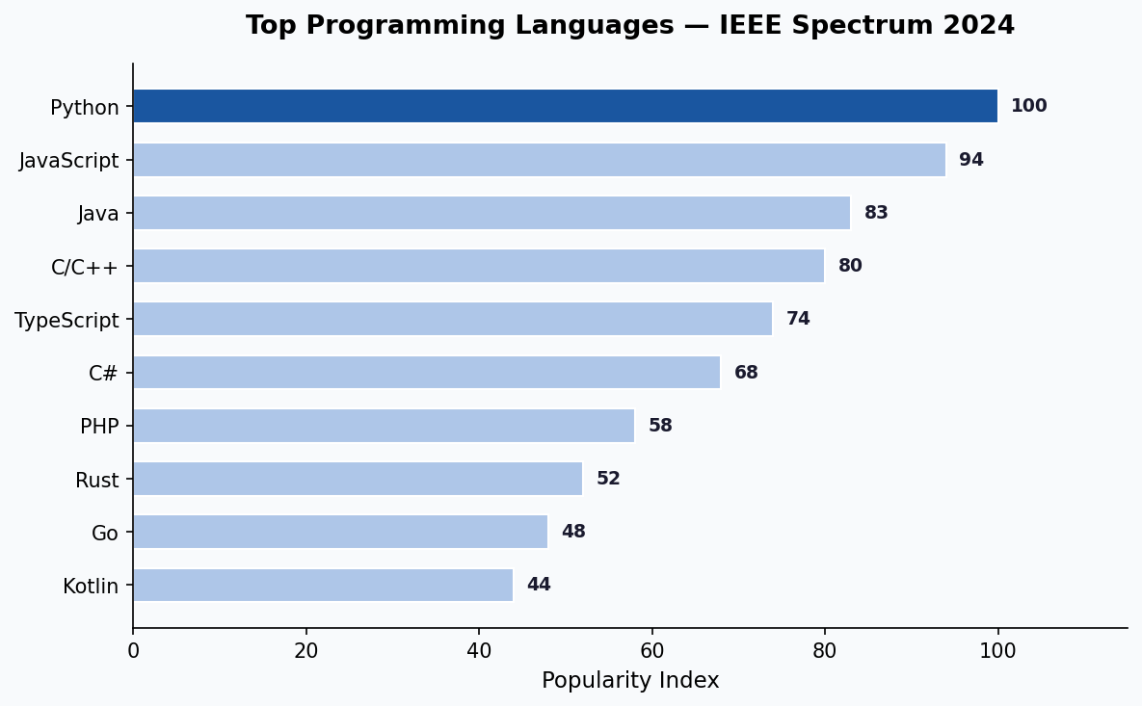
Figure 1.1: Top Programming Languages — IEEE Spectrum 2024 (Python ranks #1)

1.3 The Incredible Growth of Python
One of the most remarkable stories in software development history is the explosive growth of Python over the past decade. While languages like JavaScript and Java have remained relatively stable in usage, Python's share of developer activity has grown more than tenfold since 2014. This growth is driven primarily by the AI and Machine Learning revolution, where Python has become the de facto standard language.
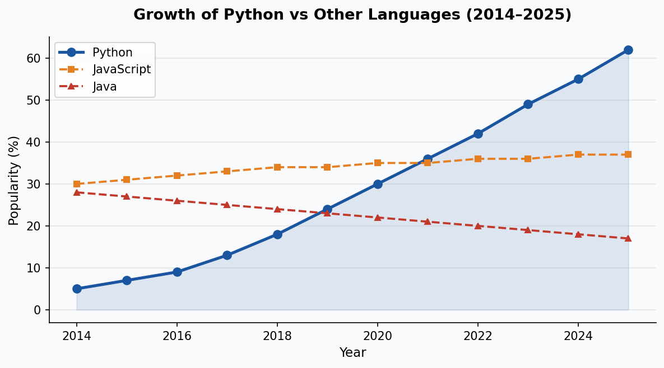
Figure 1.2: Python Growth vs Other Languages 2014–2025 (Stack Overflow Trends)

1.4 What Can You Do With Python?
Python is a true multi-purpose language. Unlike specialized languages that excel in one domain, Python performs well across an extraordinary range of application types. The chart below illustrates how Python developers use the language today, based on the 2024 Stack Overflow Developer Survey.
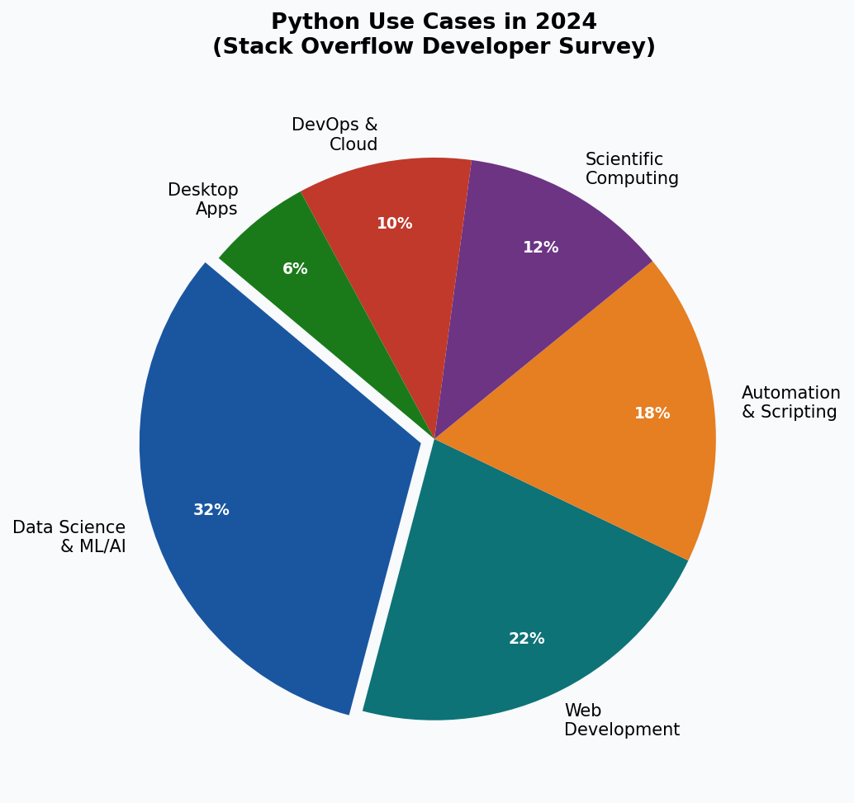
Figure 1.3: Python Use Cases in 2024 — Data Science & AI leads with 32%
As the chart shows, Data Science and Machine Learning/AI is the dominant use case for Python in 2025, representing about one-third of all Python development. Web Development comes second, powered largely by Django and FastAPI. Automation and scripting, scientific computing, and DevOps round out the major categories. This distribution reflects a fundamental shift from Python's origins as a scripting language to its current role as the backbone of the AI revolution.

Chapter 2: The Python Ecosystem

One of Python's greatest strengths is its rich ecosystem of packages and libraries. Unlike some programming languages that include extensive standard functionality, Python follows a philosophy of keeping the core language lean while making it easy to extend with third-party packages. This approach has resulted in one of the largest and most diverse software ecosystems in existence.

2.1 PyPI — Python Package Index
The Python Package Index (PyPI) is the official repository for third-party Python packages, available at https://pypi.org. As of 2025, PyPI hosts over 500,000 packages covering virtually every imaginable application domain. Packages are installed using pip, Python's built-in package manager, with a simple command such as 'pip install package-name'.
Python Package Index (PyPI)

2.2 Python Packages by Domain
The Python ecosystem is organized around application domains, with specialized packages available for each area of software development. Understanding which packages are available for your area of work is essential to being productive with Python. The diagram below illustrates the major domains and their key packages.
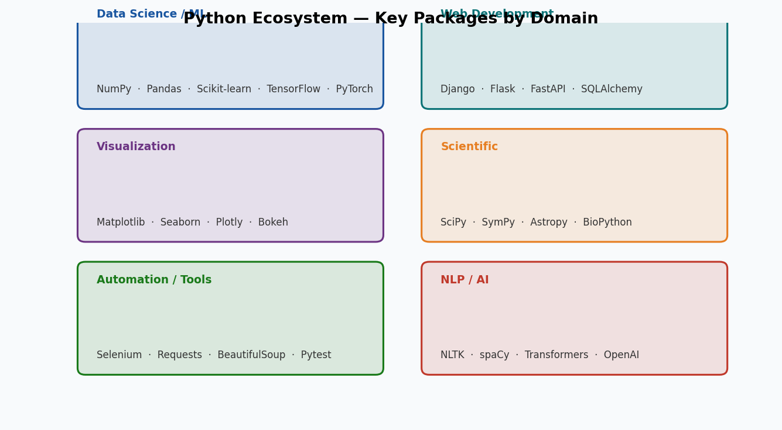
Figure 2.1: Python Ecosystem — Key Packages by Domain (2025)

2.3 Essential Packages for Science and Data
For scientific computing, data analysis, and machine learning — the areas where Python is most dominant — a core set of packages form the foundation of almost every project:

Package | Purpose & Description
NumPy | Fundamental package for numerical computing. Provides N-dimensional arrays, linear algebra, Fourier transforms, and random number generation.
Pandas | Data manipulation and analysis library. Provides DataFrame structures for working with structured tabular data, similar to Excel in Python.
Matplotlib | Comprehensive 2D plotting library. Used for creating static, interactive, and animated visualizations in Python.
SciPy | Scientific computing library built on NumPy. Includes optimization, integration, interpolation, signal processing, and statistical functions.
Scikit-learn | Machine learning library. Provides classification, regression, clustering, and dimensionality reduction algorithms.
TensorFlow | Google's deep learning framework. Used for building and training neural networks for AI applications.
PyTorch | Meta's deep learning framework. Popular in research for flexible neural network development.
Seaborn | Statistical data visualization built on Matplotlib. Creates beautiful statistical charts with less code.

2.4 Web Development Packages
Python has several mature and widely-used web frameworks that make it a strong choice for web development:

Framework | Description
Django | Full-featured, 'batteries-included' web framework. Includes ORM, admin panel, authentication, and templating. Ideal for large applications.
Flask | Lightweight micro-framework. Gives developers full control over components. Great for APIs and smaller applications.
FastAPI | Modern, high-performance API framework. Built on Pydantic and Starlette with automatic OpenAPI documentation. Best choice for REST APIs in 2025.
SQLAlchemy | SQL toolkit and ORM. Works with Django, Flask, and FastAPI for database interactions.
Celery | Distributed task queue. Used with Django/Flask for background tasks and job scheduling.

2.5 Anaconda Distribution
Anaconda is a free, open-source distribution of Python (and R) specifically designed for scientific computing, data science, and machine learning. Rather than installing Python and packages separately, Anaconda bundles the Python interpreter, conda package manager, Jupyter Notebook, Spyder IDE, and over 250 pre-installed scientific packages in a single installer.
Anaconda — Key Features (2025)
• Over 250 pre-installed data science packages included
• conda environment manager for isolated project environments
• Jupyter Notebook and JupyterLab pre-installed
• Spyder IDE included for scientific development
• Available for Windows, macOS, and Linux (free individual edition)
• Virtual environments: conda create -n myenv python=3.12
• Web: https://www.anaconda.com

Chapter 3: Interpreted vs Compiled Languages

Understanding the difference between interpreted and compiled programming languages is fundamental to understanding how Python works and why it behaves the way it does. This distinction affects performance, development workflow, portability, and the type of applications each approach is best suited for.

3.1 How Compiled Languages Work
In a compiled language such as C, C++, or Rust, the source code you write is processed by a compiler that translates the entire program into machine code (binary instructions) before the program can be run. This compilation step happens once, and the resulting executable file can be run directly by the CPU without any further translation. Compiled programs typically run at maximum speed because the CPU executes native machine instructions directly.
The compilation process involves several stages including lexical analysis, parsing, semantic analysis, optimization, and code generation. Modern compilers perform extensive optimizations during this process that can make the resulting code significantly faster than what a human programmer would write directly in assembly language. Languages like C, C++, Rust, and Go are compiled languages.

3.2 How Interpreted Languages Work
In an interpreted language like Python, the source code is not translated to machine code in advance. Instead, an interpreter program reads your source code and executes it line by line at runtime, translating each instruction to machine operations as it encounters them. This means Python programs require the Python interpreter to be present on the system where they run.
Python actually uses a hybrid approach — when you run a .py file, Python first compiles it to bytecode (.pyc files stored in __pycache__), and then the CPython virtual machine interprets that bytecode. This is why subsequent runs of the same Python file are faster, as the bytecode compilation step is skipped if the source has not changed.
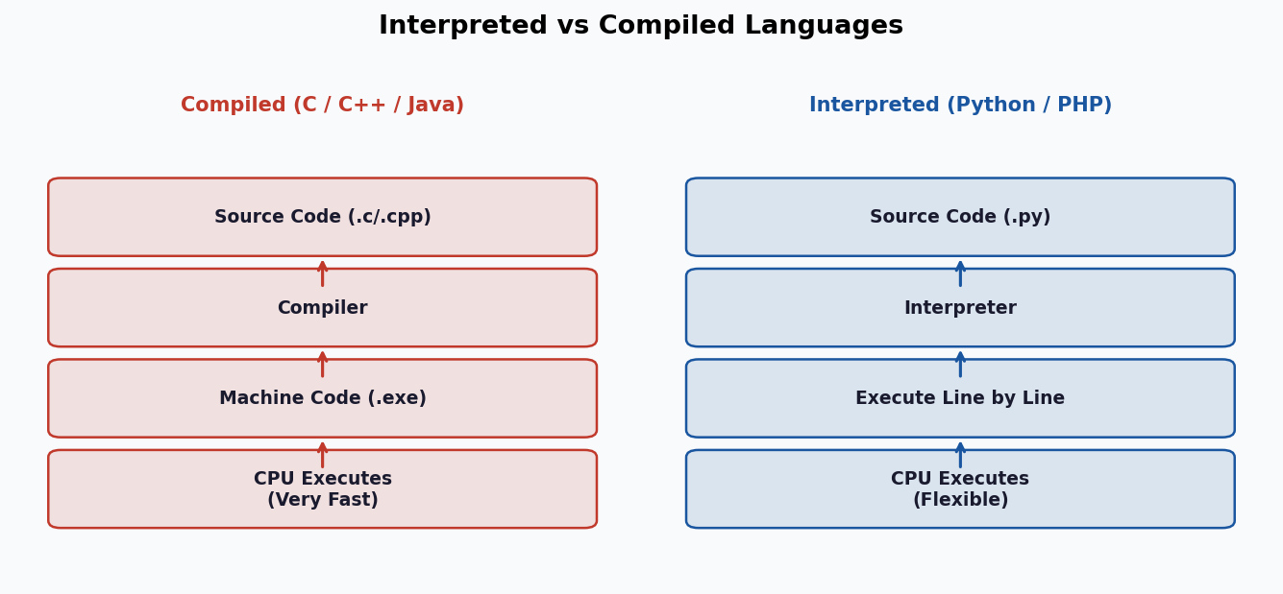
Figure 3.1: Compiled vs Interpreted Language Execution Flow

3.3 Comparison: Compiled vs Interpreted

Feature | Compiled vs Interpreted
Execution Speed | Compiled is faster (10-100x). Interpreted adds overhead from runtime translation.
Development Speed | Interpreted is faster. No compile step; run immediately after saving.
Portability | Interpreted is more portable. Python runs on any system with the interpreter installed.
Error Detection | Compiled catches errors at compile time. Python only detects errors when that line runs.
Memory Usage | Compiled generally uses less memory. Python's dynamic nature adds overhead.
Best For | Compiled: OS kernels, games, performance-critical apps. Interpreted: scripting, data science, web.
Examples | Compiled: C, C++, Rust, Go, Java. Interpreted: Python, PHP, Ruby, JavaScript.

3.4 Python Performance in 2025
While Python is slower than compiled languages in raw execution speed, several developments have significantly improved Python performance in recent years. Python 3.11 introduced significant interpreter optimizations delivering 10-60% speed improvements over Python 3.10. Python 3.12 and 3.13 continue this trend with further optimizations. For computationally intensive tasks, Python code that relies on NumPy and other C-based libraries runs at near-native speed since the heavy computation is performed in compiled C code, with Python serving as an orchestration layer.
Python Performance Tips (2025)
• Use NumPy/Pandas for numerical operations (C-based, very fast)
• Use PyPy interpreter for speed-critical pure Python code (2-10x faster)
• Use Numba JIT compiler for numerical Python functions (@jit decorator)
• Use multiprocessing module to utilize multiple CPU cores
• Use asyncio for I/O-bound concurrent programming
• Upgrade to Python 3.12+ for built-in speed improvements

Chapter 4: Python Editors and Development Tools

Choosing the right development environment is important for productivity when learning and working with Python. A good Python editor provides syntax highlighting, code completion (IntelliSense), debugging tools, integrated terminal, and version control integration. In 2025, the options range from simple online notebooks to powerful professional IDEs.

4.1 Visual Studio Code (Recommended for Beginners)
Visual Studio Code (VS Code) is a free, open-source code editor developed by Microsoft that has become the most popular development tool across all programming languages, including Python. According to the 2024 Stack Overflow Developer Survey, VS Code is used by over 73% of all developers. It combines the simplicity of a text editor with powerful IDE-like features through extensions.
VS Code — Python Setup (2025)
1. Download and install VS Code from https://code.visualstudio.com
2. Open VS Code and go to Extensions (Ctrl+Shift+X)
3. Search for and install the 'Python' extension by Microsoft
4. Search for and install 'Pylance' for enhanced IntelliSense
5. Open a .py file — VS Code will prompt you to select a Python interpreter
6. Use Ctrl+` to open the integrated terminal and run Python files
Key Features: IntelliSense, debugging, Jupyter Notebook support, Git integration

4.2 JupyterLab / Jupyter Notebook
Jupyter Notebook has revolutionized data science and scientific computing by providing an interactive, browser-based environment where code, visualizations, and explanatory text can be combined in a single document called a notebook. In 2025, JupyterLab (the next-generation interface) has largely replaced the classic Jupyter Notebook interface.
Jupyter notebooks use cells that can contain Python code, Markdown text, mathematical equations (LaTeX), images, and interactive widgets. When you run a code cell, the output (including plots and visualizations) appears immediately below the cell. This makes Jupyter ideal for exploratory data analysis, machine learning experimentation, and teaching Python.

4.3 PyCharm
PyCharm by JetBrains is a dedicated Python IDE available in two editions: Community (free) and Professional (paid). PyCharm Professional provides the most comprehensive Python development experience available, with deep code intelligence, advanced debugging, integrated database tools, web framework support (Django, Flask, FastAPI), and remote development capabilities. It is the preferred IDE for professional Python developers in 2025.

4.4 Google Colab (Cloud-Based, Free GPU)
Google Colaboratory (Colab) is a free, cloud-based Jupyter notebook environment provided by Google that requires no setup and runs entirely in the browser. Colab provides free access to GPU and TPU computing resources, making it invaluable for machine learning and deep learning tasks that would be slow or impossible on a standard laptop. As of 2025, Colab Pro offers even more powerful GPUs and longer runtime limits.
Google Colab — Key Advantages
• Completely free to use (Colab Pro available for premium GPU access)
• Free GPU (T4, V100) and TPU access for machine learning
• No installation required — runs in any web browser
• Pre-installed data science packages (NumPy, Pandas, TensorFlow, PyTorch)
• Easy sharing and collaboration like Google Docs
• Integrates with Google Drive for data storage
• Access at: https://colab.research.google.com

4.5 Editor Comparison

Editor | Best For / Key Features
VS Code (Free) | Best overall. Lightweight, extensible, works for all Python tasks. Most popular in 2025.
JupyterLab (Free) | Data science and ML. Interactive notebooks with visualizations inline.
PyCharm Community (Free) | General Python development. Strong refactoring and debugging tools.
PyCharm Professional (Paid) | Professional development. Best Django/web framework support.
Google Colab (Free/Pro) | ML & deep learning with free GPU. Cloud-based, no setup needed.
Spyder (Free) | Scientific Python (included in Anaconda). MATLAB-like interface.
Thonny (Free) | Complete beginners. Simplest interface, shows variable values visually.
Python IDLE (Free) | Very basic scripts only. Minimal features, included with Python.

Chapter 5: Installing Python

Getting Python installed correctly is the first practical step in your Python journey. In 2025, there are several ways to get Python on your system, each suited to different needs and use cases. This chapter covers all the major installation approaches with step-by-step guidance.

5.1 Installing Python from python.org
The official Python distribution from the Python Software Foundation is the standard choice for most users who want a clean, minimal Python installation. This gives you the Python interpreter, the pip package manager, and the basic IDLE editor. You can then install additional packages as needed using pip.
Step-by-Step: Install Python on Windows (2025)
1. Visit https://www.python.org/downloads/
2. Click the yellow 'Download Python 3.12.x' button (latest stable version)
3. Run the downloaded installer (.exe file)
4. IMPORTANT: Check 'Add Python to PATH' at the bottom of the installer
5. Click 'Install Now' for standard installation
6. Verify installation: Open Command Prompt and type: python --version
7. Should show: Python 3.12.x
8. Install packages with: pip install package-name

5.2 Installing Anaconda (Recommended for Data Science)
For data science, machine learning, and scientific computing, installing Anaconda is strongly recommended over the standard Python installer. Anaconda includes Python, over 250 pre-installed packages, the conda package manager, and the Spyder and JupyterLab editors — everything you need in one installation.
Step-by-Step: Install Anaconda
1. Visit https://www.anaconda.com/download
2. Download the Anaconda Individual Edition for your OS (Windows/Mac/Linux)
3. Run the installer and follow the prompts
4. After installation, open 'Anaconda Navigator' from Start Menu
5. From Navigator, you can launch JupyterLab, Spyder, VS Code, and more
6. To use from command line, open 'Anaconda Prompt'
7. Create a new environment: conda create -n myproject python=3.12
8. Activate it: conda activate myproject

5.3 Python Version Management with pyenv
Professional Python developers often work on multiple projects that require different Python versions. pyenv is a tool that allows you to install and switch between multiple Python versions on the same machine. In 2025, pyenv combined with virtual environments (venv or conda) is the standard professional workflow for Python development.

5.4 Virtual Environments
A virtual environment is an isolated Python environment that has its own Python interpreter and installed packages, separate from the system Python. Using virtual environments prevents package conflicts between different projects and is considered best practice for all Python development in 2025.
Creating and Using Virtual Environments
# Create a virtual environment
python -m venv myenv

# Activate on Windows
myenv\Scripts\activate

# Activate on macOS/Linux
source myenv/bin/activate

# Install packages (only affects this environment)
pip install django numpy pandas

# Save dependencies
pip freeze > requirements.txt

# Deactivate
deactivate

5.5 Useful Python Resources
The following resources are highly recommended for learning and reference:

Resource | URL / Description
Official Python Docs | https://docs.python.org/3/ — Complete language reference
Python Tutorial (Official) | https://docs.python.org/3/tutorial/ — Official beginner tutorial
Real Python | https://realpython.com — High-quality tutorials for all levels
W3Schools Python | https://www.w3schools.com/python/ — Quick reference with examples
Stack Overflow | https://stackoverflow.com/questions/tagged/python — Q&A community
PyPI | https://pypi.org — Search and install 500,000+ packages
Google Colab | https://colab.research.google.com — Free cloud Python with GPU
GitHub | https://github.com/topics/python — Thousands of open source projects

Chapter 6: Python in AI, ML, and Modern Development

The most significant development in the software world over the past decade has been the rise of Artificial Intelligence and Machine Learning, and Python has been at the absolute center of this revolution. In 2025, Python is not merely a popular language — it is the essential language of AI development, data science, and modern software engineering. Understanding Python's role in these domains is crucial for any aspiring developer.

6.1 Python and Machine Learning
Machine learning involves training algorithms on data to make predictions or decisions without being explicitly programmed for each scenario. Python has become the standard language for ML development due to the maturity of its ML ecosystem. Libraries like Scikit-learn provide implementations of hundreds of classical ML algorithms including linear regression, decision trees, random forests, support vector machines, and clustering algorithms. With just a few lines of Python code, you can train a model, evaluate its performance, and make predictions on new data.

6.2 Python and Deep Learning
Deep learning, a subset of machine learning using neural networks with many layers, has produced breakthrough results in image recognition, natural language processing, speech recognition, and generative AI. Python's TensorFlow (by Google) and PyTorch (by Meta) libraries are the two dominant frameworks for deep learning. Both provide high-level APIs (Keras for TensorFlow) that make it possible to build sophisticated neural networks in just a few dozen lines of Python code.
In 2025, large language models (LLMs) like GPT-4, Claude, and Llama have made generative AI accessible to everyday developers through Python APIs. The OpenAI Python library, LangChain, and Hugging Face Transformers have become essential packages for developers building AI-powered applications. The ability to integrate advanced AI capabilities into Python applications with just a few lines of code has opened entirely new categories of software development.

6.3 Python for Web Development (Django)
Django, which is mentioned in the original textbook, remains one of the most important Python web frameworks in 2025. Django follows the Model-Template-View (MTV) architectural pattern and provides a comprehensive set of built-in features including an ORM for database interaction, a powerful admin interface, user authentication, form handling, and a templating engine. Major websites and applications built with Django include Instagram, Pinterest, Mozilla, Disqus, and NASA's public website.
Django Quick Start (2025)
pip install django
django-admin startproject mysite
cd mysite
python manage.py startapp myapp
python manage.py migrate
python manage.py runserver
# Visit http://127.0.0.1:8000/
# Full docs: https://docs.djangoproject.com

6.4 Python for Data Science Workflow
A typical data science workflow in Python follows a consistent pattern that leverages the core ecosystem packages. Data is loaded and cleaned using Pandas, numerical computations are performed using NumPy, visualizations are created with Matplotlib or Seaborn, and machine learning models are built and evaluated using Scikit-learn or deep learning frameworks. The entire workflow is often conducted in a Jupyter Notebook, which allows for iterative exploration and clear documentation of the analysis.

6.5 Summary — Why Python in 2025?

Domain | Python's Role
AI & Machine Learning | Primary language. TensorFlow, PyTorch, Scikit-learn all Python-first.
Data Science | Dominant language. Pandas, NumPy, Matplotlib are industry standard.
Web Development | Major language. Django, FastAPI power thousands of production sites.
Automation | Top choice. Scripts, bots, testing (Selenium, Pytest) all use Python.
Scientific Computing | Leading language. SciPy, SymPy used in academia and industry.
DevOps & Cloud | Growing rapidly. AWS, GCP, Azure all offer Python SDKs.
NLP & Generative AI | Exclusive domain. NLTK, spaCy, LangChain, OpenAI SDK.
Finance & Trading | Strong presence. Algorithmic trading, risk analysis, data pipelines.

Conclusion: Python in 2025
Python is no longer just one of many programming languages — it has become the
language of the future. With AI and Machine Learning transforming every industry,
and Python serving as the foundation of the entire AI ecosystem, learning Python
is one of the most valuable investments any student or professional can make.

Whether you want to build websites, analyze data, create AI applications, automate
tasks, or do scientific research — Python has the tools, the community, and the
ecosystem to support you. Start with the basics, build projects, and the rest
will follow.

Official Python Website: https://www.python.org
PyPI Package Index: https://pypi.org
Real Python Tutorials: https://realpython.com

