<rsec_FRONT_PAGE#29>

Contents

1 Report Summary 2

1.1 Report Modification Record 2

1.2 Introduction 2

1.3 Brief Summary of Results 3

1.4 Product Information 4

1.5 Deviations from the Standard 4

1.6 EUT Modification Record 4

1.7 Test Location 4

2 Test Details 5

3 Test Equipment Information 6

3.1 General Test Equipment Used 6

ANNEX A ??? A.2

# Report Summary

## Report Modification Record

<rsec_REPORT_MODIFICATION_RECORD>

Alterations and additions to this report will be issued to the holders of each copy in the form of a complete document.

|  |  |  |
| --- | --- | --- |
| Issue | Description of Change | Date of Issue |
| 1 | First Issue | ?? |

## Introduction

<rsec_INTRODUCTION#2>

## Brief Summary of Results

<rsec_SummaryTable>

## Test Plan Information

<rsec_Test_Plan#37>

## Product Information

<rsec_Product_Information#9>

## EUT Port

<rsec_EUT_LINE>

## Deviations from the Standard

<rep_dfts>

## EUT Modification Record

<rsec_ModStateTable>

<rsec_ModStateTableTableStart>

<ModificationState>

<ModificationDescription>

<ModificationFittedBy>

<ModificationDate>

<ModificationFile>

<rsec_ModStateTableTableEnd>

## Test Location

<rsec_Office_Test_Locations>

# Test Details

<rsec_tr_Test_Section>

# Test Equipment Information

## General Test Equipment Used

<rsec_TestEquipmentUsed>

<rsec_MeasurementUncertainty>

<TMUsedTableStart>

TMNo<0>

DeviceNo<1>

Instrument<2>

Manufacturer<3>

|  |  |  |
| --- | --- | --- |
| Col 1 | Col 2 | Col 3 |
| <0> | <1> | <2> |

TypeNo<4>

CalibrationPeriod<5>

CalidationDue<6>

<TMUsedTableEnd>

# Test Samples

<rsec_TestSamples>

# Customer Test Plan

<rsec_App_Form_or_DoB#8>

APPENDEX/ANNEXTURE(FOR TEST DETAILS) start here

<rsec_TESTAPPENDIX>

APPENDEX/ANNEXTURE(FOR TEST DETAILS) end here

APPENDEX1 start from here

APPENDEX1 end here

**HOW TO REMOVE THE ANNEX**

* **Delete ALL unwanted pages including the last section break**
* **Double click in the header and click on ‘Link to Previous’**

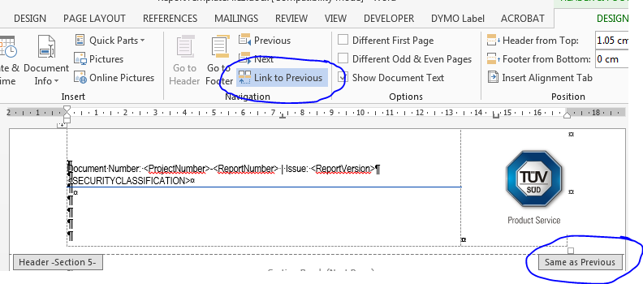

* **Click in the footer and click on ‘Link to Previous’, then press ‘ Link to Previous’ again.**



**ANNEX A**

?????

DeleteExtraSpace