**Naive Bayes classifier**

K.Meghana

IIIT Sricity,Chittoor

Andhra Pradesh.

**QUESTION:**

Implement Naïve Bayes Classifier on the given training and testing data sets.

**Aim:**

-> Given an unclassified example, we need to find out the probability of that example being classified to each of the classes (0 to 9) given its features.

->Now we classify this example into the class with the most probability.

->We will calculate all the P(features/class) values and store them according to Bayes theorem.

**Algorithm:**

->A 3D array bayes[j][k][l] is maintained which means the probability of kth feature which has value l and class j.

->The entries of this 3D array are our training examples divided by its total class members. We do this to get the probability.

->We use this 3D array and the Bayes classifier formulae array to classify each example in the testing set.

->We calculate the error rate and accuracy.

**Formulae:**

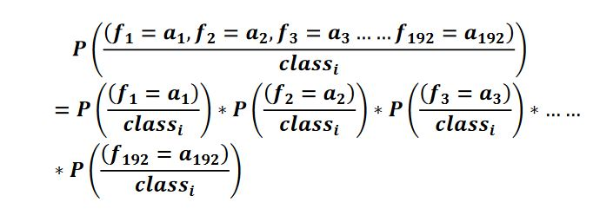

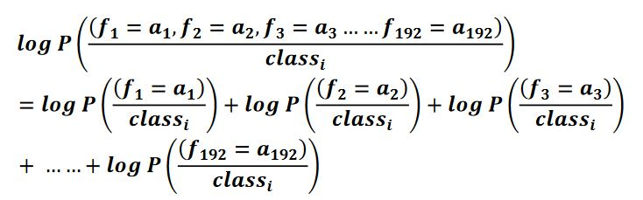

**Results:**

**Question 1:**

Accuracy:84.40%

**PLOT:**

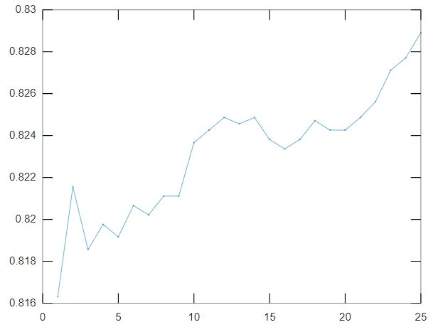

**Question 2**:

Accuracy: 81.728172%

Number of correctly classified: 2724 out of 3333