**Assignment:1**

**Cloud**

The term cloud refers to a network or the internet. It is a technology that uses remote servers on the internet to store, manage, and access data online rather than local drives. The data can be anything such as files, images, documents, audio, video, and more.

**Advantages of cloud:**

1. Back-up and restore data
2. Improved Collaboration
3. Excellemt accesseibility
4. Low maintenance cost
5. Mobility
6. IServices in the pay-use model
7. Unlimited storage capacity
8. Data Security

**Disadvantages of cloud:**

1. Internet Connectivity
2. Vendor lock-in
3. Limited control
4. Security

**Types of Cloud:**

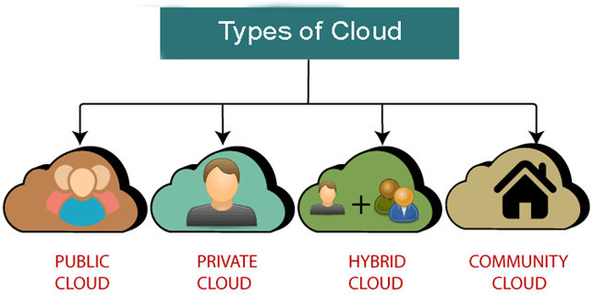

1. Public Cloud
2. Private Cloud
3. Hybrid Cloud
4. Community Cloud

**EC2:**

Amazon Elastic Computer Cloud (Amazon EC2) is a web service that provides secure, resizable computer capacity in the cloud. It is designed to make web-scale cloud computing easier for developers. Amazon EC2’s simple web service interface allows you to obtain and configure capacity with minimal friction. It provides you with complete control of your computing resources and lets you run on Amazon’s proven computing environment