REPORT

Phase 1: Synchronous Baseline
- Architecture: Direct API → Payment Processing → Response
- Technology: Go service on ECS Fargate (256 CPU, 512MB RAM)
- Result: 99% failure rate at 20 concurrent users
- Root Cause: Payment processor bottleneck (3s/transaction) blocks all concurrent requests
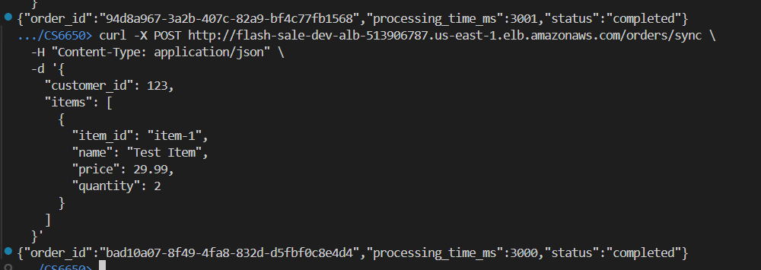
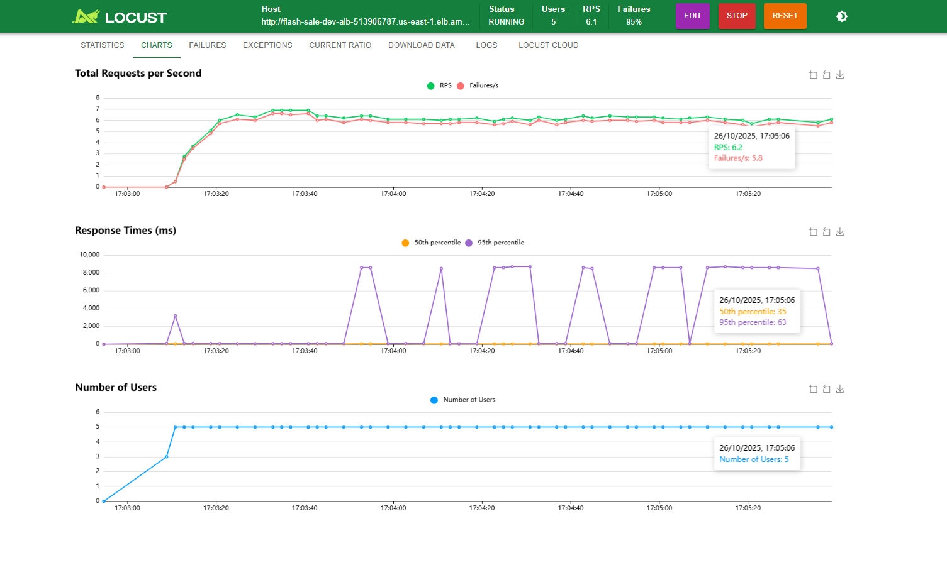
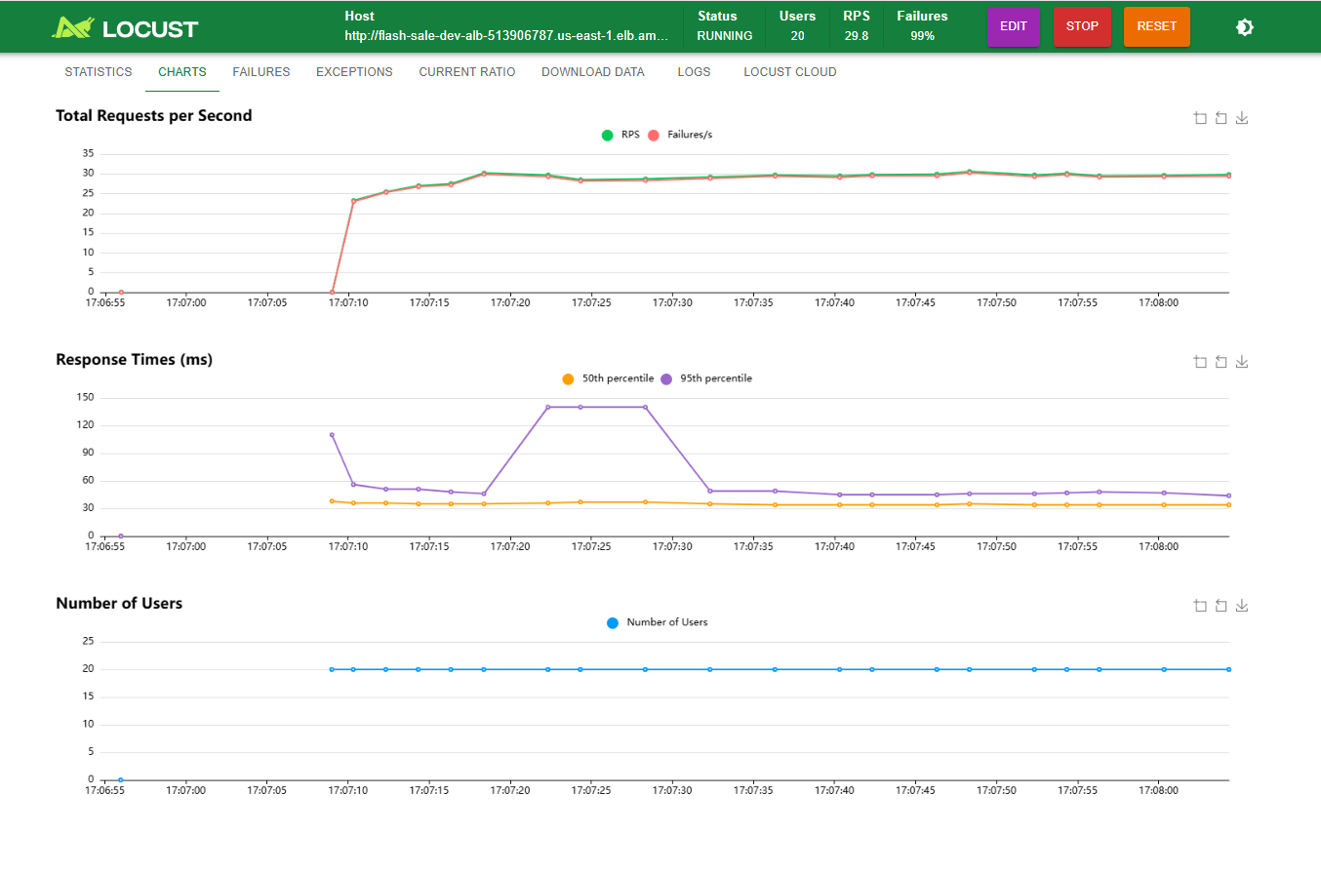
Phase 2-3: Asynchronous Solution
- Architecture: API → SNS → SQS → Background Workers
- Components:
  - Order Receiver: Accepts orders and publishes to SNS (<100ms response)
  - SNS Topic: Distributes order events
  - SQS Queue: Buffers orders for processing
  - Order Processor: Polls queue and processes payments
- Result: 100% order acceptance, but massive queue buildup (10,000+ messages)

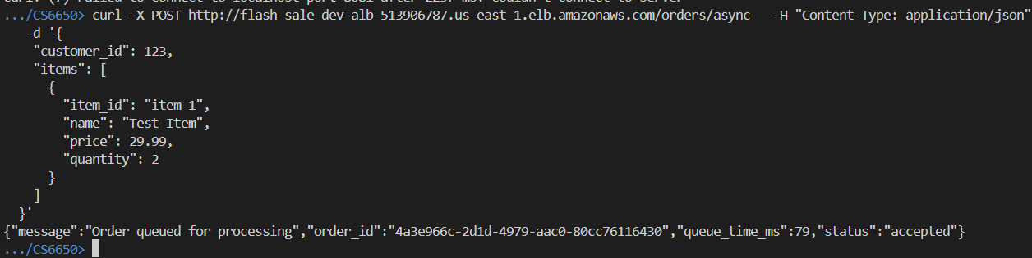
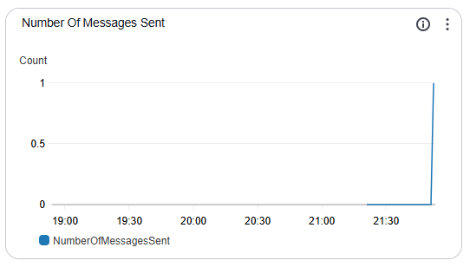
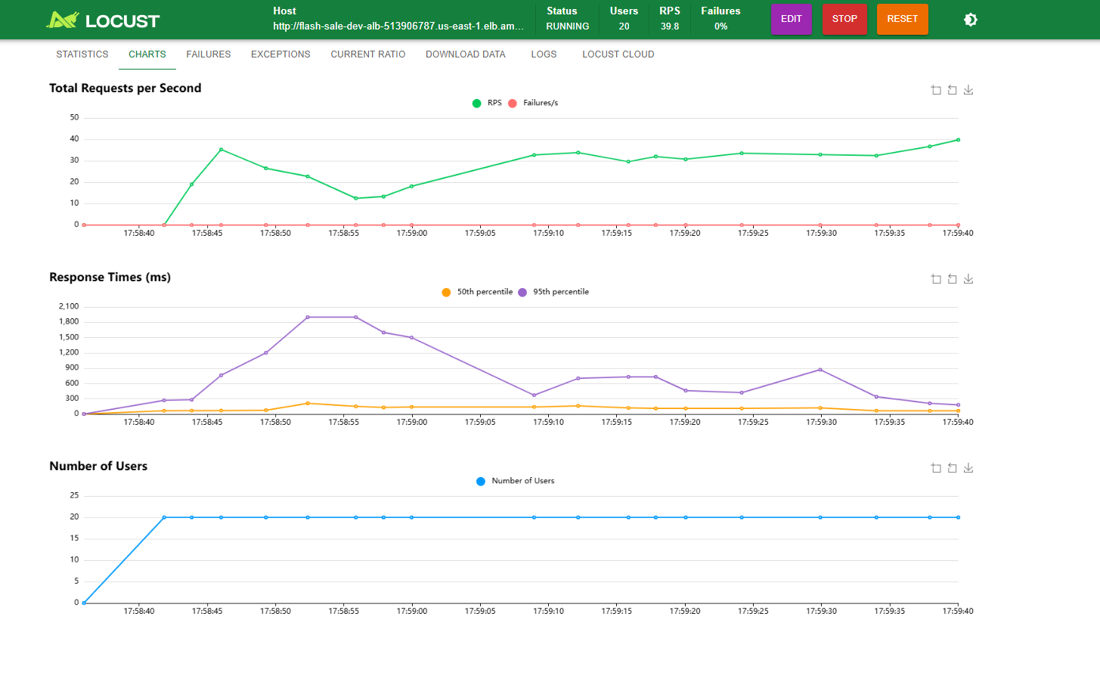
Phase 4-5: Worker Scaling Analysis
Testing revealed linear scaling relationship:
- 1 worker: 0.33 orders/sec
- 5 workers: 1.67 orders/sec
- 20 workers: 6.67 orders/sec
- Required for 60 orders/sec: 180 workers

5 workers
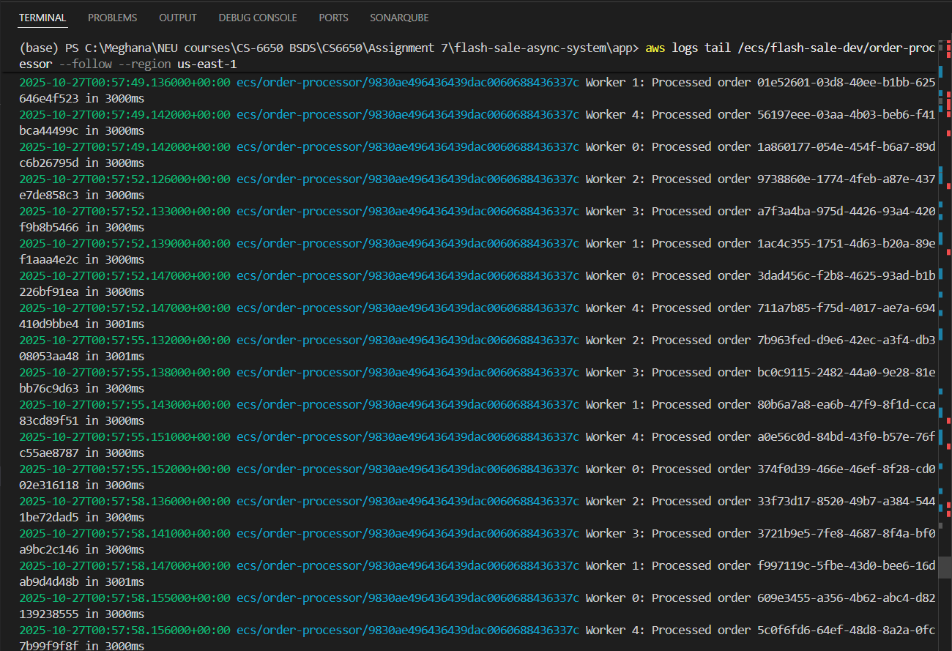
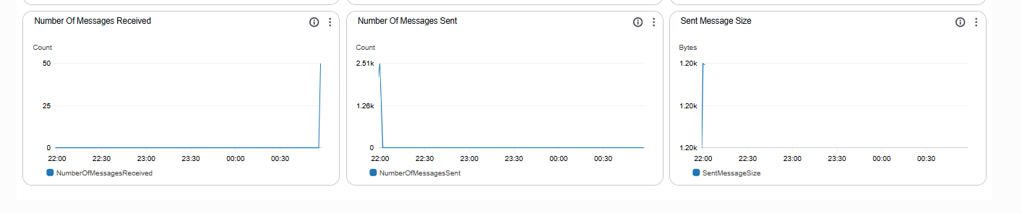
20 workers
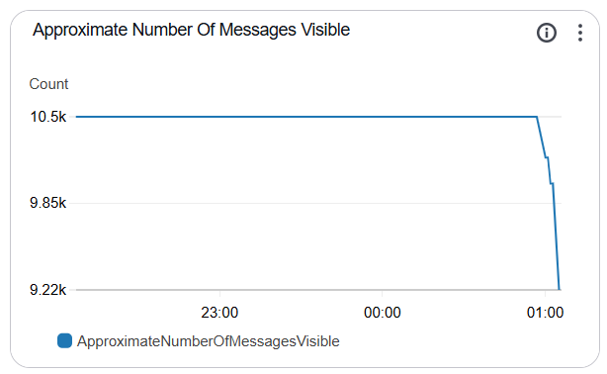
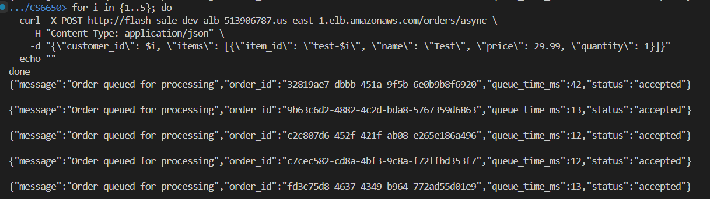
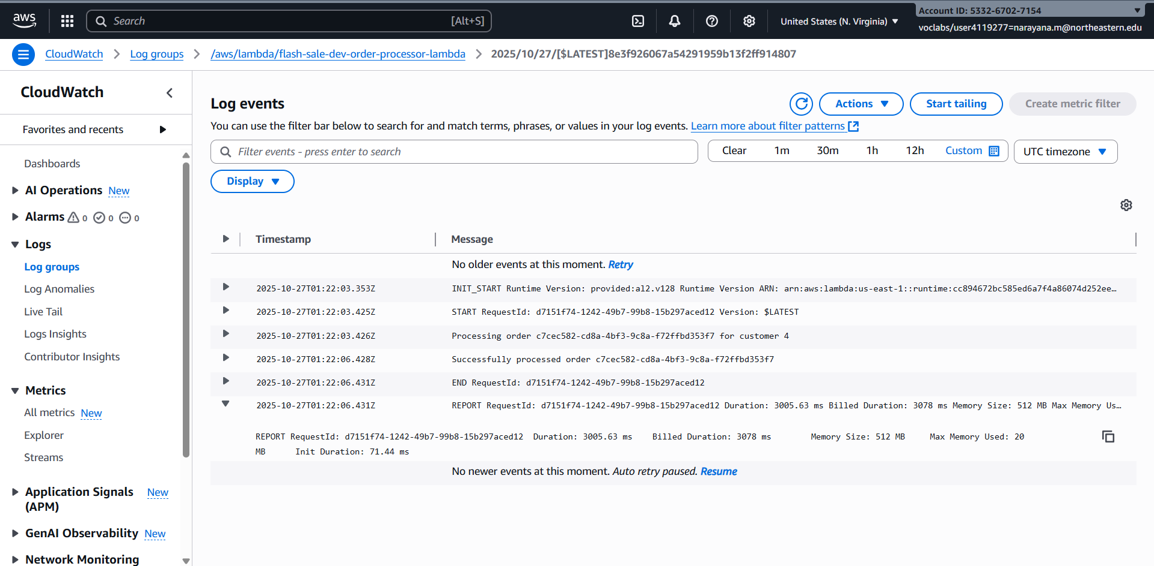
Lambda Performance Analysis
From REPORT line:
- Init Duration: 71.44 ms - This is the cold start overhead
- Duration: 3005.63 ms - Total execution time including your 3-second sleep
- Actual processing overhead: 5.63 ms (excluding the 3-second payment simulation)
- Cold start impact: 71.44ms on a 3000ms process = 2.38% overhead
- Memory used: Only 20 MB out of 512 MB allocated
Cost Optimization Insight
Using only 20 MB but paying for 512 MB. We could reduce the memory to 128 MB and save even more (though it's already free at our volume).
Final Comparison Table for Your Report
Metric | Sync (ECS) | Async (ECS+SQS) | Serverless (Lambda)
Success Rate @ 20 users | 1% | 100% | 100%
Response Time | 3000ms+ | <100ms | <100ms
Queue Buildup | N/A | 10k messages | None (direct processing)
Cold Start Overhead | None | None | 71ms (2.4%)
Monthly Cost | $8.50 | $8.50 | $0 (free tier)
Scaling | Manual | Manual (add workers) | Automatic
Max Throughput | 0.33/sec | Limited by workers | Unlimited
Message Reliability | Direct failure | SQS guarantees | SNS retry only
The Decision Framework
Choose Lambda when:
- Order volume < 267k/month (free tier)
- Can accept occasional message loss
- Want zero operational overhead
- Cold starts (71ms) are acceptable
Choose ECS+SQS when:
- Need guaranteed message delivery
- Want Dead Letter Queues
- Require batch processing
- Have consistent high volume
Trade-off Analysis
ECS + SQS Advantages
- Message persistence and replay capability
- Dead Letter Queue for failed messages
- Predictable retry patterns
- Batch processing options
- No cold starts
Lambda Advantages
- Zero infrastructure management
- Automatic, unlimited scaling
- Pay-per-use pricing model
- No operational overhead
- Perfect for sporadic loads
Lambda Limitations
- 71ms cold start overhead
- No built-in queue (relies on SNS retries)
- Messages lost after 3 retry attempts
- No batch processing
- Requires trust in AWS availability

Architectural Recommendations
For Startups (<100K orders/month)
Recommendation: Lambda
- Rationale: Zero cost within free tier, no operations overhead
- Acceptable Trade-offs: Occasional message loss, cold starts
- Migration Path: Easy transition to SQS when volume justifies cost
For Growing Companies (100K-1M orders/month)
Recommendation: Hybrid approach
- Implementation: Lambda for normal traffic, ECS+SQS for flash sales
- Benefits: Cost optimization with reliability when needed
For Enterprises (>1M orders/month)
Recommendation: ECS + SQS with auto-scaling
- Rationale: Message guarantees critical at scale
- Implementation: Auto-scale workers based on queue depth
Key Learnings
- Synchronous systems cannot handle flash sales - Even modest concurrent loads cause cascading failures
- Queue depth monitoring is critical - Without sufficient workers, queues grow unbounded at rate: Input Rate - Processing Rate
- Worker scaling is linear - Required workers = Peak Orders/Sec × Processing Time
- Serverless isn't just about cost - Eliminating operational complexity has significant value
- Cold starts are negligible for long processes - 71ms overhead on 3000ms process (2.4%) is acceptable

