Phase 9: Create Child Incident Document
Incident Lifecycle Automation in ServiceNow
Field | Details
Project Name | Incident Lifecycle Automation in ServiceNow
Team ID | Individual participant – 324103312L29@gvpce.ac.in
Current Task | Phase 9 – Create Child Incident
Platform | ServiceNow – Service Operations Workspace
Parent Incident | INC0010001
Child Incident | INC0010002

1. Task Overview & Executive Summary
Objective: Establishing a parent-child relationship between related incidents to streamline communication, tracking, and automated multi-incident resolution.
Executive Summary: A second user reported the same VPN authentication problem. Instead of investigating it separately, a child incident (INC0010002) was created from the Related Records tab of the primary incident INC0010001, so that both reports are handled together under one parent ticket.

Key outcomes
- Child incident INC0010002 created from the Child Incidents section of the parent.
- Child record captures its own short description, caller and description.
- Parent INC0010001 lists the child under Child Incidents (1), confirming the link.

2. Step-by-Step Implementation Details (Phase 9)
- Step 1: Navigated to the active incident record INC0010001 in Service Operations Workspace.
- Step 2: Selected the Related Records tab.
- Step 3: Located the Child Incidents section and clicked New.
- Step 4: Configured the child incident details:
  - Short Description: Unable to connect to Corporate VPN
  - Caller: Selected a user from the system list
  - Description: User receiving VPN authentication failure error.
- Step 5: Saved the child incident record and noted the generated child incident number (INC0010002).
- Step 6: Returned to the parent incident (INC0010001) under Related Records.
- Step 7: Verified that the new child incident (INC0010002) is correctly linked and listed under Child Incidents.

Screenshot 1 – Parent incident: Related records > Child Incidents
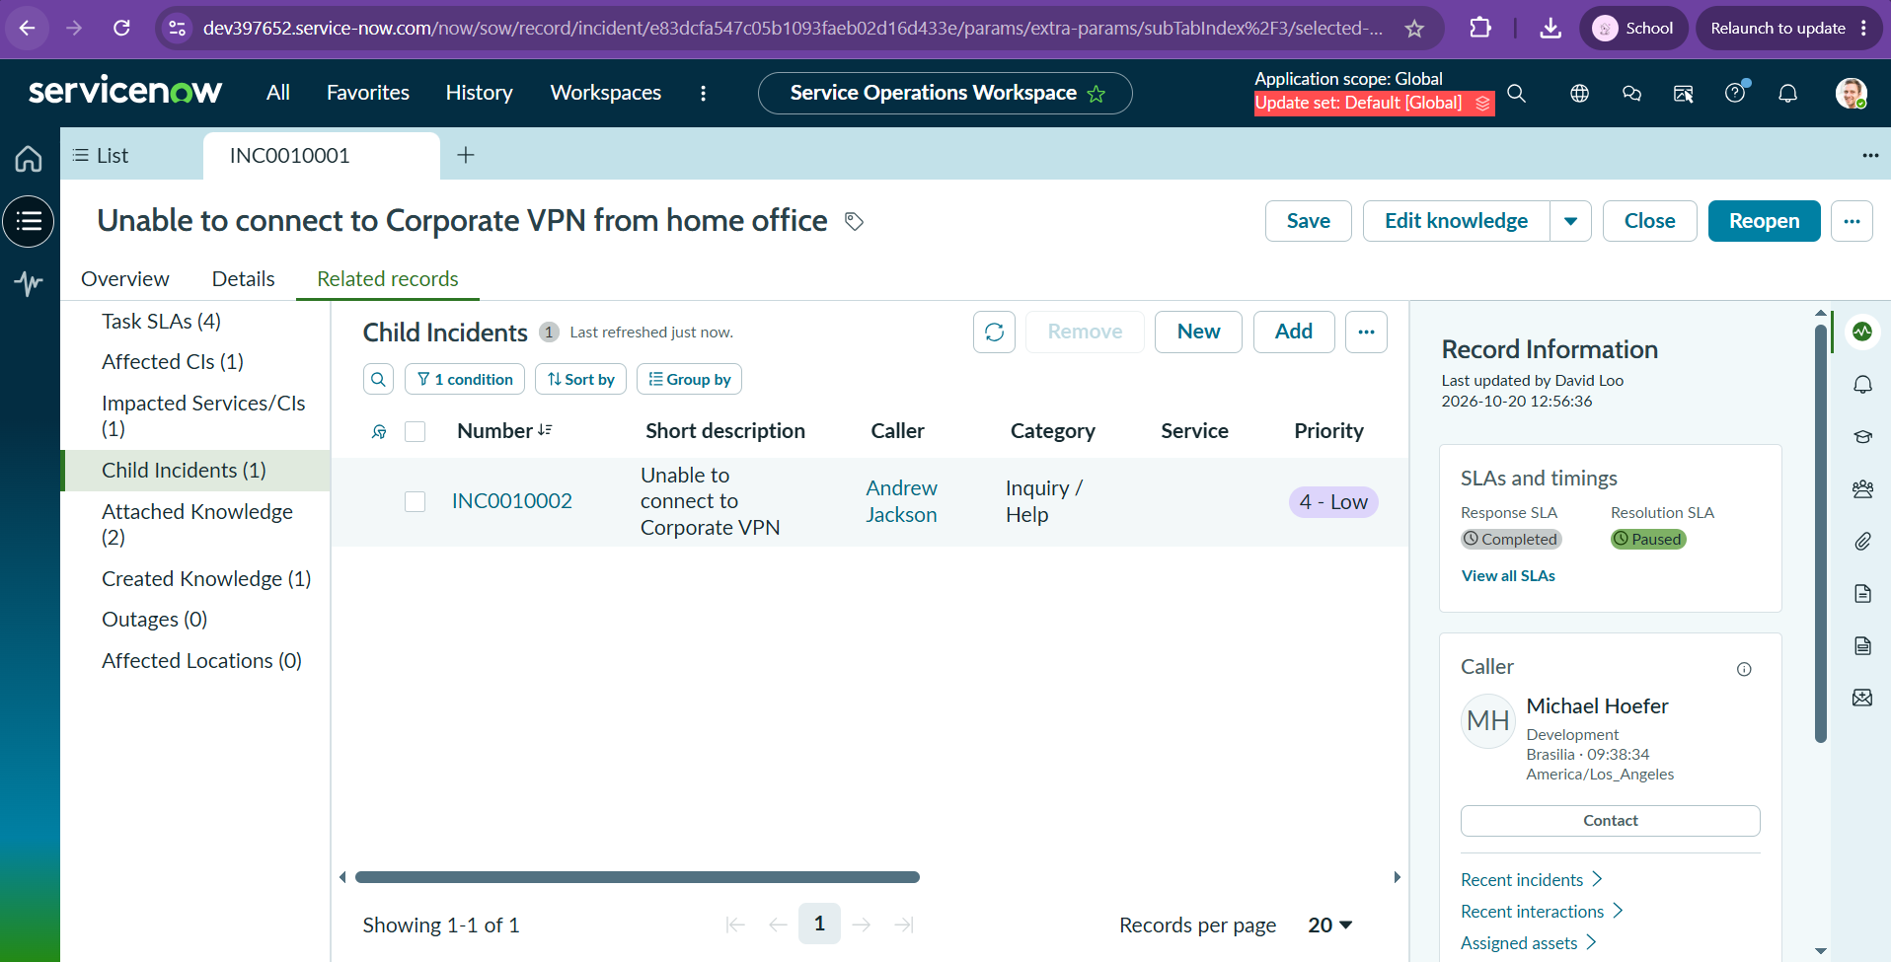
Figure 1: INC0010001 Related records tab showing Child Incidents (1): INC0010002, “Unable to connect to Corporate VPN”, Caller Andrew Jackson, Priority 4 - Low.

Screenshot 2 – Child incident record
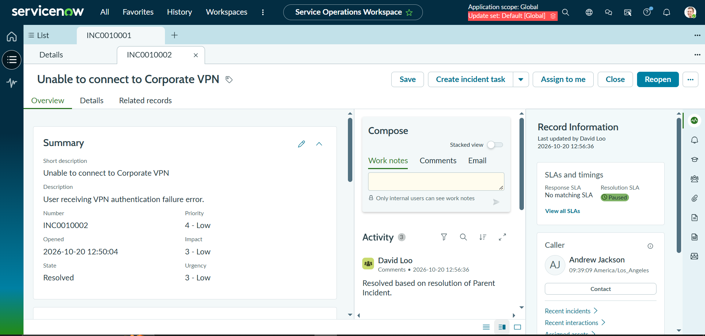
Figure 2: Child incident INC0010002 Overview tab showing the short description, description “User receiving VPN authentication failure error.” and caller Andrew Jackson.

3. Business Impact & ITIL Hierarchy Benefits
Linking related reports to one parent ticket is a core ITIL practice for handling multiple users affected by the same underlying issue.
- Avoids redundant investigations: Support teams work on the root cause once, in the parent incident, rather than diagnosing each user’s identical report separately.
- Centralizes support updates: Progress, work notes and findings are recorded on the parent, so every linked child follows the same source of truth and agents are not duplicating updates.
- Enables automatic cascading resolutions: When the parent incident is resolved, its child incidents can be resolved automatically. The Activity log of INC0010002 shows the comment “Resolved based on resolution of Parent Incident.”
- Preserves each caller’s record: Every affected user still has their own incident, so they receive communication and the individual impact is tracked and reported.
- Better trend and major-incident visibility: The number of child incidents under a parent shows how widely a problem is affecting users, helping decide whether to escalate.

4. Configuration & Verification Matrix
Phase / Step | Target Tab / Action | Configured Value / Result | Execution Status (Pass/Fail)
Step 1 | Parent incident | Opened INC0010001 in Service Operations Workspace | Pass
Step 2 | Related Records tab | Tab selected | Pass
Step 3 | Child Incidents > New | Child Incidents section located; New clicked | Pass
Step 4a | Short Description | Unable to connect to Corporate VPN | Pass
Step 4b | Caller | User selected from system list (Andrew Jackson) | Pass
Step 4c | Description | User receiving VPN authentication failure error. | Pass
Step 5 | Save | Child incident saved; number generated: INC0010002 | Pass
Step 6 | Parent incident > Related Records | Returned to INC0010001 Related Records | Pass
Step 7 | Child Incidents (1) | INC0010002 listed and linked under the parent | Pass
Summary: All Phase 9 steps were executed and verified. Child incident INC0010002 is linked to parent INC0010001.

