Phase 10: Incident Resolution Document
Incident Lifecycle Automation in ServiceNow
Field | Details
Project Name | Incident Lifecycle Automation in ServiceNow
Team ID | Individual participant – 324103312L29@gvpce.ac.in
Current Task | Phase 10 – Incident Resolution (Combining Add Cause & Add Resolution)
Platform | ServiceNow – Service Operations Workspace
Incident Record | INC0010001
State Transition | On Hold → Resolved

1. Task Overview & Executive Summary
Objective: Documenting the complete resolution workflow in Service Operations Workspace, including root-cause determination and full resolution details to transition the incident state from On Hold to Resolved.
Executive Summary: Once the emergency change was carried out, the incident could be closed out. The agent recorded the Probable cause (the PowerEdge service had been suspended and needed a restart), then completed the Resolution section with the resolution code Workaround provided and detailed resolution notes. Using Save resolution and then Resolve with confirmation, the incident moved to the Resolved state.

Key outcomes
- Root cause documented: PowerEdge service was suspended and required restart.
- Resolution documented: Workaround provided; VPN-SRV-02 service restarted as per the emergency change request.
- Incident state changed from On Hold to Resolved, recorded in the Activity log.

2. Step-by-Step Implementation Details (Phase 10)

Task 1: Add Cause
- Step 1: Navigated to the Overview tab of incident record INC0010001 in Service Operations Workspace.
- Step 2: Configured the Probable Cause: “PowerEdge service was suspended and required restart.”
- Step 3: Saved the record updates.

Task 2: Add Resolution
- Step 1: Navigated to the Resolution tab/section of the incident form.
- Step 2: Configured the Resolution Code: Workaround provided.
- Step 3: Entered the Resolution Notes: “Restarted VPN-SRV-02 service as per emergency change request.”
- Step 4: Clicked Save resolution.
- Step 5: Clicked the Resolve button in the workspace header.
- Step 6: Confirmed the modal popup prompt by clicking Resolve to formally set the incident state to Resolved.

Screenshot – Cause and Resolution on the Overview tab
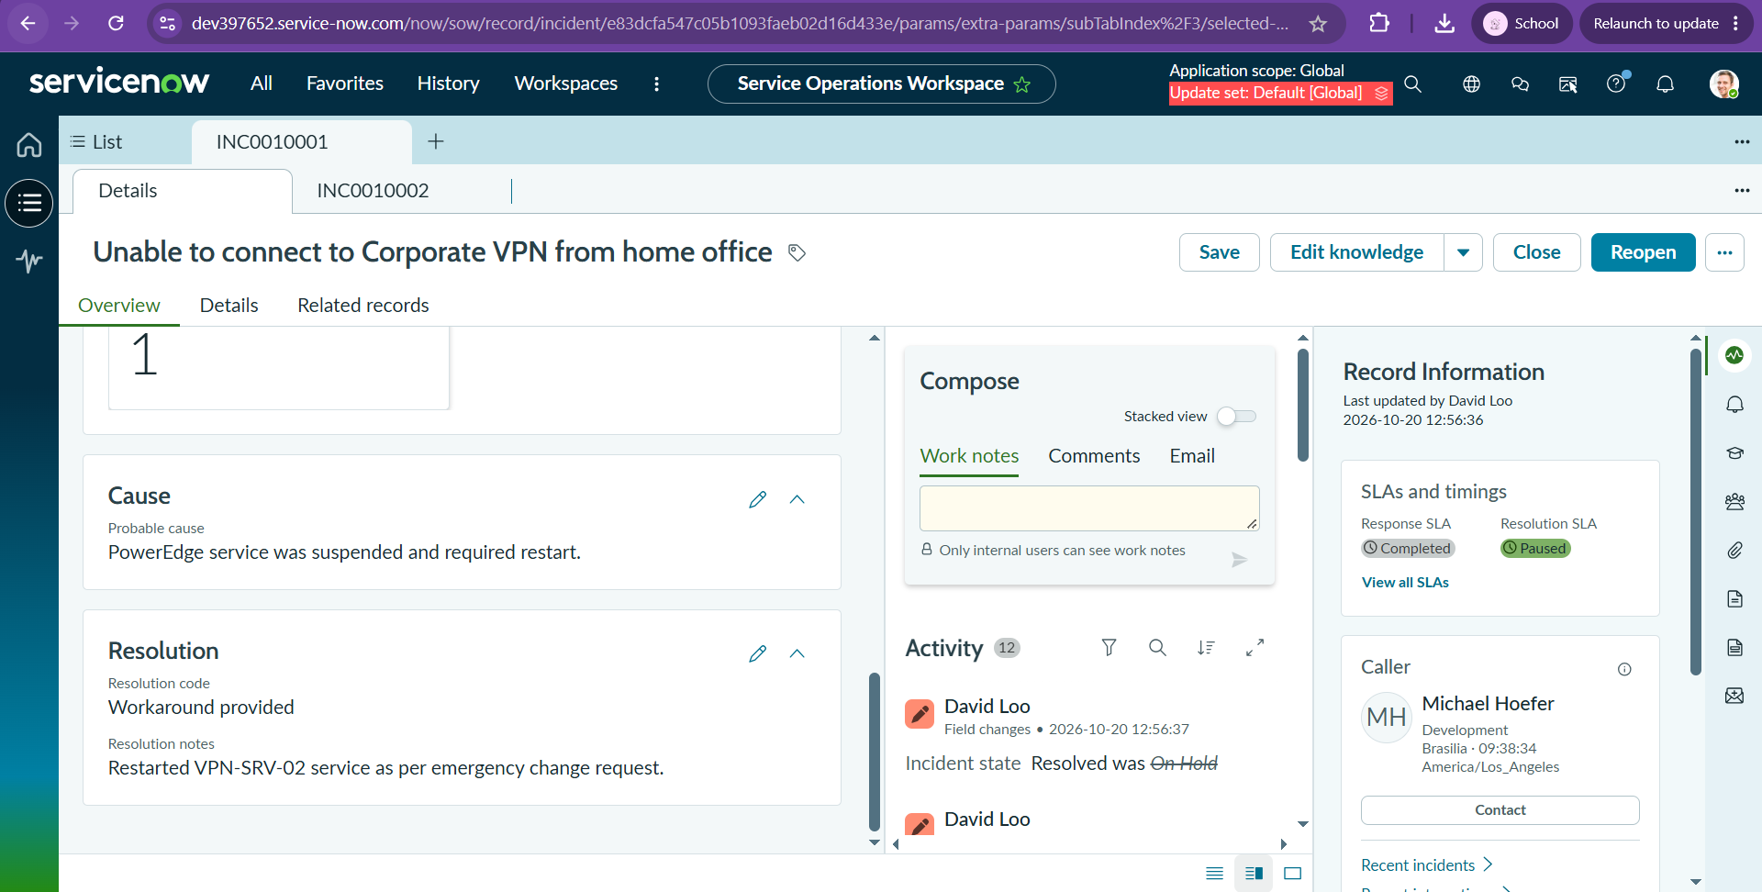
Figure 1: INC0010001 Overview tab showing Cause (probable cause), Resolution (code: Workaround provided, with resolution notes) and the Activity entry “Incident state: Resolved was On Hold”.

3. Business Impact & ITIL Best Practices
Documenting both why an incident happened and how it was fixed is central to ITIL incident and problem management.
- Complete incident transparency: Recording the probable cause together with the resolution code and notes gives anyone reading the ticket the full story, from symptom through cause to fix.
- SLA compliance metrics: Moving the incident to Resolved through the proper workflow stops the resolution clock at the right time and provides the data needed to report on SLA performance.
- Knowledge Base population: Structured cause and resolution notes can be turned into knowledge articles (the workspace’s Edit knowledge action supports this), so similar future incidents can be triaged and resolved faster, including by automation.
- Problem management input: A documented root cause helps identify recurring issues, such as a service that repeatedly stops, so that permanent fixes can be raised.
- Controlled closure: Requiring Save resolution and a confirmation step before Resolve prevents accidental or incomplete resolutions.
- Audit trail: The state change from On Hold to Resolved is logged in the Activity feed with the user and timestamp.

4. Combined Configuration & Verification Matrix
Section / Sub-task | Field Name / Navigation | Parameter / Value Entered | Execution Status (Pass/Fail)
Task 1 – Add Cause | Navigation | Overview tab of INC0010001 in Service Operations Workspace | Pass
Task 1 – Add Cause | Probable cause | PowerEdge service was suspended and required restart. | Pass
Task 1 – Add Cause | Save | Record updates saved | Pass
Task 2 – Add Resolution | Navigation | Resolution section of the incident form | Pass
Task 2 – Add Resolution | Resolution code | Workaround provided | Pass
Task 2 – Add Resolution | Resolution notes | Restarted VPN-SRV-02 service as per emergency change request. | Pass
Task 2 – Add Resolution | Save resolution (button) | Resolution details saved | Pass
Task 2 – Add Resolution | Resolve (header button) | Resolve clicked in the workspace header | Pass
Task 2 – Add Resolution | Resolve (modal popup) | Confirmed; incident state set to Resolved | Pass
Verification | Activity log | Incident state: Resolved was On Hold | Pass
Summary: All Phase 10 cause and resolution steps were executed and verified. INC0010001 is in the Resolved state.

