Phase 3: Incident Record Creation
Incident Lifecycle Automation in ServiceNow
Field | Details
Project Name | Incident Lifecycle Automation in ServiceNow
Team ID | Individual participant – 324103312L29@gvpce.ac.in
Current Task | Phase 3 – Incident Record Creation
Platform | ServiceNow – Service Operations Workspace
Record Created | INC0010001

1. Task Overview & Objective
Objective: Documenting the initial intake and logging of a user-reported IT issue in the ServiceNow Service Operations Workspace.
This phase covers the first stage of the incident lifecycle: capturing a user-reported issue as a structured Incident record, identifying the caller, and routing the ticket to the correct support team so that later phases (assignment, work notes, resolution and closure) can build on it.

Scope of this phase
- Log in and impersonate the Service Desk Agent role.
- Create a new Incident from the Incidents – Open list.
- Record the short description and caller, then save.
- Set the assignment routing on the Details tab and save again.

2. Step-by-Step Implementation Details (Phase 3)
- Step 1: Logged into the ServiceNow instance and impersonated Service Desk Agent Beth Anglin.
- Step 2: Navigated to Service Operations Workspace > List > Incidents > Open.
- Step 3: Clicked New to initialize a new Incident record.
- Step 4: Configured the core ticket details:
  - Short Description: Unable to connect to Corporate VPN from home office
  - Caller: Michael Hoefer
- Step 5: Saved the initial record.
- Step 6: Navigated to the Details tab and set the assignment routing:
  - Assignment Group: Service Desk
- Step 7: Saved the record to complete initial creation.

Screenshot 1 – Incidents – Open list
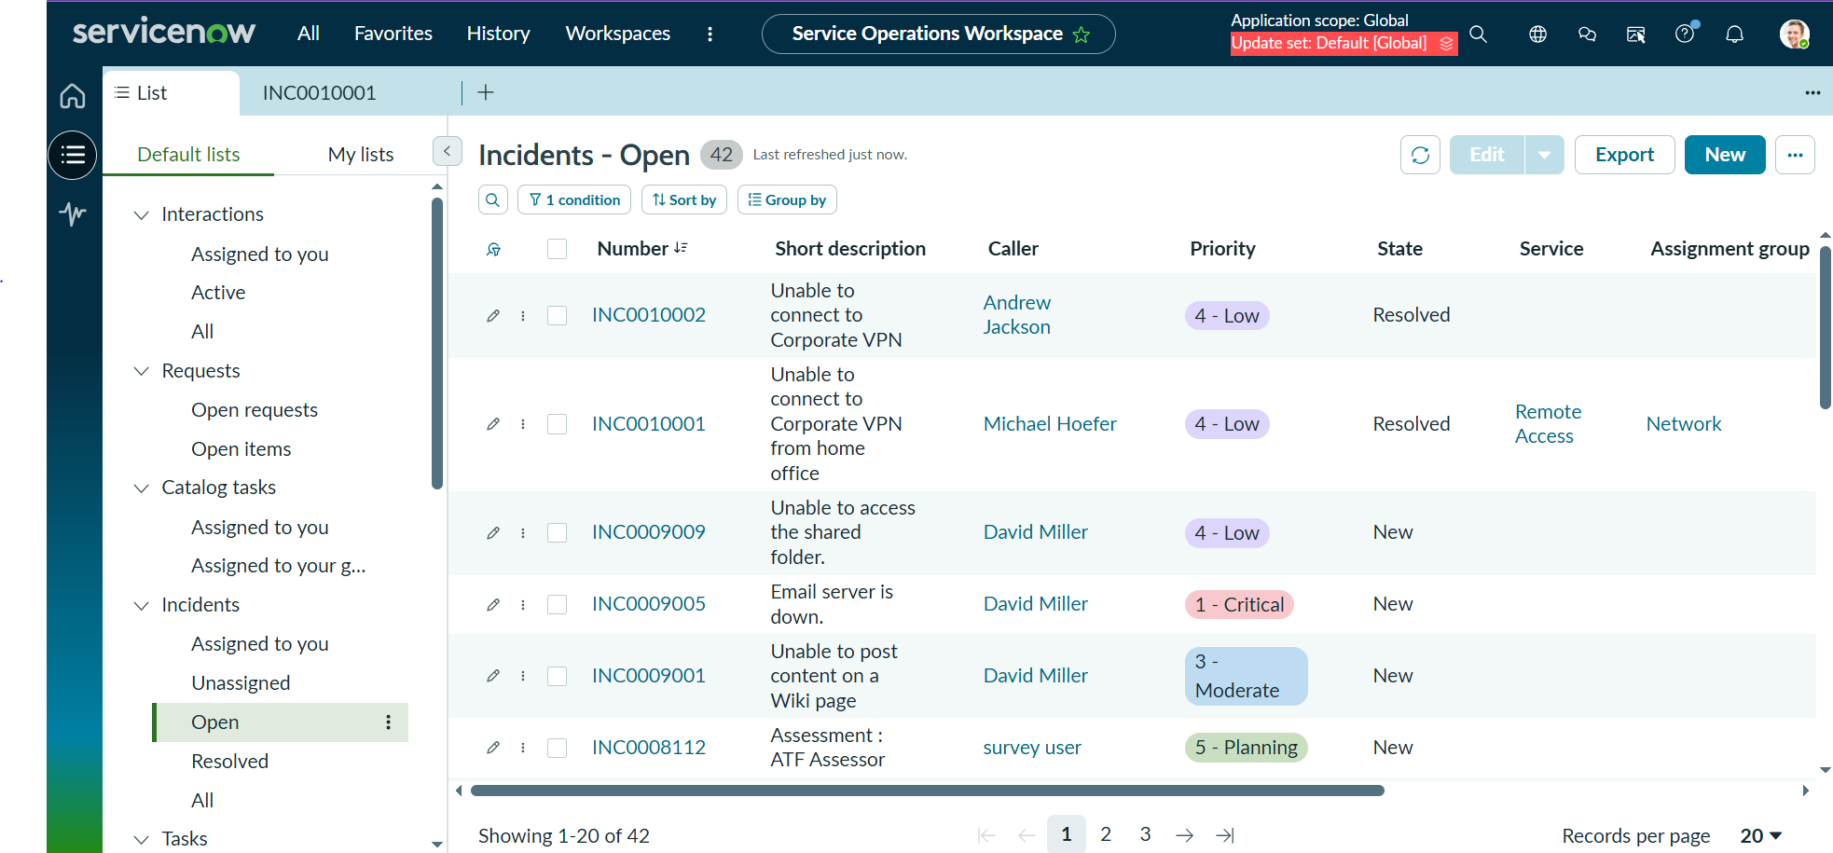
Figure 1: Incidents – Open list in Service Operations Workspace showing INC0010001 (Caller: Michael Hoefer).

Screenshot 2 – Incident record (Details tab)
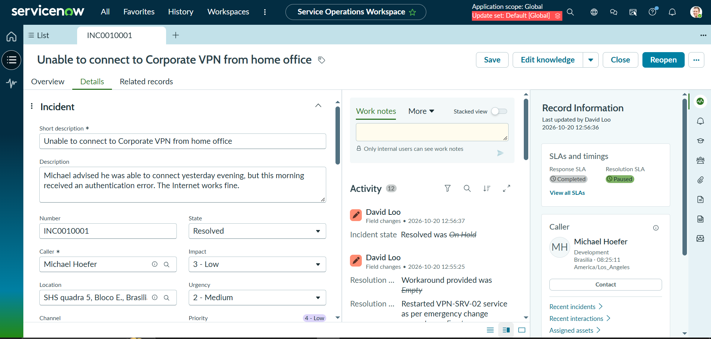
Figure 2: Incident INC0010001 – “Unable to connect to Corporate VPN from home office”, Details tab.

3. Business Impact & ITSM Best Practices
Standardized ticket creation in the Service Operations Workspace gives the support organization a consistent, reliable starting point for every incident.
- Structured caller data logging: Mandatory fields such as Short description and Caller ensure that who reported the issue, and what the issue is, are captured in a uniform format. The caller’s details (department, location, time zone) are then available to the agent in the Record Information panel.
- Immediate visibility across support tiers: Once saved, the incident appears in shared lists such as Incidents – Open, so Tier 1, Tier 2 and managers can see its state, priority and ownership without manual hand-offs.
- Consistent initial routing: Setting the Assignment group at creation sends the ticket to the right queue from the start, reducing mis-routing, re-assignment delays and SLA breaches.
- Foundation for automation and reporting: Clean, structured records support SLA tracking, priority calculation (Impact and Urgency), notifications and later lifecycle automation, as well as accurate trend reporting.
- Audit trail: Every field change is recorded in the Activity stream with the user and timestamp, supporting accountability and traceability.

4. Configuration Verification Matrix
Phase | Execution Step | Field Name / Navigation | Value / Action | Status (Pass/Fail)
Phase 3 | Step 1 | Login / Impersonation | Logged in; impersonated Service Desk Agent Beth Anglin | Pass
Phase 3 | Step 2 | Service Operations Workspace > List > Incidents > Open | Opened the Incidents - Open list | Pass
Phase 3 | Step 3 | New (button) | Clicked New to initialize a new Incident record | Pass
Phase 3 | Step 4a | Short description | Unable to connect to Corporate VPN from home office | Pass
Phase 3 | Step 4b | Caller | Michael Hoefer | Pass
Phase 3 | Step 5 | Save | Initial record saved (INC0010001) | Pass
Phase 3 | Step 6 | Details tab > Assignment group | Service Desk | Pass
Phase 3 | Step 7 | Save | Record saved; initial creation complete | Pass
Summary: All Phase 3 configuration steps were executed and verified. The Incident record was created successfully.

