Phase 7: Incident Tracking by Level 2 Document
Incident Lifecycle Automation in ServiceNow
Field | Details
Project Name | Incident Lifecycle Automation in ServiceNow
Team ID | Individual participant – 324103312L29@gvpce.ac.in
Current Task | Phase 7 – Incident Tracking by Level 2 (Investigation by Network Team)
Platform | ServiceNow – Service Operations Workspace
Incident Record | INC0010001
Level 2 Agent | David Loo (Network Support Analyst)

1. Task Overview & Executive Summary
Objective: Documenting the Level 2 Network support agent’s login, ticket acceptance, and initial technical investigation within Service Operations Workspace.
Executive Summary: Following the escalation in Phase 6, the incident now sits with the Network team. David Loo logged in, opened INC0010001 from the Open incidents list, took ownership with Assign to me, and reviewed the issue description, attached knowledge and SLA tracking to prepare for investigation.

Key outcomes
- Network Support Analyst David Loo accessed the incident from the Open incidents list.
- Formal ownership taken through Assign to me.
- Caller description, KB0000008 and active SLA tracking confirmed visible to the L2 agent.

2. Step-by-Step Implementation Details (Phase 7)
- Step 1: Logged into the ServiceNow instance and impersonated Network Support Analyst David Loo.
- Step 2: Selected the three-dots menu on the banner, selected Workspaces, and navigated to Service Operations Workspace > Incidents > Open.
- Step 3: Located and opened the reassigned VPN incident record (INC0010001).
- Step 4: Clicked Assign to me to take formal ownership of the ticket.
- Step 5: Conducted record verification across key workspace areas:
  - Confirmed the detailed caller issue description is fully visible.
  - Verified that attached Knowledge Base articles (e.g., KB0000008) are accessible.
  - Navigated to the Related Records section and verified active SLA tracking under Task SLAs (e.g., Priority 4 Resolution SLA).

Screenshot – Incident overview as seen by the L2 agent
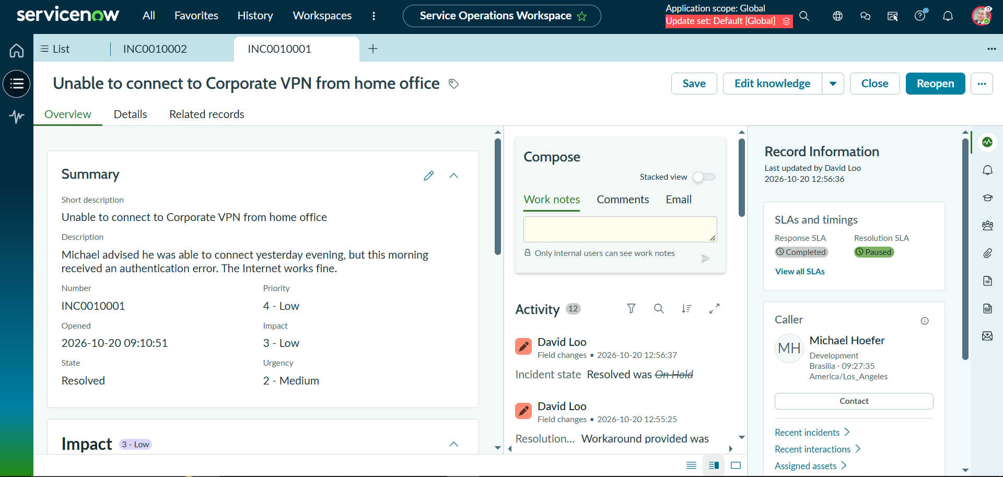
Figure 1: INC0010001 Overview tab showing the short description, caller description, Priority 4 - Low, Compose area, Activity feed and SLAs and timings.

3. Business Value & ITSM Escalation Best Practices
A smooth hand-off between support tiers keeps the user’s issue moving and keeps the service provider accountable.
- Seamless role impersonation: Impersonating the Network analyst lets the workflow be tested end to end under the correct role, confirming that L2 agents see and can act on escalated incidents without extra configuration.
- Agent ticket claim: Assign to me gives a single accountable owner, avoids duplicate work on the same ticket, and makes it clear to the caller and other teams who is investigating.
- Contextual data access across tiers: The L2 agent sees the full caller description, work notes history and attached knowledge such as KB0000008, so the caller is not asked to repeat information and investigation starts from what Tier 1 already did.
- Minimized handover friction: Because all context lives on one record, escalation does not rely on emails or verbal hand-offs, reducing delays and loss of information.
- Preserved SLA accountability: Task SLAs continue to run on the incident after reassignment, so response and resolution commitments stay visible and measurable for the new owner.

4. Verification & Testing Matrix
Phase / Step | Inspection Item | Expected Result | Execution Status (Pass/Fail)
Step 1 | Login / impersonation | Logged in; impersonated Network Support Analyst David Loo | Pass
Step 2 | Workspace navigation | Three-dots menu > Workspaces > Service Operations Workspace > Incidents > Open | Pass
Step 3 | Incident lookup | Reassigned VPN incident INC0010001 located and opened | Pass
Step 4 | Assign to me | Ticket ownership taken by David Loo | Pass
Step 5a | Issue description | Detailed caller issue description fully visible | Pass
Step 5b | Knowledge articles | Attached articles (e.g., KB0000008) accessible | Pass
Step 5c | Related Records > Task SLAs | Active SLA tracking visible (e.g., Priority 4 Resolution SLA) | Pass
Summary: All Phase 7 Level 2 tracking and verification checks were completed for INC0010001.

