Phase 4: Incident Classification Document
Incident Lifecycle Automation in ServiceNow
Field | Details
Project Name | Incident Lifecycle Automation in ServiceNow
Team ID | Individual participant – 324103312L29@gvpce.ac.in
Current Task | Phase 4 – Incident Classification (Updating Incident Details)
Platform | ServiceNow – Service Operations Workspace
Incident Record | INC0010001

1. Task Overview & Executive Summary
Objective: Classifying, categorizing, and assigning an open incident in Service Operations Workspace to ensure accurate routing, urgency prioritization, and Configuration Item (CI) mapping.
Executive Summary: Building on the incident logged in Phase 3, this phase enriches INC0010001 with the details needed to triage and resolve it. The agent recorded the contact Channel, set the Category and Subcategory, set the Urgency, linked the affected Service, Service Offering and Configuration Item, added a work note, and assigned the ticket to themselves.

Key outcomes
- Incident classified as Network > VPN.
- Urgency set to 2 - Medium, feeding the Priority calculation.
- Incident linked to the Remote Access service, the Corporate VPN offering and CI ThinkStationS20.
- Ticket ownership taken through Assign to me, with an audit note recorded.

2. Step-by-Step Implementation Details (Phase 4)
- Step 1: Navigated to the Details tab of active incident INC0010001 in Service Operations Workspace.
- Step 2: Configured the ticket classification parameters:
  - Description: Michael advised he was able to connect yesterday evening, but this morning received an authentication error. The Internet works fine.
  - Channel: Phone
  - Category: Network
  - Subcategory: VPN
  - Urgency: 2 - Medium
  - Service: Remote Access
  - Service Offering: Corporate VPN
  - Configuration Item: ThinkStationS20
- Step 3: Added Work Notes in the Compose section: “Classified and assigned incident.”
- Step 4: Clicked Assign to me to assign the ticket to the active agent.
- Step 5: Saved the record to update the classification and assignment state.

Screenshot – Incident Details tab
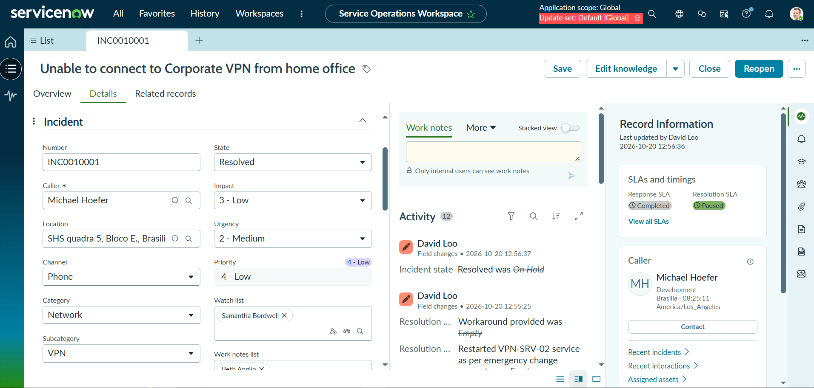
Figure 1: Incident INC0010001 Details tab showing Channel (Phone), Category (Network), Subcategory (VPN) and Urgency (2 - Medium).

3. Business Value & ITSM Categorization Impact
Structured classification turns a free-text complaint into data that the platform can act on automatically.
- Category / Subcategory: Network > VPN labels the issue type consistently. This supports correct routing to the right resolver group, knowledge article suggestions, and reliable trend reporting (for example, recurring VPN problems).
- Urgency and Priority matrix: ServiceNow calculates Priority from Impact and Urgency. Setting Urgency to 2 - Medium alongside Impact 3 - Low produces Priority 4 - Low, so the incident is queued in line with its real business effect.
- Service, Service Offering and CI linking: Mapping the ticket to Remote Access, Corporate VPN and ThinkStationS20 gives agents the context of what is affected, enables impact analysis against related records, and helps identify recurring problems tied to a CI.
- SLA assignment: Priority and service data drive SLA definitions. The record shows Response and Resolution SLAs under SLAs and timings, so response and resolution targets are tracked against the incident.
- Ownership and accountability: Using Assign to me sets a single accountable agent, and the work note provides an audit trail of who classified and assigned the incident and when.

4. Configuration Verification Matrix
Phase | Field / Option Name | Target Parameter / Value | Execution Status (Pass/Fail)
Phase 4 | Navigation | Incident INC0010001 > Details tab (Service Operations Workspace) | Pass
Phase 4 | Description | Michael advised he was able to connect yesterday evening, but this morning received an authentication error. The Internet works fine. | Pass
Phase 4 | Channel | Phone | Pass
Phase 4 | Category | Network | Pass
Phase 4 | Subcategory | VPN | Pass
Phase 4 | Urgency | 2 - Medium | Pass
Phase 4 | Service | Remote Access | Pass
Phase 4 | Service Offering | Corporate VPN | Pass
Phase 4 | Configuration Item | ThinkStationS20 | Pass
Phase 4 | Work Notes | Classified and assigned incident. | Pass
Phase 4 | Assign to me (button) | Incident assigned to the active agent | Pass
Phase 4 | Save | Record saved; classification and assignment state updated | Pass
Summary: All Phase 4 classification and assignment steps were executed and verified for INC0010001.

