Phase 11: Knowledge Creation Document
Incident Lifecycle Automation in ServiceNow
Field | Details
Project Name | Incident Lifecycle Automation in ServiceNow
Team ID | Individual participant – 324103312L29@gvpce.ac.in
Current Task | Phase 11 – Knowledge Creation (Create Knowledge Article)
Platform | ServiceNow – Service Operations Workspace
Incident Record | INC0010001
Knowledge Article | KB0010001 v0.01 (IT Knowledge Base)
1. Task Overview & Executive Summary
Objective: Converting incident resolution details into a standardized Knowledge Base article to enable self-service, shift-left support, and faster resolution for recurring issues.
Executive Summary: After incident INC0010001 was resolved, the resolution details were turned into a knowledge article using the Create Knowledge action in Service Operations Workspace. The article was created in the IT Knowledge Base with the Standard template, producing KB0010001 v0.01, which is linked to the incident.
Key outcomes
- Knowledge article KB0010001 v0.01 created from incident INC0010001.
- Article details auto-populated: Short Description, Resolution Work Notes and Category.
- Article is listed under Created Knowledge on the incident for traceability.
2. Step-by-Step Implementation Details (Phase 11)
- Step 1: Navigated to the resolved incident record INC0010001 in Service Operations Workspace.
- Step 2: Clicked Create Knowledge from the header / UI actions menu.
- Step 3: Selected the Knowledge Base:
  - Knowledge Base: IT
- Step 4: Selected the article template and clicked Next:
  - Template: Standard
- Step 5: Verified the auto-populated details (Short Description, Resolution Work Notes and Category) and clicked Save.
- Step 6: Returned to the parent incident record (INC0010001).
- Step 7: Navigated to Related Records and verified the newly generated Knowledge Article is listed under Created Knowledge.
Screenshot – Related records > Attached Knowledge
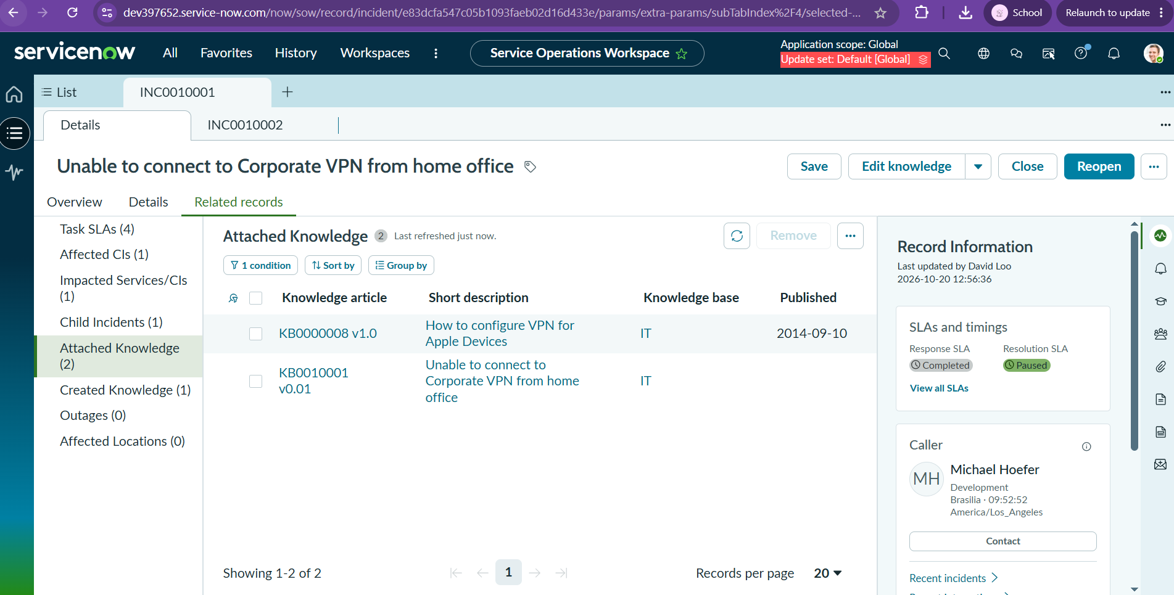
Figure 1: INC0010001 Related records tab showing Attached Knowledge (2): KB0000008 v1.0 and KB0010001 v0.01, with the Response SLA Completed and the Resolution SLA Paused.
Screenshot – Knowledge article KB0000008 v1.0
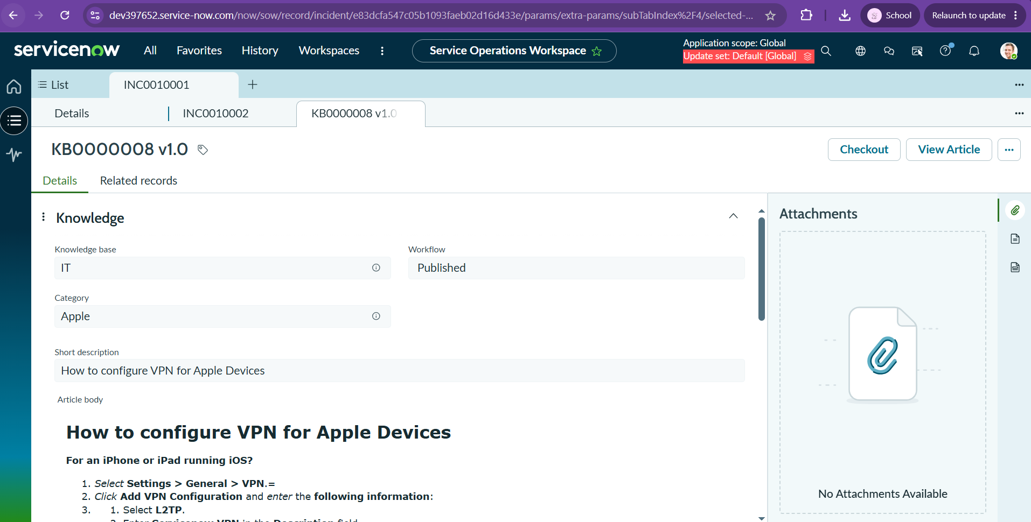
Figure 2: Knowledge article KB0000008 v1.0 (How to configure VPN for Apple Devices) in the IT Knowledge Base, Workflow Published.
3. Business Value & Knowledge Management Alignment
Turning resolved incidents into articles builds the Knowledge Base from real work and keeps fixes reusable.
- Feeds the Knowledge Base: Each resolved incident becomes a reusable article in the ITSM Knowledge Base, so the fix is captured once and shared.
- Empowers agents: Service Desk agents find these articles through Agent Assist while working on similar incidents.
- Reduces MTTR: Known fixes are found quickly, so Mean Time to Resolve goes down for recurring issues.
- Standardization: The Standard template and auto-populated fields keep articles consistent and save writing time.
- Traceability: The article is linked to INC0010001 under Created Knowledge, so its source is always clear.
4. Configuration & Verification Matrix
Phase / Step | Form Field / Action | Configured Setting / Result | Execution Status (Pass/Fail)
Step 1 | Navigation | Opened resolved incident INC0010001 in Service Operations Workspace | Pass
Step 2 | Create Knowledge | Knowledge creation started from the header / UI actions menu | Pass
Step 3 | Knowledge Base | IT | Pass
Step 4 | Article Template | Standard, then Next | Pass
Step 5 | Auto-populated details | Short Description, Resolution Work Notes and Category verified; Save clicked | Pass
Step 6 | Navigation | Returned to parent incident INC0010001 | Pass
Step 7 | Related Records > Created Knowledge | New article KB0010001 v0.01 listed | Pass
Verification | Related records > Attached Knowledge | KB0000008 v1.0 and KB0010001 v0.01 listed | Pass
Verification | SLAs and timings | Response SLA Completed; Resolution SLA Paused | Pass
Summary: All Phase 11 steps were executed and verified for INC0010001.

