Phase 8: Emergency Change Request Creation Document
Incident Lifecycle Automation in ServiceNow
Field | Details
Project Name | Incident Lifecycle Automation in ServiceNow
Team ID | Individual participant – 324103312L29@gvpce.ac.in
Current Task | Phase 8 – Emergency Change Request Creation (Configuration Update & On-Hold State)
Platform | ServiceNow – Service Operations Workspace
Incident Record | INC0010001
Incident State | On Hold – Awaiting Change

1. Task Overview & Executive Summary
Objective: Linking an emergency change requirement to the primary incident record and updating the ticket state to On Hold while awaiting change execution.
Executive Summary: Level 2 investigation (Phase 7) showed that the incident depends on a change to the affected infrastructure. In this phase the Configuration Item on INC0010001 was updated from ThinkStation to PowerEdge T110 II, and the incident was placed in the On Hold state with the reason Awaiting Change, recording the dependency until the change is carried out.

Key outcomes
- CI on the incident corrected to PowerEdge T110 II.
- Incident state set to On Hold with reason Awaiting Change.
- Pending change dependency recorded on the incident for tracking and audit.

2. Step-by-Step Implementation Details (Phase 8)
- Step 1: Navigated to the active incident record INC0010001 in Service Operations Workspace.
- Step 2: Updated the Configuration Item on the incident form from ThinkStation to PowerEdge T110 II.
- Step 3: Saved the incident record to apply the CI update.
- Step 4: Updated the ticket lifecycle state parameters:
  - State: On Hold
  - On Hold Reason: Awaiting Change
- Step 5: Saved the incident record to log the pending change dependency.

Screenshot – Related records > Affected CIs
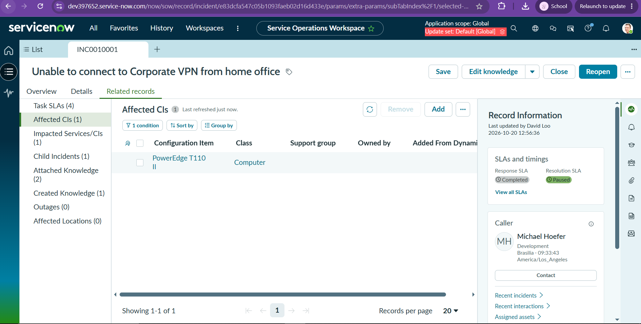
Figure 1: INC0010001 Related records tab showing Affected CIs (1): PowerEdge T110 II (Class: Computer), with the Resolution SLA shown as Paused under SLAs and timings.

3. Business Value & ITIL Alignment
Holding the incident while a change is pending keeps incident and change processes properly separated, as ITIL recommends.
- Pauses the SLA resolution clock: The On Hold state with the reason Awaiting Change stops the resolution SLA timer while the team is waiting on something outside its control, so the SLA reflects real working time.
- Prevents premature closure: The incident stays open and visible, so it cannot be closed or forgotten before the change is carried out and the fix is confirmed.
- Enforces ITIL Change Control: Hardware or service reconfiguration goes through a controlled change (here, an emergency change) with its own approval, implementation and review, rather than being done informally from the incident.
- Accurate CI mapping: Updating the CI to PowerEdge T110 II ties the incident and the change to the correct asset, improving impact analysis and the configuration history of that CI.
- Traceability: The state change, reason and CI update are logged on the record, giving a clear audit trail of why the incident was waiting and what it was waiting for.

4. Configuration & Verification Matrix
Phase / Step | Field / Option Name | Updated Value / Action | Execution Status (Pass/Fail)
Step 1 | Navigation | Opened incident INC0010001 in Service Operations Workspace | Pass
Step 2 | Configuration Item | Updated from ThinkStation to PowerEdge T110 II | Pass
Step 3 | Save | Incident saved; CI update applied | Pass
Step 4a | State | On Hold | Pass
Step 4b | On Hold Reason | Awaiting Change | Pass
Step 5 | Save | Incident saved; pending change dependency logged | Pass
Verification | Related records > Affected CIs | PowerEdge T110 II (Computer) listed as the affected CI | Pass
Verification | SLAs and timings | Resolution SLA shown as Paused | Pass
Summary: All Phase 8 configuration and state updates were executed and verified for INC0010001.

