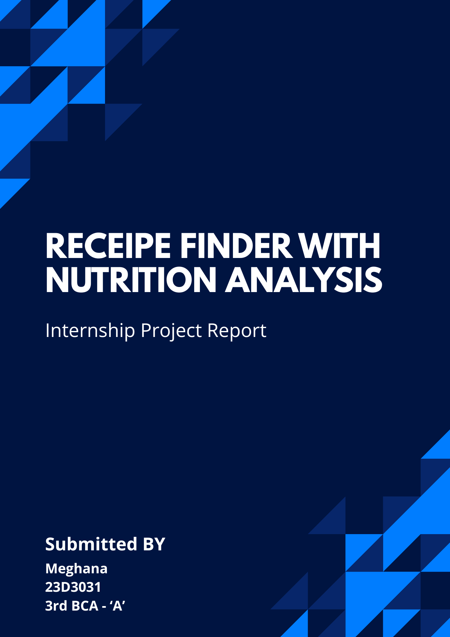

1. Project Overview
This project presents a desktop application for searching recipes by available ingredients and analysing their nutritional content. Built entirely in Python, the application integrates the Spoonacular API to fetch real-time recipe data, presents results in a polished Tkinter GUI, and visualises nutritional breakdowns using Matplotlib charts rendered inside the window. The project was developed over four weeks as part of an internship programme, covering environment setup, core feature development, optimisation, and final testing and documentation.

Problem Statement
Develop a Python-based desktop recipe search tool with a user-friendly GUI, integrating the Spoonacular API for recipe details, dietary filtering, and nutritional analysis, featuring multi-threading for smooth performance, logging for error tracking, and graphical data visualisation.

Expected Deliverables
- Source Code — with clear comments throughout all modules.
- Project Report — outlining the development process and key learnings.
- Demonstration — working demo of the application presented live.

2. Technology Stack
The following technologies were used across the project:
Component | Technology | Purpose
Programming Language | Python 3.12 | Core application language
GUI Framework | Tkinter (+ ttk) | Desktop window, widgets, layout
API Integration | Spoonacular API | Recipe search & nutrition data
Data Handling | Pandas 2.x | Structure nutrition into DataFrames
Data Visualisation | Matplotlib 3.x | Bar chart + pie chart of macros
Image Handling | Pillow (PIL) | Load & display recipe images
PDF Export | ReportLab 4.x | Export recipe + nutrition as PDF
Environment Config | python-dotenv | Load API key from .env file safely
HTTP Requests | requests | Make GET calls to Spoonacular
Logging | Python logging module | Rotating log file, DEBUG + INFO

3. System Architecture
The application is split into four focused modules. main.py is the entry point: it checks all dependencies, initialises the logger, and launches the GUI window. gui.py contains the RecipeApp class, which inherits from tk.Tk and builds the entire interface — search panel, dietary filters, results list, recipe detail pane, and nutrition tab. All slow operations (API calls, image downloads) run in daemon background threads; results are handed back to the main thread using self.after(0, callback), Tkinter's thread-safe mechanism. api_handler.py wraps every Spoonacular endpoint with retry logic (up to 3 attempts), HTTP error handling, and MD5-keyed disk caching for images. nutrition.py turns the raw JSON from the API into Pandas DataFrames and renders side-by-side bar and pie charts using Matplotlib's non-interactive Agg backend, returning PNG bytes that are embedded directly in the Tkinter window.

Module Overview
Module | Responsibility
main.py | Entry point. Checks dependencies, sets up logger, launches RecipeApp window.
gui.py | RecipeApp (tk.Tk subclass). Builds all widgets; handles search, display, theming, and threading.
api_handler.py | All Spoonacular API calls. Retry logic, HTTP error handling, image disk cache.
nutrition.py | Pandas DataFrames from JSON. Matplotlib Agg charts rendered as PNG bytes.
logger.py | Centralised rotating logger. Writes to logs/recipe_app.log (1 MB, 3 backups).

Threading Model
Tkinter is single-threaded. All API calls run in daemon background threads. Results return to the main thread via self.after(0, callback, data). A boolean _fetching flag prevents concurrent requests. A _current_img_url token discards stale image downloads when the user switches recipes quickly.

4. Implementation Timeline
Week | Objective | Key Tasks Completed
Week 1 | Research & Environment Setup | Studied Spoonacular API endpoints · Set up Python virtual environment · Installed all dependencies · Designed initial GUI layout · Implemented basic API key loading via python-dotenv
Week 2 | Core Feature Development | Implemented ingredient-based recipe search (findByIngredients) · Added dietary filters using complexSearch endpoint · Displayed recipe images, ingredient lists, and step-by-step instructions · Set up rotating log file with logger.py · Added search history persistence (JSON)
Week 3 | Enhancements & Optimisation | Introduced multi-threading for non-blocking API calls · Built Pandas DataFrame pipeline for nutrition data · Integrated Matplotlib Agg backend for embedded bar + pie charts · Added MD5 image caching to disk · Implemented PDF export using ReportLab · Added CSV nutrition export · Polished UI with light/dark themes and hover effects
Week 4 | Testing, Documentation & Deployment | Performed full regression testing across search, filter, and nutrition flows · Fixed edge cases (empty results, API limit, no internet) · Wrote inline code comments throughout all modules · Created HOW_TO_RUN.txt · Added requirements.txt · Prepared project report · Packaged run.bat / run.sh launchers

5. Features Implemented

Ingredient-Based Recipe Search
Users type comma-separated ingredients (e.g. chicken, rice, tomato) and press Search. The app calls Spoonacular's findByIngredients endpoint, which returns up to 15 matching recipes ranked by how many of the supplied ingredients they use. Results appear in a scrollable list on the left panel within seconds.

Dietary Filters
Three checkboxes — Vegetarian, Vegan, and Gluten Free — allow users to narrow results. When a filter is active, the app switches to the complexSearch endpoint which supports dietary parameters, automatically adapting the API call.

Recipe Detail View
Clicking any result loads the full recipe: a high-resolution image (fetched and cached on disk), dietary flags (vegan/gluten-free badges), preparation time and servings, a full ingredients list, and numbered step-by-step instructions.

Nutritional Analysis & Charts
The Nutrition button fetches macro data (calories, protein, carbohydrates, fat) from the nutritionWidget.json endpoint. Pandas structures this into a DataFrame. Matplotlib renders a side-by-side bar chart (all four macros) and pie chart (protein/carbs/fat ratio) as a PNG embedded in the Nutrition tab.

Multi-threading
Every API call — recipe search, detail loading, nutrition fetch, image download — runs in a daemon background thread. The GUI remains fully responsive (progress bar animates, buttons stay clickable) during all network operations. A fetching flag and URL token prevent race conditions when the user navigates quickly.

Logging & Error Tracking
logger.py provides a centralised rotating logger (1 MB per file, 3 backups). Every API request, response, warning, and unhandled exception is written to logs/recipe_app.log with timestamps. HTTP errors (401, 402, 429, 5xx) each produce specific, user-friendly error messages.

Favourites & Search History
Any recipe can be saved to Favourites with one click; saved recipes persist in favorites.json across sessions. All past searches are stored in search_history.json and displayed in the History tab for quick re-search.

PDF & CSV Export
The PDF button generates a formatted A4 document (via ReportLab) containing the recipe title, ingredients, instructions, and a nutrition table. A CSV export option saves the full nutrient breakdown (all bad/good nutrients) as a spreadsheet with UTF-8 BOM encoding for correct Excel rendering.

Dark / Light Theme
A toggle button switches between a warm cream light theme and a deep dark theme inspired by the food aesthetic. Both themes are fully applied to every widget via a recursive recolour walk, including the embedded Matplotlib charts.

Image Disk Cache
Downloaded recipe images are saved to cache/ using an MD5 hash of the URL as the filename. Subsequent views of the same recipe load the image from disk instantly, saving API quota and reducing load time to near-zero.

6. Application Screenshots
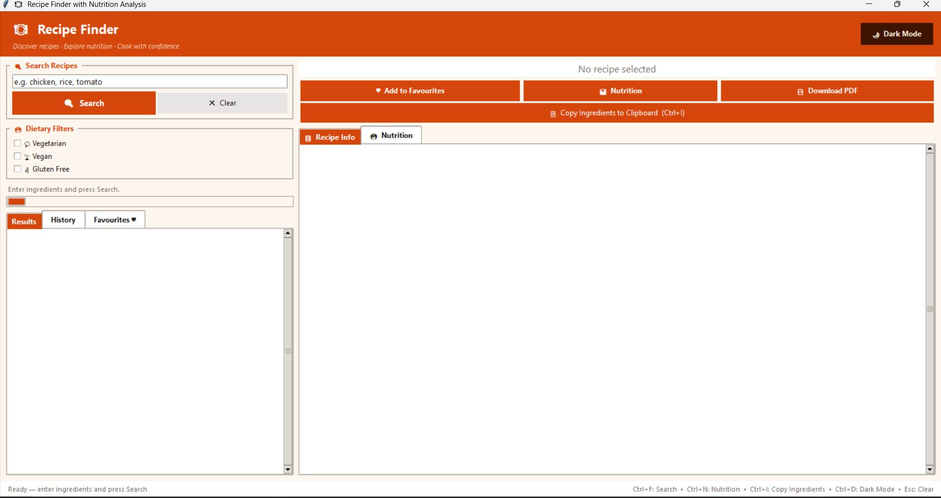
Figure 1: Application startup — empty state with search panel and dietary filters

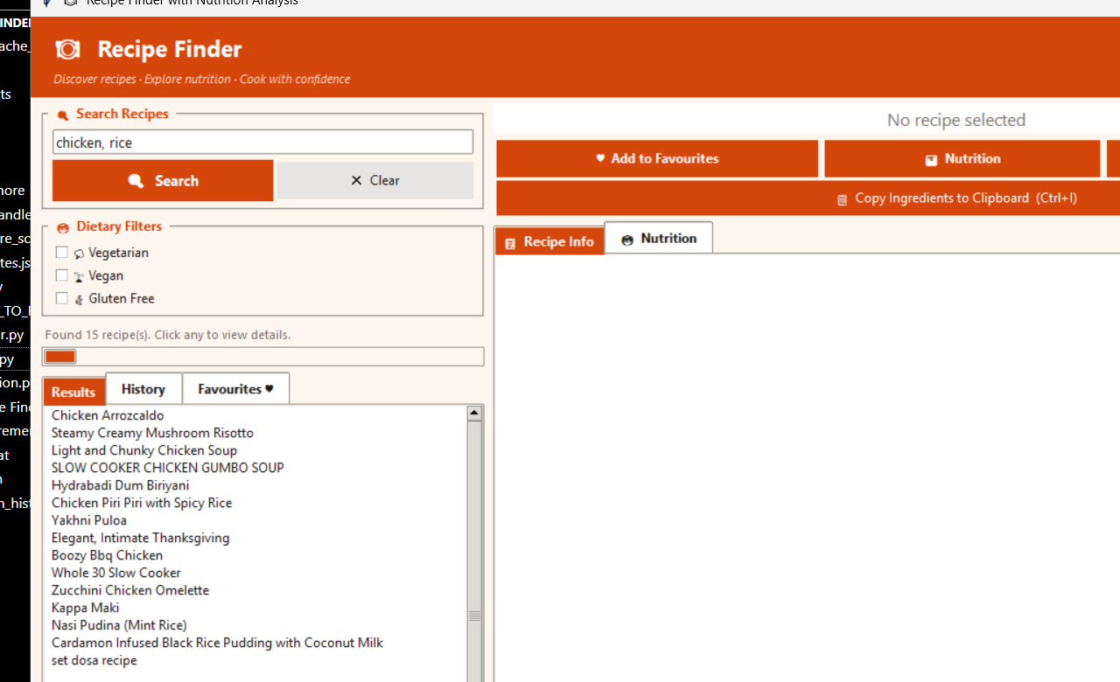
Figure 2: Search results for 'chicken, rice' — 15 recipes listed

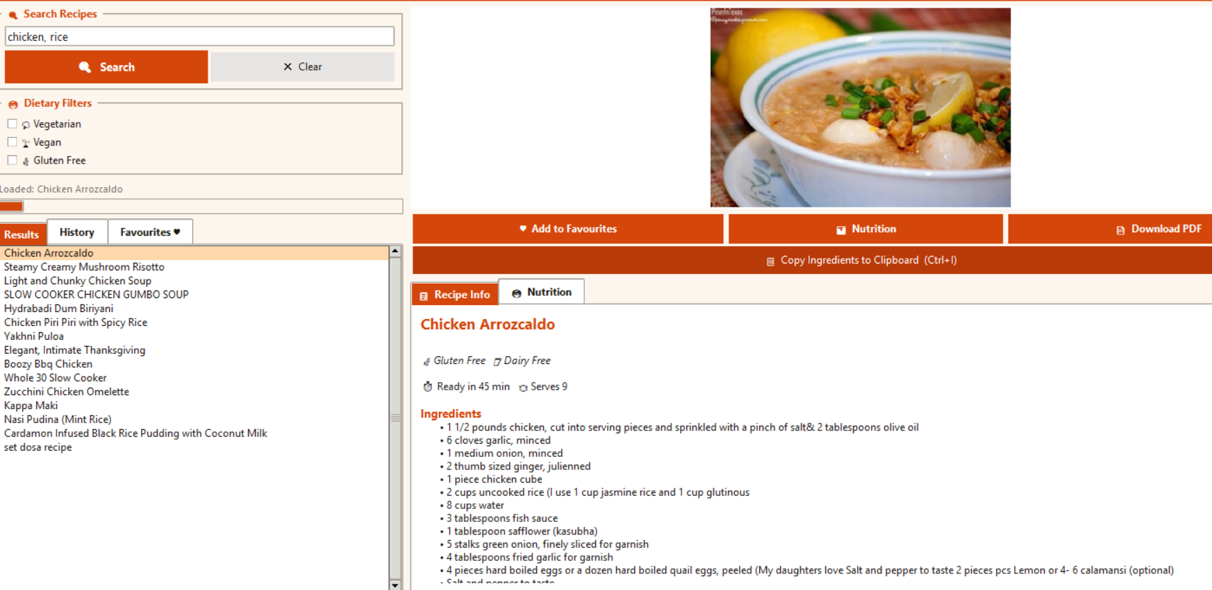
Figure 3: Recipe detail view — image, ingredients, and step-by-step instructions

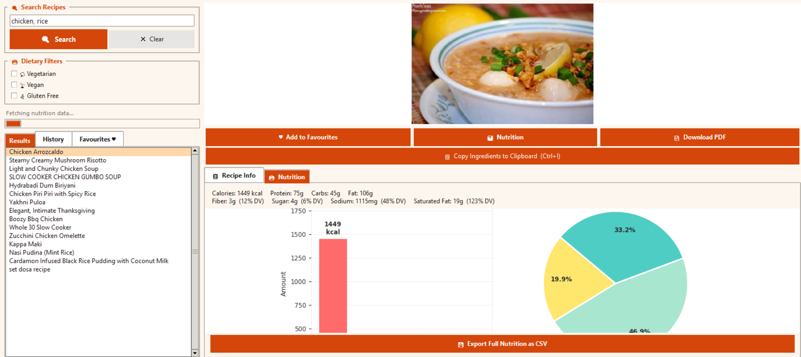
Figure 4: Nutrition tab — bar chart and pie chart for macro breakdown

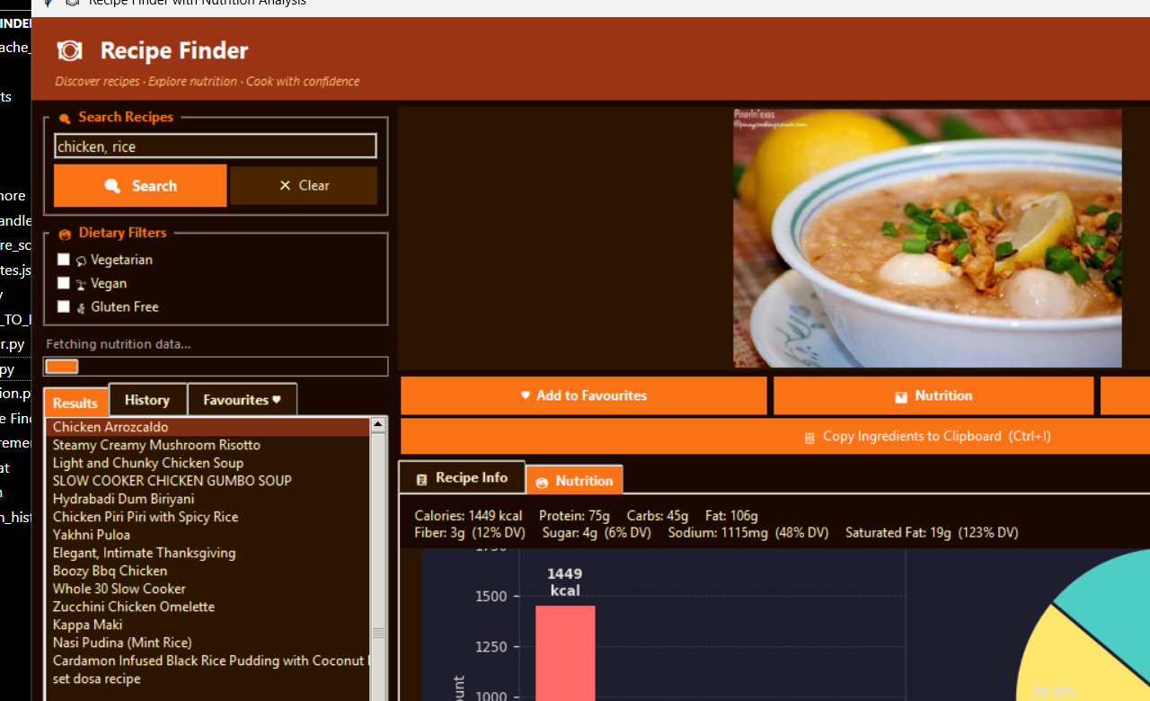
Figure 5: Dark mode theme applied to the full application

7. Challenges and Solutions

Tkinter Thread Safety
Tkinter does not allow widget updates from background threads. Any direct call to .configure() from a worker thread causes silent failures or crashes. Solution: all background threads end by calling self.after(0, callback, data), which posts the update to the main thread's event queue — the standard Tkinter thread-bridge pattern.

Matplotlib Inside Tkinter
Matplotlib's default backends open a separate pop-up window, which is undesirable in an embedded GUI. Solution: force the Agg (non-interactive) backend at import time using matplotlib.use('Agg'). Charts are rendered to an in-memory BytesIO buffer as PNG bytes, then loaded with Pillow and shown inside a tk.Label.

API Dual-Endpoint Design
The findByIngredients endpoint is faster and better at ingredient matching but does not support dietary filters. The complexSearch endpoint supports diet parameters but returns fewer metadata fields. Solution: detect whether a filter is active and route to the appropriate endpoint dynamically, normalising the response structure on return.

Retry and Rate Limiting
The free Spoonacular plan allows 150 calls/day and can return HTTP 429 (rate limited) on rapid searches. Solution: a retry loop with up to 3 attempts and 1.5-second back-off handles transient errors. 401, 402, and 429 codes each surface a specific, actionable error message to the user.

Image Race Condition
If a user clicked through recipes quickly, a slow image download for recipe A could finish after recipe B was already selected, showing the wrong image. Solution: store the URL of the most recently requested image in _current_img_url; on download completion, compare before rendering — discard stale bytes if the URL no longer matches.

CSV Encoding on Windows Excel
Standard UTF-8 CSV files show garbled characters when opened in Microsoft Excel on Windows because Excel expects a Byte Order Mark (BOM). Solution: use encoding='utf-8-sig' in pandas DataFrame.to_csv(), which adds the BOM automatically, making Excel open the file correctly without user intervention.

8. Key Learnings
- Spoonacular API integration — endpoint selection, parameter handling, pagination, and quota management on a free plan.
- Tkinter GUI design — widget layout with grid/pack, ttk themes, custom colour application via recursive widget walks.
- Thread-safe GUI programming — daemon threads, self.after() as a thread bridge, and race condition prevention patterns.
- Pandas for structured data — building DataFrames from JSON, sorting, filtering, and exporting to CSV.
- Matplotlib in embedded contexts — the Agg backend, Figure/FigureCanvasAgg API, and rendering charts as in-memory PNG bytes.
- Python logging best practices — rotating file handlers, multiple named loggers per module, DEBUG vs INFO levels.
- Defensive API design — input sanitisation, response validation, specific HTTP error handling, and retry logic.
- Python packaging for end users — virtual environments, requirements.txt, cross-platform launcher scripts (run.bat / run.sh), and HOW_TO_RUN documentation.

9. Conclusion
The Recipe Finder with Nutrition Analysis application successfully fulfils all requirements set out in the internship problem statement. The application delivers a fully functional desktop tool with ingredient-based search, dietary filtering, detailed recipe views, and embedded nutritional charts — all within a polished, responsive GUI. Beyond the core requirements, the project added several enhancements: PDF and CSV export, persistent favourites and search history, a dark/light theme toggle, and an image disk cache. The four-week development cycle provided hands-on experience across the full Python desktop application stack — API integration, GUI design, multi-threading, data analysis, and deployment — building a strong practical foundation for future software development work.

10. References
- Spoonacular API Documentation — https://spoonacular.com/food-api/docs
- Python Tkinter Documentation — https://docs.python.org/3/library/tkinter.html
- Pandas Documentation — https://pandas.pydata.org/docs/
- Matplotlib Documentation — https://matplotlib.org/stable/contents.html
- ReportLab User Guide — https://www.reportlab.com/docs/reportlab-userguide.pdf
- python-dotenv — https://pypi.org/project/python-dotenv/
- Pillow (PIL Fork) — https://pillow.readthedocs.io/
- Requests Library — https://requests.readthedocs.io/

