**Problem Statement**

Three Developers are working in Aperture Technology co. Their company wants better Source Code Management System because the earlier tool had the tendency to save redundant code. Multiple Developers working simultaneously on the same block of code also caused problems. You are Mike, and your manager has given you the task of moving the company’s code base to git and Github.

**Action Items:**

**1. Create a Local Git Repository and Move the Entire Code Base:**

* Navigate to the Project Directory



* Initialize new git repository



* Add all files to the repository
* Commit the changes



### 2. Create a New Branch for a New Feature:

* Create new branch feature



* Switch to the new branch



* Made changes in the index.html
* Commit the changes

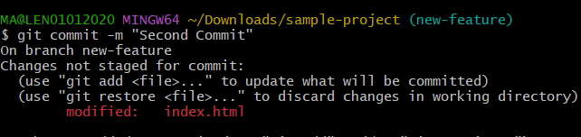

* Switch back to the master branch

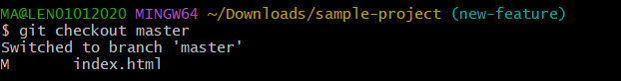

### 3. Merge the Created Branch with the Master Branch:

### 

### 4. Create a Remote Repository on GitHub

* Go to GitHub and login
* Click on + to create new repository as shown below

### 

* Give the name of the repository

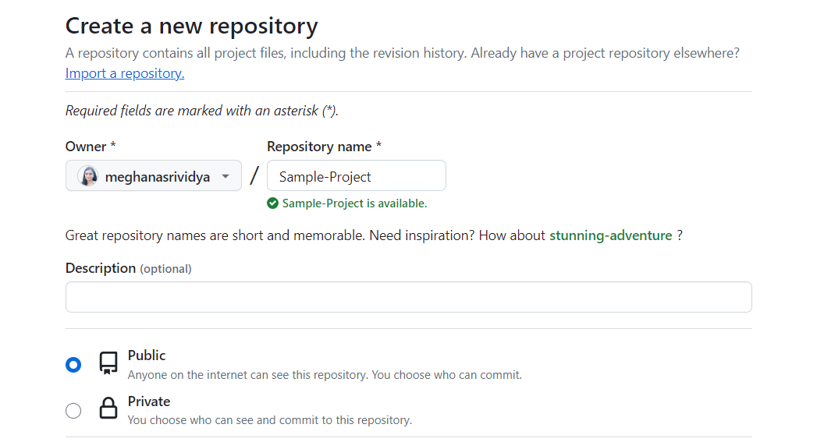

* Click on create repository

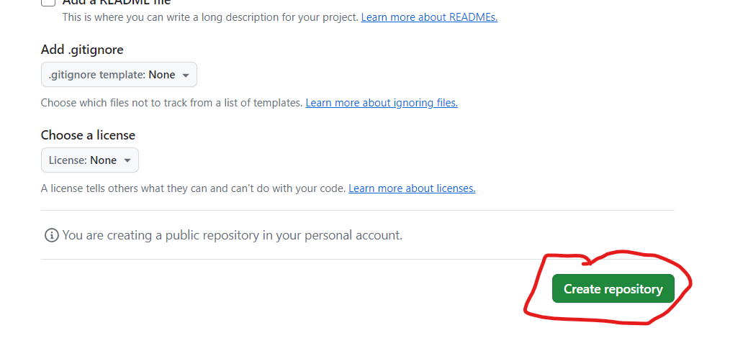

* New repository created

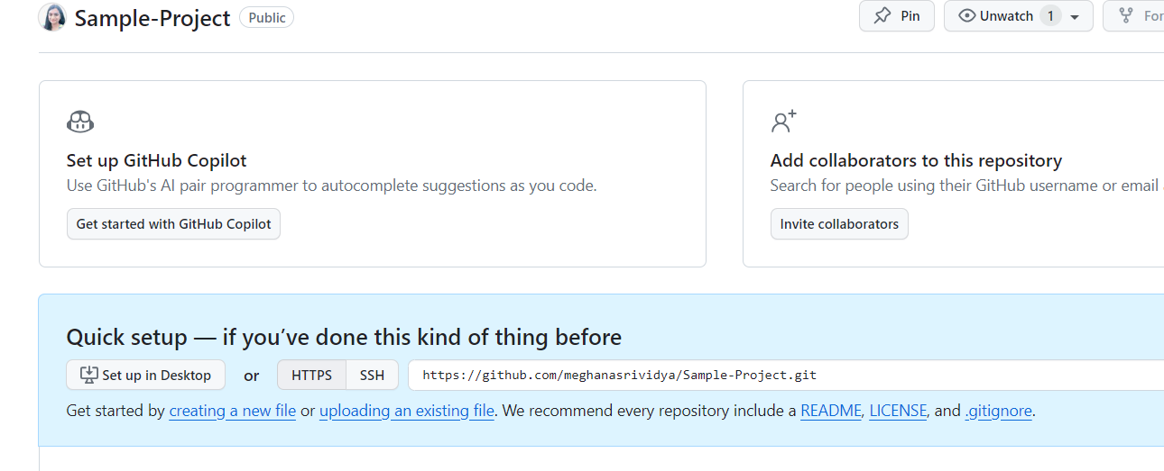

### 5. Push the Local Repository to the Company’s Remote Repository:

* Add the remote repository URL



* Push the master branch to the remote repository

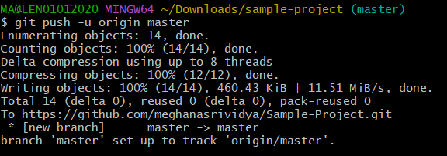

* Push the new-feature branch to the remote repository

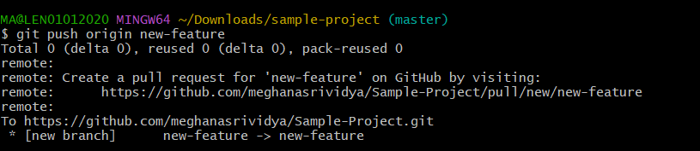

* Code in remote repository

