**SUMMARY**

## USC ID/s: 7870573217, 6565038173, 6117696230

|  |  |  |  |  |
| --- | --- | --- | --- | --- |
| M+N | Time in MS (Basic) | Time in MS (Efficient) | Memory in KB (Basic) | Memory in KB (Efficient) |
| 16 | 0.0 | 0.0 | 13864.0 | 14000.0 |
| 64 | 1.5869140625 | 3.0126571655273438 | 14032.0 | 13968.0 |
| 128 | 12.833833694458008 | 11.99960708618164 | 14008.0 | 14004.0 |
| 256 | 136.80315017700195 | 62.22653388977051 | 14468.0 | 13936.0 |
| 384 | 50.5366325378418 | 100.6472110748291 | 15328.0 | 14060.0 |
| 512 | 139.55116271972656 | 199.99265670776367 | 16132.0 | 13952.0 |
| 768 | 187.43276596069336 | 447.800874710083 | 18176.0 | 13932.0 |
| 1024 | 362.05196380615234 | 682.3165416717529 | 22020.0 | 14076.0 |
| 1280 | 577.0320892333984 | 1037.4088287353516 | 27716.0 | 14072.0 |
| 1536 | 849.576473236084 | 1520.9853649139404 | 33220.0 | 14072.0 |
| 2048 | 1732.1856021881104 | 2751.5475749969482 | 51564.0 | 14532.0 |
| 2560 | 2372.6236820220947 | 4557.240724563599 | 66712.0 | 14568.0 |
| 3072 | 3737.927198410034 | 7852.494955062866 | 99628.0 | 14440.0 |
| 3584 | 3846.257448196411 | 13125.321865081787 | 102176.0 | 14452.0 |
| 3968 | 6143.084287643433 | 18215.56043624878 | 143044.0 | 14520.0 |

## Datapoints

## Insights

### Graph1 – Memory vs Problem Size (M+N)

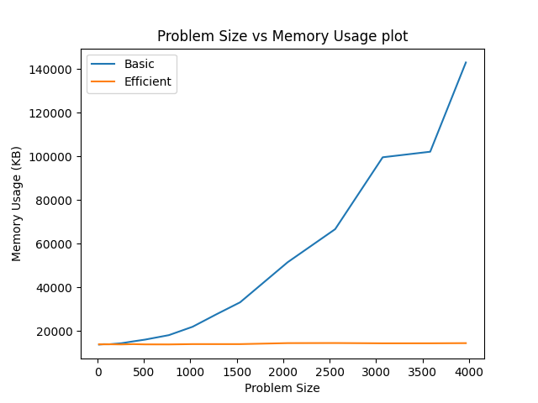

#### Nature of the Graph (Logarithmic/ Linear/ Polynomial/ Exponential)

Basic:

Efficient:

#### Explanation:

### Graph2 – Time vs Problem Size (M+N)

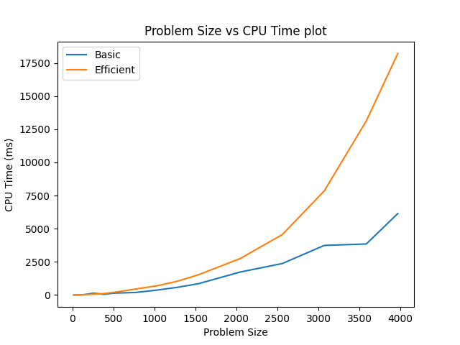

#### Nature of the Graph (Logarithmic/ Linear/ Polynomial/ Exponential)

Basic:

Efficient:

#### Explanation:

## Contribution

(Please mention what each member did if you think everyone in the group does not have an equal contribution, otherwise, write “Equal Contribution”)

7870573217: <Equal Contribution>

6565038173: <Equal Contribution>

6117696230: <Equal Contribution>