PROJECT REPORT
Title:
Visualization Tool for Electric Vehicle Charge and Range Analysis

INTRODUCTION

Project Overview
    - EV analytics project introduction
    - Need for EV data visualization
    - Tableau + MySQL + Flask overview

Purpose
    - Why this project is developed
    - Benefits for EV users, analysts, decision makers

IDEATION PHASE

Problem Statement
Electric vehicle data is distributed across multiple sources, making it difficult for users, analysts, and organizations to understand vehicle performance, charging infrastructure, pricing, and market trends.
There is a need for an interactive analytics solution that combines electric vehicle datasets and provides meaningful insights through visual dashboards.
The project aims to develop an Electric Vehicle Analytics platform using MySQL and Tableau to analyze charging stations, EV specifications, vehicle efficiency, price comparison, and brand performance.

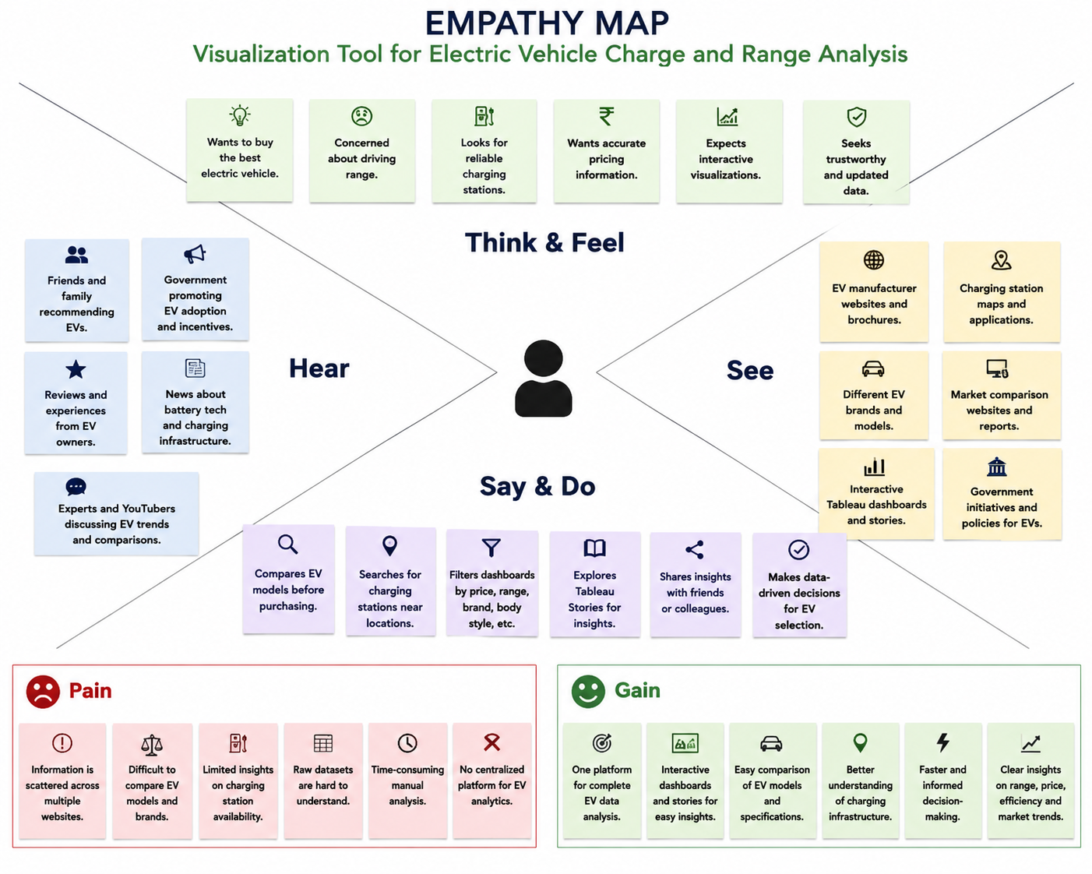
Empathy Map Canvas

Brainstorming
Electric vehicle data is available from different sources, but users face difficulties in analyzing EV
performance, pricing, charging availability, and market comparison.
A centralized visualization platform is required to combine EV datasets and generate interactive insights through dashboards.

Brainstorming Ideas:
Data Analysis
- Electric vehicle dataset collection
- SQL database creation
- Data preprocessing and cleaning
- EV market trend analysis

Visualization
- Interactive Tableau dashboard
- EV charging station map
- Vehicle price comparison
- Efficiency and performance analysis
- Dynamic filters and dashboard actions

EV Insights
- Charging station availability analysis
- EV price comparison
- Brand performance comparison
- Vehicle efficiency analysis
- PowerTrain analysis

Web Integration
- Tableau Public publishing
- Dashboard embedding
- User-friendly web interface

Idea Prioritization:
The selected idea is the development of an Electric Cars Analytics Platform by integrating MySQL database management and Tableau visualization.
The solution provides interactive insights about electric vehicle performance, pricing, brands, efficiency, and charging infrastructure.

REQUIREMENT ANALYSIS

Customer Journey Map

Need Information about Electric Vehicles

Search for EV Details Online

Visit EV Visualization Web Application

Open Tableau Dashboard / Story

Apply Filters & Explore Visualizations

Compare EV Models, Prices, Range & Charging Stations

Analyze Insights

Make Data-Driven EV Purchase Decision

Share Insights & Recommendations

Solution Requirement

Functional Requirements
The Electric Cars Analytics system provides the following functionalities:
- Collect and process electric vehicle datasets from multiple sources.
- Store EV-related information using a MySQL database.
- Retrieve and analyze EV data using SQL queries.
- Create interactive Tableau visualizations for better data understanding.
- Display electric vehicle performance, pricing, efficiency, and charging station insights.
- Provide dynamic filters and dashboard actions for user interaction.
- Publish Tableau dashboards and stories through Tableau Public.
- Integrate Tableau visualizations with a web-based interface.

Non-Functional Requirements
- The system should provide accurate analytical results.
- Dashboard interaction should be smooth and responsive.
- Visualizations should be simple and easy to understand.
- The system should support future dataset expansion.
- Published dashboards should be accessible through online links.

Data Flow Diagram
EV Dataset Sources
↓
Data Collection Process
↓
MySQL Database
↓
SQL Data ProcessingTableau Visualization
↓
Flask Web Application
↓
End Users
(Customers / Analysts / Companies)

Technology Stack
Database Technology MySQL Database
MySQL is used for storing and managing electric vehicle datasets. It helps organize structured data and execute SQL queries for analysis.
Tools:
- MySQL Server 8.0
- MySQL Workbench

Visualization Technology Tableau
Tableau is used for creating interactive dashboards and stories from processed EV datasets. Features Used:
- Worksheets
- Dashboards
- Stories
- Filters
- Maps
- Tableau Public Publishing

Web Technology Flask Framework
Flask is used to create a web interface for displaying embedded Tableau dashboards and stories. Technologies:
- Python Flask
- HTML
- CSS

Programming and Query Language
- SQL - Database operations and analysis
- Python - Web application development

PROJECT DESIGN

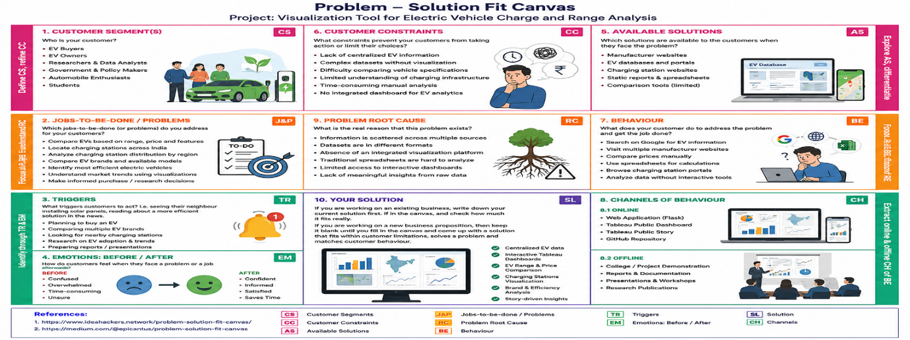
Problem Solution Fit

The Problem Solution Fit explains how the Electric Vehicle Analytics Platform addresses challenges faced by users in understanding EV information.

The solution combines multiple electric vehicle datasets and provides interactive Tableau dashboards to analyze charging stations, pricing, vehicle specifications, efficiency, and performance.
This helps users make better decisions through centralized and visual data insights.

Proposed Solution
The proposed solution is an Electric Vehicle Analytics Platform that integrates MySQL database management, Tableau visualization, and Flask web technology.
The system collects EV datasets from different sources and stores structured data inside a MySQL database. SQL operations are performed for data processing and analysis.
The processed data is connected with Tableau to create interactive worksheets, dashboards, and stories. Users can analyze EV brands, charging station availability, vehicle prices, top speed, efficiency, body style, and powertrain categories.
The final Tableau dashboard and story are published through Tableau Public and integrated into a Flask web application to provide easy access through a user-friendly interface.

Solution Architecture
USER
(End User)

Web Browser Access
(Desktop / Mobile)

Flask Web Application
(HTML • CSS • Bootstrap)

Tableau Dashboard Tableau Story User Interface
(Interactive Charts) (Insights) (Filters & Views)

Tableau Public
(Published Dashboard)

SQL Processing Layer
(Cleaning • Queries • Analysis)

MySQL Database

EV CSV Dataset Files
The solution architecture represents the complete workflow of the Electric Vehicle Analytics Platform.
The system begins with EV CSV datasets which are processed and stored inside the MySQL database. SQL operations are performed for data preparation and analysis.
The processed data is connected with Tableau Desktop to create interactive dashboards, charts, maps, KPIs, and stories.
The dashboards are published through Tableau Public Server and embedded into a Flask web application using HTML, CSS, and JavaScript.
End users such as EV customers and analysts can access the web application to explore electric vehicle insights interactively.

PROJECT PLANNING & SCHEDULING
Project planning defines the complete development process of the Electric Vehicle Analytics Platform. The project activities were divided into different sprint phases to complete development in an organized manner.
The planning process includes dataset preparation, database creation, visualization development, dashboard implementation, Tableau publishing, web integration, testing, and documentation.

Sprint | Activities | Duration
Sprint 1 | Dataset Collection, Data Cleaning, MySQL Database Creation  SQL Processing | 24 Jun 2026 - 26 Jun 2026
Sprint 2 | Tableau Worksheets, Dashboard Creation, Filters and Action  Implementation | 27 Jun 2026 - 30 June 2026
Sprint 3 | Tableau Story Creation and Tableau Public Publishing | 01 Jul 2026 - 03 Jul 2026
Sprint 4 | Flask Web Integration, Testing and Documentation | 04 Jul 2026 - 05 Jul 2026

FUNCTIONAL AND PERFORMANCE TESTING
Functional and performance testing was performed to verify the working efficiency, accuracy, and responsiveness of the Electric Vehicle Analytics Platform.

Testing ensures that datasets are properly processed, Tableau dashboards work correctly, filters respond accurately, and users can interact with the published analytics platform without issues.

Data Rendering Testing
The EV datasets were successfully imported into MySQL database and connected with Tableau Desktop for visualization.
Datasets Tested:
- ElectricCarData_Clean
- EVIndia
- Electric Vehicle Charging Station List
- Cheapest Electric Cars Database
The database connection and data rendering process were verified successfully.

Visualization Testing
All Tableau worksheets and visualizations were tested to ensure proper data representation.
Visualizations Tested:
- Charging Stations by Region & Type
- EV Charging Station Map
- Different Electric Vehicle Cars
- Top Speed by Brand
- Price Analysis
- Top 10 Efficient Brands
- Brands by Body Style
- Powertrain Treemap
All visualizations generated expected analytical results.

Publishing and Web Integration Testing
The completed Tableau dashboard and story were published successfully using Tableau Public.
The Tableau Public embed code was integrated into the Flask web application, allowing users to access interactive EV analytics through a web interface.

The web page responsiveness and dashboard loading performance were successfully verified.

Testing Result:
The Electric Vehicle Analytics Platform successfully passed functional and performance testing. The system provides accurate visualization results, interactive filtering, and smooth dashboard accessibility.

RESULTS

Output Screenshots
The Electric Vehicle Analytics Platform was successfully developed by integrating MySQL database, Tableau visualization, and Flask web application.

The final system provides interactive dashboards and stories that allow users to analyze EV charging infrastructure, vehicle specifications, pricing, efficiency, and performance insights.

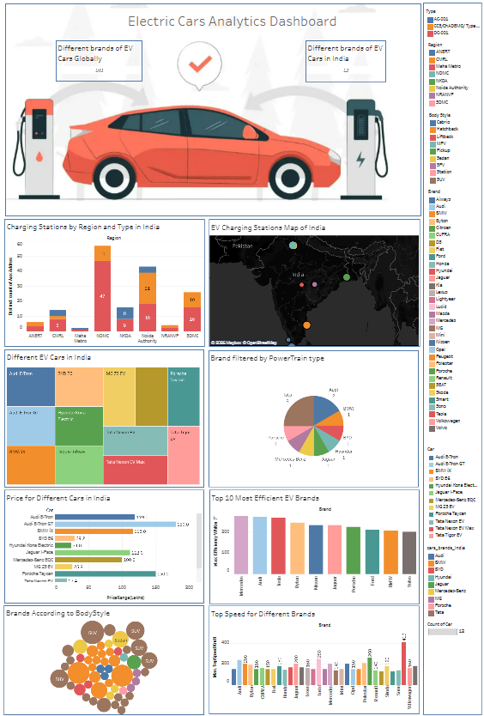
Tableau Dashboard Output

The interactive Tableau dashboard displays complete electric vehicle analysis including charging stations, EV maps, brand comparison, price analysis, top speed, efficiency, body style, and powertrain insights.

Users can interact with dashboard filters to explore specific EV information.

Tableau Story Output
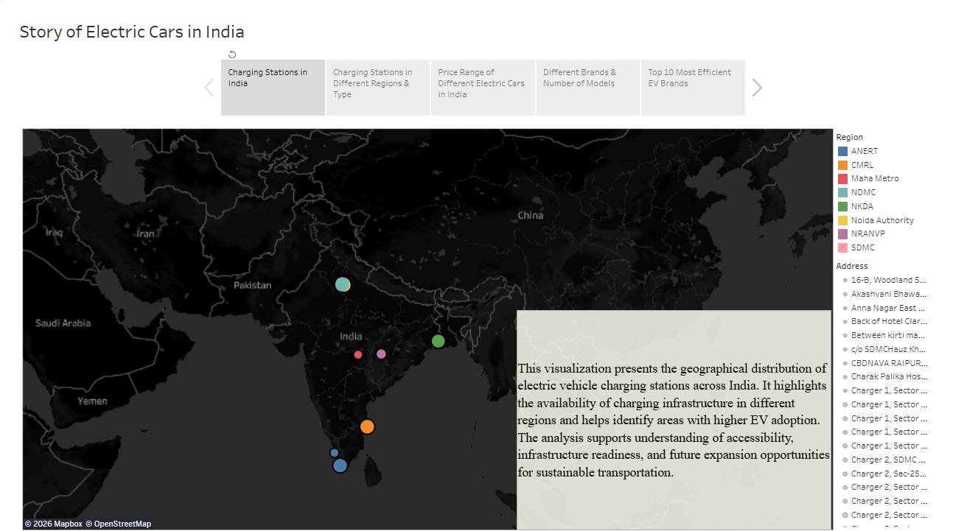

The Tableau story presents electric vehicle analytics in a sequential storytelling format. It helps users understand important EV trends and insights step by step.

Web Application Output
The Flask web application provides a user-friendly interface where Tableau dashboards and stories are embedded.
Users can access EV analytics directly through the web application without opening Tableau separately.

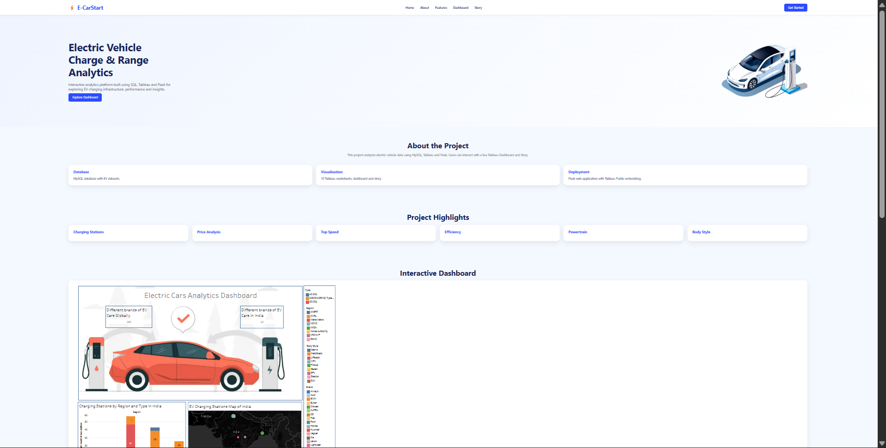

ADVANTAGES & DISADVANTAGES

Advantages
The advantages of the Electric Vehicle Analytics Platform are:
- Provides interactive visualization of electric vehicle data through Tableau dashboards.
- Combines multiple EV datasets into a centralized analytics platform.
- Helps users compare electric vehicles based on price, speed, efficiency, and specifications.
- Provides geographical analysis of EV charging station availability.
- Dynamic filters allow users to explore specific brands, models, and vehicle categories.
- Tableau Public publishing enables easy online access and sharing of dashboards.
- Web integration provides a simple and user-friendly interface for accessing analytics.
- Reduces complexity in understanding large EV datasets through visual representation.

Disadvantages
The limitations of the Electric Vehicle Analytics Platform are:
- The analysis depends on the accuracy and availability of collected datasets.
- Real-time electric vehicle data updates are not implemented.
- Tableau Public dashboards require internet connectivity for online access.
- The system currently focuses on visualization and does not include predictive analytics.
- Large dataset processing may require additional optimization techniques.

CONCLUSION
The Electric Vehicle Analytics Platform was successfully developed to analyze and visualize electric vehicle data using MySQL and Tableau.
The project integrated multiple EV datasets containing vehicle specifications, pricing details, performance information, and charging station data. The datasets were processed using MySQL database operations and transformed into meaningful visual insights using Tableau.
Interactive dashboards and stories were created to represent EV charging infrastructure, brand comparison, price analysis, vehicle efficiency, top speed, body style, and powertrain distribution.
The Tableau dashboards were published through Tableau Public and integrated into a Flask web application to provide a simple and interactive user experience.

The project demonstrates how data analytics and visualization technologies can help users understand electric vehicle trends and support better data-driven decisions.

FUTURE SCOPE
The future enhancements of the Electric Vehicle Analytics Platform include:
- Integration of real-time electric vehicle datasets for continuous updates.

- Implementation of machine learning models to predict EV market trends.

- Development of an EV recommendation system based on user requirements.

- Addition of battery performance and charging time prediction features.
- Integration of real-time charging station availability tracking.
- Implementation of advanced geographical analytics for charging infrastructure planning.

- Expansion of datasets to include more countries and global EV markets.

- Deployment of the application using cloud platforms for improved accessibility and scalability.

APPENDIX

Source Code
The complete source code contains:
- Flask application files
- HTML and CSS user interface
- Tableau integration code
- SQL database scripts
- Project datasets

GitHub Repository Link:

Dataset Link
Datasets used in this project:
- ElectricCarData_Clean
- EVIndia
- Electric Vehicle Charging Station List
- Cheapest Electric Cars Database

Dataset Link:
https://drive.google.com/drive/folders/1Rkzdks6Us1Uq2SRB4nxMAb83jN5bpHll

GitHub & Project Demo Link
GitHub Repository:
https://github.com/meghanath0225/Visualization-Tool-for-Electric-Vehicle-Charge-and-Range-Analysis

Tableau Dashboard Public Link:

https://public.tableau.com/app/profile/vutti.venkata.meghanath/viz/ElectricCarsAnalyticsDashboard_17831451243460/Dashboard1
Tableau Story Public Link:
https://public.tableau.com/app/profile/vutti.venkata.meghanath/viz/StoryofElectricCarsinIndia_17832669081640/StoryofElectricCarsinIndia
Flask Link:
http://127.0.0.1:5500/templates/index.html
Project Demonstration Video:

