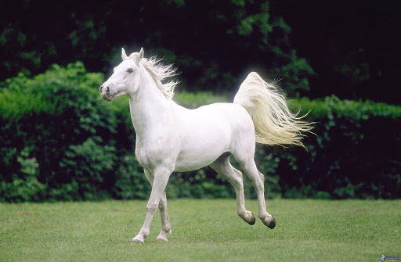

|  |  |  |  |
| --- | --- | --- | --- |
| Sno | Name | Roll no | Marks |
| 1 | Meghana | 93 | 90 |
| 2 | Sarika | 91 | 90 |
| 3 | Krishna | 90 | 93 |
| 4 | Prashanth | 92 | 92 |

