**Introduction:**

In this project, we will trying to find popular Italian restaurant near Mandarin Oriental Hotel, Hong Kong. Hong Kong, as a special administrative region of China, is a highly developed territory and ranks fourth on the UN Human Development Index. Hong Kong is recognized as one of the world's most liberal economic systems due to its free trade policy, no trade barriers and no limit for foreign onshore and offshore investments, so the capital just flows and flows. The topic might be interesting as there are so many business travelers who will be staying at a luxury hotel and will need guidance in finding nice restaurants.

**Data acquisition & cleaning**

* I will be using **Google API** to get the hotel location---longitude and latitude
* I will be using **Foursquare API** to retrieve the restaurants information.

**Methodology**

* We will assign relevant part of JSON to venues and transform venues into a data frame.

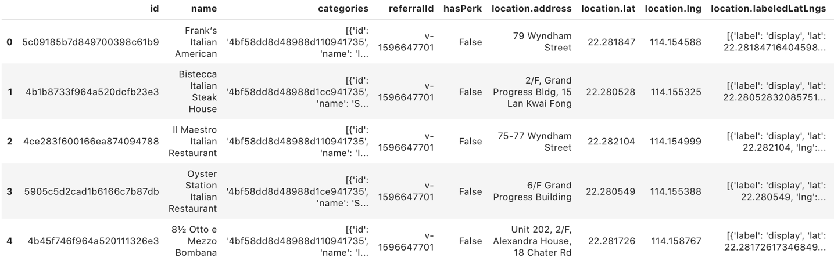

* By using **filter function**, we will have a clearer table of the restaurants near the hotel.

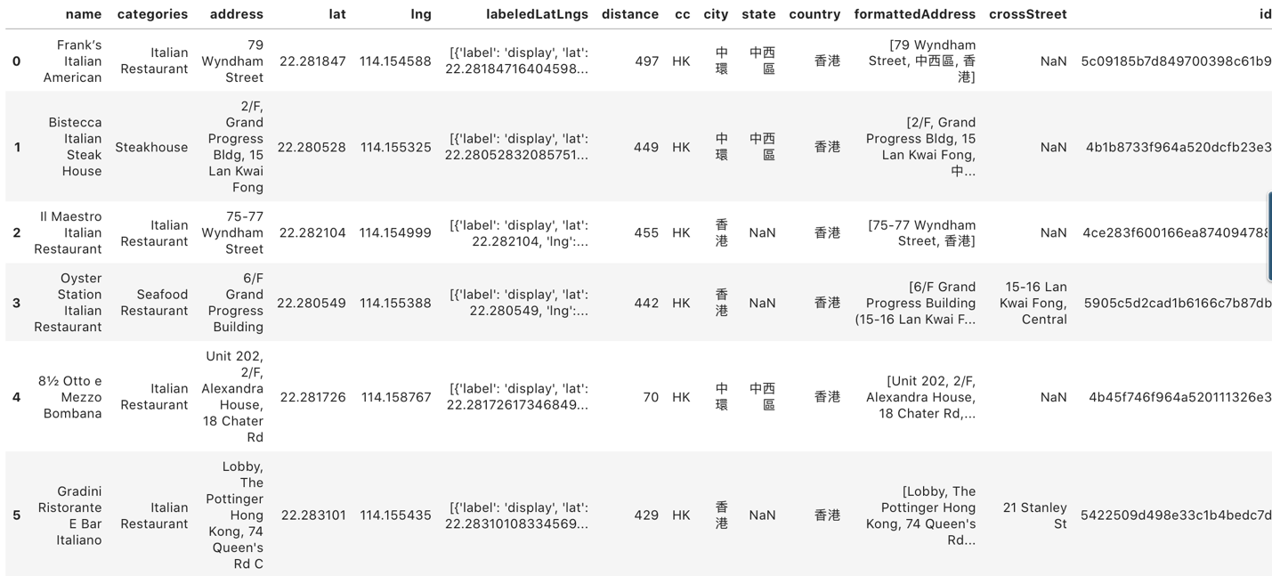

**Result**

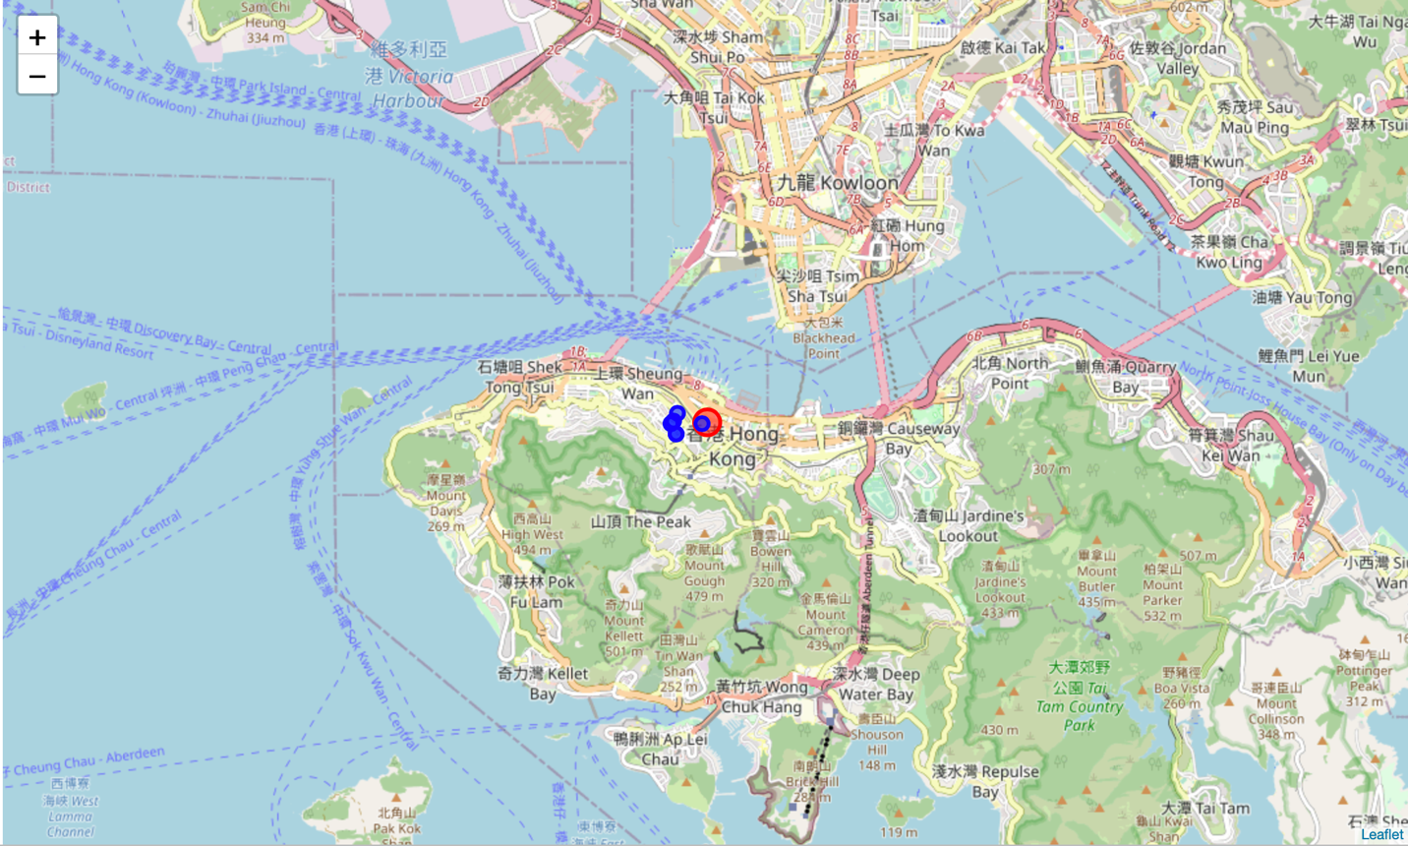

In the map we created above, we could clearly see the available Italian restaurants near hotel. As a result, business travelers, mostly from Europe, will have an easy time knowing the nearest Italian restaurant.

**Discussion & Conclusion**

In this study, I researched popular Italian restaurants near the Mandarin Oriental Hotel in Hong Kong. I utilized Foursquare API to retrieve a list of restaurants near the hotel, and used the filter function to get a clear table. This result will be useful for business travelers to find nice Italian places to dine in when they have limited time to decide.