Diamond sizes

Megha Nair

2023

#Giving echo = TRUE will save the code and result also in the output

We have data about 53940 diamonds. Only 1889 are larger than 2 carats. The distribution of the remainder is shown below:

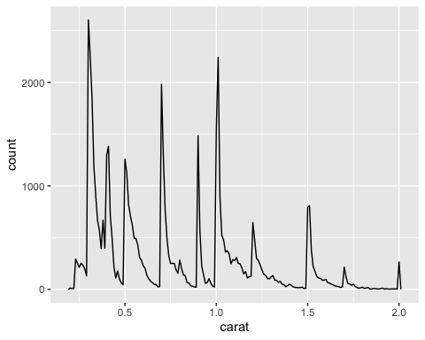

End of document