

**BBA Semester – VI Research Project**

|  |  |
| --- | --- |
| **Name** | MEGHANSH CHAUHAN |
| **USN** | 211VBBR01399 |
| **Elective** | Banking and finance |
| **Date of Submission** | 15th June 2024 |



A study on a critical analysis on Adani FPO and impact of Hindenberg report

Research Project submitted to Jain Online (Deemed-to-be University) In partial fulfillment of the requirements for the award of:

Bachelor of Business Administration

*Submitted by:*

MEGHANSH CHAUHAN

USN: 211VBBR01399

*Under the guidance of:*

Prof. Laxmi Devi (Faculty-JAIN Online)

Jain Online (Deemed-to-be University) Bangalore

**2023-24**

#### DECLARATION

I, Meghansh Chauhan, hereby declare that the Research Project Report titled A critical analysis on Adani FPO and impact of Hindenburg report has been prepared by me under the guidance of the of Prof. Lakshmidevi. I declare that this Project work is towards the partial fulfilment of the University Regulations for the award of the degree of Bachelor of Business Administration by Jain University, Bengaluru. I have undergone a project for a period of Six Weeks.

Place: Delhi Meghansh Chauhan

Date: 15 June 2024 USN NO- 211VBBR01399

#### CERTIFICATE

This is to certify that the Research Project report submitted by Mr. Meghansh Chauhan bearing 211VBBR01399 on the title ‘**A Critical Analysis on Adani FPO and Hindenburg Report’** is a record of project work done by him/ her during the academic year 2022-23 under my guidance and supervision in partial fulfillment of Bachelor of Business Administration.

Place: Delhi Prof. .Lakshmi Devi

Date: 15 June 2024 Faculty Guide

#### ACKNOWLEDGEMENT

To list who all have helped me is difficult because they are so numerous and the depth is so enormous. I would like to acknowledge the following as being idealistic channels and fresh dimensions in the completion of this project. I express deep gratitude to the officials and faculty members of Jain University for their provision of essential resources and the creation of an environment conducive to learning. I would also like to express my sincere gratitude towards my project guide **Prof. Lakshmi Devi** whose guidance and care made the project successful.

Lastly, I would like to thank every person who directly or indirectly helped me in the completion of the project especially **my Parents and Peers** who supported me throughout my project.

Meghansh Chauhan USN NO- 211VBBR01399

#### EXECUTIVE SUMMARY

A Critical Analysis of Adani FPO and a Study on Hindenburg Report Project Overview:

This project report provides an in-depth analysis of the Adani Group's Follow-on Public Offering (FPO) and examines the implications of the Hindenburg Report on the conglomerate. The Adani Group, founded by Gautam Adani in 1988, is one of India's largest and most diversified companies, with interests spanning energy, agribusiness, resources, logistics, and real estate. The report delves into the company's major projects, financial health, and the controversies it has faced, particularly the Hindenburg allegations.

Key Findings:

1. Adani Group Overview:
   * The Adani Group is known for its large-scale infrastructure projects, such as ports, airports, and power plants.
   * Significant projects include the Mundra Port and Adani Power Ltd.
   * The group has a notable presence in Australia through the Carmichael coal mine and rail project.
2. Financial Performance and Strategy:
   * The Adani Group has expanded from a commodity trading business to a major player in multiple industries.
   * The company's aggressive growth strategy has involved substantial investments and diversification.
   * Despite its expansion, the group has faced scrutiny regarding its financial practices and governance.
3. Hindenburg Report:
   * Published on January 24, 2023, the Hindenburg Report accused the Adani Group of financial misconduct, leading to a significant drop in the company's market value.
   * Key accusations included overvaluation of companies, high promoter holdings, and questionable governance practices.
   * The report raised 88 questions, many related to transparency and regulatory compliance.
4. Adani's Response:
   * The Adani Group issued a 413-page rebuttal defending its practices, highlighting its credit ratings, business portfolio, and rapid debt repayment.
   * The group claimed that the timing of the Hindenburg Report was strategically aimed at undermining its FPO.
5. FPO Analysis:
   * The Adani Group's FPO aimed to raise funds for debt repayment and capital expenditure.
   * Despite being fully subscribed, the FPO was called off due to market volatility and low retail investor participation.
   * The decision to cancel the FPO was positioned as a moral and ethical choice amidst fluctuating stock prices.

Conclusions and Recommendations:

* The Hindenburg Report significantly impacted the Adani Group's valuation and public perception.
* Regulatory bodies should ensure unbiased oversight and thorough investigation of corporate practices.
* Companies must maintain transparency and adhere to regulations to sustain investor confidence and market stability.
* The Adani Group should focus on strengthening governance frameworks and addressing the concerns raised to restore market trust and continue its growth trajectory.

##### Implications:

* The findings emphasize the importance of transparency and robust governance in maintaining corporate reputation and investor trust.
* For investors and stakeholders, it is crucial to scrutinize financial statements and corporate practices critically.
* The report underscores the need for regulatory bodies to enhance oversight mechanisms to prevent market manipulation and protect investors.

This analysis provides a comprehensive understanding of the challenges faced by the Adani Group and the broader implications for corporate governance and market integrity in India.

#### TABLE OF CONTENTS

|  |  |
| --- | --- |
| **Title** | **Page Nos.** |
| Executive Summary | I-II |
| Chapter 1: Introduction and Background | 1-2 |
| Chapter 2: Review of Literature | 3-4 |
| Chapter 3: Research Methodology | 5-7 |
| Chapter 4: Data Analysis and Interpretation | 8-39 |
| Chapter 5: Findings, Recommendations and Conclusion | 40-41 |
| Bibliography | 42-43 |

**CHAPTER 1 INTRODUCTION AND BACKGROUND**

## Background

The Adani Group is a conglomerate headquartered in India that operates in various industries such as energy, agribusiness, resources, logistics, and real estate. They are known for their large-scale infrastructure projects, including developing ports, airports, and power plants

It is a highly diversified company interested in ports, agribusiness, logistics, power, solar and renewable energy. The group was founded by Gautam Adani in 1988 and has since grown to become one of the largest conglomerates in India. Adani Group's significant projects include the Mundra Port, the largest private port in India, and the Adani Power Ltd, the largest private thermal power producer in India.

The group also has a significant presence in Australia, where it operates the Carmichael coal mine and rail project in Queensland. The Adani Group began as a commodity trading business, primarily dealing in agricultural products and textiles. In the early 1990s, the company expanded into importing and exporting raw materials and finished goods.

In recent years, the Adani Group has faced controversy and opposition over its proposed Carmichael coal mine in Australia. It has been met with significant opposition from environmental groups and local communities. Despite this, the company continues to expand its operations and investments in various industries across India and the world.

## Introduction

Adani Group is a diversified organization in India comprising 7 publicly traded companies. It has created a world-class transport and utility infrastructure portfolio that has a pan-India presence. Adani Group is headquartered in Ahmedabad, in the state of Gujarat, India. Over the years, Adani Group has positioned itself to be the market leader in its transport logistics and energy utility portfolio businesses focusing on large-scale infrastructure development in India with O & M practices benchmarked to global standards. With four IG-rated businesses, it is the only Infrastructure Investment Grade issuer in India.

Adani owes its success and leadership position to its core philosophy of ‘Nation Building’ driven by ‘Growth with Goodness’- a guiding principle. Adani is committed to increasing its ESG footprint by realigning its businesses with an emphasis on climate protection and increasing community outreach through its CSR program based on the principles of sustainability, diversity, and shared values.

In the late 1990s, the Adani Group began diversifying into other industries, including infrastructure, logistics, and energy. The company built India's first private port, Mundra Port, in 1998 and later expanded into developing airports, roads, and power plants.

In the early 2000s, the Adani Group became a leading player in India's renewable energy sector, focusing on solar and wind power projects. The company also expanded its operations globally, investing in ports, mines, and power plants in countries such as Indonesia, Australia, and Africa.

Chapter – 2 Review of Literature

**"The Adani Brief: What Governments and Financiers need to Know about the Adani Group’s record overseas"** is a comprehensive report that examines the overseas record of Adani Group, an Indian multinational conglomerate that operates in the fields of energy, infrastructure, and logistics. The report has been authored by Environmental Justice Australia, a not-for-profit environmental law organization, and legal research contributor to Earthjustice.

The report provides an in-depth analysis of the Adani Group's operations in four countries: Australia, India, Indonesia, and Myanmar. It highlights the company's poor environmental and human rights record in these countries and raises concerns about the company's potential impact on the environment, public health, and human rights.

The report emphasizes the need for governments and financiers to take into account Adani's track record before engaging with the company or providing financial support for its projects. It also calls for increased transparency and accountability from the company and for stronger regulations to prevent its harmful practices.

The report provides numerous examples of Adani's harmful practices, including the destruction of critical habitat for endangered species in Australia, illegal mining and environmental violations in India, and violations of labor rights and human rights in Indonesia and Myanmar. The authors of the report argue that such practices should not be ignored and that the company should be held accountable for its actions.

Overall, "The Adani Brief" is a well-researched and informative report that sheds light on the Adani Group's overseas operations and raises important questions about its environmental and social impact. The report highlights the need for increased scrutiny and regulation of companies operating in sensitive industries and the importance of holding companies accountable for their actions.

"Did Adani Group Evade ₹1,000 Crore Taxes?" by Paranjoy Guha Thakurta, Shinzani Jain, and Advait Rao

**Palepu.** The research paper suggests that the Adani Group may have evaded taxes in India amounting to

₹1,000 crores (approximately USD 135 million) through various methods such as inflated invoices and fraudulent import claims. The authors cite documents obtained from the Directorate of Revenue

Intelligence (DRI) and other sources to support their claims.

The research paper also raises concerns about the Adani Group's alleged lack of transparency and accountability, citing instances of conflicts of interest and opaque ownership structures.

The Adani Group has repudiated these allegations and has stated that it has always complied with all laws and regulations in India.

**"Default Risk and Capital Structure: An Analysis of Select Indian Companies" by Gnyana Bal.**

This research paper shows the relationship between risk and capital of selected Indian companies. The authors analyzed data from 10 Indian companies in various industries using regression analysis to determine the relationship between risk and capital structure.

Findings show that there is a negative association between risk and capital structure. This means that the company's risk decreases as the company's resources become more valuable.

The authors discuss the implications of these findings for Indian companies, particularly with regard to financial decisions. The report suggests that companies in India could benefit from more debt-to-equity capital to reduce default risk.

Overall, this research paper makes a positive contribution to the current investment model and risk management literature in India.

## Chapter 3 Research methodology

**Need of the Study**

Adani Group is one of India's largest conglomerates, active in real estate, energy, logistics and agriculture. As a major player in the Indian economy, Adani Group's research can provide insights into the country's business environment, business opportunities and growth opportunities.

In addition, Adani Group's global development in recent years, including operations in countries such as Australia, Indonesia and the United States, has made it a major player in international business.

Adani Group Research can also provide insight into the challenges and opportunities facing large companies, including sustainability, governance and accountability. Overall, studying Adani Group is useful to understand the Indian economy and the global economy.

##### Research gap

Although there has been some research conducted on the Adani Group, there are still significant gaps in the literature that need to be addressed. Specifically, there is a need for more research that examines the impact of the company's practices on its financial performance and risk profile

The Adani Group has been involved in a number of high-profile financing deals in recent years, including controversial loans from foreign banks. There were no such research papers that investigate the company's financing strategies and their impact on the company's performance and risk profile.

In addition, the drivers and effects of Adani Group's international expansion, especially in terms of financing and capital structure, should be explored. By completing these studies, this research paper aims to gain a deeper understanding of the Adani Group and its role in the Indian economy and the global economy.

Research methodology

## Objectives of the Study

* Promoting individual analysis and decision-making based on reliable information, rather than relying on tips from external sources and being influenced by the prevailing market sentiments.
* To examine all the Financial Ratios of the company, and determine the correct valuation of a company using different Financial Methods.
* To analyze the finances of Adani Group and its impact on the Indian Economy.

## Research Design

* + 1. **Sources of Data:**

**Primary Data**- <https://forms.gle/CdovVUBDEUBgTgjE7>

* + - * Sample Size- 68
      * Sample Population- Majorly Youngsters of age 18-25 majorly of Tricity (Chandigarh, Panchkula, Mohali). Still, respondents of other age groups are also considered
      * Sampling Technique- - Convenience Sampling, In the graph, we have represented the number of people aware of the Adani Group and further divided them into being an investor or not. The majority of the audience knew about Adani Group and X% of them are or were an investor in the company. The prime focus was on the investor because they can only be considered to have deep knowledge regarding the Company and its financial record. Being an investor is the major factor affecting the choices of people and this is the only factor that can be used to differentiate between people.

# SECONDARY DATA

Secondary data was collected from online available sources listed in the bibliography.

## Limitations of the Study

**Primary Data Limitations:**

* + - * Data gathered through google forms is limited to forms filled by the known authors involved which fall largely in the bracket of 18 - 24 and are not a precise representation of the general population.
      * Primary data collected from a specific stakeholder group, such as employees or investors, may not provide a comprehensive picture of the company's impact on all stakeholders.
      * There can be a potential for response bias as the Adani Group is a large and Controversial Company

## Secondary Data Limitations:

* + - * Restricted access to academic journals and research papers was a limiting factor, due to the limited availability of platforms that provide such materials.
      * The company has not made all of its reports and financial records transparent and are not There can be chances of publication bias. This can skew the overall picture of the Company’s Impact.
      * It is not important that the company has mentioned each and every legal action taken against them by the authorities.

Chapter-4

DATA ANALYSIS & INTERPRETATION

Primary Data Analysis

Pie charts were drawn to analyze the mindset of our sample set.

Q1- Have you heard of Adani Group?

As we can clearly see that all the people who participated in the survey knew about Adani Group.

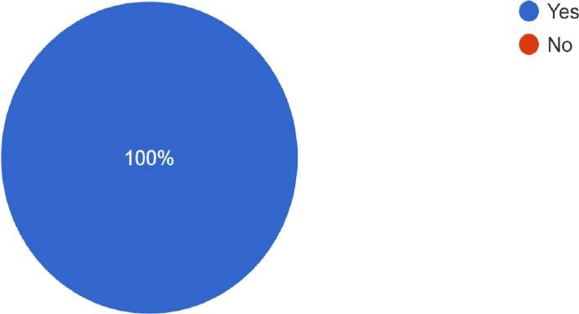

Q2- Were you an investor in Adani Group before Hindenburg Research?

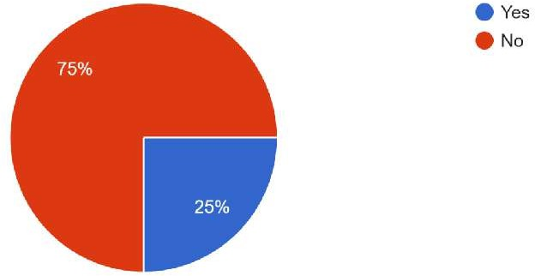We can observe from this chart that 25% people invested in Adani stocks before January 2023.

Q3- If yes, do you still remain invested?

We can make out from this chart that 28.6 percent people still remain invested even after the Hindenburg Research.

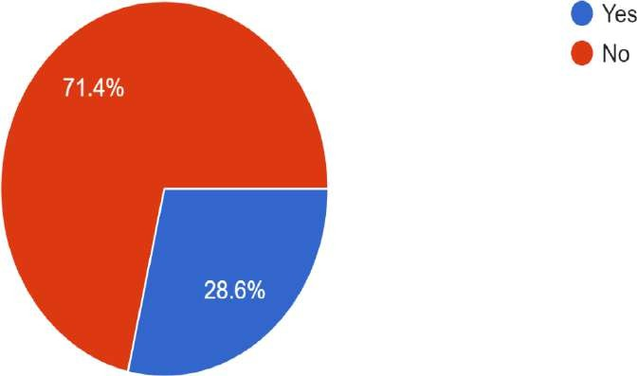

Q4- How much do you honestly believe that the Adani Group's participation in various sectors has helped to boost Indian economy

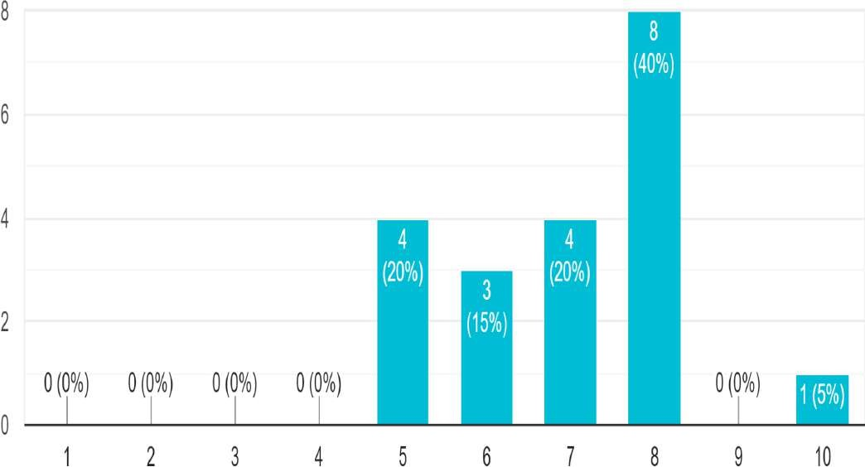

We can take away from this chart that most people trusted Adani and believe that he has contributed largely to the economy.

Q5- Were you convinced by the Hindenburg research's perception to believe that Adani's stock prices were overvalued before?

Only 50 percent of the people already knew that the stocks were overvalued, rest of them were carried away by the market perception.

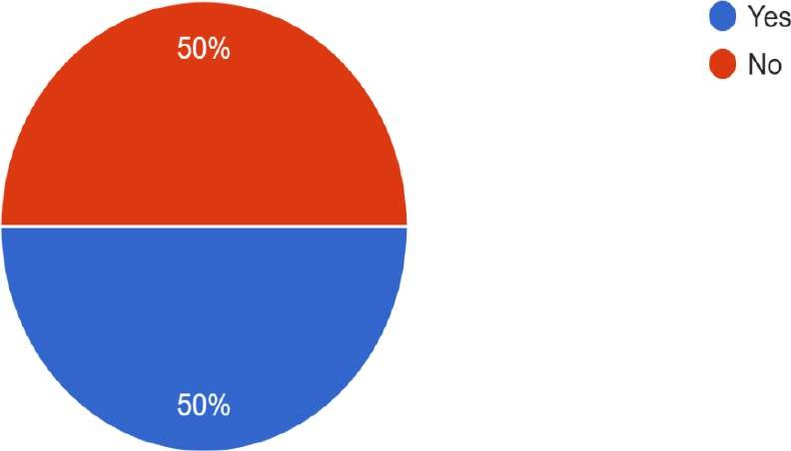

Q6- How much do you believe the statement "Adani is supported by the government"?

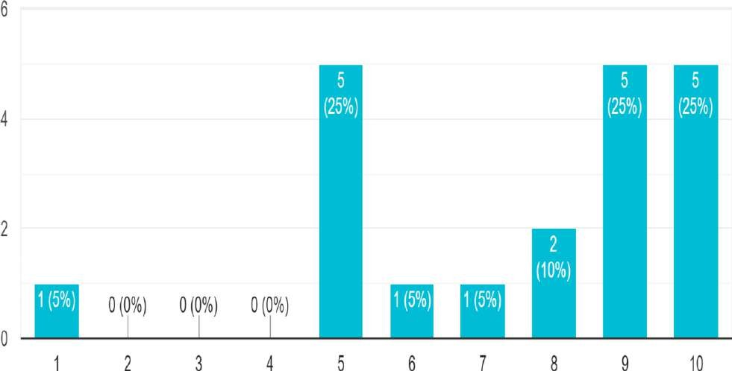

Most people believe that Adani is supported by the Government clearly. People have a mindset built that these types of companies enjoy special privileges and partially regulated policies because of Government support.

Q7- According to you, was it a strategy by Hindenburg to release the research at the time of launch of FPO?

Here, we can clearly see that most people believed that it was a planned move by the Hindenburg company to devastate the image of the Adani Group and earn profit by short-selling.

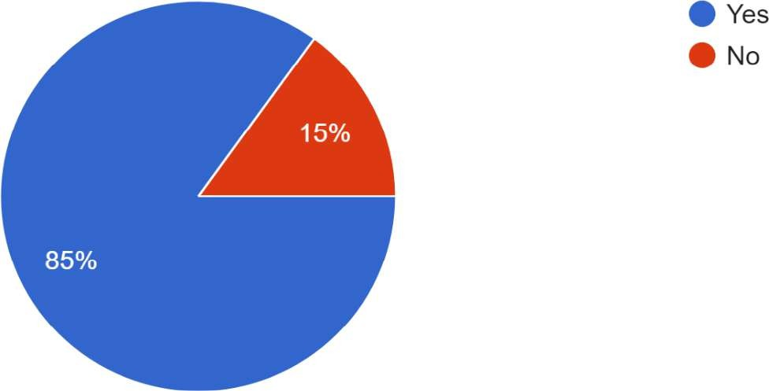

Q8- Previously, Hindenburg's research was 70% accurate. So, how would you rate it for Adani?

Despite the accuracy of Hindenburg Research being 70 percent, the majority of the people believed that they were right with the research of Adani.

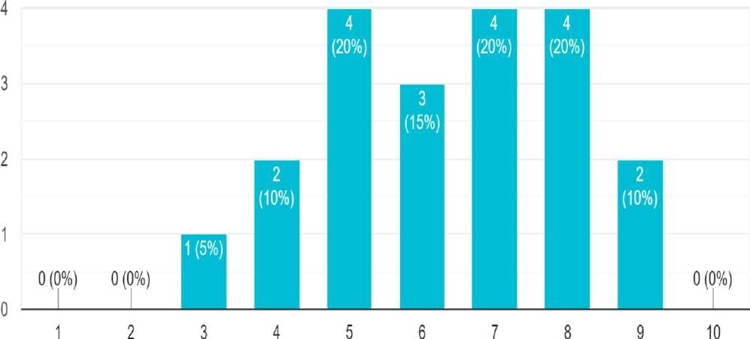

Q9- "Many big investors and founders believed that the concerns around the Adani Group were overblown by Hindenburg research." What's your take on this statement?

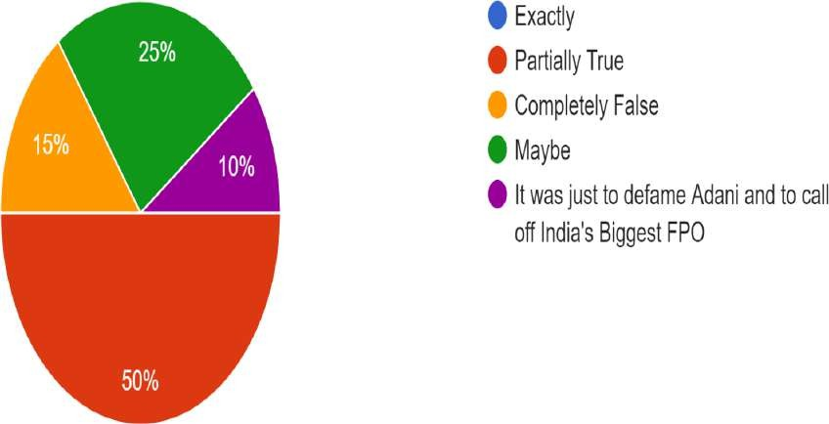From the above pie chart, we can see that nobody is sure about the above statement. 50 percent of the people think that it may be partially true and 15 percent think that the given statement is completely false. Only 10 percent of the people think that it was to defame Adani and to call off its FPO.

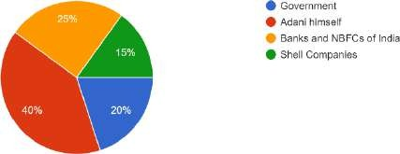Q10- Whom do you believe is the main culprit for overvaluation of Adani Stocks?

Majority portion believed that Adani himself is responsible for overvaluation of his own stocks. Some of them also believed that Banks & NBFCs and government also upto certain level are responsible.

Q11- Adani has paid a Billion-dollar loan currently, which was to be paid in mid-2024. So, do you believe that its stock can regain its position or not?

Majority of people believe that Adani will regain its position soon but almost the same number is doubtful for the same. Only a minority did not believe this.

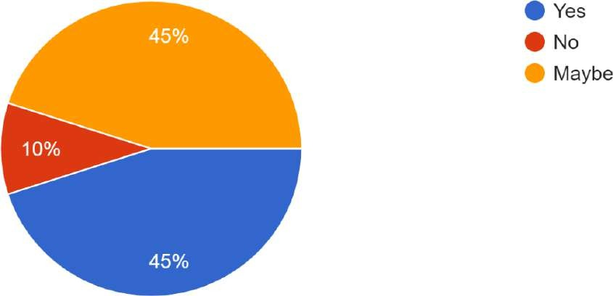

# SECONDARY DATA ANALYSIS

History:

Adani Exports Limited started as a commodity trading company in 1988 and expanded into import and export of various commodities. 5 lakh capital, the company was formed in partnership with the flagship Adani Enterprises, formerly known as Adani Exports. In 1990, the Adani Group developed its port in Mundra to provide a base for its business activities.

It started construction in Mundra in 1995. In 1998, it became India Inc. the largest net currency earner. The company began trading in coal in 1999, followed by the establishment of edible oil refining joint venture Adani Wilmar in 2000.

Adani handled 4 megatons of cargo at Mundra in 2002, making it India's largest private port. Later in 2006, the company became India's largest coal importer by processing 11 megatons of coal. The company expanded its operations in 2008 by purchasing the Bunyu mine in Indonesia.

In 2010, Adani Group set up a fixed cargo port with the help of Petronet LNG through its joint venture Adani Petronet (Dahej) Port Private Ltd. The bulk cargo terminal would have facilities for import/export of bulk products such as coal, steel and fertilisers.

The Adani Group became India's largest private sector coal mining company after Adani Enterprises won the mining rights in Orissa in 2010. The operation of Dahej port started in 2011 and its capacity has since increased to 20 million tonnes. In 2010, the company also acquired the Galilee Basin mine. Australia, with 10.4 gigatons (Gt) of coal reserves.

The company has also commissioned 60 Mt of processing capacity at its coal import terminal at Mundra, making it the largest in the world.In 2011, Adani Group also acquired Abbot Point Port in Australia with a handling capacity of 50 Mt. It commissioned the largest solar power plant in India with a capacity of 40 MW.

When the company reached a capacity of 3,960 MW, it became India's largest private thermal power producer. In 2012, the company moved into three business clusters - resources, logistics and energy. Adani Power became India's largest private power producer in 2014. At that time, Adani Power had a total installed capacity of 9,280 MW. On 16 May of the same year, Adani Ports acquired Dhamra Port on the east coast of India for RS. 5,500 crore(equivalent to ₹75 billion or $940 million in 2020). Dhamra Port was a 50:50 joint venture between Tata Steel and LandT Infrastructure Development Projects, which was acquired by Adani Ports.

The port began operations in May 2011 and handled a total of 14.3 million tons of cargo in 2013- 2014..With the acquisition of [Dhamra Port](https://en.wikipedia.org/wiki/Dhamra_Port), the Group is planning to increase its capacity to over 200

Mt by 2020.

In 2015, the Adani Group's Adani Renewable Energy Park signed a pact with the [Rajasthan](https://en.wikipedia.org/wiki/Government_of_Rajasthan) [Government](https://en.wikipedia.org/wiki/Government_of_Rajasthan) for a 50:50 joint venture to set up India's largest solar park with a capacity of 10,000 MW. In November 2015, the Adani group began construction at the port in [Vizhinjam,](https://en.wikipedia.org/wiki/Vizhinjam) [Kerala.](https://en.wikipedia.org/wiki/Kerala)

Adani Aero Defence signed a pact with the Israeli arms manufacturer, [Elbit](https://en.wikipedia.org/wiki/Elbit)-ISTAR, and Alpha Design Technologies to work in the field of Unmanned Aircraft Systems (UAS) in India in 2016. In April, Adani Enterprises secured approval from the [Government of Gujarat](https://en.wikipedia.org/wiki/Government_of_Gujarat) to begin work on building a solar power equipment plant. In September, [Adani Green](https://en.wikipedia.org/wiki/Adani_Green_Energy) [Energy](https://en.wikipedia.org/wiki/Adani_Green_Energy) ([Tamil Nadu](https://en.wikipedia.org/wiki/Tamil_Nadu)), the renewable wing of the Adani Group, began operations in [Kamuthi](https://en.wikipedia.org/wiki/Kamuthi) in [Ramanathapuram](https://en.wikipedia.org/wiki/Ramanathapuram), Tamil Nadu with a capacity of 648 MW at an estimated cost of

₹4,550 crore (equivalent to ₹56 billion or US$700 million) in 2020. In the same month, the Adani Group inaugurated a 648 MW single-location solar power plant. It was the world's largest solar power plant at the time it was set up.

On 22 December 2017, the Adani Group acquired the power arm of [Reliance](https://en.wikipedia.org/wiki/Reliance_Infrastructure) [Infrastructure](https://en.wikipedia.org/wiki/Reliance_Infrastructure) for ₹18,800 crore

(US$2.89 billion).

In October 2019, [French](https://en.wikipedia.org/wiki/France) oil and gas company [TotalEnergies](https://en.wikipedia.org/wiki/TotalEnergies) bought a 37.4% stake in Adani Gas for

₹6,155 crore (US$874.04 million) and obtained joint control of the company. Total also invested US$510 million in a subsidiary of Adani Green Energy in February 2020.

In August 2020, Adani Group obtained a majority stake in Mumbai and Navi Mumbai airports after entering a debt acquisition agreement with [GVK Group.](https://en.wikipedia.org/wiki/GVK_Industries) Through a [concession agreement](https://en.wikipedia.org/wiki/Concession_(contract)) with the [Airports](https://en.wikipedia.org/wiki/Airports_Authority_of_India) [Authority of India,](https://en.wikipedia.org/wiki/Airports_Authority_of_India) Adani Group also obtained a 50-year lease on Ahmedabad, Guwahati, Jaipur, Lucknow, Mangalore and Thiruvananthapuram airports.

In May 2021, Adani Green Energy acquired SB Energy, a joint venture of [SoftBank Group](https://en.wikipedia.org/wiki/SoftBank_Group) and [Bharti](https://en.wikipedia.org/wiki/Bharti_Enterprises) [Enterprises,](https://en.wikipedia.org/wiki/Bharti_Enterprises) for US$3.5 billion.

In May 2022, the Adani Group acquired [Ambuja Cements](https://en.wikipedia.org/wiki/Ambuja_Cements) and [ACC](https://en.wikipedia.org/wiki/ACC_(company)) for $10.5 billion. The deal will make the Adani Group the second largest cement maker in India.

In May 2022, UAE-based conglomerate International Holding Company (IHC), headed by Syed Basar Shueb, invested US$2 billion in three Adani Group companies, namely Adani Green Energy, Adani Transmission and Adani Enterprises. In June 2022, [TotalEnergies](https://en.wikipedia.org/wiki/TotalEnergies) acquired a 25% stake in Adani New Industries, the newly formed [green hydrogen](https://en.wikipedia.org/wiki/Green_hydrogen) subsidiary of [Adani Enterprises](https://en.wikipedia.org/wiki/Adani_Enterprises), for US$12.5 billion.

##### Growing Stage:

Adani ports:

Mundra Port and Special Economic Zone Limited is developer and operator of the Mundra Port, a leading seaport located in Kutch Gujarat. Mundra Port is Adani Group promoted company and has exclusive right to develop and operate Mundra Port and related facilities for 30 years starting from February 17, 2001. Mundra Port provides port services for bulk cargo, container cargo, crude oil cargo and value-added port services, including railway services.

IPO Date: Nov 1, 2007 to Nov 7, 2007

Listing Date: Nov 27, 2007 Face Value: Rs 10 per share Price: Rs 400 to Rs 440 per share Lot Size: 15 Shares

Total Issue Size: 40,250,000 shares (aggregating up to ₹1,771.00 Cr)

### Adani Green energy:

###### The company was incorporated on 23 January 2016, as Adani Green Energy Limited under the Companies Act 2013.

Adani Green Energy Limited (AGEL) is an Indian renewable energy company headquartered in Ahmedabad, Gujarat. It is owned by the Indian conglomerate Adani Group. The company operates the Kamuthi Solar Power Project, one of the largest solar photovoltaic plants in the world.

In 2022, Adani Green Energy Limited had a market cap of Rs. 3,26,635.42 crore IPO Date: 18 June 2018 Face value: Rs 10.00

Shares outstanding:1584,032,478

### Adani Power:

Incorporated in 1996, Adani Power Limited (APL), is a power project development company. The company operates and maintains power projects across India. Adani Power Limited is a part of Adani Group, a leading business group in India.

Adani Power has four thermal power projects under various stages of development, with a combined installed capacity of 6,600 MW. In addition, they are also planning to develop two thermal power

projects at Dahej and Kawai with a combined installed capacity of 3,300 M IPO Open: Jul 28, 2009

IPO Close: Jul 31, 2009 IPO Price: Rs 100 Face Value: Rs 10

IPO Size: Rs 3,016.52 Cr

Listing At BSE, NSE- Lot Size: 65

### Adani Enterprises:

Incorporated in 1988, Adani Enterprises Limited is part of the Adani Group. They are among India's top business houses having an integrated energy and infrastructure platform in India The Group is an Indian Multinational company engaged in multiple business ventures.

Open Date: 12 Sept, 1994 Close Date: 15 Sept,1994 Shares offered: 1261900 IPO Price Range: Rs 140

### Adani Transmission:

Adani Transmission Ltd is an electric power transmission company headquartered in Ahmedabad. Currently, it is one of the largest private-sector power transmission companies operating in India. As of July 2020, the company operates a cumulative network of 12,200 circuit kilometers, and more than 3,200 circuit kilometers are under various stages of construction.

### Adani Wilmar:

Incorporated in 1999 as a joint venture between the Adani Group and the Wilmar Group, Adani Wilmar is an FMCG food company offering most of the essential kitchen commodities for Indian consumers, including edible oil, wheat flour, rice, pulses, and sugar. The company also offers a diverse range of industry essentials, including oleochemicals, castor oil, and its derivatives, and de-oiled cakes

IPO Date: Jan 27, 2022, to Jan 31, 2022

Listing Date: Feb 8, 2022 Face Value: Rs 1 per share Price: Rs 218 to Rs 230 per share Lot Size: 65 Shares Discount: Rs 21 per share

### Actions Against the Company:

The Directorate of Revenue Intelligence (DRI) accused Gautam Adani’s younger brother Rajesh Adani of playing a key role in the diamond trading import/export scheme of 2004-05 that used offshore shell entities to generate artificial turnover, the report points out. Rajesh Adani was arrested twice -- in 1999 and 2010 -- over separate allegations of forgery and tax fraud before being promoted to the Managing Director of Adani Group.

Gautam Adani’s brother-in-law Samir Vora was also accused by the DRI of being a ringleader in the same scam and of making false statements to regulators, it further states. He was eventually promoted as Executive Director of the Adani Australia division.

As part of the DRI investigation into over-invoicing of power imports, Adani claimed that Vinod Adani was “not at all having any involvement in any Adani Group of companies”, except as a shareholder. Despite this claim, a pre-IPO prospectus for Adani.

Power from 2009 detailed that Vinod was the director of at least 6 Adani Group companies. In 2014, India’s top anti-smuggling agency, the Directorate of Revenue Intelligence (DRI), investigated the Adani Group for overstating the costs of imported power plant equipment. The DRI claimed that between 2009 and 2013, the company routed invoices through offshore entities to “siphon off money abroad,” including nearly $900 million that ended up in a Mauritius-based company owned by Vinod Adani.

The Adani Group has previously been the focus of 4 major government fraud investigations which have alleged money laundering, theft of taxpayer funds and corruption, totalling an estimated

U.S. $17 billion.

Adani family members allegedly cooperated to create offshore shell entities in tax-haven jurisdictions like Mauritius, the UAE, and Caribbean Islands, generating forged import/export documentation in an apparent effort to generate fake or illegitimate turnover and to siphon money from the listed companies. In the southwestern Indian state of Karnataka, Adani Enterprises and other companies bribed officials between 2004 and 2010 to abet the export

of illegally mined iron.

##### Cronyism

Chairman and MD Gautam Adani has been described as close Chief Minister of Gujarat and Indian Prime Narendra Modi and his Bharatiya Janata Party (BJP). This has led to allegations of cronyism as his firms have won many Indian energy and infrastructure government contracts. In 2012, an Indian government auditor accused Modi of low-cost fuel from a Gujarat state-run gas company to the Adani group and other companies. In Jharkhand, the BJP-led state government made an exception to its energy policy for Adani's Godda power plant. Both the Adani Group and Modi's government have denied allegations of cronyism.

The Modi government extended an extraordinary favor to Gautam Adani to promote his coal business. Although the Modi government had ascertained that a particular regulation handing over coal blocks to the private sector was ‘inappropriate’ and lacked transparency, the government made an exception. It allowed Adani Enterprises Limited to mine from a block holding more than 450 million tonnes of coal in one of India’s densest forest patches.

##### Tax evasion

On 27 February 2010, the Central Bureau of Investigation arrested Rajesh Adani, managing director of

Adani Enterprises Ltd., on charges of customs duty evasion amounting to ₹80 lakh.

In August 2017, Indian customs alleged the Adani Group was diverting millions of funds from the company's books to Adani family tax havens overseas. Adani was accused of using a Dubai shell company to divert the funds. The details of a $235 million diversion were obtained and published by *The Guardian.* In 2014, the Directorate of Revenue Intelligence mapped out a complex money trail from India through South Korea and Dubai, and eventually to an offshore company in Mauritius allegedly owned by Vinod Shantilal Adani, the older brother. of Gautam Adani.

###### Best Phase of the Company:

SWOT Analysis Strengths

* + - * **Big Vision:** The company considers inclusive progress and focuses on the best outcome for all stakeholders.
      * **Strong Business**: The man behind the rise of the Adani Group, Gautam Adani has become a strong leader and businessman.
      * **Diversified investment:** Adani Group has a layout in many key sectors such as coal, electric power, steel, infrastructure, energy, logistics, and real estate, and covers almost all key sectors, allowing a group of people to have a strong influence on most of them. industrial development areas.
* **Strong Financial Data**: The increase in the ratio of operating profit to sales indicates that operations have improved.
* WEAKNESSES
  + **Ethical issues**: Adani was sued in court for committing coal mining crimes, despite speaking out about her commitment to humanity.

###### High-risk appetite

Opportunity

* + **Renewable energy diversification:** Strong government support for sustainable and renewable energy such as wind power.
  + **Development Period**: India's Planning System is planned to be expanded in the areas of roads and highways, ports, civil aviation and airports, and electrical infrastructure.

### Threats

* + **Foreign investment**: The last decade has seen an increase in foreign investment in areas such as energy and infrastructure. There are still many foreign groups entering India.
  + **Misunderstanding of the group**: Compared to other Indian holdings like Tatas or Birlas, the Adani group is newly formed and therefore does not have the same trust or goodwill as others.

### Factors leading to success

* + Business Development: The expansion of Adani Group into various industries such as ports, shipping, energy, and agribusiness has resulted in higher revenue for the company, reducing its reliance on a single segment.
  + Strong leadership: The leadership of Gautam Adani, the founder of Adani Group, played a

critical role in the success of the company. Gautam Adani helped the company grow and expand.

* + Strategic Partnerships: Adani Group's partnerships with other companies and governments have helped the company expand its reach and enter new markets. For example, the company partnered with the government of Gujarat to build Mundra Port, helping Adani Group become a key player in ports and logistics.
  + Financial Performance**:** Adani Group's financial performance, including increased revenue and profit, has allowed the company to reinvest in its business and seek a new path.

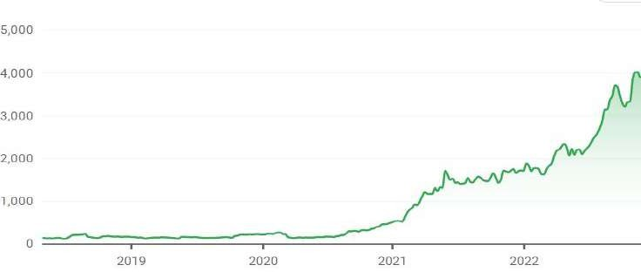

* Efficiency: The Adani Group's efficient and cost-effective operations contribute to its profitability and help the company remain competitive in various industries.
  + Innovation: Adani Group's ability to create and develop new products and services has helped it stay ahead of the competition and expand into new markets. For example, the company's focus on renewable energy has helped the company establish a strong position in the renewable energy space.
  + Good business: Adani Group benefits from good business because of low cost, and a stable business environment. The Indian economy has grown rapidly in recent years, providing Adani Group with opportunities to expand its business and capitalize on the growing demand for its products and services
  + .

ADANI ENTERPRISES Share Price Performance

2020 Annual - 2022, Adani Enterprises 1 Rs from Rs 2,296.0, with earnings of Rs 425.5 to Rs 870. 5 or about

61.1%.

Strategic Partnerships, alliances, and Acquisitions (2020-FY2022)

Stated here are the partnerships and Acquisitions that led to the sudden Growth of the company.

* + In October 2019, French oil and gas company TotalEnergies acquired a 37.4% stake in Adani Gas for Rs 6,155 ($874). 04 million) and took control of the company. In February 2020, Tag also invested $510 million in a subsidiary of Adani Green Energy.
  + In August 2020, Adani Group acquired most of Mumbai and Navi Mumbai airports after signing a loan agreement with GVK Group. Through a franchise agreement with the Airports Authority of India, Adani Group also obtains a 50-year lease.
  + In May 2021, Adani Green Energy acquired SB Energy, a joint venture of SoftBank Group and Bharti Enterprises, for $3.5 billion.
  + In May 2022, Adani Group acquired Ambuja Cements and ACC for $10.5 billion. The deal will make Adani Group India's second-largest cement producer.
  + Airports: Adani Group builds security at Indian airports, serves 100 million passengers a year, and operates the country's airports.
  + The group recently jointly managed the ownership of Mumbai Airport and is also developing Navi Mumbai Airport. The group has raised $250 million in space.

## Innovation and Research and Development (R&D)

This signifies the total expenditure on the Innovation and R&D Department of the Adani group. As this department signifies the innovation the company brings which is somewhat directly proportional to the growth of the company.

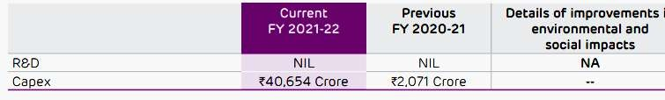

## Financial Issues

In December 2022:

Rating agencies and financial experts drew attention to the dangerous situation and how the group is falling into expenses.

CreditSights, a member of Fitch Ratings, said in August that Adani Group is "more vulnerable" and could lead to the "default of one or more of its group companies". The group also suffers from a "critical man crisis": there is no strong leader under

Adani. "Earnings are so high that Indian banks, along with some international investment funds, are considering limiting lending to a group that could create competition for the group," said Abhishek Dangra, global head of S&P in 2022. August report. In a 15-page response to the CreditSights report, Adani Group claimed that the ratio of net debt to EBITDA, a measure of a company's liabilities that includes debt and other liabilities, has dropped from 7 to 7.6 In the last nine years. A debt-to-EBITDA ratio below 3 is considered healthy. The lower the ratio, the more likely a company is to meet its debt. The overall tension is the cost of Adani's growth and acquisitions across various businesses, and the question on everyone's mind is whether the group can digest things.

The massive takeover of one or more of Adani's companies not only shakes up the stock market but also affects the Indian economy as a whole because the depth and breadth of this company are in the national system. The taxpayer will also be hit as it has a direct influence on the group from the LIC and state banks. Funds will limit the damage. This too will be financed from public funds, but this will be inevitable if the government decides that the Adani group is too big to fail.

### FPO to be launched soon:

What is a follow-on public offer?

1. An FPO is a process wherein a company that is already publicly listed in the stock market issues additional shares to investors. During an FPO, a company could decide to issue fresh

shares to investors, or existing shareholders in the company could decide to sell their shares to other investors.

1. An FPO is similar to an initial public offering (IPO), except that an IPO refers to the issuance or sale of shares by a company to investors when it taps into the public market for the very first time. Companies can float an FPO to raise equity capital for various reasons such as to pay off debt or to improve their capital structure.

### 1.3.4 Worst Phase of the Company:

All went well for Adani. His company is at the top and he is the second richest man in the world.But the taste of success was lost and everything suddenly changed when the Hindenburg report was published on January 24, 2023.

This is where the worst part of the company began, when it started and the cost of the stock market falls by 30-70%. .A two-year investigation has found that Indian conglomerate Adani Group was involved in a stock manipulation scheme and accounting fraud over several years.His main findings are as follows

.• Gautam Adani, the founder and chairman of the Adani Group, is worth $120 billion and has amassed more than $100 billion in the past three years, thanks to rising share prices. The share prices of the seven largest companies in the group increased by 819% during the period.

* Their investigations included talking to dozens of people, including former Adani Group executives,

reviewing thousands of documents and making mandatory visits to nearly half a dozen countries

.• Adani's main listed companies have also taken on significant debt, including pledging their increased shares against loans, putting the entire group on shaky financial footing. Five of the seven major listed companies reported a "current ratio" below 1, indicating imminent liquidity pressures.

* The highest ranks of the group and eight of the 22 main leaders are members of the Adan family. This dynamic puts control of the group's financial and major decisions in the hands of a few. One former executive described the Adani Group as a "family business".
* Members of the Adani family are said to have collaborated to set up offshore sales entities in tax havens such as Mauritius, the United Arab Emirates and the Caribbean islands, creating fake import/export documents in an attempt to generate fake or illegal turnover and raise. money for listed companies.

.• They identified 38 shell entities in Mauritius controlled by Vinod Adani or his associates. They identified entities that Vinod Adan also secretly controls in Cyprus, the United Arab Emirates, Singapore and several Caribbean islands.

* Listed companies in India are subject to rules that require disclosure of all promoter holdings (known as insider holdings in the US). The rules also require listed companies to have at least 25% of the share capital owned by non-promoters to reduce manipulation and insider trading. Four of Adani's listed companies are going public due to heavy advertising interests.

The group has 7 major publicly traded stocks (a total of 9) with a combined market capitalization of approximately INR 17.8 trillion ($218 billion). It also includes Adani's maze of private companies and family foundations.

Gautam Adani and his family have amassed a fortune of over $120 billion through their holdings, of which over $100 billion has come in the last 3 years, mainly due to a sharp rise in stock prices. of.The 7 key Adani listed companies have seen their stock prices mysteriously surge over the past 3 years – with most increasing multifold – ranking them individually among the largest companies in India.

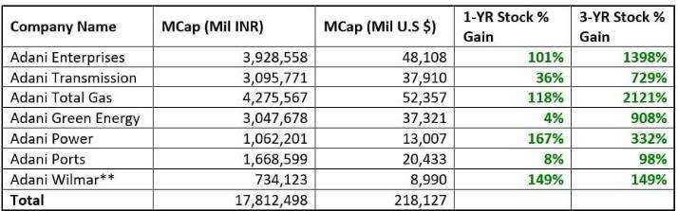

The 7 Listed Companies Of Adani Group Are 85%+ Overvalued Even If You Ignore there Investigation And

Take The Companies’ Financials At Face Value

Even before examining the evidence put forward in this report the Adani Group appears to be highly overvalued.

Infrastructure firms are generally relatively sleepy, low growth, low multiple enterprises, yet valuation metrics of the Adani listed companies are comparable to the frothiest of high-growth tech companies.

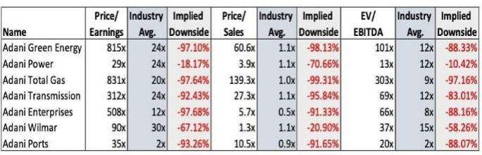

From a solvency perspective, multiple listed entities in the group are highly leveraged relative to industry averages: Four of 7 of these entities have negative free cash flow, indicating that the situation is worsening.

Five companies in the group (all but Adani Ports and Adani Wilmar) have current ratios below 1.0, suggesting a heightened short-term liquidity risk.

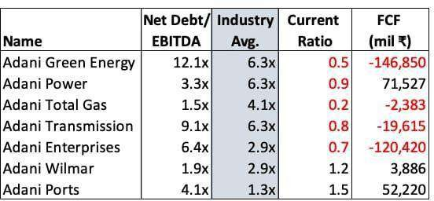

A Portion Of Promoter Equity In Adani Group Listed Entities Is Pledged For Loans, Effectively Leveraging The Group To The Hilt

Beyond debt held by individual Adani Group entities, the companies’ promoter group (i.e., Adani

insiders) have pledged portions of their equity as collateral for loans.

Equity share pledges are an inherently unstable source of lending collateral because if share prices drop, the lender can make a collateral call. If no additional collateral is available, the lender could require a forced liquidation of shares (often perpetuating a self-fulfilling cycle as stock prices move lower and selling continues).

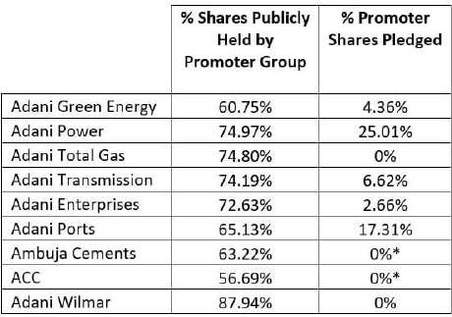

4 of Adani’s Listed Companies Are On The Brink Of India’s Delisting Threshold Due To High Reported Promoter Ownership

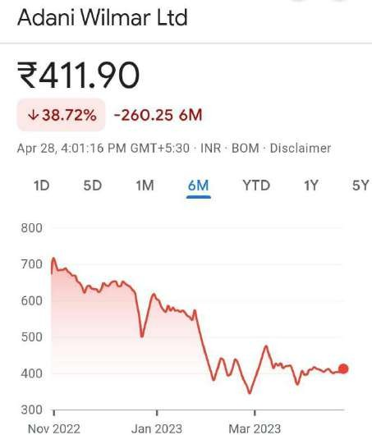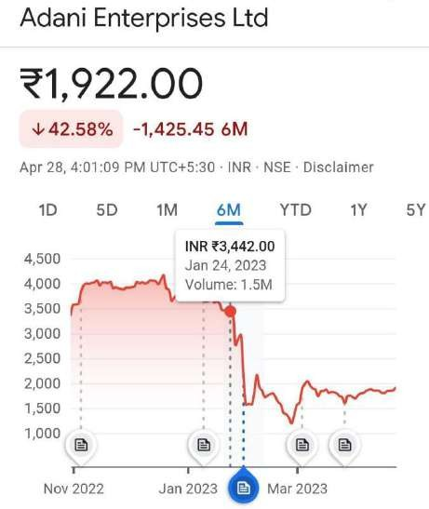

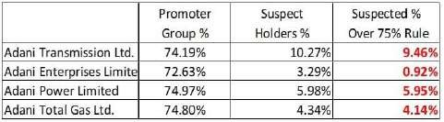

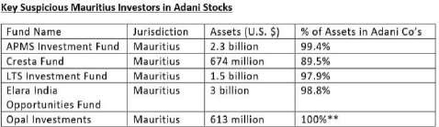

As soon as these questions were raised on Adani

, a perception was created in the stock market and some shares fell upto 50% . Some of the graphs of the companies are shown below.

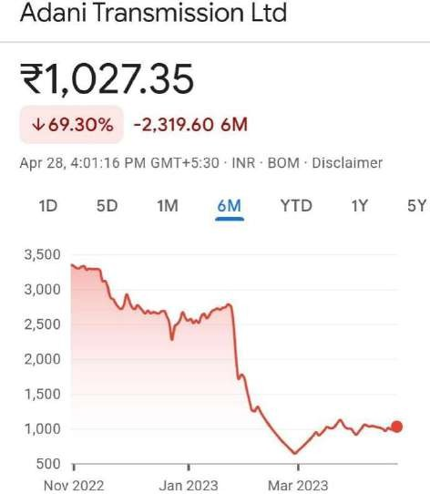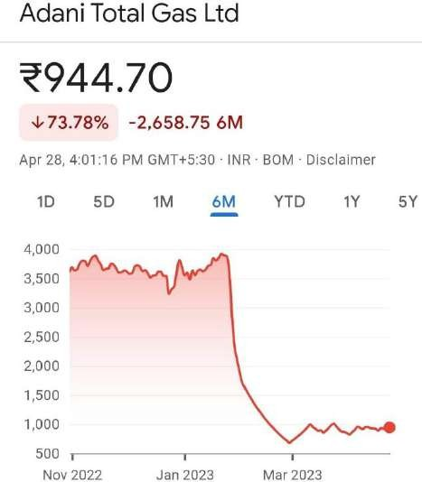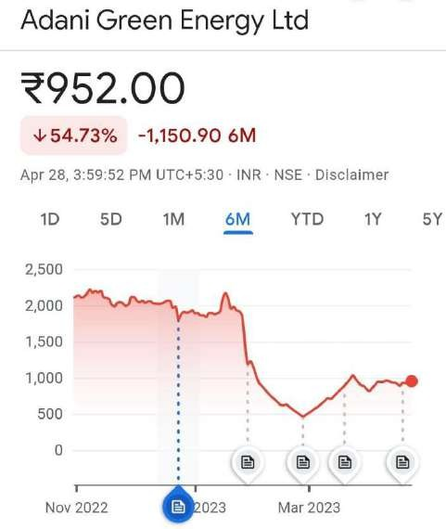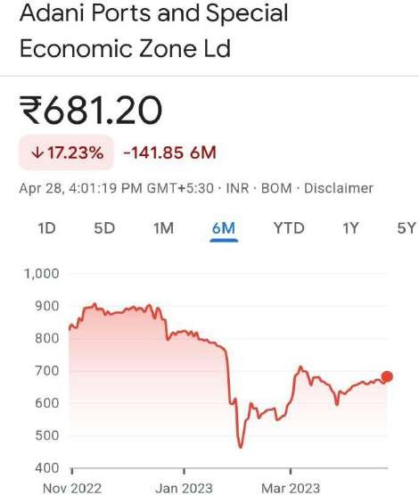

4) The Group has denied all allegations.

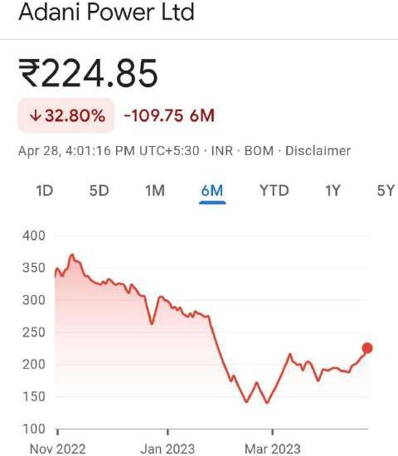

Adani Group calls off FPO: Why, what happened?

1) The meltdown in Adani Group stocks and bonds resumed , with shares in Adani Enterprises plunging 28% and Adani Ports and Special Economic Zone dropping 19%, the worst day on record for both, Reuters reported.

##### FPO Launched But Called-Off: The story so far:

1. Adani Enterprises has decided to liquidate its IPO of Rs 20,000 crore on February 1 and return the money raised from investors.
2. Adani Group saw its listed company's shares fall, reducing its market capitalization to Rs 9.11 crore.2) On January 24, a report by US company Hindenburg Research accused the Adani Group of stock manipulation and accounting fraud.
3. Shares of Adani Enterprises tumbled over 34% to an intraday low of Rs 1,942, a drop below Rs 1,933.75 from the previous closing price of Rs 2,975. At the close, it was trading at Rs 2,128.70, down 28.45%.
4. Bloomberg reports that Credit Suisse Group AG has stopped accepting bonuses from Adani group companies as collateral for tax credits to private equity clients.
5. The private banking arm of the Swiss lender provided a zero loan value for the bonds purchased by Adani Ports and Special Economic Zone, Adani Green Energy and Adani Electricity Mumbai Ltd.

##### But wasn’t the Adani FPO oversubscribed?

* 1. Although the market price of AEL shares was trading below the issue price, the FPO was managed by foreign institutional investors (FIIs) and non-institutional investors, such as family offices of industrialists, large private property control and very expensive. Individuals (NII) were oversubscribed

1.12 times on the last day of publication, following strong responses from qualified institutional buyers (QIB), including).

* 1. QIB share was subscribed 1.26 times and NII 3.32 times. Institutions bid for 166 million shares worth Rs 543.8 billion and FIIs for 124 million shares worth Rs 412.7 billion.
  2. However, the individual investor's share is only 0.12 times (12%) and only 27.45 million shares are issued by investors against the limit of 229 million shares. The workers' quota is still low, only 55% of the quota is released.

##### What does the Adani Group say at the FPO?

1. Considering past and current market volatility, the company intends to protect the interests of the investing community by repatriating FPO products and carrying out transactions

.2) Gautam Adani, Chairman, Adani Enterprises Ltd, said: "The Board would like to take this opportunity to thank all our investors for their support and commitment to FPO. Your subscription to FPO has been successfully completed.

3) The despite the financial uncertainty and my faith and trust in the company, I was completely reassured and humbled by the business and the management of the company.

##### Future of the Company:

Hindenburg Research, a report published on January 24, 2023, boosted Adani shares nine times in a few weeks. This followed the tragedy of 1937 when the Hindenburg balloon caught fire, killing 35 of the 97 crew and passengers.

Hindenburg Research suggests looking for similar talents in the stock market and spotting them before they become windfalls. The research firm investigates stocks that have become overvalued due to mismanagement, fraudulent financial statements and stock price manipulation. You have to be in the market to benefit from falling stock prices, and Gautam Adani, the world's third-richest man, saw his fortune halved by the Hindenburg. Nine stocks in his port-to-power empire lost more than $120 billion in a week. Everyone has one question in mind: What are the fair prices of Adani stocks?

Is Adani Enterprises, the group's parent, worth ₹3,436.35 per share, closing price on 23 Jan 2023 or less than

₹100?

In the report, Hindenburg said Adani Enterprises traded at more than 500 times its earnings compared to the industry average of 12 times, a decline of 97.58%.

* This reduces the value of the shares. percent or less than ₹100.
* This is the case for Adani Total Gas (-97.64%), Adani Green Energy (-97.1%), Adani Ports (-93.26%) and Adani Transmission (-92.43%).
* In a blog post (Feb. 4, 2023), Aswath Damodaran, who teaches corporate finance and valuation at New York

University, is less sanguine. He wrote: "The valuation of Adani Enterprises based on best

estimates...disregarding Hindenburg's allegations of fraud and irregularities, comes to just ₹945 per seat. However, bulls expect the price to return above ₹3,000 by the end of 2023.What happens to Adani shares at times when the future depends on how often short sellers strike like Hindenburg.

* Short sales are sold at a large margin.
* The first phase will be completed in a few days or weeks.Often, without funds, their strategy is to borrow money, buy at a high price, and pay back at a low price.Consider what happened to Adani Enterprises between January 23, 2023 and February 8, 2023 or 12 business days excluding public holidays.Most of the trees led by Hindenburg lost value within days.
* PureCycle Technologies fell from around $26 on April 30, 2021 to $12.43 on May 14, 2021, just before the Hindenburg report (May 6, 2021).
* Tecnoglass dropped from around $32 on December 3, 2021. It fell below $19 on December 10, 2021, the day

after the research firm's report..

Tecnoglass hit a low of $17.42 (June 17, 2022) before returning above $35 (February 3, 2023).Twitter, attacked by Hindenburg in May 2022, also suffered a similar decline.

The difference between the fools and the winners ultimately lies in policy makers, regulators, courts and the media. After the CEO immediately resigned, criminal connections were discovered and the tree fell. Prime Minister Narendra Modi did not mention Adani in his speech to Parliament, but investors and government lenders continue to support the Adani Group.

The government agreed to set up a panel to study the decline in share prices and gaps in regulatory processes. Moody’s downgraded its outlook for some Adani companies and MSCI downgraded four Adani stocks in its global equity index due to low volume.

As of March 31, 2022, Adani Enterprises has 226,071 shareholders among these 595, including promoters and large investors, who hold 98.47% of the funds. On February 8, 2023, less than 1 million shares were enough to increase the price by 20%, which is good news for bullies.

# CHAPTER-5

## FINDINGS and RECOMMENDATIONS

* + One should read the trusted sources regulated by the government authorities so that no misinformation is transferred.
  + One should invest only after analyzing the background, policies, and financial position of the company.
  + Even the minority shareholders should attend management meetings to know more about the company and its internal affairs.
  + Business should be given in the hands of a few for better control, not for justifying personal bias.
  + Each and every company should provide a proper Annexure mentioning all the legal actions and other activities which are done against them, other than providing the financial information.
  + Regulatory bodies should not have any personal bias against any company. They should keep proper track of the companies and their promoter's holdings.

# CONCLUSION

Adani Group is a multi-sector company operating in various sectors such as energy, agriculture, resources, logistics and real estate. They are known for developing large infrastructure projects, including ports, airports and power plants. On January 24, 2023, Hindenburg issued a report against Adani, accusing him of several things that resulted in Adani losing more than 30-40% of its wealth and falling out of the ten richest people in the world. The conclusion of the Hindenburg study shows that most of the Adani group companies were overvalued and their current ratio was less than 1. They believed that if people do not want to value any company by other parameters, then they are enough to be. the judge They have clearly shown that many companies are close to holding more than seventy-five percent stake in promoters which is against SEBI rules. They even criticized Adani and the group for making it a completely family business. Despite the legal review, many of his relatives continue to hold key positions in the company. They also asked 88 questions and asked Adan to answer each one. In response, Adani published a 413-page report in which it said the company had good international credit ratings. He also talked about portfolio presence and business expansion. He also paid off the loans earlier than announced so that investors would trust him. He answered 88 questions, saying that 65 were clearly public, 18 were third-party questions and 5 were baseless allegations. He even accused Hindenburg of attacking the independence, integrity and quality of Indian institutions. The Adani Group mentioned that the Hindenburg report came just before the launch of Adani Enterprise FPO, India's largest FPO. It was just an attack that failed. The main purpose of this FPO was to repay debts and remaining capital expenditure.

However, the FPO was fully launched and branded. But it was cancelled due to moral ethics as the stock fluctuated strongly and the expected share of retail investors was also less. Adani believed that now is not the right time to launch it..

BIBLIOGRAPHY:

* + - [www.linkedin.com/pulse/green-hr-practices-get-competitive-advantages-nilufar-](http://www.linkedin.com/pulse/green-hr-practices-get-competitive-advantages-nilufar-sharmin) [sharmin](http://www.linkedin.com/pulse/green-hr-practices-get-competitive-advantages-nilufar-sharmin) [jessy.](http://www.linkedin.com/pulse/green-hr-practices-get-competitive-advantages-nilufar-sharmin-jessy)
    - Renwick, Douglas W. S., et al. “Green Human Resource Management: A Review and Research Agenda*.” *International Journal of Management Reviews*, vol. 15, no. 1, 2012, pp. 1–14. *Crossref*, doi:10.1111/j.1468-2370.2011.00328.x.
    - Chan Wm, Wendy. “AIF_ResearchReport_GHRM.Pdf.” *AIF_ResearchReport_GHRM.Pdf*, 2017, [www.academia.edu/35352012/AIF_ResearchReport_GHRM_pdf.](http://www.academia.edu/35352012/AIF_ResearchReport_GHRM_pdf)
    - Almarzooqi, Abdulla Hasan, et al. “The Role of Sustainable HRM in Sustaining Positive Organizational Outcomes.” *International Journal of Productivity and Performance Management*, vol. 68, no. 7, 2019, pp. 1272–92. *Crossref*, doi:10.1108/ijppm-04-2018-0165.
    - Bombiak, Edyta, and Anna Marciniuk-Kluska. “Green Human Resource Management as a Tool for the Sustainable Development of Enterprises: Polish Young Company Experience.” *Sustainability*, vol. 10, no. 6, 2018, p. 1739. *Crossref*, doi:10.3390/su1006173 iEduNote.com.

“GreenHRM: Definition, Advantages, Green HRM Practices,

* + - Policies.” *IEduNote.Com*, 22 July 2020, [www.iedunote.com/green-hrm](http://www.iedunote.com/green-hrm)
    - “Green Human Resource Management: Policies and

Practices.” *Taylor & Francis*, 2015, [www.tandfonline.com/doi/full/10.1080/23311975.2015.1030817.](http://www.tandfonline.com/doi/full/10.1080/23311975.2015.1030817)

* + - ---. “A QUALITATIVE STUDY OF GREEN HRM PRACTICES AND THEIR BENEFITS IN THE ORGANIZATION: AN INDONESIAN COMPANY
    - EXPERIENCE.” *Business: Theory and*
    - *Practice*, vol. 21, no. 1, 2020, pp. 200–11. *Crossref*, doi:10.3846/btp.2020.11386.
    - [https://www.researchgate.net/publication/281901233_Green_Human_Resource](https://www.researchgate.net/publication/281901233_Green_Human_Resource_Management_Practices_A_Review)
    - [_Management_Practi](https://www.researchgate.net/publication/281901233_Green_Human_Resource_Management_Practices_A_Review) [ces_A_Review](https://www.researchgate.net/publication/281901233_Green_Human_Resource_Management_Practices_A_Review)
    - [https://www.researchgate.net/publication/336357517_Green_Human_Resource_Ma](https://www.researchgate.net/publication/336357517_Green_Human_Resource_Management) [nageme](https://www.researchgate.net/publication/336357517_Green_Human_Resource_Management) [nt](https://www.researchgate.net/publication/336357517_Green_Human_Resource_Management)
    - [https://www.researchgate.net/publication/331476172_Green_Human_Resource_Management_](https://www.researchgate.net/publication/331476172_Green_Human_Resource_Management_Practices_A_Review) [Practi](https://www.researchgate.net/publication/331476172_Green_Human_Resource_Management_Practices_A_Review) [ces_A_Review](https://www.researchgate.net/publication/331476172_Green_Human_Resource_Management_Practices_A_Review)
    - [https://www.researchgate.net/publication/304169968_Green_Human_Resource](https://www.researchgate.net/publication/304169968_Green_Human_Resource_Management_A_Theoretical_Overview)
    - [_Management_A_Th](https://www.researchgate.net/publication/304169968_Green_Human_Resource_Management_A_Theoretical_Overview) [eoretical_Overview](https://www.researchgate.net/publication/304169968_Green_Human_Resource_Management_A_Theoretical_Overview)
    - [https://www.researchgate.net/publication/328277326_Green_Human_Resource](https://www.researchgate.net/publication/328277326_Green_Human_Resource_Management_A_Review)
    - [_Management_A_Re](https://www.researchgate.net/publication/328277326_Green_Human_Resource_Management_A_Review) [view](https://www.researchgate.net/publication/328277326_Green_Human_Resource_Management_A_Review)
    - <https://www.sheffield.ac.uk/polopoly_fs/1.120337!/file/Green-HRM.pdf>
    - <http://www.bvimr.com/PDF/Major-Research-Project-2019.pdf>
    - <https://globaljournals.org/GJMBR_Volume17/4-Green-HRM-Practices.pdf>