HotelCRM Enterprise Platform
Lead Management · 4-Day Automated WhatsApp Escalation · Post-Call WhatsApp Templates · Analytics
Confidential Client System Architecture & Systematic Screen Designs · 2026
—————————————————————————————————————————————
1. Executive Overview & System Architecture
HotelCRM is an enterprise-grade sales acceleration, lead management, automated WhatsApp customer engagement, and SLA governance CRM built specifically for hotel sales and reservation teams. It unifies multi-channel inquiry capture (Instagram Lead Ads, WhatsApp Business, Facebook Ads, Website, and Manual Inquiries), provides customer support staff with an automated one-by-one calling queue, instantly triggers outcome-based WhatsApp message templates to guests after calls, and enforces a rigorous 2-tier escalation hierarchy.
Role | Primary Scope | System Governance & Permissions
👑 Admin (Hotel Owner / GM) | Complete System Control | Full hotel visibility, staff breach leaderboards, Level 2 critical escalation alerts, WhatsApp template builder, settings, and authority to reassign leads to any Manager.
👔 Manager (Sales Supervisor) | Team & Pipeline Oversight | Oversees all hotel leads, team conversion leaderboards, Level 1 support escalation queue, and authority to reassign overdue leads to any Customer Support agent.
🎧 Customer Support Staff | Frontline Calling & Sales | One-by-one sequential lead queue delivery, 1-tap call & WhatsApp triggers, post-call disposition logging with automated guest WhatsApp template dispatch, and personal call history tracking.

2. Systematic Master Screen Directory (Screens 1 to 11)
# | Screen Name | Platform | Target Users & Key Deliverables
Screen 1 | Web Login Page | 🖥️ Web Dashboard | All Users — Split-layout luxury hotel image with glassmorphism login card and JWT auth.
Screen 2 | Executive Main Dashboard | 🖥️ Web Dashboard | Admin & Manager — Zero-clutter 5-tab architecture (Overview, Escalations, Leads, Team, Analytics).
Screen 3 | All Leads Master Directory | 🖥️ Web Dashboard | Admin & Manager — Support Staff grouping dropdown + Multi-Status filter chips.
Screen 4 | Lead Detail Profile & Activity Timeline | 🖥️ Web Dashboard | All Users — Full guest profile, status progress bar, and chronological WhatsApp/call audit log.
Screen 5 | Customer Support Calling Workspace | 🖥️ Web & 📱 Mobile | Customer Support — One-by-One active lead queue with 6-outcome Post-Call Disposition modal and Automated Guest WhatsApp Template triggers.
Screen 6 | Manager & Admin Escalation Dashboard | 🖥️ Web Dashboard | Manager & Admin — Real-time overdue leads feed with SLA timer badges and 1-click reassign actions.
Screen 7 | Mobile Home Hub | 📱 Mobile App | Admin & Manager — Clean 2-KPI cards, alert warning banner, and single bottom navigation.
Screen 8 | Mobile Escalations Tab | 📱 Mobile App | Manager & Admin — Overdue leads feed with Level 1 / Level 2 sub-filters & 1-tap call/reassign.
Screen 9 | Mobile Leads Directory Tab | 📱 Mobile App | Manager & Admin — Staff dropdown filter + status chips ([Interested], [Follow-up], [Registered]).
Screen 10 | Mobile Team & Performance Tab | 📱 Mobile App | Manager & Admin — Role-separated sub-tabs: Managers (3) vs Customer Support (8) with Breach Counters & downloadable/email user stats.

3. Automated 4-Day WhatsApp Escalation Engine & Governance
The system features an automated, multi-tiered SLA Escalation engine that continuously monitors assigned leads and dispatches structured WhatsApp alert templates with guest name, phone number, overdue duration, and direct actions:
Timeline | Trigger Condition | Recipients | Automated WhatsApp Message & System Action
Day 1  (24h Inaction) | Support agent has not made a call or logged activity for 1 day. | Customer Support Staff | Reminder: "You have not called Guest [Name] (+91 [Phone]). Please call today to avoid Level 1 Manager Escalation."
Day 2  (48h Inaction) | Support agent failed to call for 2 days. Triggers Level 1 Escalation. | Manager & Customer Support | To Manager: "Escalation Alert: Support agent [Staff] has NOT called [Guest] (+91 [Phone]) for 2 days. Lead is now in your queue."  📢 To Support: "Lead [Guest] escalated to Manager due to inactivity (+1 Breach Count)."
Day 3  (72h Inaction) | Manager has not resolved, called, or reassigned for 1 day. | Manager | Manager Reminder: "Lead [Guest] (+91 [Phone]) is pending action for 3 days. Please resolve or reassign to avoid Admin escalation."
Day 4  (96h Inaction) | Manager also failed to take action for 2 days. Triggers Level 2 Critical Escalation. | Admin & Manager | To Admin: "CRITICAL ESCALATION: Lead [Guest] (+91 [Phone]) neglected by Support [Staff] and Manager [Manager] for 4 days."  To Manager: "Lead [Guest] has breached SLA and reached Admin Escalation (+1 Manager Breach)."

🔄 Strict Reassignment & Escalation Resolution Rules
• Admin Reassignment Power (Level 2 Critical):
- Admin has authority to reassign critical leads to ANY Manager.
- Resets SLA timer, sends instant WhatsApp alert to the assigned Manager, and logs: "Reassigned by Admin to Manager [Name]".
• Manager Reassignment Power (Level 1 Escalation):
- Manager has authority to reassign overdue leads to ANY Customer Support agent of their choice.
- Strips the lead from the inactive agent's queue (showing "Previous lead was reassigned by Manager") and injects it at the top of the new agent's queue with a WhatsApp alert.

4. Post-Call Automated Guest WhatsApp Template Engine
When a Customer Support agent finishes a phone call with a guest and saves the disposition status, the system can automatically trigger a tailored WhatsApp message template directly to the guest’s phone number. The Admin has complete control in the Settings panel to design and customize the templates for each specific outcome:
Call Outcome / Disposition | Target Guest Scenario | Automated WhatsApp Template Dispatched to Guest
Interested / Registered | Guest expresses interest in booking, luxury suites, packages, or confirms reservation. | "Hi {guest_name}! Thank you for speaking with our sales team. As discussed, here is our luxury room brochure, photos, and an exclusive 15% booking code: {promo_code}. Direct Booking Link: {booking_url}. Contact {support_name} anytime!"
Awaiting Follow-up | Guest asked to be called back at a specific date and time. | "Hi {guest_name}! Thank you for your time today. As requested, we have scheduled our follow-up call with you on {followup_date_time}. In the meantime, feel free to explore our resort gallery here: {gallery_url}."
Not Interested | Guest politely declined the current offer or is not traveling right now. | "Dear {guest_name}, thank you for speaking with us. We completely understand. If you plan a stay or holiday in the future, save this number for member-only seasonal discounts. Have a wonderful day!"
⚫ Lost / Junk / Wrong Number | Invalid number or wrong person. | No message sent (System logs invalid number tag in ActivityLog).

5. Web Dashboard Master Screen Designs (Screens 1 to 6)
Screen 1: Web Login Page (Split-Layout Luxury Design)
Platform: Web Dashboard | Target Users: All Users (Admin, Manager, Customer Support)
Features:
• Left Panel: 5-star luxury hotel lobby with branded overlay: "Manage Your Hotel Leads Smarter - Enterprise CRM & SLA Escalations".
• Right Panel: Dark glassmorphism login card with Gold Crown logo, Work Email, Password, and gradient "Sign In" button.
• Security: JWT authentication with automatic role-based redirect to respective dashboards.
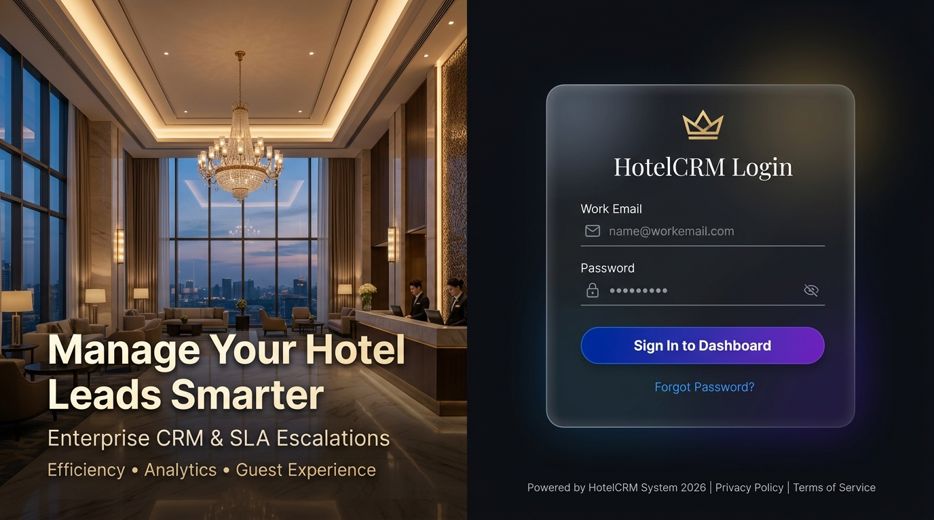
Figure 1: Screen 1 — Web Login Page

Screen 2: Executive Main Dashboard (Zero-Clutter 5-Tab Architecture)
Platform: 🖥️ Web Dashboard | Target Users: Admin, Manager
Features:
• 5 Dedicated Tabs: [Overview] [🚨 Escalations (3)] [📋 Leads Directory] [👥 Team & Breaches] [📊 Analytics].
• Overview Tab: 3 large metric cards (Total Leads: 148, Today Converted: 12, SLA Breaches: 3).
• Minimalist Lead Sources donut chart + 3 Quick Action buttons (+ Add Lead, Reassign, Broadcast WhatsApp).
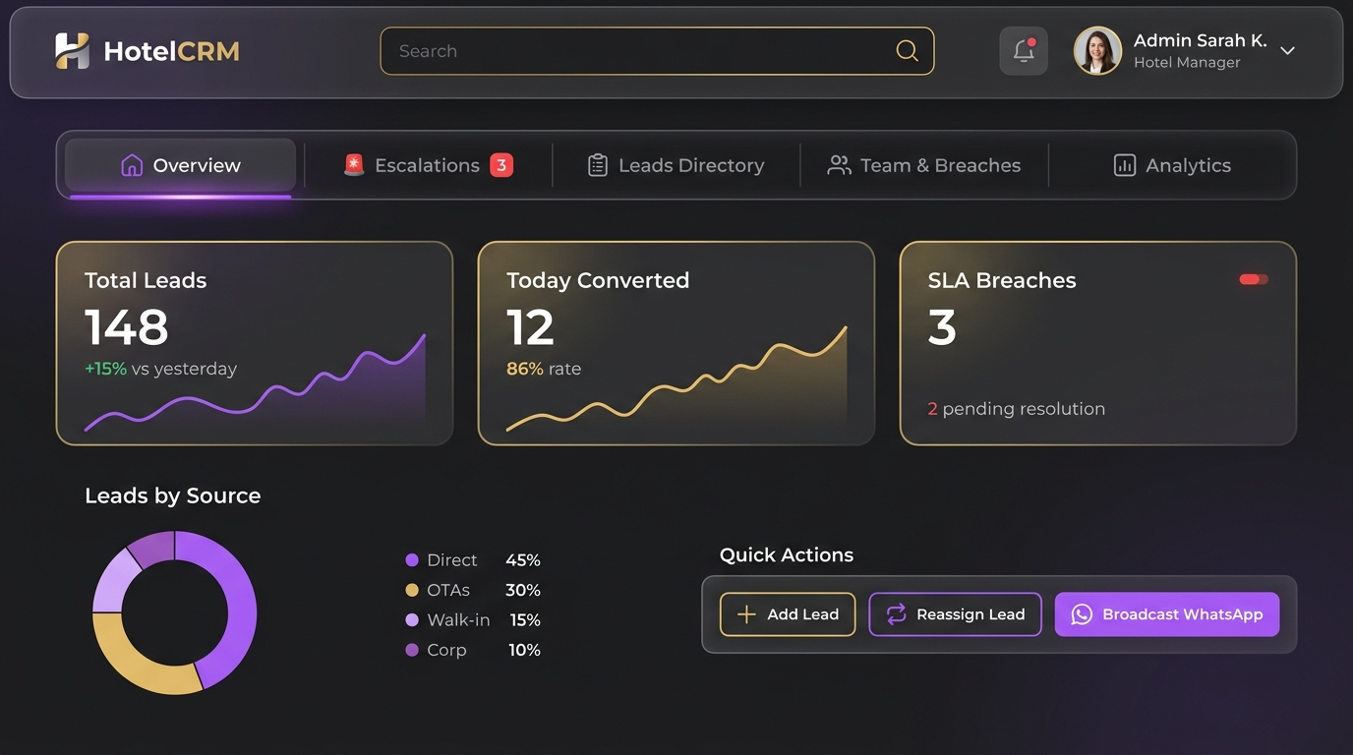
Figure 2: Screen 2 — Executive Main Dashboard (Web)

Screen 3: All Leads Master Directory (Customer Support Grouping & Multi-Status Filter)
Platform: Web Dashboard | Target Users: Admin, Manager
Features:
• Dedicated Support Staff Filter: "Filter Staff: Agent Rahul Sharma (Support)".
• Multi-Status Filter Chips: [All] [Interested] [Awaiting Follow-up] [Completed Follow-up] [Registered / Converted] [Not Interested] [Lost].
• Staff Summary Banner: "Total Assigned: 42 | 18 Called | 9 Interested | 4 Registered".
• Master Directory Table: Guest details, Mobile (+91), Source icon, Assigned Support Agent, Last Call Date & Duration, and Last Disposition note.
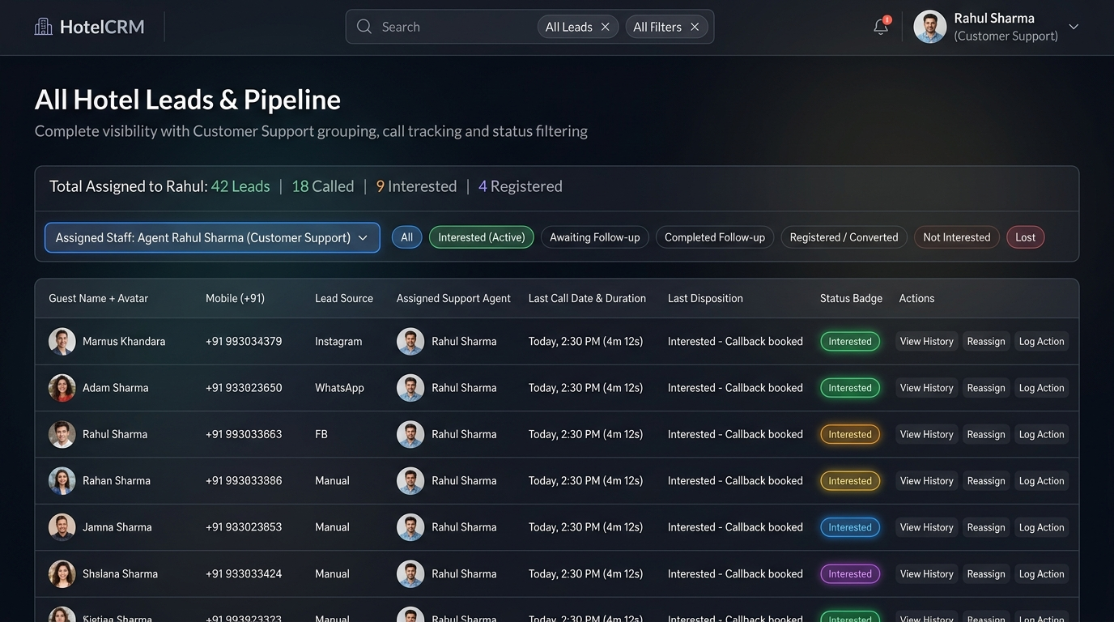
Figure 3: Screen 3 — All Leads Master Directory with Staff Grouping (Web)

Screen 4: Lead Detail Profile & Interactive Activity Timeline
Platform: Web Dashboard | Target Users: All Users
Features:
• Guest Profile Card: Avatar, Name, Mobile (+91), Work Email, Stay Inquiry (e.g. "Presidential Suite 4 Nights"), and Source badge.
• Status Pipeline Indicator: Step progress bar showing New ➔ Contacted ➔ Interested (Active) ➔ Registered.
• Activity & Call Timeline: Chronological audit history of every phone call (with duration & notes), WhatsApp brochure dispatched, and lead ingestion timestamps.
• Action Bar: 1-Click "Log Call", "Add Note", and "Send WhatsApp".
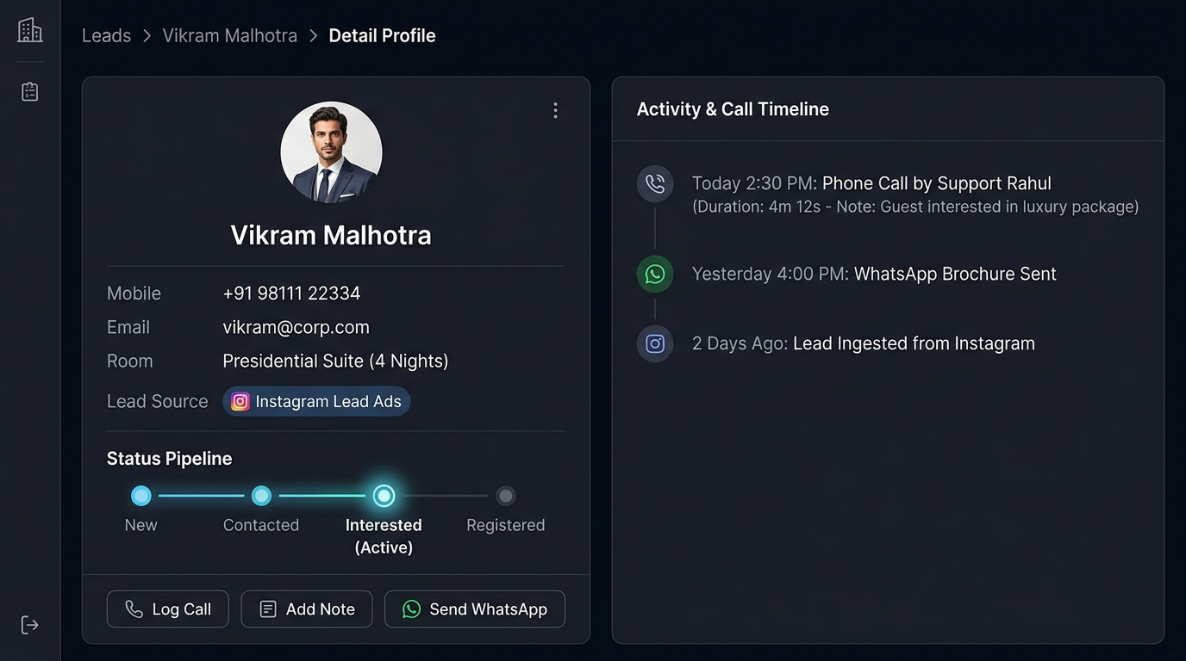
Figure 4: Screen 4 — Lead Detail Profile & Interactive Activity Timeline (Web)

Screen 5: Customer Support Calling Workspace & Post-Call Disposition Modal
Platform: Web Dashboard & Mobile App | Target Users: Customer Support Staff
Features:
• One-by-One Queue Delivery: Support agents focus on 1 active lead at a time without cherry-picking.
• Manager-Reassigned Alert Notice: "Previous lead was reassigned by Manager. You are now working on Lead #2" with "Fetch Next Lead" button.
• 6-Outcome Post-Call Disposition Modal with Automated WhatsApp Template Trigger:
1. Interested (Auto-triggers Hotel Brochure & 15% Booking Code WhatsApp template)
2. Awaiting Follow-up (Auto-triggers Callback Confirmation & Resort Gallery WhatsApp template)
3. Completed Follow-up (Follow-up conversation concluded)
4. Registered / Converted (Auto-triggers Booking Confirmation & Welcome WhatsApp template)
5. Not Interested (Auto-triggers Polite Future Membership WhatsApp template)
6. ⚫ Lost / Junk (Invalid number)
• "Save Disposition & Fetch Next Lead ➔" Gradient Button: Instantly logs ActivityLog, dispatches guest WhatsApp, updates status, and pulls next lead.
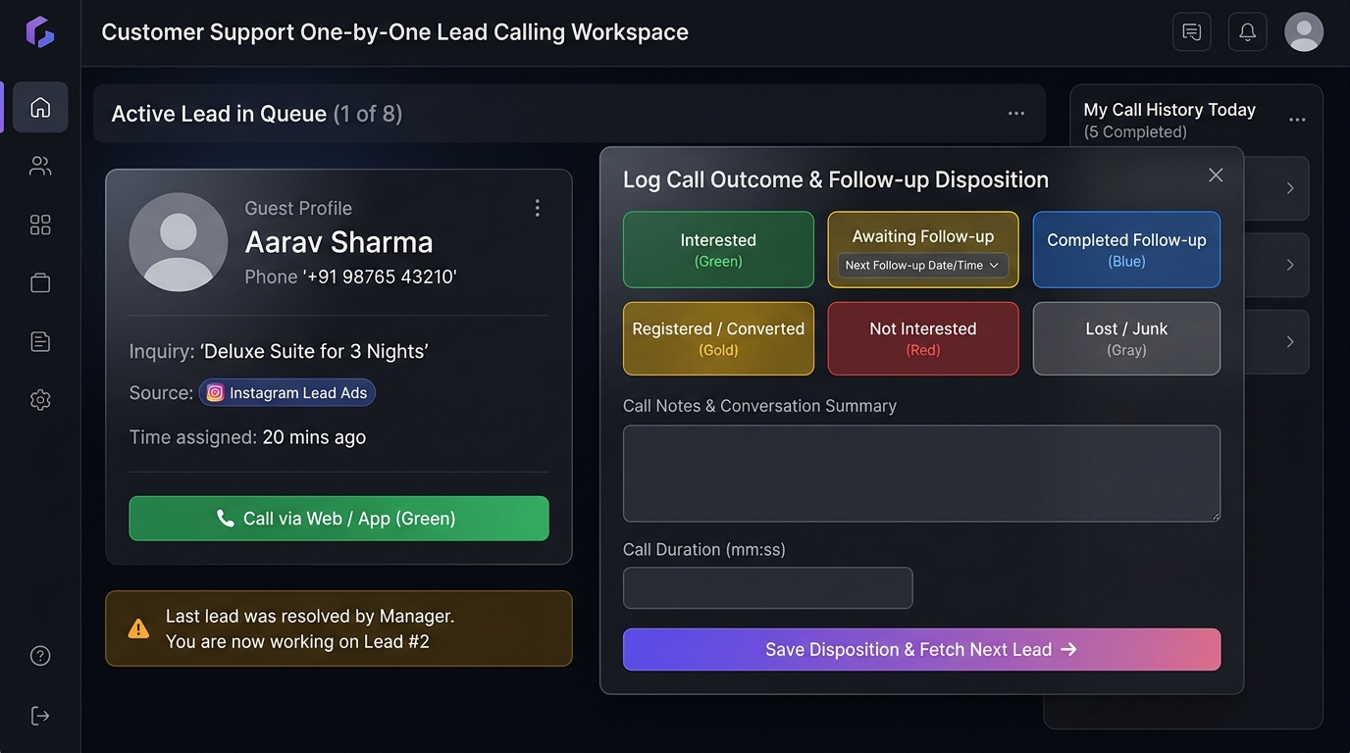
Figure 5: Screen 5 — Customer Support One-by-One Queue & Post-Call Disposition Modal

Screen 6: Manager & Admin Escalation & SLA Monitoring Dashboard
Platform: Web Dashboard | Target Users: Manager (Level 1), Admin (Level 2)
Features:
• Real-time Overdue Feed: Leads exceeding SLA deadlines with glowing overdue badges ("2d 6h overdue").
• Metric Cards: Total Escalated Leads (19), Support Inaction (14), Admin Critical (5), Avg Resolution Time (3.2 hrs).
• Filter Bar: Filter by Support Staff, SLA Severity Level, Lead Source.
• Action Triggers: 1-Click "Reassign Staff", "Resolve", "Call Now".
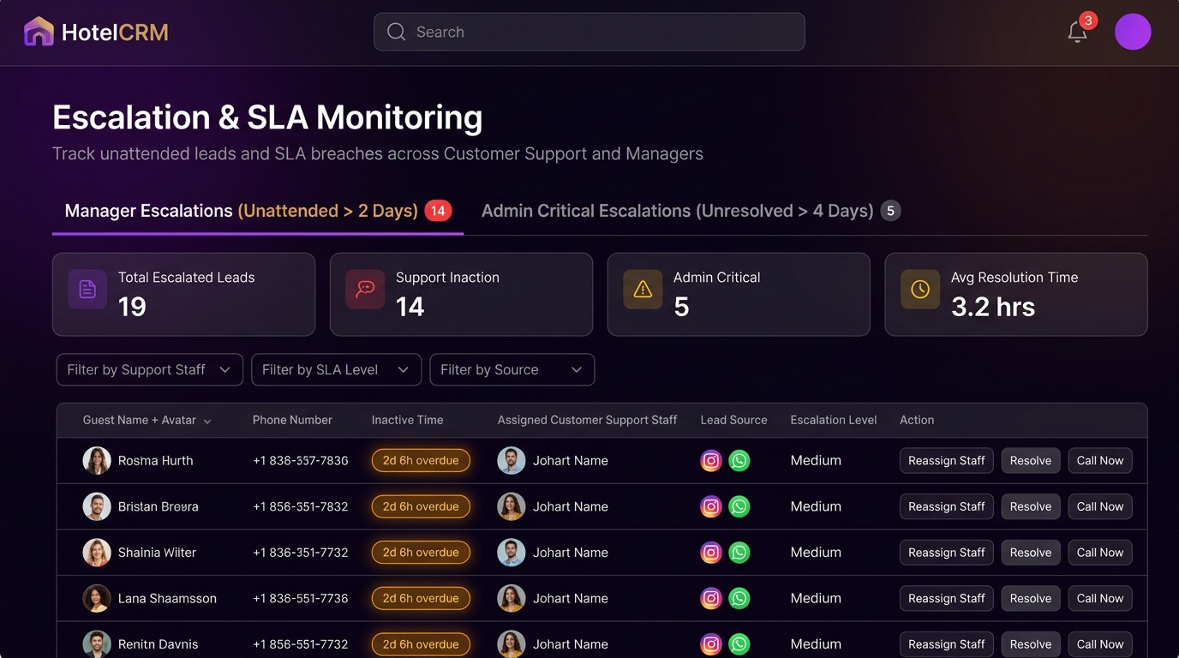
Figure 6: Screen 6 — Escalation & SLA Monitoring Dashboard (Web)

6. Mobile App Master Suite Designs (Screens 7 to 11)
The mobile app is engineered for zero clutter on handheld devices. A single Bottom Navigation Bar controls the app sections, eliminating duplicate top tabs and providing lightning-fast navigation for On-the-Go Hotel Executives and Staff:
Screen 7: Mobile Home Hub (Zero-Clutter Dashboard)
Platform: Mobile App | Target Users: Admin, Manager
Features:
• 2 Large KPI Cards: Total Leads (148) with purple glow, Converted (12) with gold glow.
• Glowing Alert Banner: " 3 Critical Escalations Need Action" with instant "Review Now ➔" button.
• Quick Action Grid: "+ Add Lead", "Reassign", "WhatsApp Alert".
• Single Bottom Navigation: Home (Active), Leads, Escalations (Red Dot 3), Team, Settings.
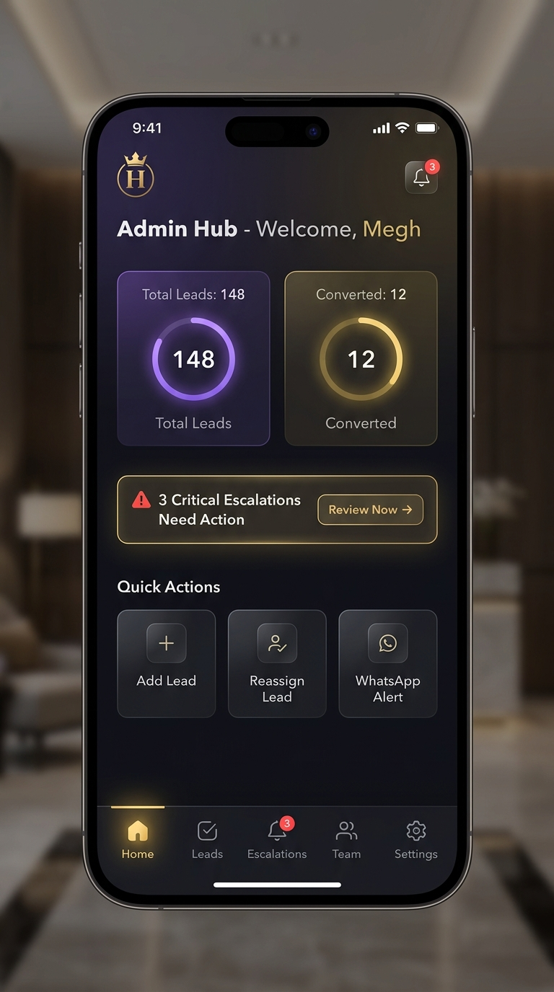 Figure 7: Screen 7 — Mobile Home Hub (Admin & Manager)

Screen 8: Mobile Escalations Tab (Action Overdue Leads)
Platform: Mobile App | Target Users: Manager (Level 1), Admin (Level 2)
Features:
• Contextual Sub-Filter Chips: [ All (3) ] [ Level 1: Manager (2) ] [ Level 2: Admin Critical (1) ].
• Overdue Lead Cards: Guest Name, Mobile (+91), Room Inquiry, Overdue timer ("4d 2h Overdue - Critical Level 2"), assigned Support & Manager.
• 1-Tap Quick Actions: "Direct Call" (green) and "Reassign to Manager / Support" (purple).
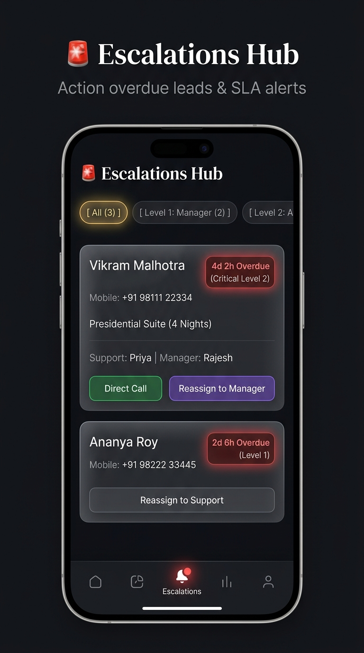
Figure 8: Screen 8 — Mobile Escalations Tab

Screen 9: Mobile Leads Directory Tab (Staff Grouping & Status Chips)
Platform: Mobile App | Target Users: Admin, Manager
Features:
• Staff Filter Dropdown: "Filter Staff: Agent Rahul Sharma (Support)".
• Status Filter Chips: All, Interested (Active), Awaiting Follow-up, Registered.
• Lead Cards: Guest Name, Mobile (+91), Source icon (Instagram, WhatsApp), Last Call Date & Duration, and Status Pill with "View Timeline ➔".
• View Timeline Section: In the View Timeline section, you can see who called the user, along with the notes and status of each call.
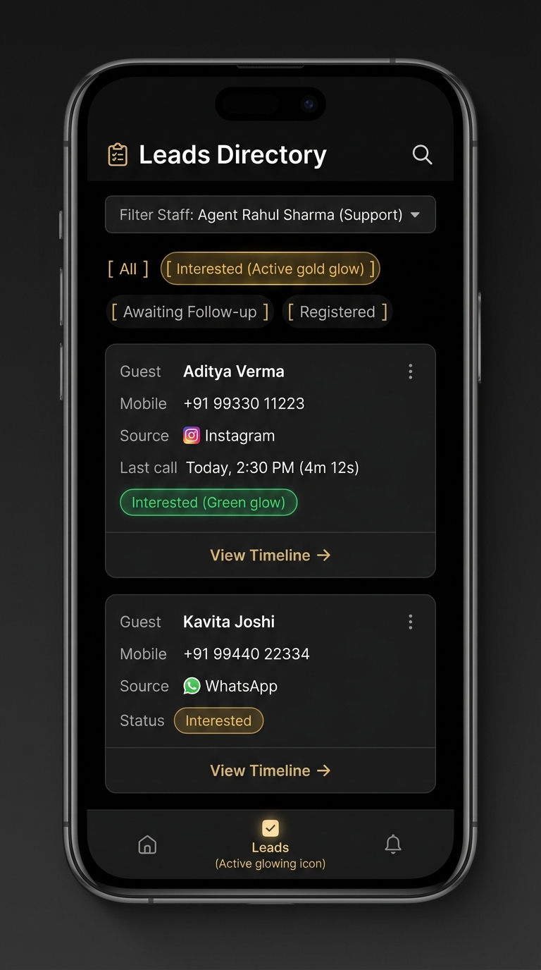
Figure 9: Screen 9 — Mobile Leads Directory Tab

Screen 10: Mobile Team & Performance Tab (Role-Separated Managers vs Support)
Platform: Mobile App | Target Users: Admin, Manager
Features:
• Role-Separated Segmented Sub-Tabs: [ Customer Support (8) ] vs [ Managers (3) (Active Gold) ].
• Manager Cards: Leads Overseeing (45), Team Staff Supervised (4), Team Conversion (82%), and glowing "Manager Critical Breaches: 1 (Breached to Admin)".
• Support Cards: Leads Assigned (18), Conversion Rate (74%), and "Support Inaction Escalations: 2".
• User Statistics & Downloads: When you click on a user card, their statistics will open. You can also download the user’s statistics or have them emailed on a monthly, weekly, or yearly performance basis.
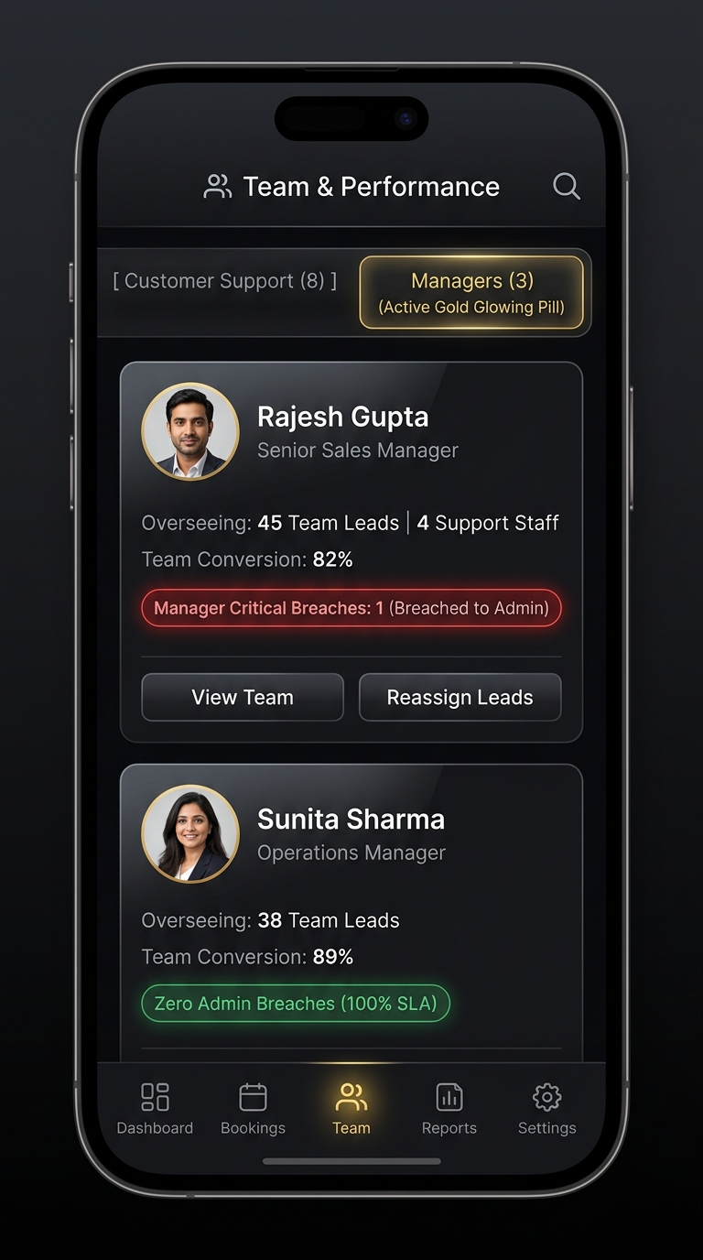
Figure 10: Screen 10 — Mobile Team & Performance Tab (Managers vs Support)

