***Software Engineering***

***Software Requirements Specification***

***(SRS) Document***

**Spartan Sellers Campus Marketplace Application**

**05/01/2024**

**Version 1.0**

**By: Meghan Wilcox, Alli Weavil, and Carrissa Boddie**

**I HAVE ABIDED BY THE UNCG ACADEMIC POLICY ON THIS ASSIGNMENT.**

**Table of Contents**

1. Introduction 3

1.1. Purpose 3

1.2. Document Conventions 3

1.3. Definitions, Acronyms, and Abbreviations 3

1.4. Intended Audience 3

1.5. Project Scope 4

1.6. Technology Challenges 4

1.7. References 4

2. General Description 5

2.1. Product Features 5

2.2. User Class and Characteristics 5

2.3. Operating Environment 5

2.4. Constraints 5

2.5. Assumptions and Dependencies 5

3. Functional Requirements 6

3.1. Primary 6

3.2. Secondary 6

3.3. Use-Case Model 6

3.3.1. Use-Case Model Diagram 6

3.3.2. Use-Case Model Descriptions 6

3.3.2.1. Actor: Manager (Alice) 6

3.3.2.2. Actor: Actor Name (Responsible Team Member) 7

3.3.2.3. Actor: Actor Name (Responsible Team Member) 7

3.3.3. Use-Case Model Scenarios 7

3.3.3.1. Actor: Manager (Alice) 7

3.3.3.2. Actor: Actor Name (Responsible Team Member) 8

3.3.3.3. Actor: Actor Name (Responsible Team Member) 8

4. Technical Requirements 12

8.1. Interface Requirements 12

8.1.1. User Interfaces 12

8.1.2. Hardware Interfaces 12

8.1.3. Communications Interfaces 12

8.1.4. Software Interfaces 12

5. Non-Functional Requirements 13

5.1. Performance Requirements 13

5.2. Safety Requirements 13

5.3. Security Requirements 13

5.4. Software Quality Attributes 13

5.4.1. Availability 13

5.4.2. Correctness 13

5.4.3. Maintainability 13

5.4.4. Reusability 13

5.4.5. Portability 13

5.5. Process Requirements 14

5.5.1. Development Process Used 14

5.5.2. Time Constraints 14

5.5.3. Cost and Delivery Date 14

5.6. Other Requirements 14

6. Design Documents 15

6.1. Software Architecture 15

6.2. High-Level Database Schema 15

6.3. Software Design 16

6.3.1. State Machine Diagram: Admin (Carissa) 16

6.3.2. State Machine Diagram: Buyer (Alli) 16

6.3.3. State Machine Diagram: Seller (Meghan) 17

6.4. UML Class Diagram 17

7. Scenario 18

7.1 Written Scenario 18

# Introduction

## Purpose

The goal of the Spartan Sellers Campus Marketplace Application is to enable UNCG students to advertise used academic and housing items to other university students and faculty, in order to reduce the hassle of finding affordable housing materials each year.

## Document Conventions

The purpose of this Software Requirements Specifications document is to detail the needs for the user and developer sides of the Spartan Sellers Campus Marketplace Application. The developer side requirements are the necessary functions, methodologies, and systems that need to be installed, edited, and maintained in order to build the back-end functionality of the application. The user-side requirements detail the data visibility, user interaction, user experience, and user views that need to be available and functional for our users. These requirements outline the necessary tasks that need to be accomplished by our software application, and from these we will derive the process by which these tasks are to be built.

## Definitions, Acronyms, and Abbreviations

|  |  |
| --- | --- |
| HTML | Hyper Text Markup Language. This is the code that will structure and design the content of our website. |
| CSS | Cascading Style Sheets. This code creates the visual styling of the website. |
| JavaScript | A programming language that we will use to build the front-end behavior and some backend functionality as well. |
| Node.JS | A programming language that builds on JavaScript to program back-end functionality for web applications. |
| SQLite | An open-source relational database. |
| Visual Studio Code | A multi-platform IDE in which we will do our development work. |
| Abstract API | Application Programming Interface. This will be used to validate emails before a user registers, ensuring safety in our app’s community. |
| Git/GitHub | A version control system that we will use to collaborate on this project efficiently. |

## Intended Audience

The intended audience for the SpartanSellers Campus Marketplace Application includes UNCG campus students seeking to buy and sell used dorm and school supplies. This includes undergraduate and graduate students who are actively enrolled at the university and are interested in purchasing affordable, second-hand items or selling their own belongings to fellow students.

## Project Scope

The project scope for SpartanSellers Campus Marketplace Application includes developing a user-friendly platform for UNCG campus students to buy and sell used dorm and school supplies. Key features would include user registration/authentication, listing items for sale with admin approval, seller reviews for accountability, and a messaging system for communication. The application aims to enhance the student experience by providing a convenient and reliable platform for trading used items within the UNCG campus community.

## Technology Challenges

Technology challenges for the SpartanSellers Campus Marketplace Application include ensuring scalability to accommodate a growing user base, implementing security measures, optimizing for mobile responsiveness, designing a user-friendly interface. These challenges require careful planning and collaboration to ensure smooth operation and a positive user experience.

## References

N/A

# General Description

## Product Features

The SpartanSellers Campus Marketplace Application is an application that allows UNCG campus students to easily browse used dorm and school supplies from other students. In addition, SpartanSellers allows buyers to leave reviews for sellers, making sure that students who are frequent users of the application throughout their time at university are held accountable to maintain a professional demeanor when selling their used items. Sellers can list items for sale on the site. Sellers are also able to view historic pricing by category for items they post, allowing them to be more informed when pricing their items. In addition, items must be approved before being listed, and admins can remove problematic users. Finally, buyers can search for items, post reviews about sellers, and contact sellers.

## User Class and Characteristics

Our website application is designed specifically for UNCG students attending the university in person. The website content will not be available to non-account holding UNCG students in order to best preserve the safety of an online student platform. Users will need to have prior knowledge of using a web browser, and be familiar with navigating the basic menu options of a typical website.

## Operating Environment

This software application is designed to operate on the internet across a variety of online compatible platforms.

## Constraints

N/A.

## Assumptions and Dependencies

The application will be dependent on the internet server hosting and database functionality. In addition, the application will be dependent on the Abstract API to validate the user’s email.

# Functional Requirements

## Primary

* FR0: The system enables users to login as either a regular user or as an Administrator, where they will be taken to a corresponding main menu page.
* FR1: The system enables regular users to browse listed items by category.
* FR2: The system enables regular users to search for items by keyword.
* FR3: The system enables regular users to list items for sale.
* FR4: The system enables regular users to view historic pricing data by category.
* FR5: The system enables users to view their profile information.
* FR6: The system enables users to update their email and password.
* FR7: The system enables users to update their profile information.
* FR8: The system enables admin users to view listing waiting to be approved.
* FR9: The system enables admin users to approve/not approve listings.
* FR10: The system enables admin users to view a list of users that are registered with the application.
* FR11: The system enables admin users to remove users from the system entirely.
* FR12: The system enables new users with a UNCG email to register with the site in a secure account.

## Secondary

* Login protection so that passwords are stored securely and are not visible to regular users.

## Use-Case Model

## Use-Case Model Diagram

## Use-Case Model Descriptions

### Actor: Buyer (Alli)

* **Search for/Browse Items:** The buyer can search for items by keyword, and look through lists of items for sale.
* **Post Seller Reviews:** The Buyer can post reviews on the sellers they interact with, creating accountability between buyers and sellers to create a safe interactive online space.
* **Login:** All users must login to the application with a unique UNCG email address and password in order to view and manipulate the website’s content.

### Actor: Seller (Meghan)

* **Post Listings**: Sellers are able to post listings to the platform, visible to buyers to search for and browse.
* **View Historic Pricing Information:** Sellers are able to view historic pricing information by item category, allowing them to better price their own item to the area’s standards.
* **Login:** All users must login to the application with a unique UNCG email address and password in order to view and manipulate the website’s content.

### Administrator (Carissa)

* **Approve Sellers:** Administrators must approve sellers when they initially try to register as a “Seller” on the application.
* **Approve/Remove Listings:** Administrators must approve listings against a set of university approved criteria in order for a listing to be shown as content on the site.
* **Login:** All users must login to the application with a unique UNCG email address and password in order to view and manipulate the website’s content.

## Use-Case Model Scenarios

### Actor: Buyer (Alli)

* **Use-Case Name:** Search for/Browse Items
  + - **Initial Assumption:** The Buyer has access to the website (has successfully logged in) and is in the buyer role.
    - **Normal:** The buyer will enter item keyword(s) into the search bar, and hit enter. Or the buyer will select a category to view all available items in that category.
    - **What Can Go Wrong:** The buyer enters invalid keywords that do not match any items listed, thus returning no items.
    - **Other Activities:** The buyer, assuming they have successfully logged into the website and are in the buyer role, initiates the process by entering item keyword(s) into the search bar or selecting a category to view available items. They can further refine their search results by applying filters such as price range, condition, or seller rating, and sort the results by relevance, price, or other criteria. The buyer may save items to a wish list for future reference or add them to a shopping cart for purchase. By clicking on individual items, they can access detailed descriptions and images to make informed decisions.
    - **System State on Completion**: The application delivers an interactive list of all matching available items, and/or the user is able to browse a master list of available items by category.

**-** **Use-Case Name:** Post Seller Reviews

* + - **Initial Assumption:** The Buyer has access to the website (has successfully logged in) and is in the buyer role.
    - **Normal:** The buyer will navigate to the seller’s profile and select the option to write a review. They will type their review and post it to the list of reviews.
    - **What Can Go Wrong:**
* The buyer's internet connection may be unstable or lost during the review writing process, resulting in incomplete or lost data.
* The buyer encounters technical difficulties or errors while navigating to the seller's profile or attempting to write and post a review.
* The seller's profile may not load properly or may not have the option to write a review due to system errors or bugs.
* The buyer may accidentally delete their review or encounter errors when trying to submit it, leading to loss of the review.
  + - **Other Activities:**
* The buyer viewing existing reviews on the seller's profile to gather information before writing their own review.
* Editing or revising the review content before posting if needed to ensure accuracy and clarity.
* Receiving confirmation or feedback from the system upon successful submission of the review, indicating that it has been posted to the seller's profile.
  + - **System State on Completion**: The application successfully posts the review to the seller’s profile.

**-** **Use Case Name:** Login

* + - **Initial Assumption:** The user has access to the website via the internet.
    - **Normal:** The user will navigate to the login page, enter their UNCG email and password, and hit log in.
    - **What Can Go Wrong:** The user enters an email or password that is not recognized by the system; thus, the system responds with an error message to indicate that the user must re-enter the correct UNCG email and password combination.
    - **Other Activities:** A new user may also choose to register as a new user, where they must enter required fields, those fields must be validated, and a new user id will be created for them.
    - **System State on Completion**: The application successfully validates the login of the user, and they are brought to the main menu of the application.

### Actor: Seller (Meghan)

* **Use-Case Name:** List Item for Sale
  + **Initial Assumption:** The Seller has access to the website (has successfully logged in) and is in the seller role.
  + **Normal:** The Seller will navigate to the page to list an item, they will enter the necessary information into the fields, and submit their item for approval.
  + **What Can Go Wrong:** The seller enters invalid information into the fields, thus the system returns an error message requesting the seller to re-enter the correct information.
    - **Other Activities:**
* Uploading images of the item to provide visual representation for potential buyers.
* Selecting relevant categories and subcategories to classify the item appropriately within the marketplace.
* Setting a price for the item based on its condition, market value, or other relevant factors.
* Providing a detailed description of the item, including its features, condition, and any additional information that may be relevant to potential buyers.
* Specifying pickup details, such as location and time.
* Responding to any messages or inquiries from potential buyers regarding the listed item.
  + **System State on Completion**: The data entered is successfully validated, an item id is created for the item, and the item will be submitted to the admin user for approval, where it will be either approved and listed on the site, or not approved and removed from the system. The seller will receive a message on the status of the approval process once completed.
* **Use-Case Name:** View Historic Pricing Information
* **Initial Assumption:** The Seller has access to the website (has successfully logged in) and is in the Seller role.
* **Normal:** The Seller will navigate to the page for viewing historic pricing information. They will select a category from a list, and then view in read-only-mode the average price, median price, and range of prices for items in this category.
* **What Can Go Wrong:** The seller selects a category in which no items have been listed yet, thus displaying no data.
* **Other Activities:**
* Filtering or sorting the historic pricing data based on specific criteria such as date range or item condition to narrow down the results.
* Comparing the historic pricing information of different categories to analyze trends or fluctuations in pricing over time.
* **System State on Completion**: The application successfully loads the data, and it is displayed to the user for them to view.
* **Use Case Name:** Login
* **Initial Assumption:** The user has access to the website via the internet.
* **Normal:** The user will navigate to the login page, enter their UNCG email and password, and hit log in.
* **What Can Go Wrong:** The user enters an email or password that is not recognized by the system; thus, the system responds with an error message to indicate that the user must re-enter the correct UNCG email and password combination.
* **Other Activities:** A new user may also choose to register as a new user, where they must enter required fields, those fields must be validated, and a new user id will be created for them.
* **System State on Completion**: The application successfully validates the login of the user, and they are brought to the main menu of the application.

### Actor: Administrator (Carissa)

* **Use-Case Name:** Approve Sellers
  + - **Initial Assumption:** The Admin has access to the website (has successfully logged in) and is in the admin role.
    - **Normal:** The admin will navigate to the page displaying the list of sellers waiting to be approved. They will view the profile and select either approve or not approve the seller.
    - **What Can Go Wrong:**
* Technical difficulties or errors preventing the admin from accessing the page displaying the list of sellers waiting to be approved.
* Incomplete or incorrect information provided by sellers during the registration process, requiring additional verification or clarification from the admin.
* System errors or bugs preventing the admin from selecting the approve or not approve for a seller.
  + - **Other Activities:**
* Verifying the authenticity of seller profiles and ensuring compliance with university policies and regulations.
* Communicating with sellers to request additional information or clarification if needed before making a decision on their approval status.
* Documenting the reasons for not approving a seller and providing feedback or guidance for improvement if necessary.
* Updating the list of approved sellers and their profiles in the system, including registering UNCG email addresses and corresponding passwords for approved sellers.
* Sending notifications to sellers regarding the status of their approval and any necessary actions they need to take.
  + - **System State on Completion**: The application records the seller as either approved or not approved. If the seller is approved its profile is added and the UNCG email and corresponding password are registered for use. If the seller is not approved, they receive a message, and their information is scrapped from the system.
* **Use-Case Name:** Approve Listings
  + - **Initial Assumption:** The Admin has access to the website (has successfully logged in) and is in the admin role.
    - **Normal:** The Admin will navigate to the page listing all of the items waiting to be approved. For any one item, they will view its info, and select either approve or not approve.
    - **What Can Go Wrong:**
* Technical difficulties or errors preventing the admin from accessing the page listing all items waiting to be approved.
* Incomplete or incorrect information provided for some listings, requiring additional verification or clarification from the admin.
* System errors or bugs preventing the admin from selecting the appropriate action (approve or not approve) for a listing.
  + - **Other Activities:**
* Reviewing and verifying the accuracy and completeness of listing information, including item details, pricing, and images.
* Communicating with sellers to request additional information or clarification if needed before making a decision on the listing's approval status.
* Documenting the reasons for not approving a listing and providing feedback or guidance for improvement if necessary.
* Updating the status of approved listings and categorizing them appropriately on the site.
* Sending notifications to sellers regarding the status of their listings and any necessary actions they need to take.
  + - **System State on Completion**: The application records the item as either approved or not approved. If the item is approved its profile is created on the sire under its appropriate category. If the item is not approved, they seller receives a message, and the item information is scrapped from the system.
* **Use Case Name:** Login
* **Initial Assumption:** The user has access to the website via the internet.
* **Normal:** The user will navigate to the login page, enter their admin email and password, and hit log in.
* **What Can Go Wrong:** The user navigates to the admin login portal, enters an email or password that is not recognized by the system; thus, the system responds with an error message to indicate that the user must re-enter the correct UNCG email and password combination.
* **Other Activities:**
* Providing an option for users to reset their password in case they forget it, including sending a password reset link to their registered email address.
* Implementing multi-factor authentication (MFA) options for enhanced security, such as sending a verification code to the user's mobile device
* **System State on Completion**: The application successfully validates the login of the user, and they are brought to the main menu of the application.

# Technical Requirements

## Interface Requirements

### User Interfaces

This software application will allow users to login as a regular user or administrator. Users can navigate through the different pages of the website by clicking links and there will be buttons for publishing products as well as buying products. There will be a search bar to allow for searching key words. The color of the website will be similar to the school’s colors.

### Hardware Interfaces

This software application will run on any hardware device that is able to connect to the internet and display a webpage on a screen, including but not limited to PCs, mobile phones, and tablets.

### Communications Interfaces

The application must be able to connect to the internet via the localhost server, in addition to the SQLite relational database. The application must also be able to connect to the Abstract API to display the location of an item listing.

### Software Interfaces

We will use HTML, CSS, and JavaScript to design the front-end, SQLite for the database, and JavaScript with Node.js for the backend functionality. We will use a localhost server to host our server.

.

# Non-Functional Requirements

## Performance Requirements

* The application should run smoothly and without extended wait periods. The database should be clean and store information in an organized manner.

## Safety Requirements

* NFR1(R): Listings must be able to be approved by admins to prevent any inappropriate language or photos from being posted to the site.
* NFR2(R): Users must be able to be removed by admins if deemed necessary.

## Security Requirements

* NFR5(R): The system will only be usable by authorized users.

## Software Quality Attributes

### Availability

* NFR6(R): The software application should allow FR1-4 to be available to users registered as regular users.
* NFR7(R): The software application should allow FR8-11 to be available to the administrative user.
* NFR8(R): The software application should allow FR1-12 to be available to all users.

### Correctness

* NFR9(R): Making sure that search functionalities (FR1, FR2) return accurate and relevant results.
* NFR10(R): Verifying that historic pricing data (FR4) is accurately calculated and displayed for users.

### Maintainability

* NFR11(R): Having clear and well-documented code for both front-end and back-end components.
* NFR12(R): Establishing a version control system, like Git/GitHub, to track changes and allow for collaborative development.
* NFR13(R): Creating documentation for developers to understand the system's structure and components.

### Reusability

* NFR14(R): Using reusable components for common functions.
* NFR15(R): Organizing code to find common functions.

### Portability

* NFR16(R): Making sure the application is compatible with all web browsers (e.g., Chrome, Firefox, Safari) for both regular users and administrators.
* NFR17(R): Using responsive designs to allow for different screen sizes, making the application accessible on all devices like PCs, mobile phones, and tablets.

## Process Requirements

### Development Process Used

Waterfall Model

### Time Constraints

This project will be completed by the end of the semester, Spring 2024.

### Cost and Delivery Date

The cost of the project should be $0.

## Other Requirements

## N/A

1. **Design Documents**
   1. **Software Architecture**

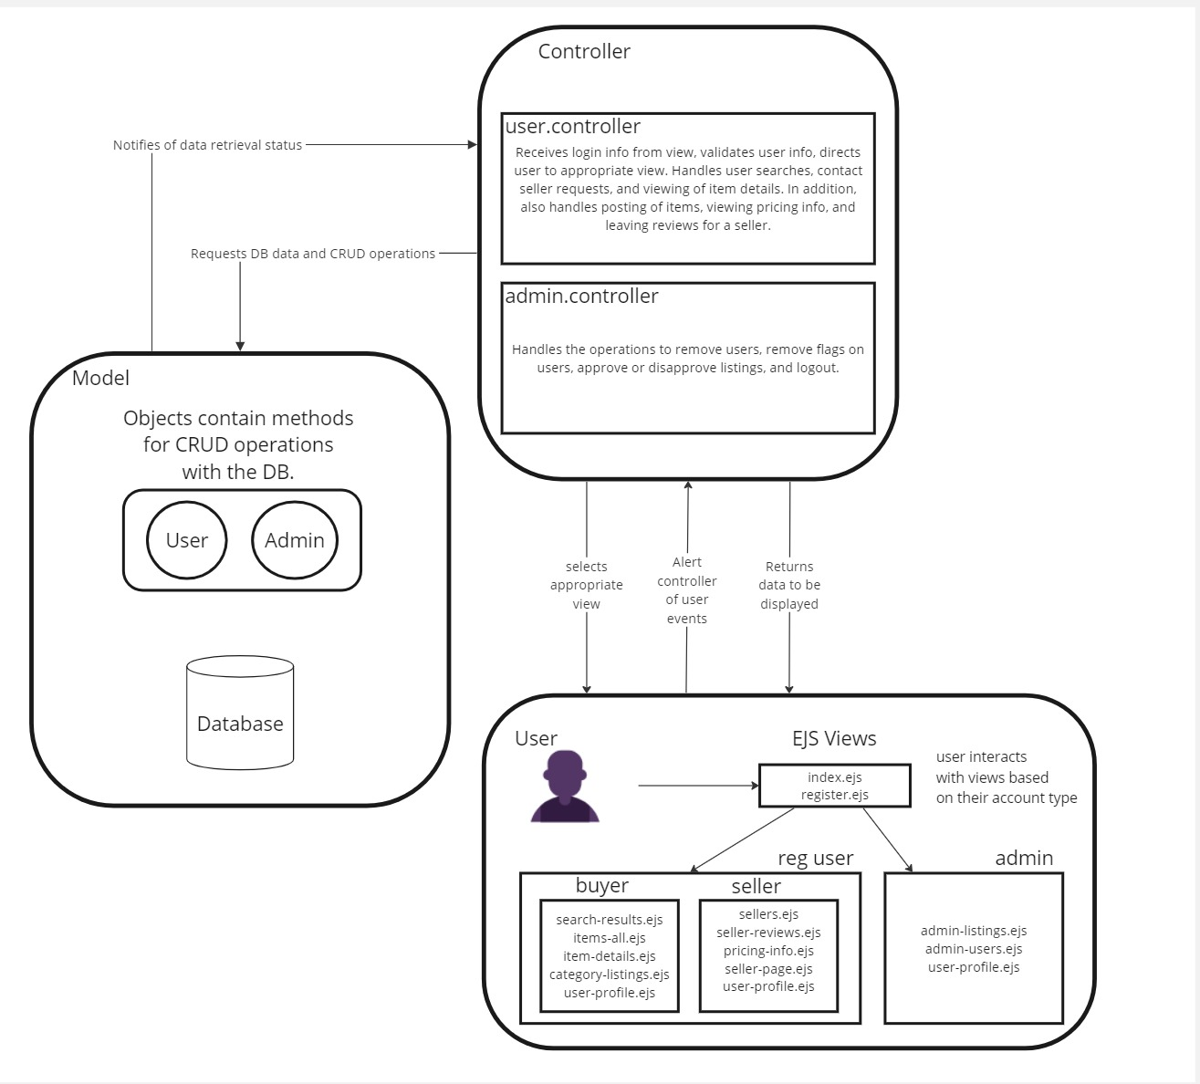

* 1. **High-Level Database Schema**

* 1. **Software Design**
     1. **A diagram of a flowchart

        Description automatically generatedState Machine Diagram: Admin (Carissa)**
     2. **A diagram of a company

        Description automatically generatedState Machine Diagram: Buyer (Alli)**
     3. **A diagram of a diagram

        Description automatically generatedState Machine Diagram: Seller (Meghan)**
  2. **UML Class Diagram**

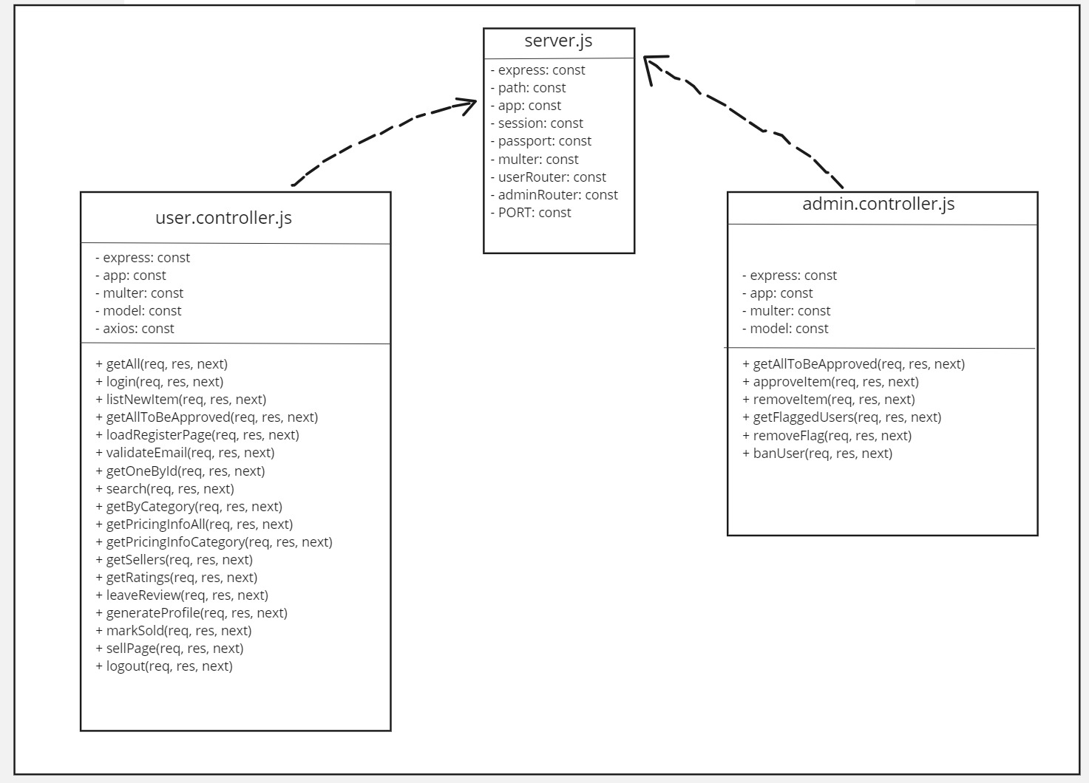

1. **Scenario**

**7.1 Written Scenario**

Seller:

Make sure you are logged in as a regular user, if not, login.

* Register Use Case:
* Click on the register button at the bottom of the login page.
* Enter your information and click register.
* Once directed back to the login page, login with your new credentials.
* Login Use Case:
* Enter your credentials, click LOGIN.
* Based on your credentials, you will be directed to the main shopper page or the admin page.

- List an Item Use Case:

* Navigate to the SELL button in the top left corner of the main buyer page .
* To list an Item, enter the item’s information into the form, and hit submit.

- View Historic Pricing Info Use Case:

* From the main seller page, navigate to the VIEW HISTORIC PRICING INFO button.
* From here you can view the default category as all, or select a category to see more detailed information about a specific category.

Admin: Approve/ Deny Listings Use Case:

1. Admin logs in and is brought to the “View Listings” page.
2. Admin is able to see the full list of listed items waiting for approval.
3. Admin is able to decide whether to approve or deny listing based on the condition and description.

Admin: Remove (Ban) Users/ Remove Flag Use Case:

1. Admin Clicks on the “View Users” button and is brought to a list of problematic users.
2. Admin decides whether to ban users or remove the flag based on the reason flagged.

Buyer:  Search items, contact seller use case:

1. Buyer B1 logs in and searches for a product with a keyword.

2. Buyer B2 clicks on a product and clicks on the ‘Contact Seller” button to communicate with S1.

Buyer:  Write reviews use case:

1. Buyer B2 logs in and writes a positive review of S2. B2 exits.