1) What is SDLC?

ANS: SDLC is structure imposed on the development of software product define the process of planning, implementation, testing, documentation, maintenance and support.

There are different types of model in SDLC.

2) What are the software testing?

ANS: Software testing is process used to identify the correctness, completeness and identity of developed computer software.

3) What is agile methodology?

ANS: Agile model is combination of iterative and incremental process with focus on process adaptability and customer satisfaction by rapid delivery of working software product.

4) What are the SRS?

ANS: A software requirements specification is a complete description of the behaviour of the system to be developed.

It is consist user case which described all interaction of user and software.

5) What is oops?

ANS: Object oriented programming is programming structure based on the concept of “Object” which can contain data and code. The data in the form of field and the code is in the form of procedure.

5) What are the basic concept of oops?

ANS:

1. Identify the objects and assigning the responsibilities the object.
2. Object is communicate with other object by sending the massages.
3. Massage will be accept by method of object.
4. The object is like a black box.
5. The internal detail are hidden.
6. Object interact with each other by sending massages.

6) What is object?

ANS: An object is represents an individual, identical item, unit or entity, it’s either real or abstract.

An object is thing that any concept can applied on it.

7) What is class?

ANS: Class is blueprint of object.

Class is template for declaring and creating the objects.it also described the properties and behaviour of the object, without actual existence.

8) What is encapsulation?

ANS: A way to restrict the direct access to some component of object, so users cannot access state values for all the variable of particular object.

9) What is inheritance?

ANS: Inheritance means the one class inherits the characteristics of another class. This is called a “is a” relationship.

10) What is polymorphism?

ANS: Poly refers too many. That is single function or operator functioning in many ways different upon the usage is called polymorphism.

11) Draw Usecase on online book shopping.

ANS:

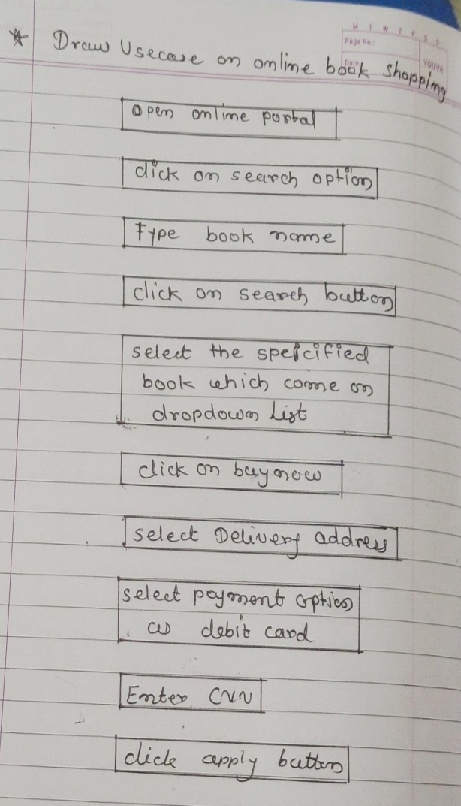

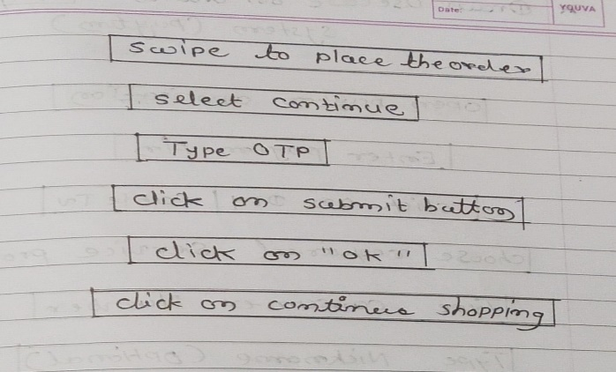

12) Draw usecase on online bill payment system. (PAYTM)

ANS:

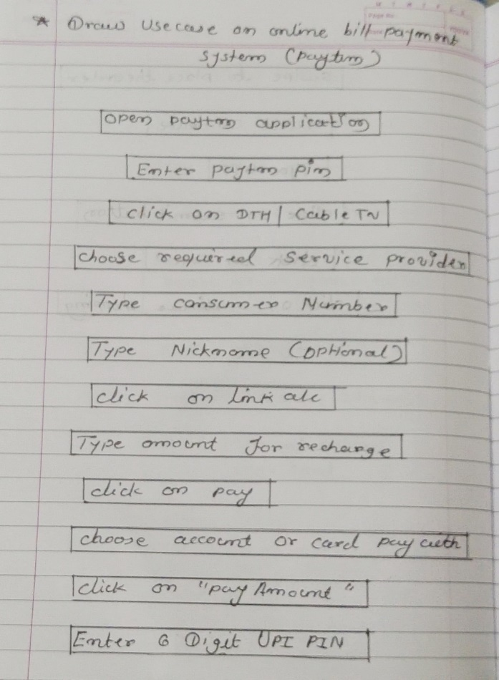

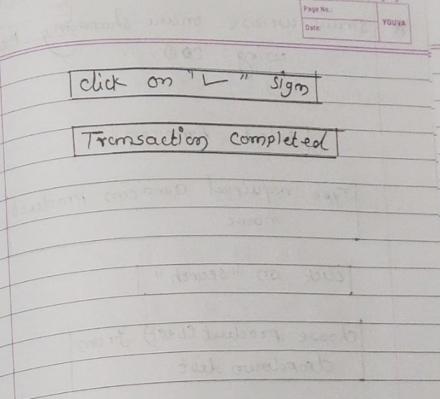

13) Write SDLC phases with basic introduction?

ANS:

1) Requirements Collecting/gathering: Establish customer needs.

There are three types of problem can arise::

1) Lack of clarity

2) Requirements confusion

3) Requirements amalgamation

2) Analysis: Model and specify the requirements “what”

3) Design: Model and specify a Solution “why”.

4) Implementation: Construct a Solution in software.

5) Maintenance: Repair defects and adapt the solution to the new requirements.

14) Explain phases of waterfall model?

ANS:

1) Requirements: All possible requirements of the system to be developed. Requirements must be frozen to early in life cycle.

2) Analysis: the analysis phase defines the how these requirements of system will be accomplished.

3) Design phase: The requirements specification from the first phase are studied in this phase and the system design is prepared.

4) Implementation phase: with inputs from the system design, the system first developed in small programs called units, which is integrated in the next phase.

5) Testing: all the units developed in the implementation phase are integrated into system after testing of each unit.

6) Maintenance: there are three types of maintenance.

1) Corrective maintenance

2) Adaptive maintenance

3) Perfective maintenance

15) Write the spiral model?

ANS: Spiral model is very widely used in software industry as it is in synch with the natural development process if any product i.e. learning with maturity and also involves minimum risk for the customer as well as development firm.

16) Write agile manifesto principles.

1) Individual interaction

2) Working software

3) Customer collaboration

4) Respond into changes

17) Explain working methodology of agile model and also write pros and cons.

ANS: Agile SDLC model is combination of iterative and incremental process model with focus on process adaptability and customer satisfaction by rapid delivery of working software product.

Agile methods break the product into small incremental builds.

This build are provided in the iterations.

Pros:

1) Resource requirements are minimum.

2) Suitable for fixed or changing requirements.

3) Good model for the environments that change steadily.

4) Minimal rules, documentation easily employed.

5) Promotes teamwork and cross training.

Cons:

1. Management is more complex.
2. End of project may not be known early.
3. Process is complex.
4. Nor suitable for small or low risk projects.
5. Spiral may go indefinitely.

18) Draw usecase on online shopping product using COD.

ANS:

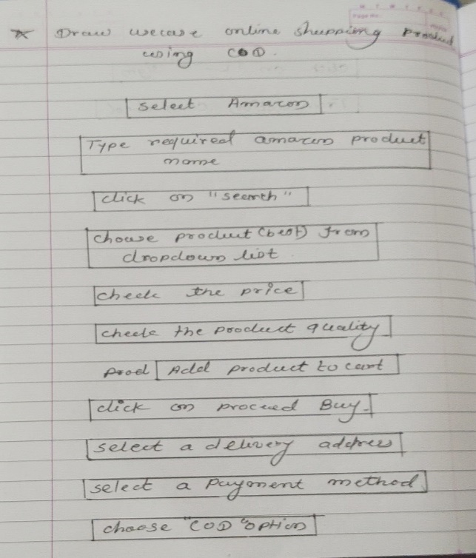

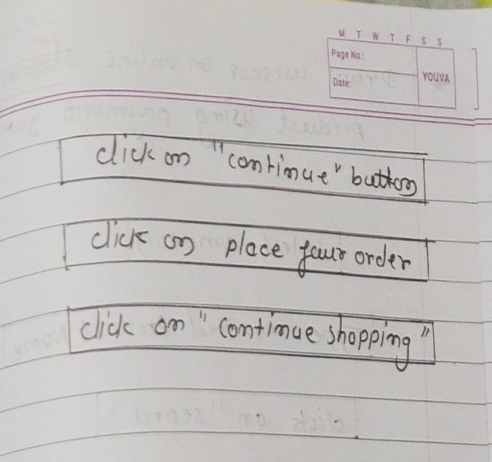

19) Draw usecase on online shopping product using payment gateways.

ANS:

