What is Sysmon?
Sysmon (System Monitor) is a Windows system service and device driver from Microsoft Sysinternals that monitors and logs detailed security-relevant events.
It helps SOC analysts detect suspicious activity such as malicious processes, network connections, and persistence mechanisms.
Objective
To install Sysmon on a Windows machine and configure it to generate detailed security events for monitoring and analysis.

Prerequisites
- Windows 10 (64-bit)
- Administrator privileges
- Internet access
- PowerShell

Step 1: Open the Virtual Machine
- Open VirtualBox
- Start the Windows 10 Defender VM
- Log in to Windows

Step 2: Open File Explorer
- Click on File Explorer
- Navigate to:
- C:\

Step 3: Create Sysmon Directory
- Inside C:\
- Create a new folder named
- Sysmon

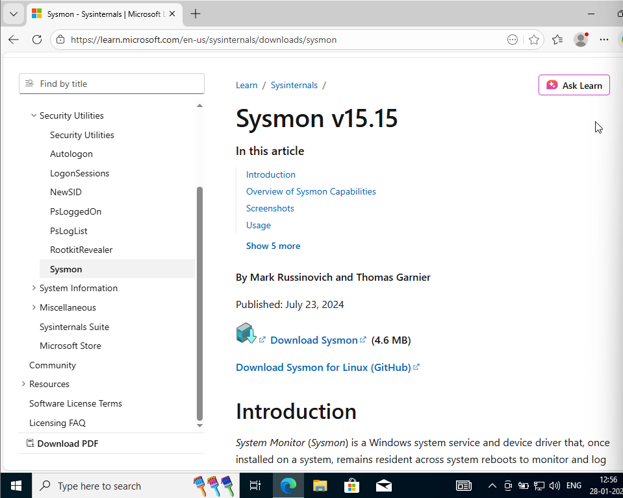
Step 4: Download Sysmon
- Open a web browser
- Go to the official Microsoft Sysinternals page:
- https://learn.microsoft.com/sysinternals/downloads/sysmon
- Download Sysmon
- The file will be downloaded as a ZIP file

Step 5: Extract Sysmon Files
- Go to the Downloads folder
- Right-click on Sysmon.zip
- Click Extract All
- Open the extracted folder
- Copy Sysmon64.exe
- Paste it into:
- C:\Sysmon

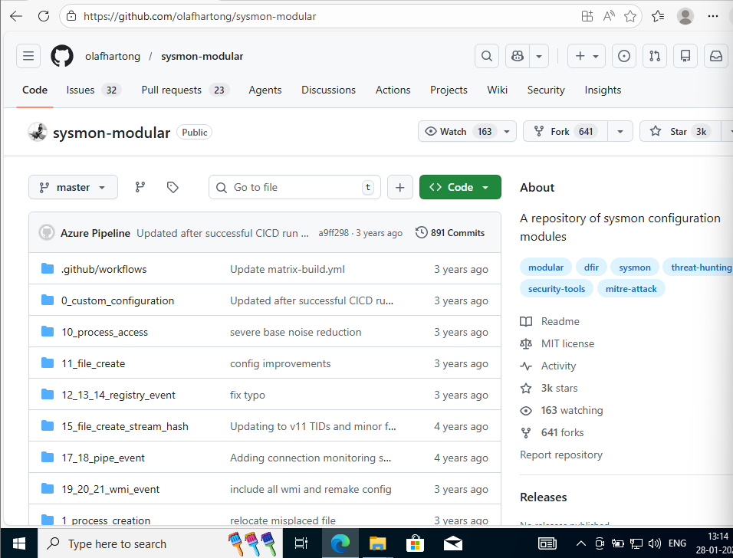
Step 6: Download Sysmon Configuration File
- Open browser
- Go to GitHub Sysmon modular configuration:
- https://github.com/olafhartong/sysmon-modular
- Click the green Code button
- Click Download ZIP
- Extract the ZIP file
- Open the extracted folder
- Locate:
- sysmonconfig.xml
- Copy sysmonconfig.xml
- Paste it into:
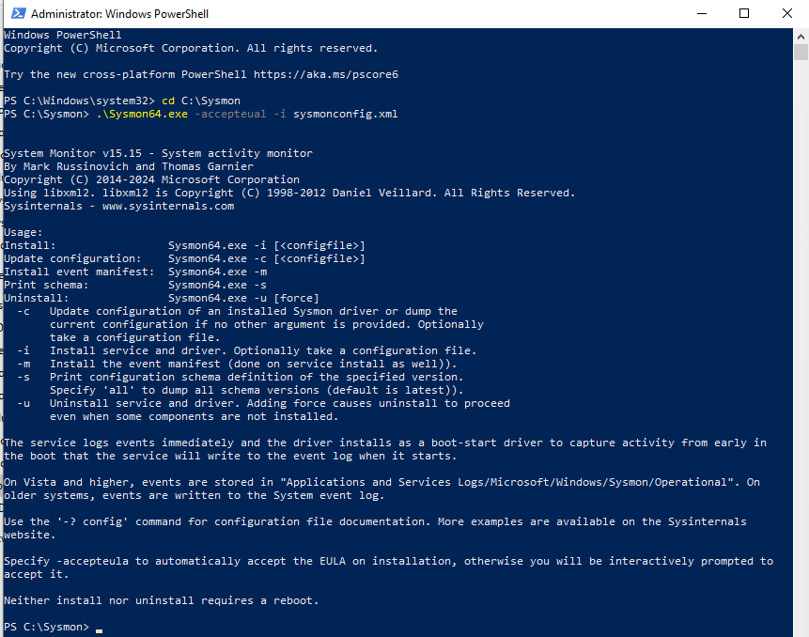
- C:\Sysmon

Step 7: Open PowerShell as Administrator
- Press Windows + R
- Type: PowerShell
- Press Ctrl + Shift + Enter
- Click Yes to allow administrator access

Step 8: Navigate to Sysmon Folder
- In PowerShell, run:
- cd C:\Sysmon
- Verify files: dir
- You should see:
- Sysmon64.exe
- sysmonconfig.xml

Step 9: Install Sysmon
- Run the following command:
- Sysmon64.exe -accepteula -i sysmonconfig.xml

Explanation:
- -accepteula → Accepts license agreement
- -i → Installs Sysmon
- sysmonconfig.xml → Applies monitoring rules

Step 10: Verify Sysmon Service
Check whether Sysmon is running: Sc query sysmon64
Expected result: STATE: RUNNING

Step 11: Verify Sysmon Event Logging
- Press Windows + R
- Type: eventvwr
- Navigate to:
- Applications and Services Logs
- → Microsoft
- → Windows
- → Sysmon
- → Operational
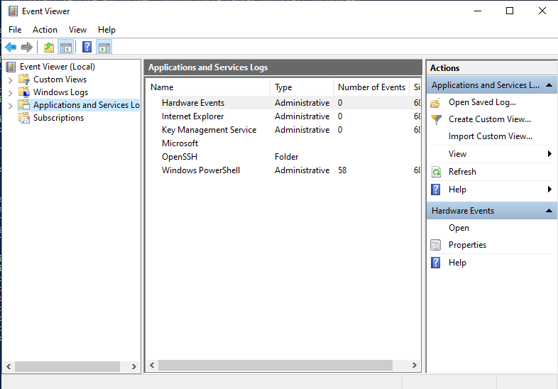
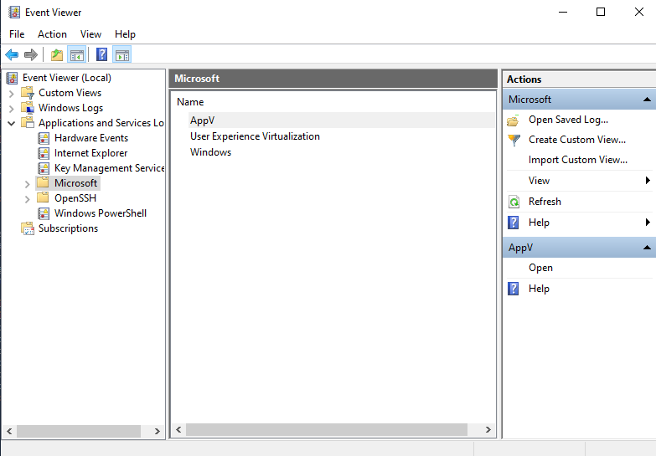
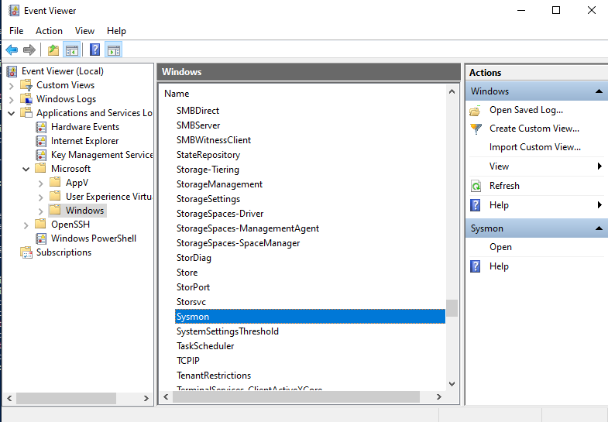
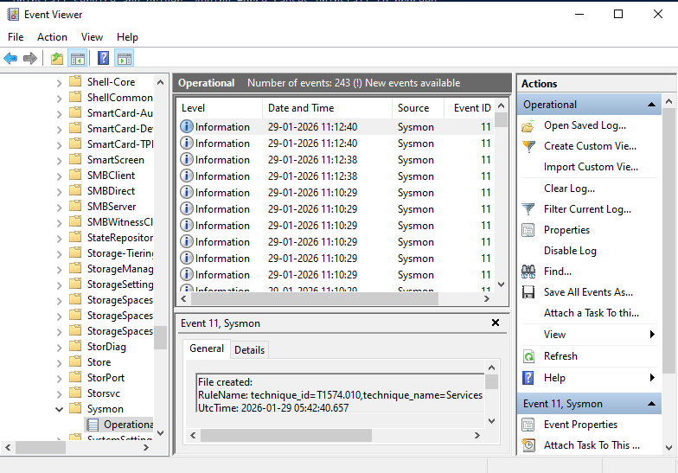

Step 12: Confirm Sysmon Events
You should see events such as:
- Event ID 1 – Process Creation
- Event ID 3 – Network Connection
- Event ID 7 – Image Load
- Event ID 11 – File Creation
This confirms Sysmon is successfully logging security events.

