**VISVESVARAYA TECHNOLOGICAL UNIVERSITY**

**“JnanaSangama”, Belgaum -590014, Karnataka.**



**LAB REPORT**

**on**

**Machine Learning**

***Submitted by:***

**MEGHA SURESHA**

**(1BM21CS262)**

**Under the Guidance of**

**Sunayana S**

**Assistant Professor, BMSCE**

***in partial fulfillment for the award of the degree of***

**BACHELOR OF ENGINEERING**

***in***

**COMPUTER SCIENCE AND ENGINEERING**



**B.M.S. COLLEGE OF ENGINEERING**

**(Autonomous Institution under VTU)**

**BENGALURU-560019**

**March 2024 - June 2024**

**B. M. S. College of Engineering,**

**Bull Temple Road, Bangalore 560019**

(Affiliated To Visvesvaraya Technological University, Belgaum)

**Department of Computer Science and Engineering**



**CERTIFICATE**

This is to certify that the Lab work entitled “**Machine Learning**” carried out by **Megha Suresha (1BM21CS262),** who is a bonafide student of **B. M. S. College of Engineering.** It is in partial fulfillment for the award of **Bachelor of Engineering in Computer Science and Engineering** of the Visvesvaraya Technological University, Belgaum during the year 2024. The Lab report has been approved as it satisfies the academic requirements in respect of **Machine Learning - (22CS6PCMAL)** work prescribed for the said degree.

**Sunayana S**              **Dr. Jyothi S Nayak**

Associate Professor Professor and Head

Department of CSE Department of CSE

BMSCE, Bengaluru BMSCE, Bengaluru

**Table Of Contents**

|  |  |  |  |  |
| --- | --- | --- | --- | --- |
| **S.No.** | **Experiment Title** | | | **Page No.** |
| **1** | **Course Outcomes** | | | **1** |
| **2** | **Experiments** | | | **1 - 57** |
|  | **2.1** | **Experiment - 1** | | **1** |
| **2.1.1** | **Question:**  Write a python program to import and export data using Pandas library functions. | **1** |
| **2.1.2** | **Code with Output** | **1** |
| **2.2** | **Experiment - 2** | | **2 - 20** |
|  | **2.2.1** | **Question:**  End-to-end ML Project. | **2** |
| **2.2.2** | **Code with Output** | **2** |
| **2.3** | **Experiment - 3** | | **21 - 23** |
|  | **2.3.1** | **Question:**  Use an appropriate data set for building the decision tree (ID3) and apply this knowledge to classify a new sample. | **21** |
| **2.3.2** | **Code with Output** | **21** |
| **2.4** | **Experiment - 4** | | **24 - 30** |
|  | **2.4.1** | **Question:**  Implement Linear and Multi-Linear Regression algorithm using appropriate dataset. | **24** |
| **2.4.2** | **Code with Output** | **24** |
| **2.5** | **Experiment - 5** | | **31 - 36** |
|  | **2.5.1** | **Question:**  Build Logistic Regression Model for a given dataset. | **31** |
| **2.5.2** | **Code with Output** | **31** |
| **2.6** | **Experiment - 6** | | **37 - 38** |
|  | **2.6.1** | **Question:**  Build KNN Classification model for a given dataset. | **37** |
| **2.6.2** | **Code with Output** | **37** |
| **2.7** | **Experiment - 7** | | **39 - 44** |
|  | **2.7.1** | **Question:**  Build Support vector machine model for a given dataset. | **39** |
| **2.7.2** | **Code with Output** | **39** |
| **2.8** | **Experiment - 8** | | **45 - 50** |
|  | **2.8.1** | **Question:**  a) Implement Random forest ensemble method on a given dataset.  b) Implement Boosting ensemble method on a given dataset. | **45** |
| **2.8.2** | **Code with Output** | **45** |
| **2.9** | **Experiment - 9** | | **51 - 53** |
|  | **2.9.1** | **Question:**  Build k-Means algorithm to cluster a set of data stored in a .CSV file. | **51** |
| **2.9.2** | **Code with Output** | **51** |
| **2.10** | **Experiment - 10** | | **54 - 55** |
|  | **2.10.1** | **Question:**  Implement Dimensionality reduction using Principle Component Analysis (PCA) method. | **54** |
| **2.10.2** | **Code with Output** | **54** |
| **2.11** | **Experiment - 11** | | **56 - 57** |
|  | **2.11.1** | **Question:**  Build Artificial Neural Network model with back propagation on a given dataset. | **56** |
| **2.11.2** | **Code with Output** | **56** |

1. **Course Outcomes**

**CO1:** Apply machine learning techniques in computing systems.

**CO2:** Evaluate the model using metrics.

**CO3:** Design a model using machine learning to solve a problem.

**CO4:** Conduct experiments to solve real-world problems using appropriate machine learning techniques

1. **Experiments**
   1. **Experiment - 1**
      1. **Question:**

Write a python program to import and export data using Pandas library functions.

* + 1. **Code with Output:**

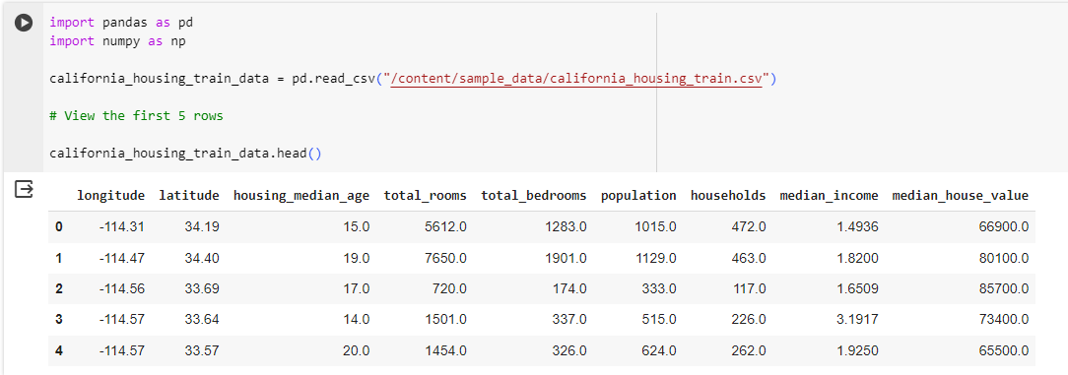

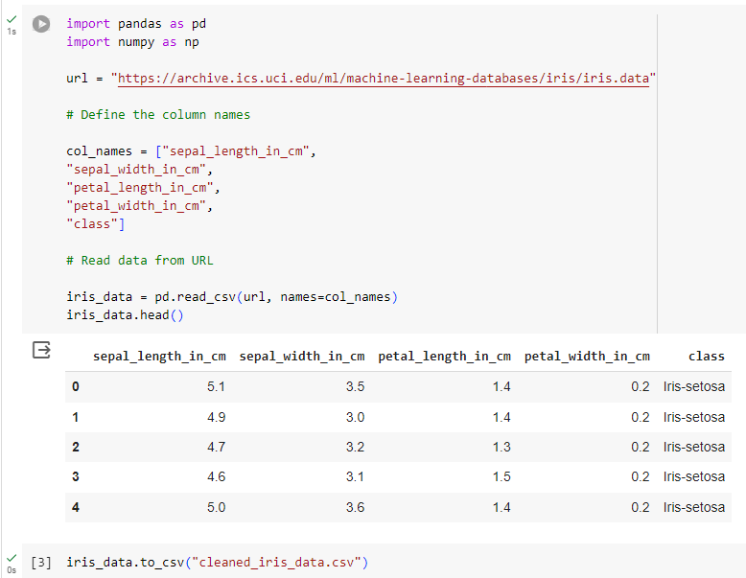

* 1. **Experiment - 2**
     1. **Question:**

End-to-end ML Project.

* + 1. **Code with Output:**

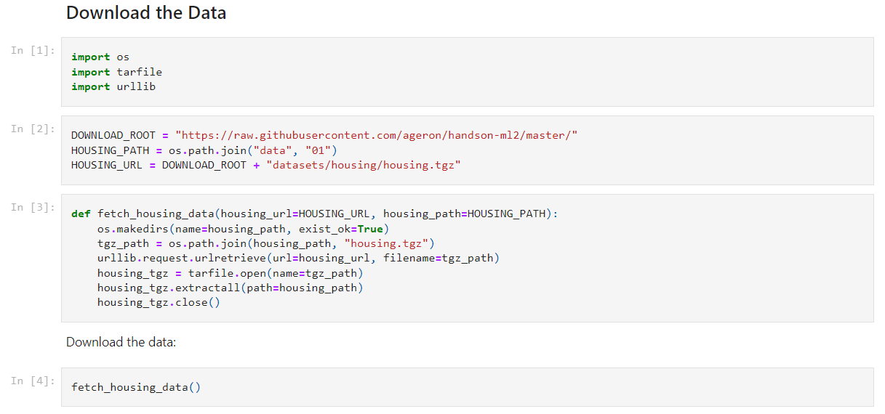

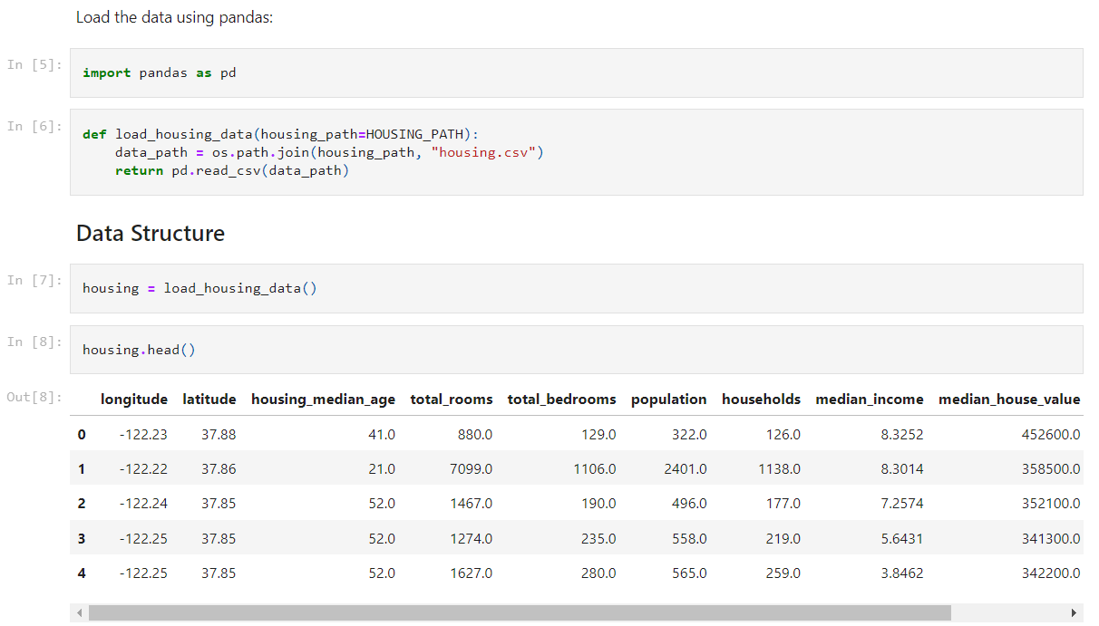

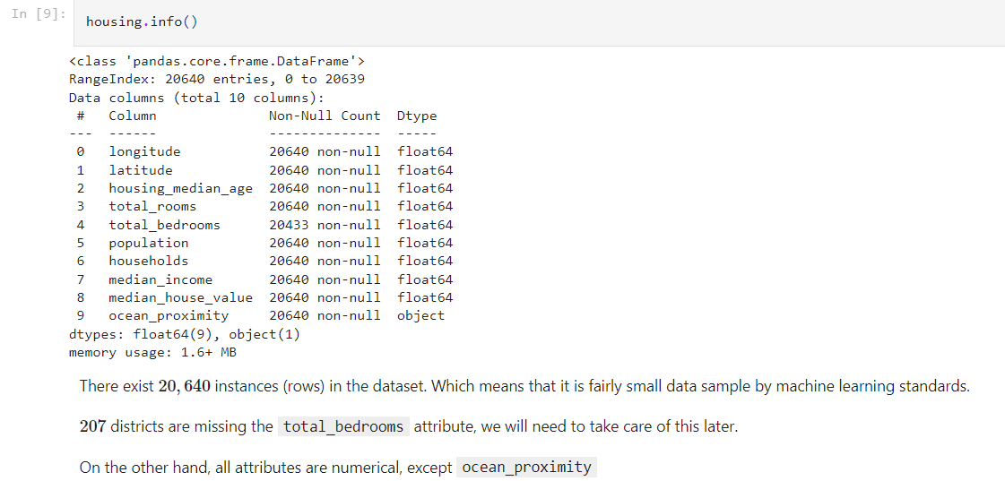

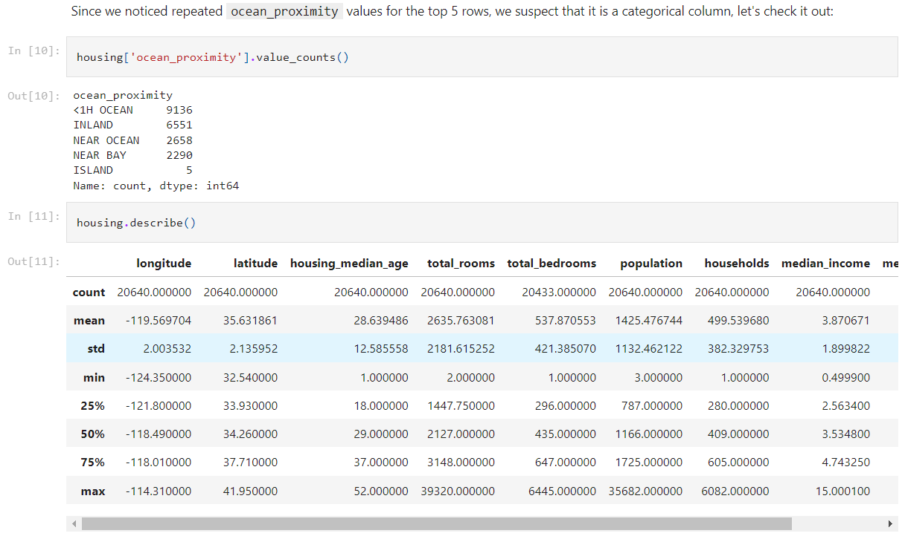

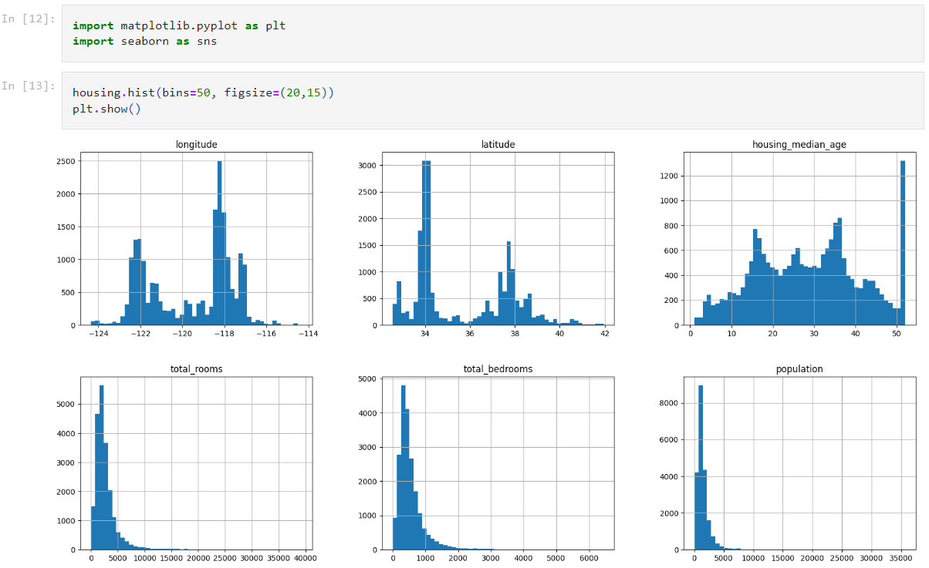

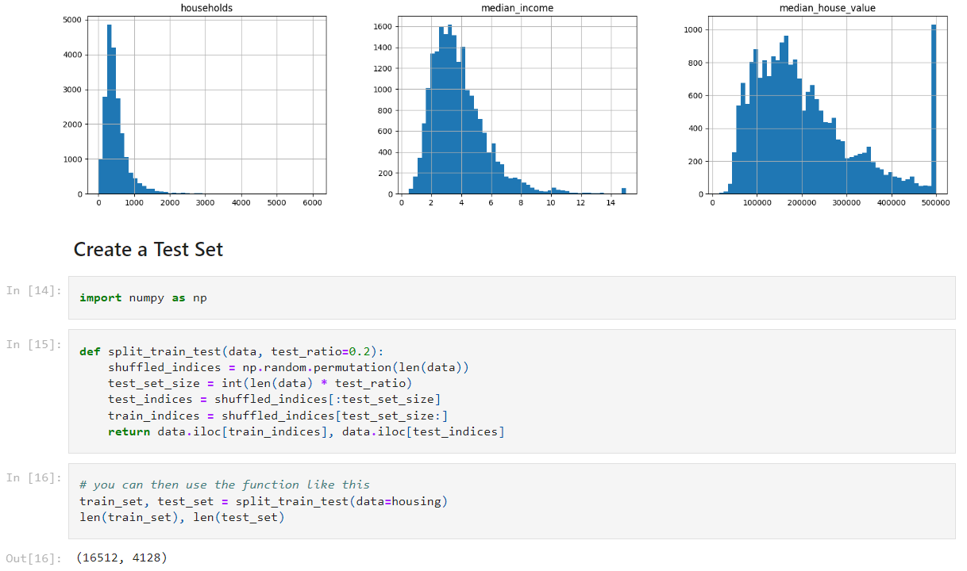

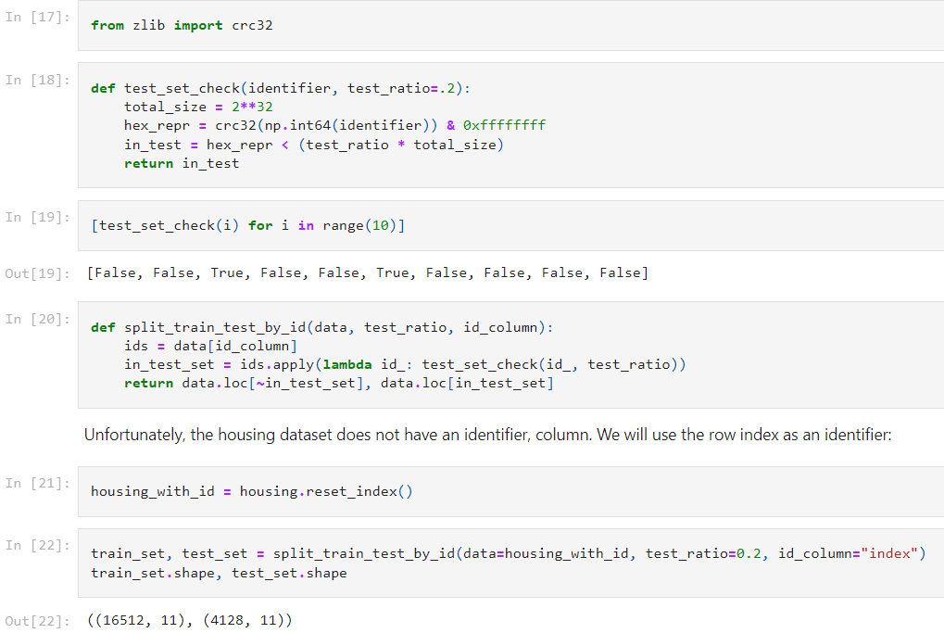

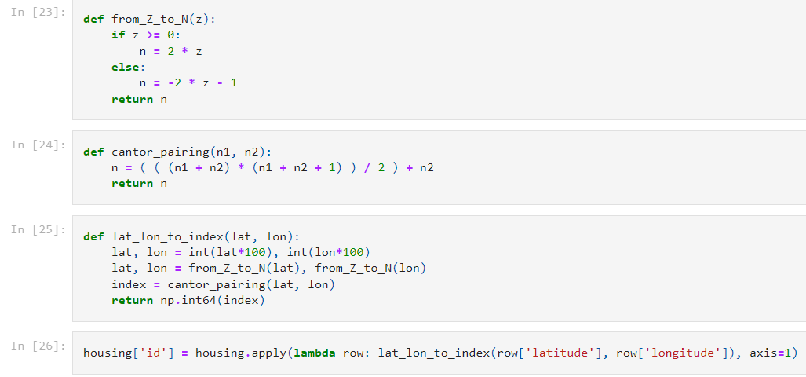

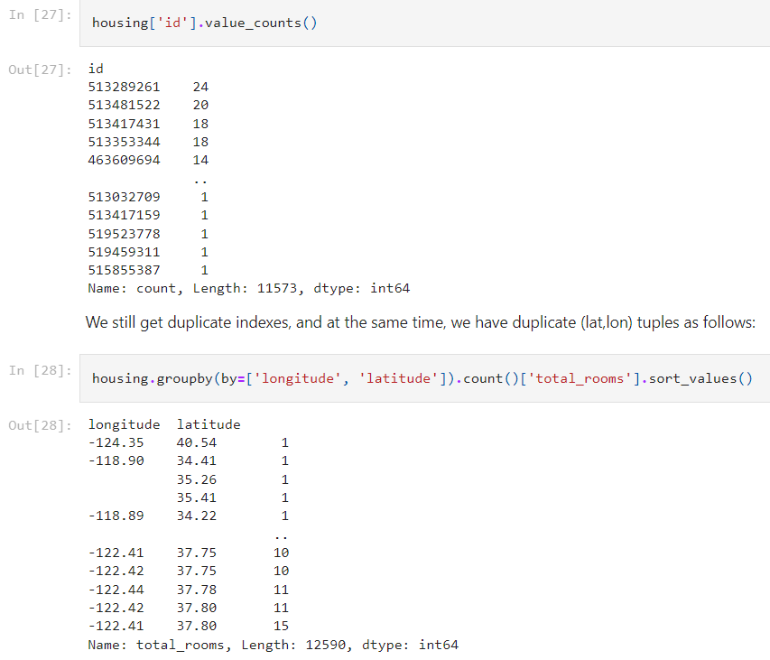

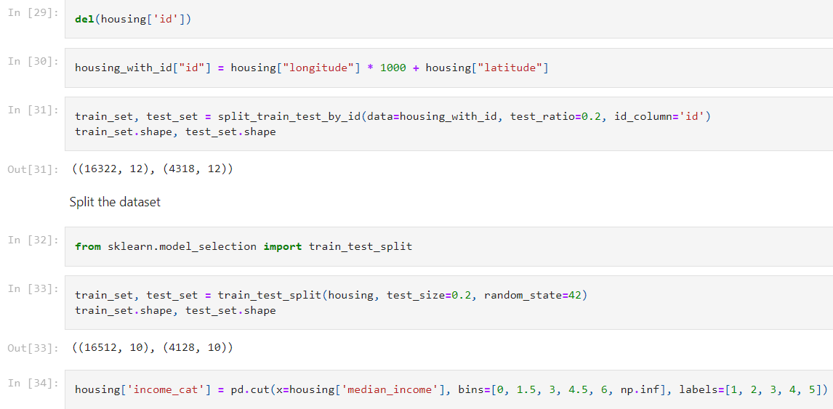

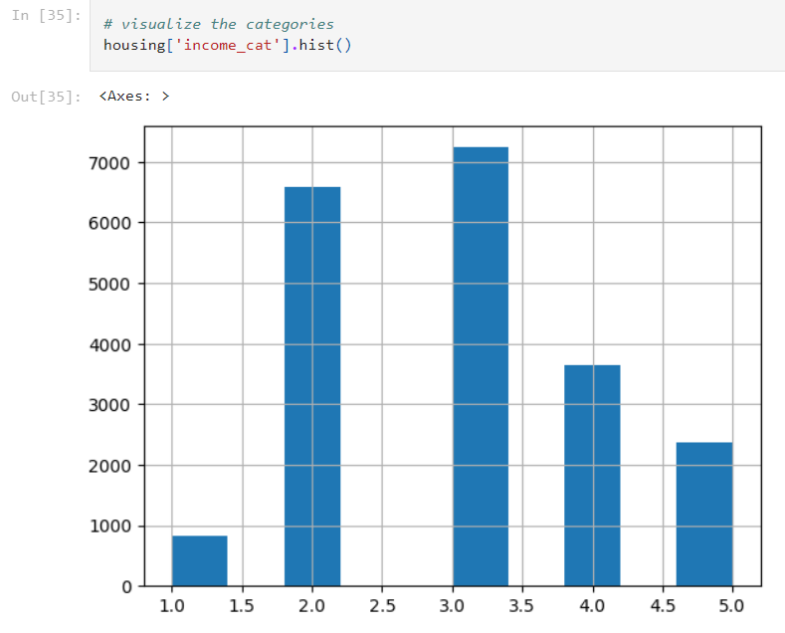

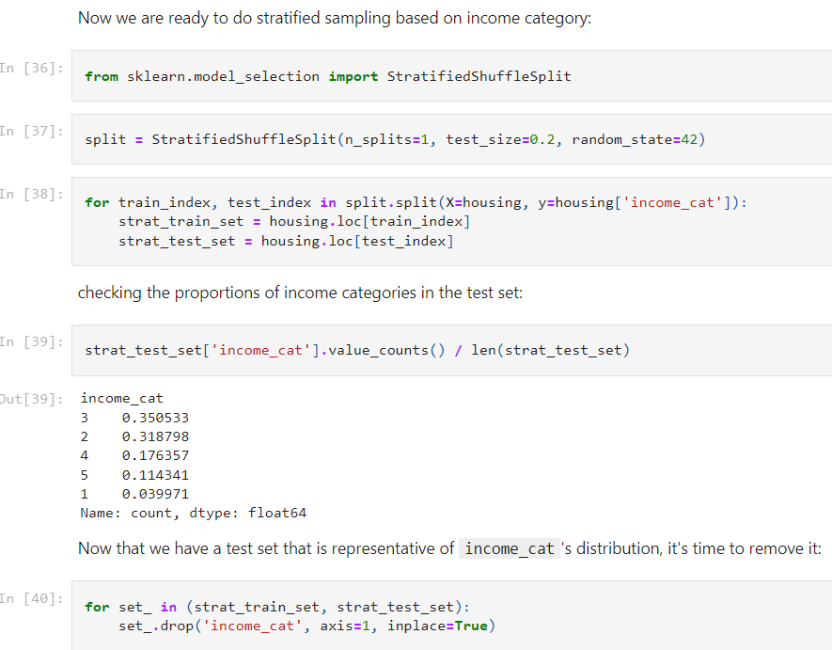

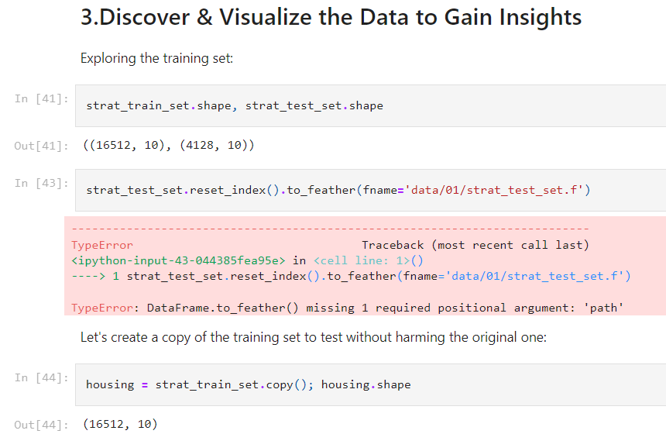

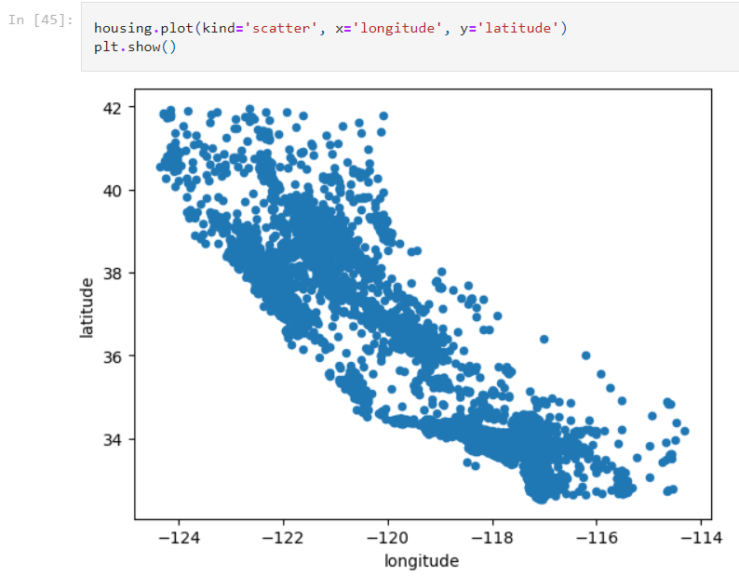

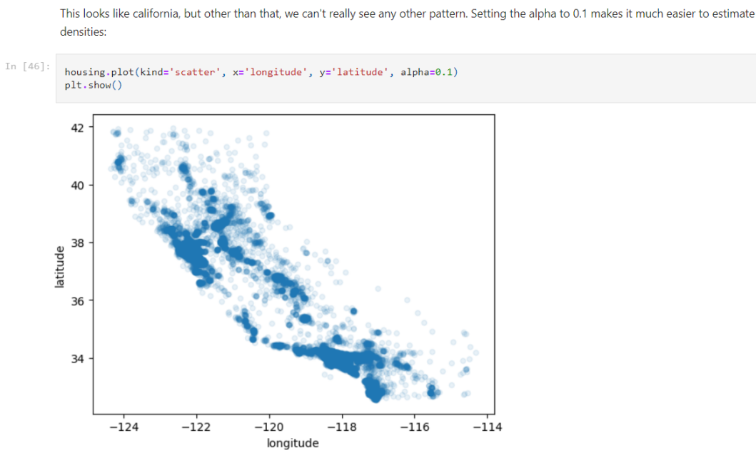

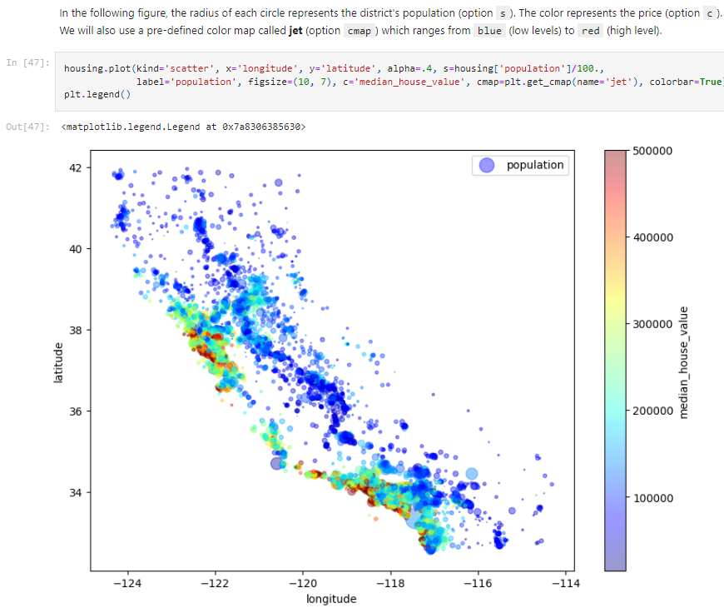

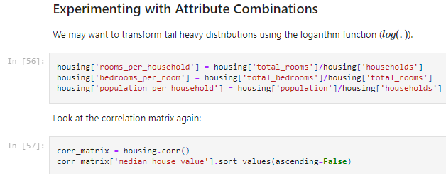

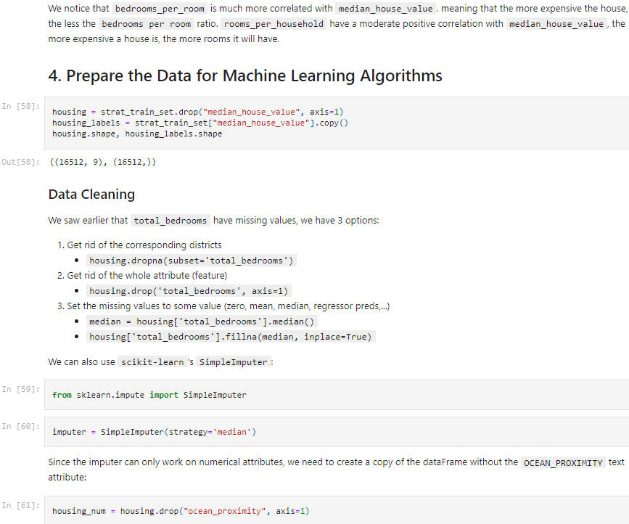

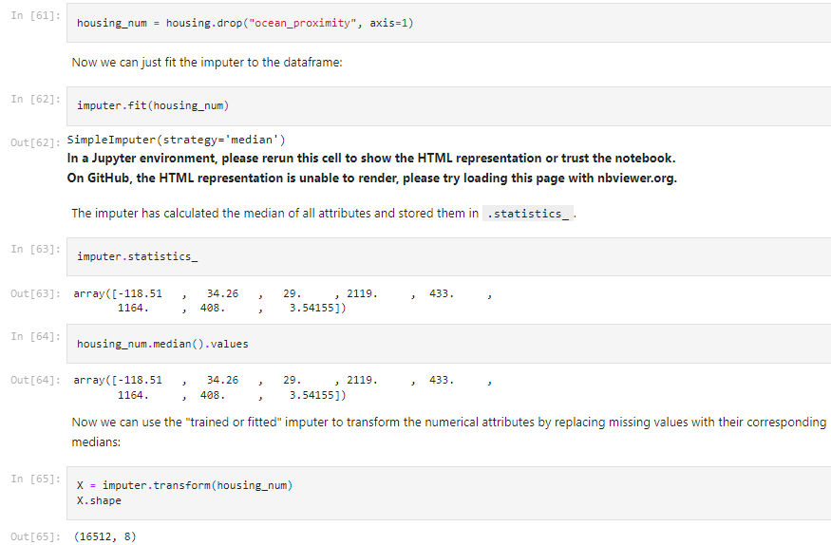

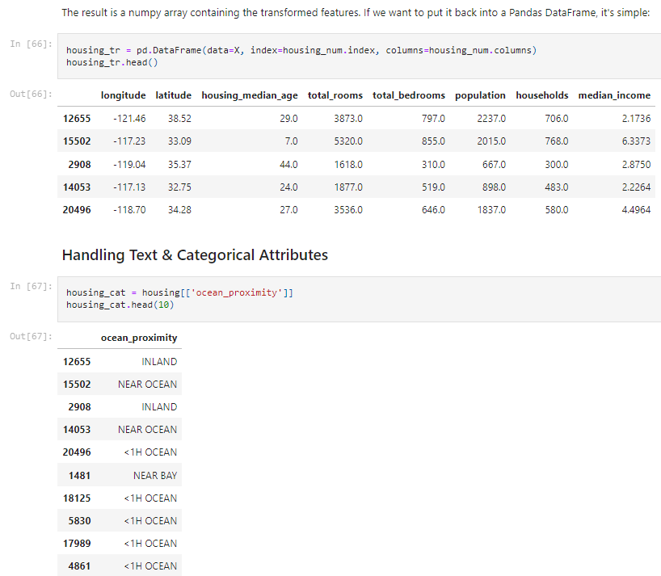

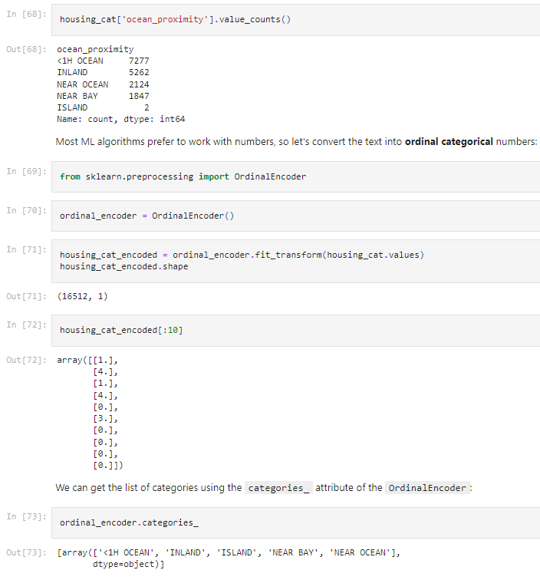

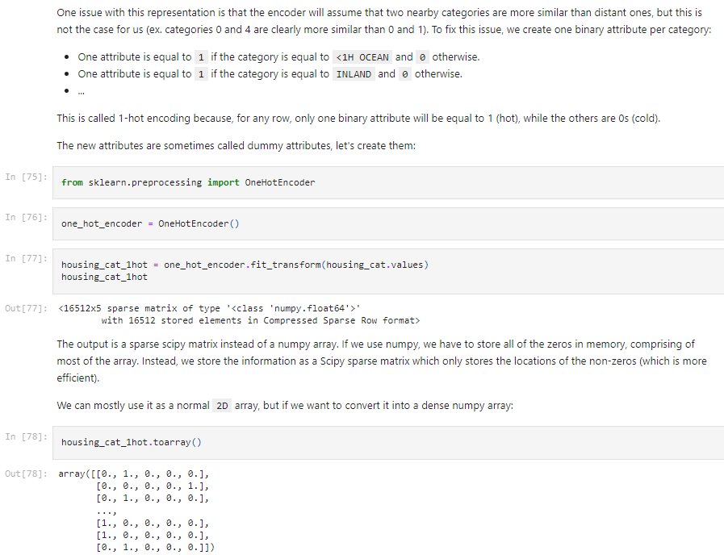

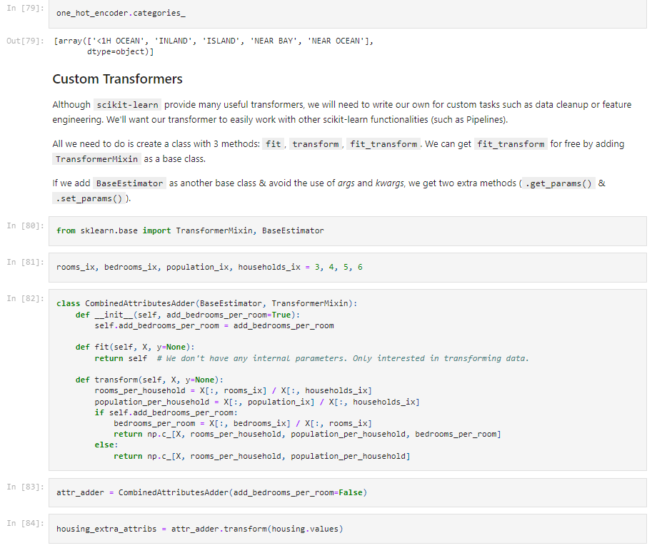



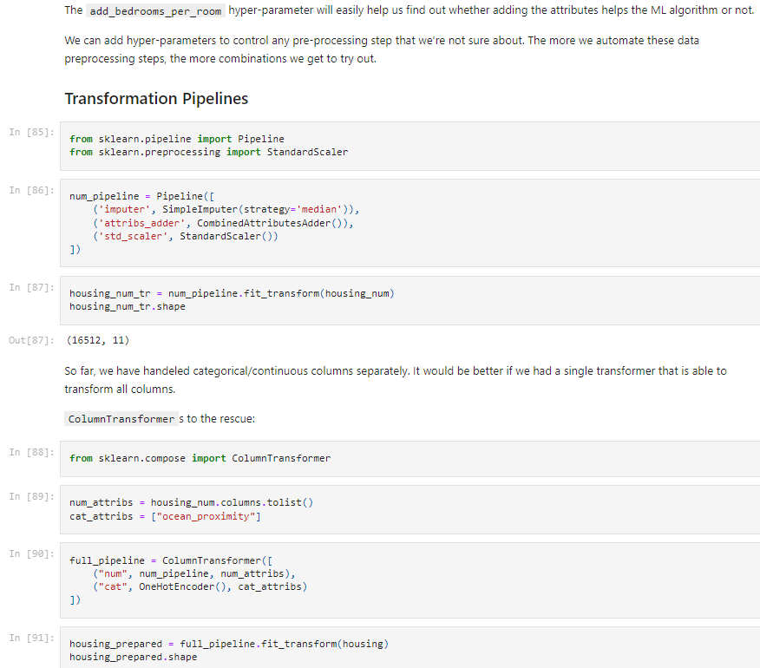

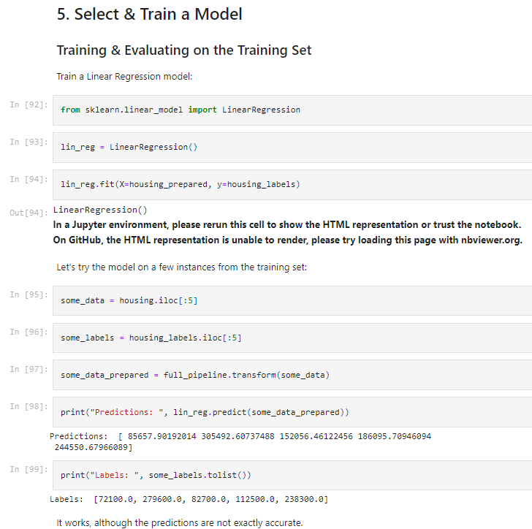

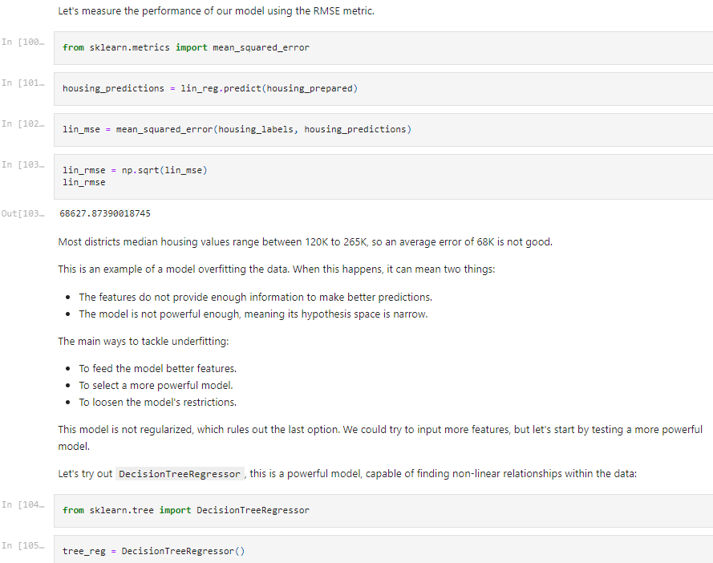



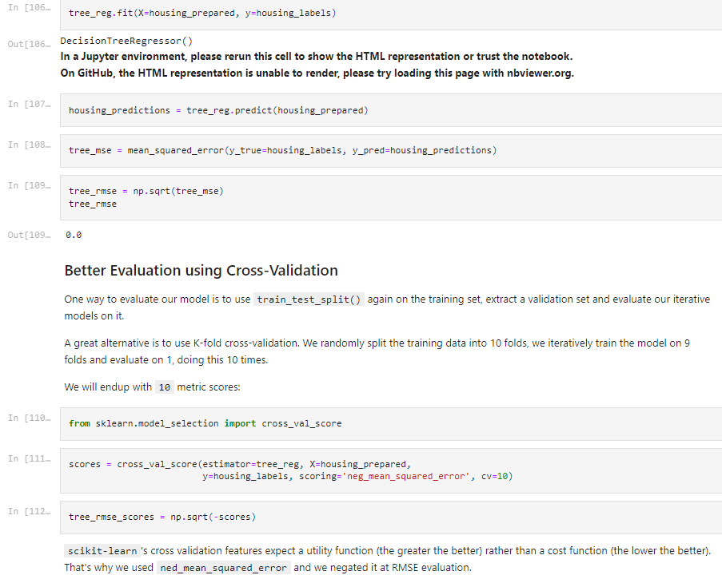

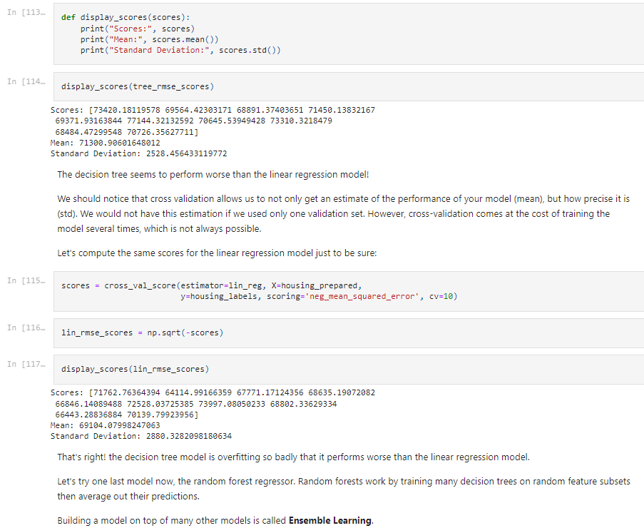

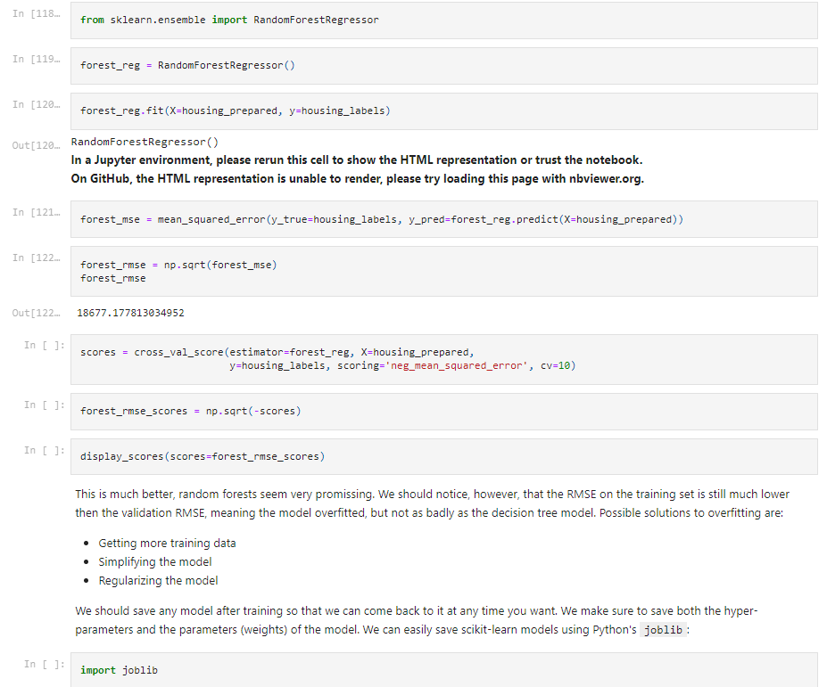



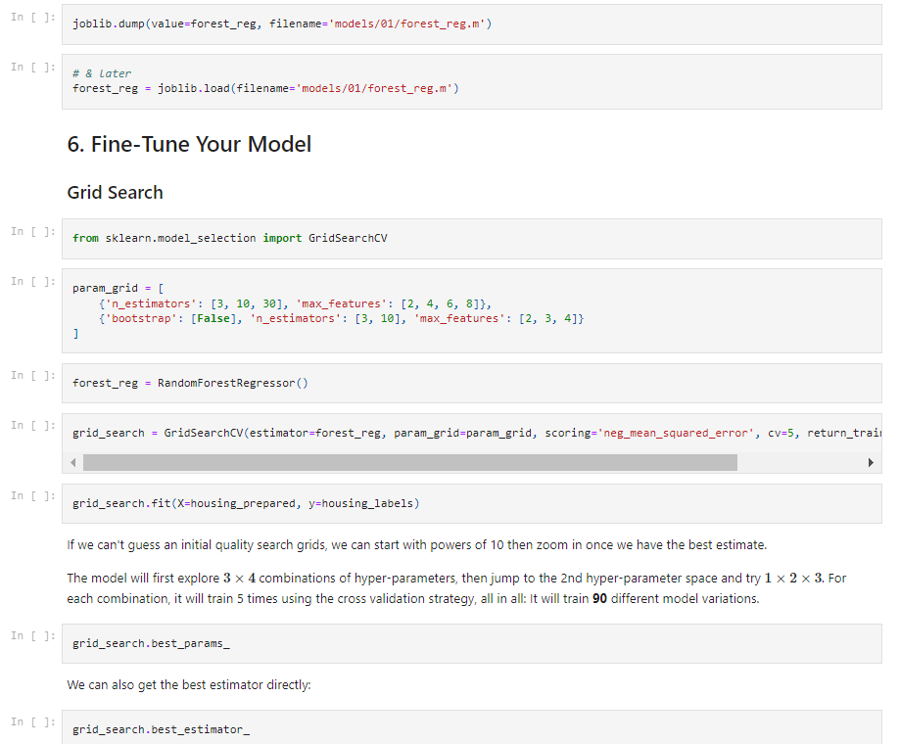

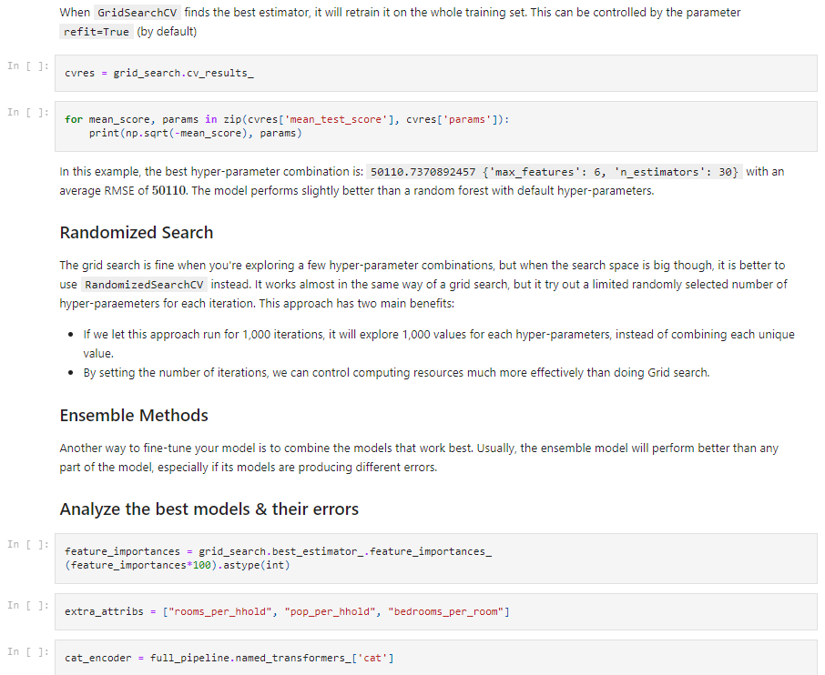



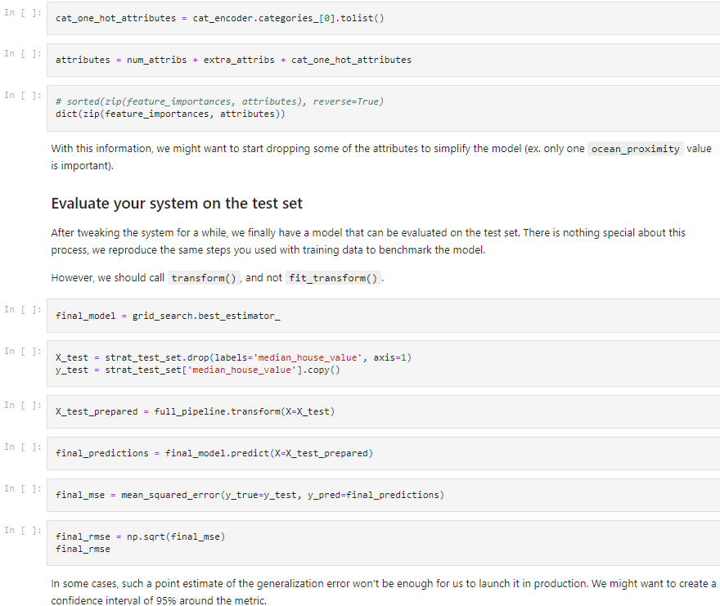

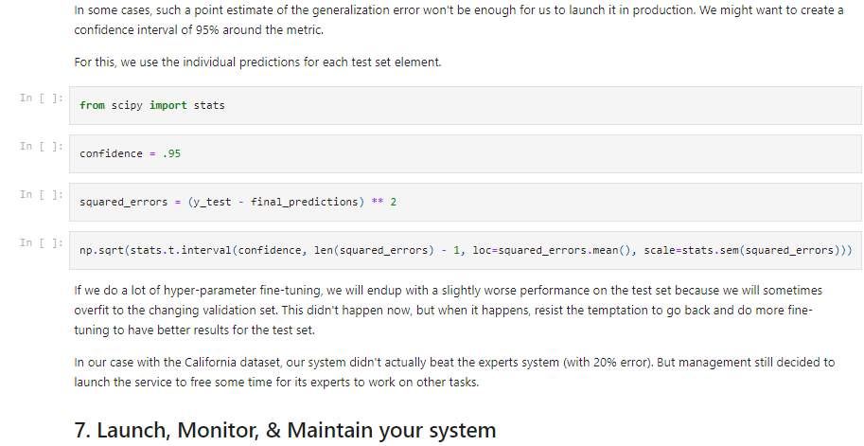

* 1. **Experiment - 3**
     1. **Question:**

Use an appropriate data set for building the decision tree (ID3) and apply this knowledge to classify a new sample.

* + 1. **Code with Output:**

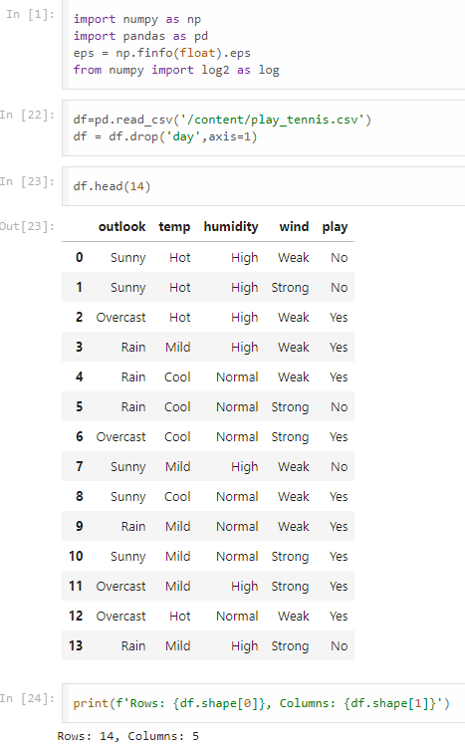

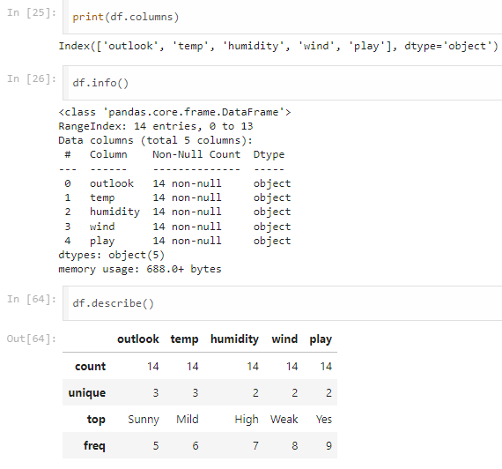



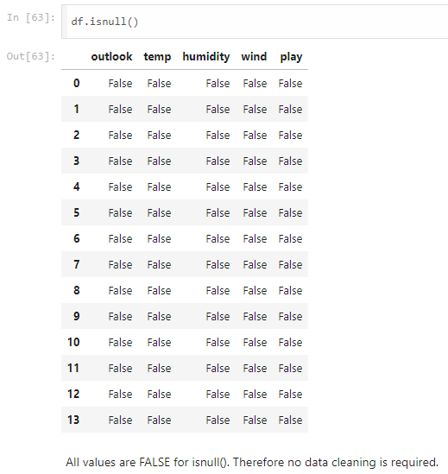

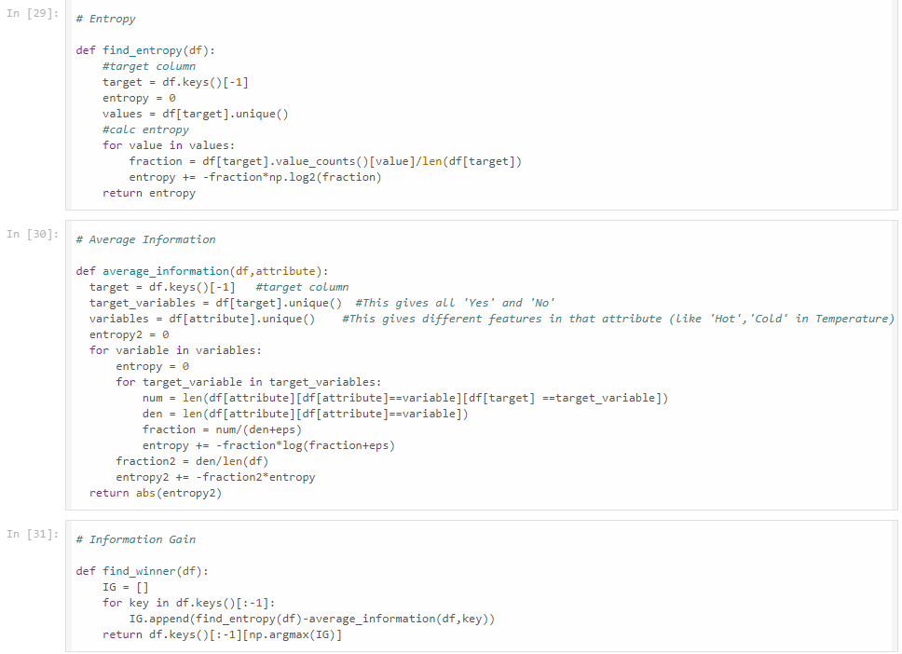



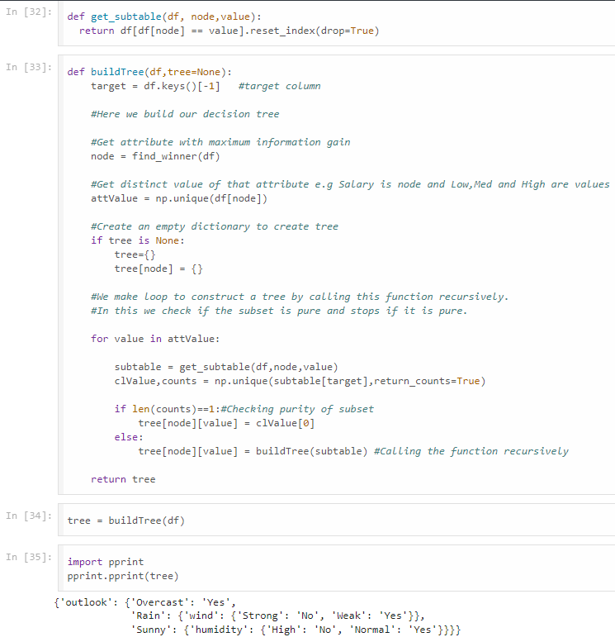

* 1. **Experiment - 4**
     1. **Question:**

Implement Linear and Multi-Linear Regression algorithm using appropriate dataset.

* + 1. **Code with Output:**

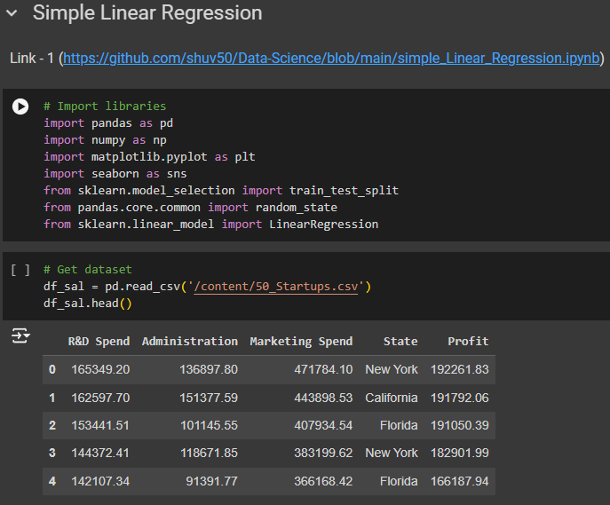

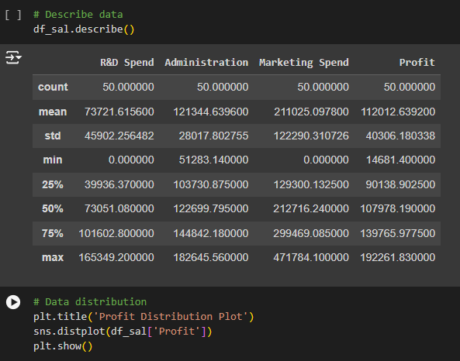

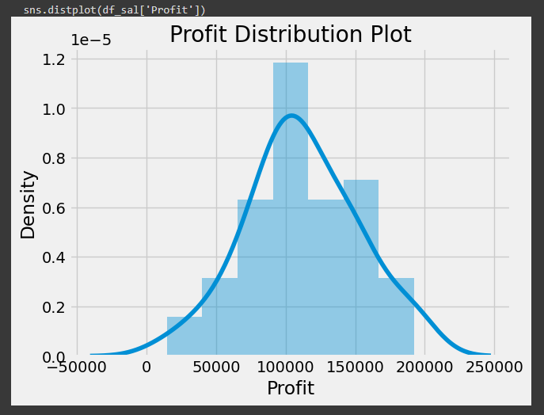

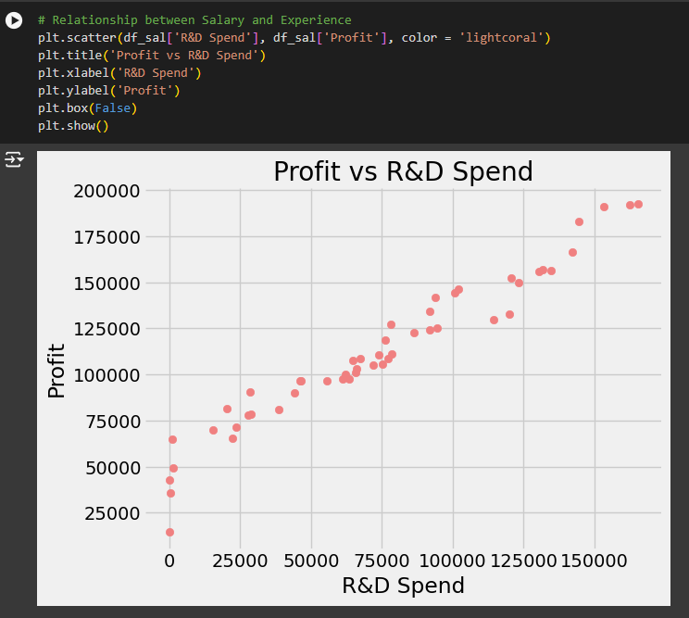

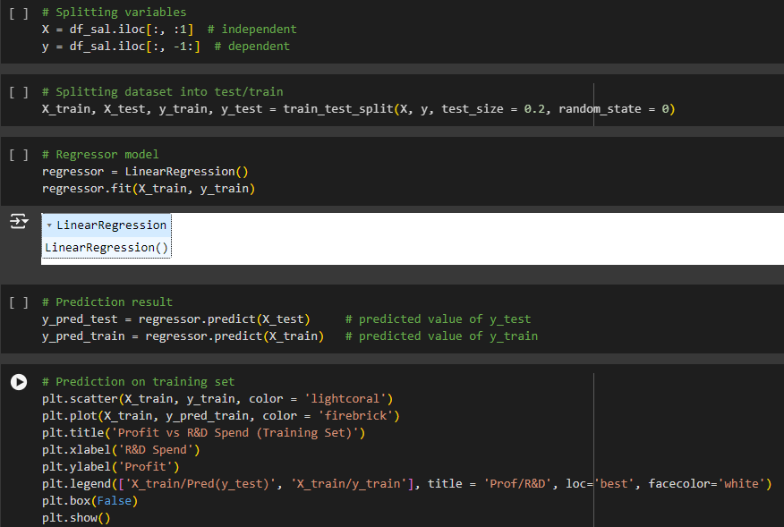

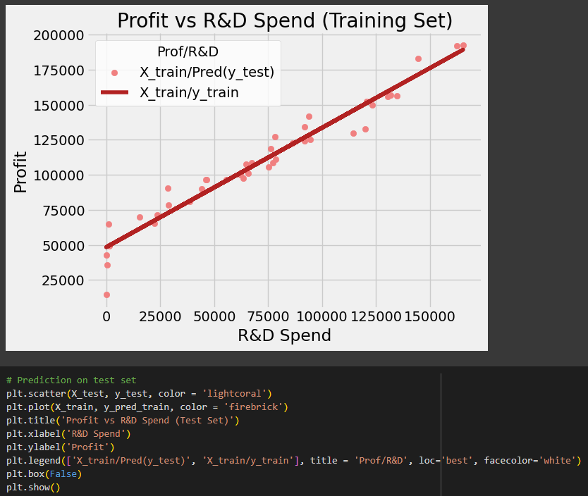

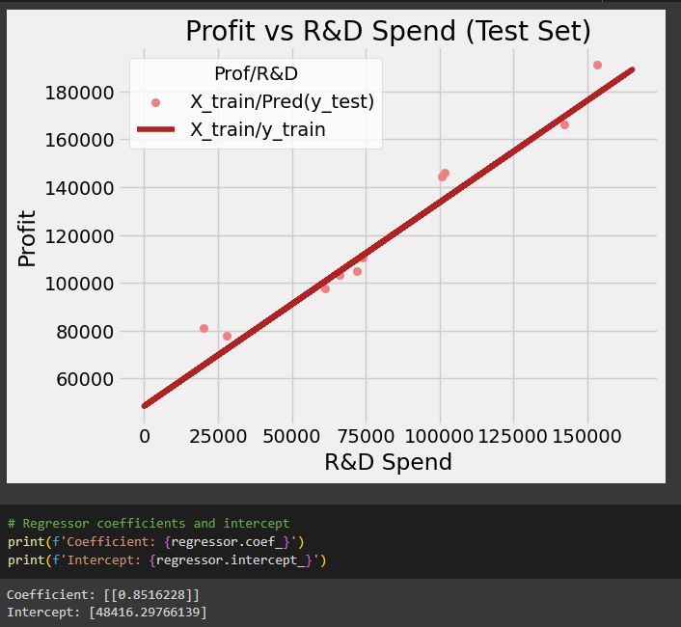

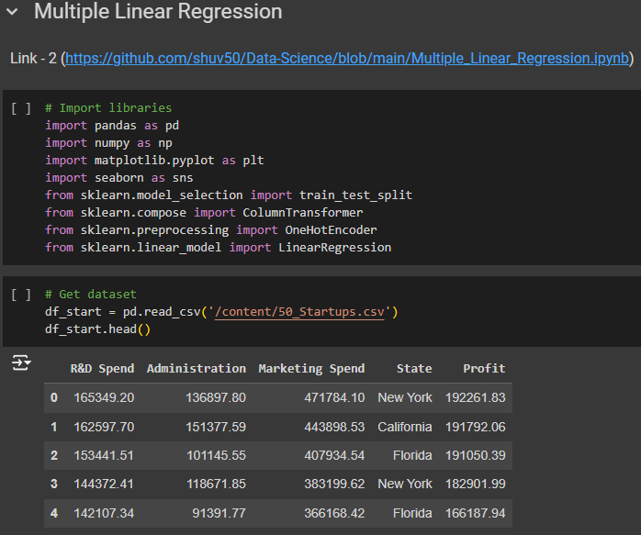

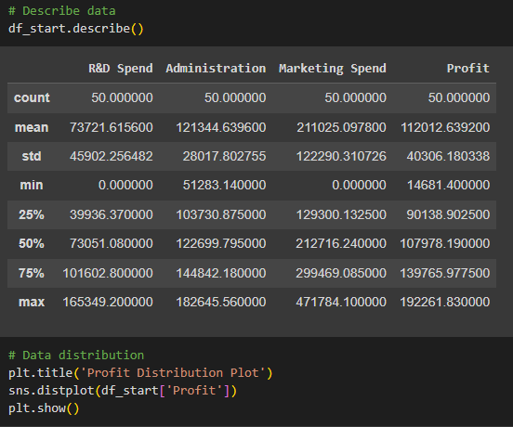

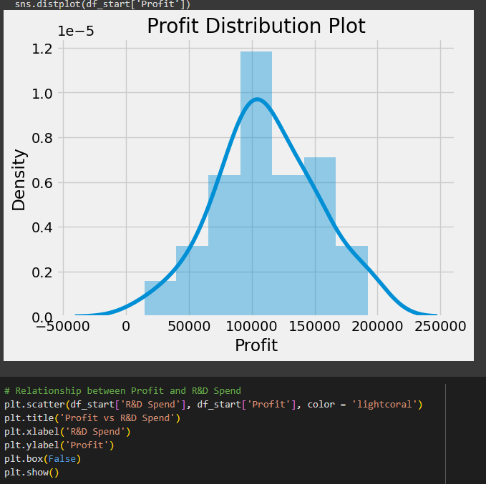

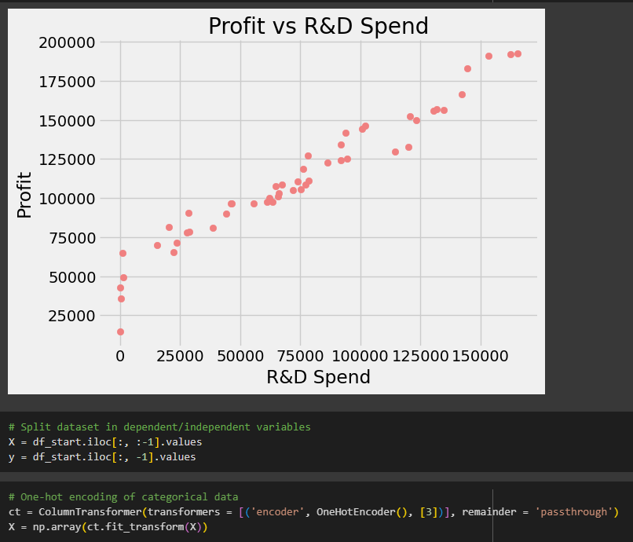

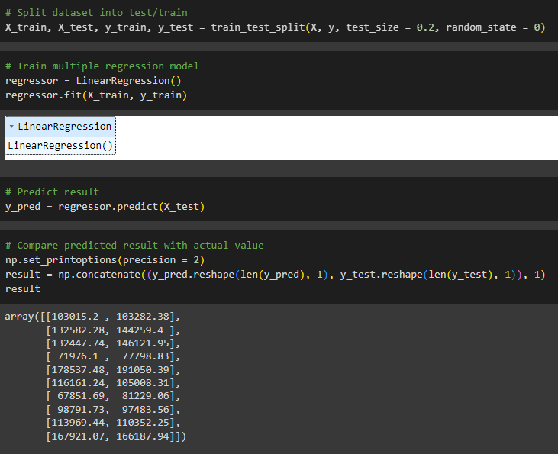

* 1. **Experiment - 5**
     1. **Question:**

Build Logistic Regression Model for a given dataset.

* + 1. **Code with Output:**

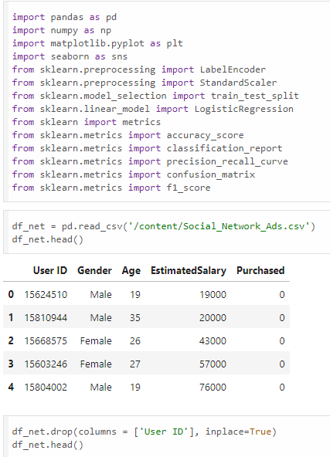

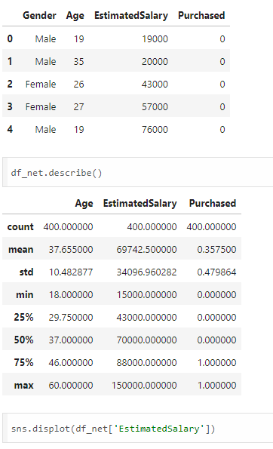



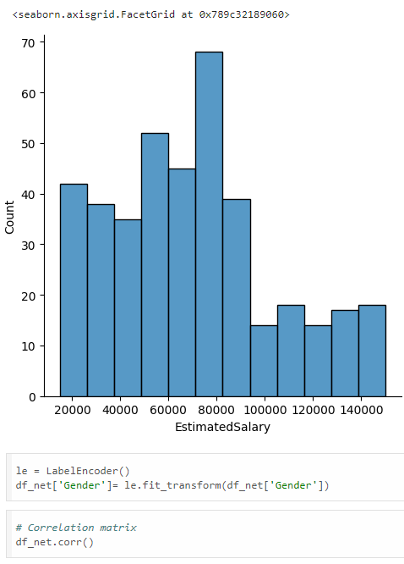

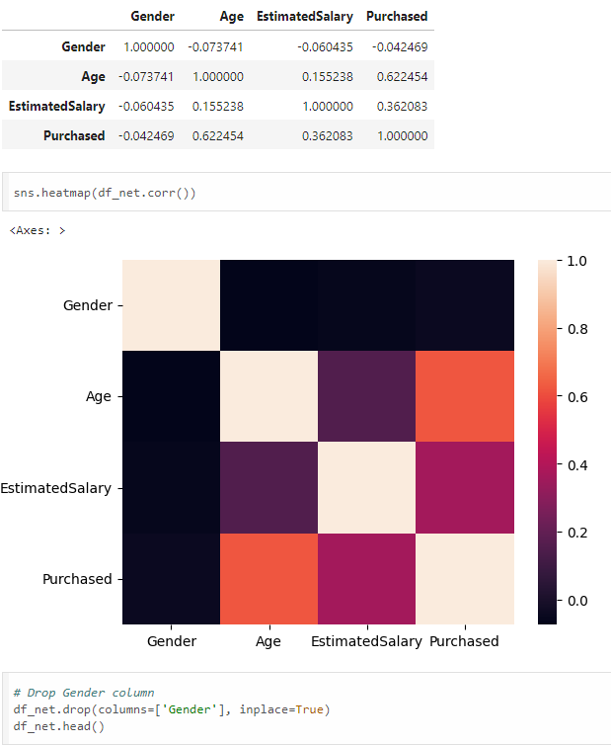

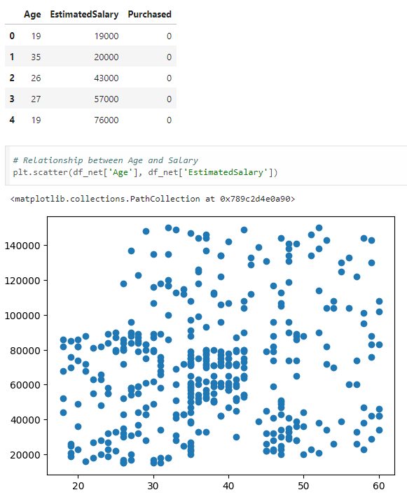



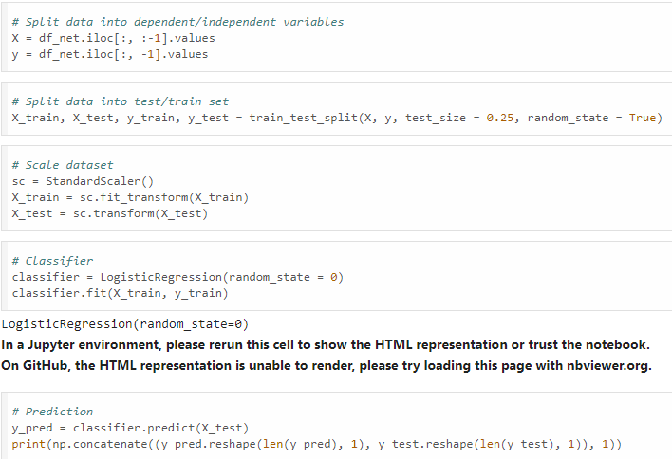

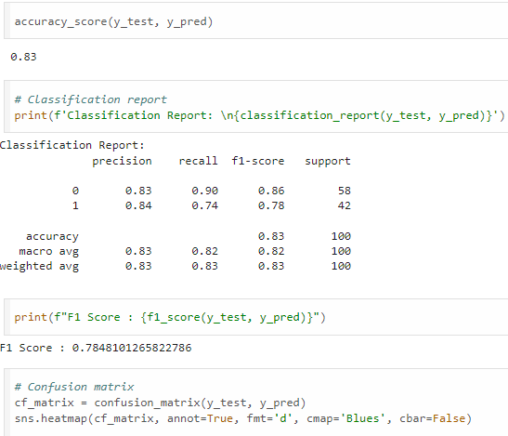

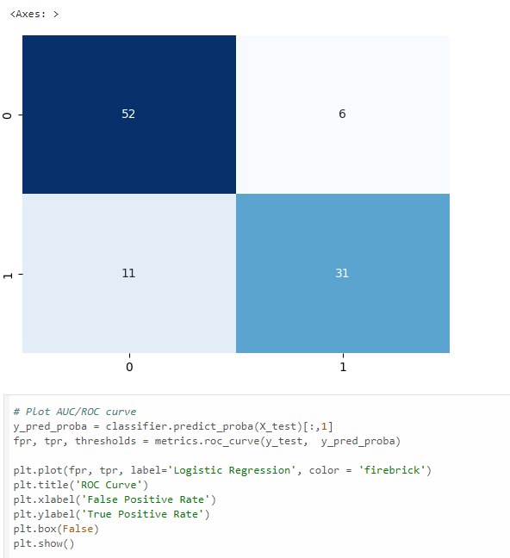

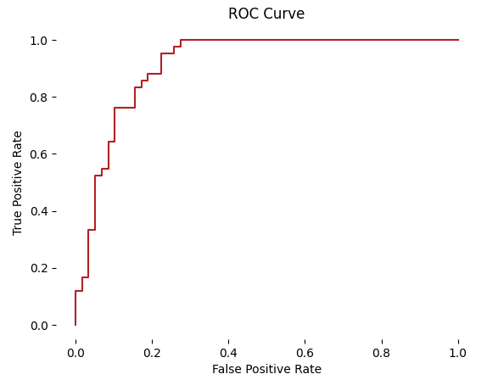

* 1. **Experiment - 6**
     1. **Question:**

Build KNN Classification model for a given dataset.

* + 1. **Code with Output:**

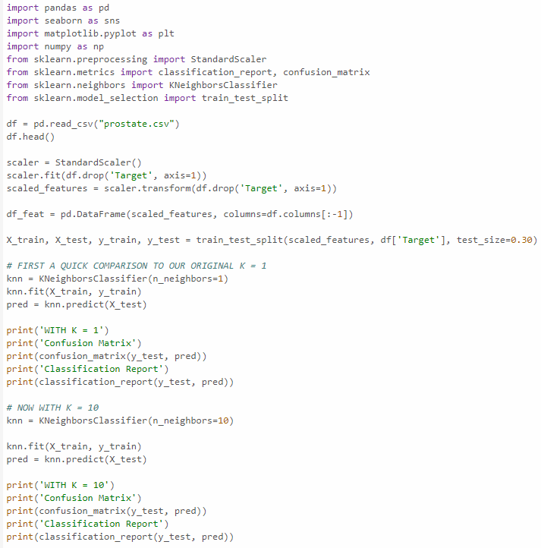

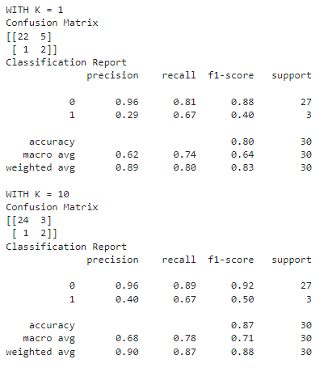

* 1. **Experiment - 7**
     1. **Question:**

Build Support vector machine model for a given dataset.

* + 1. **Code with Output:**

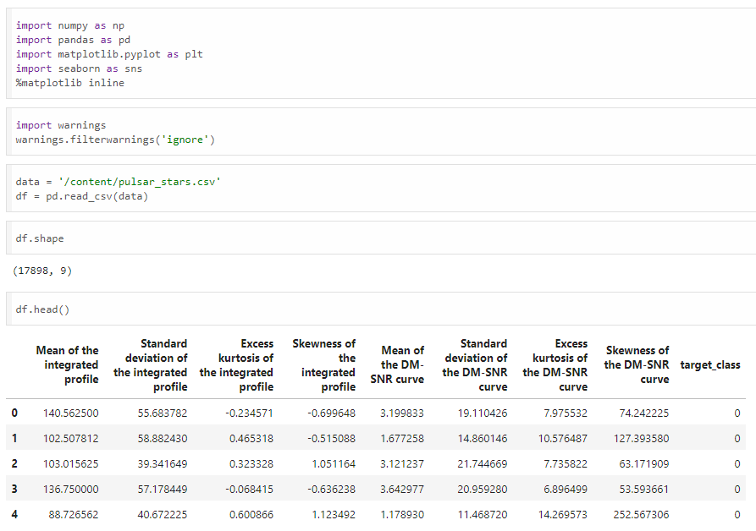

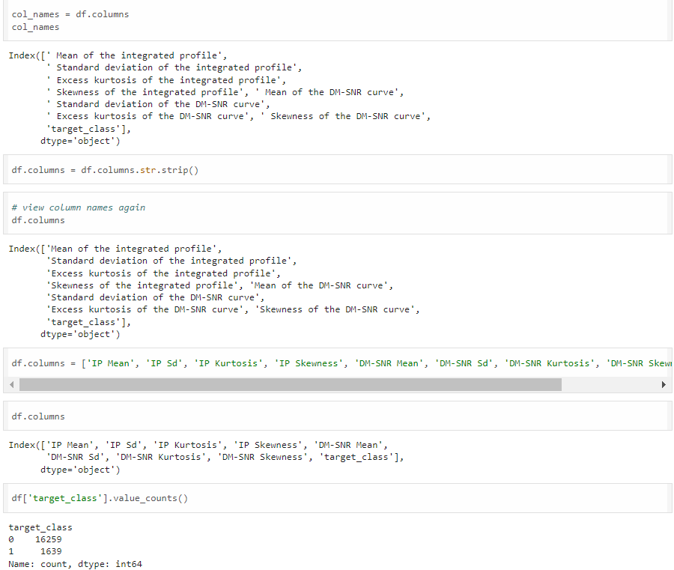



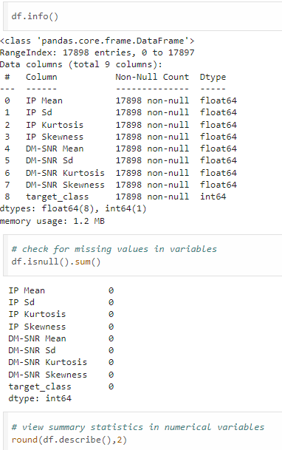

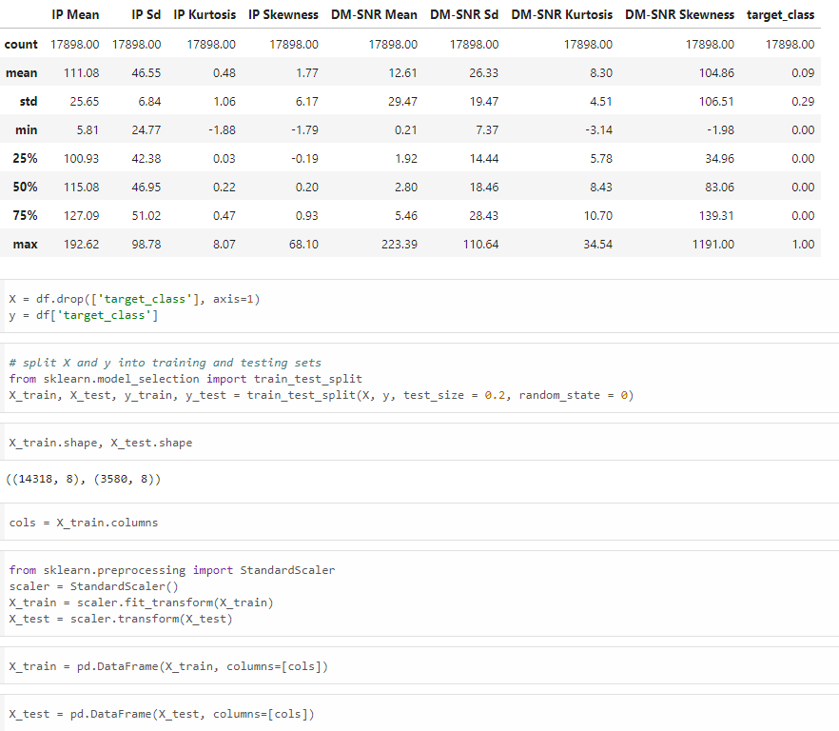



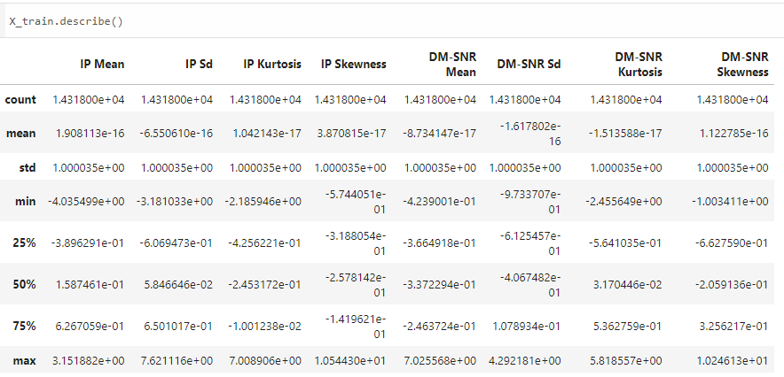

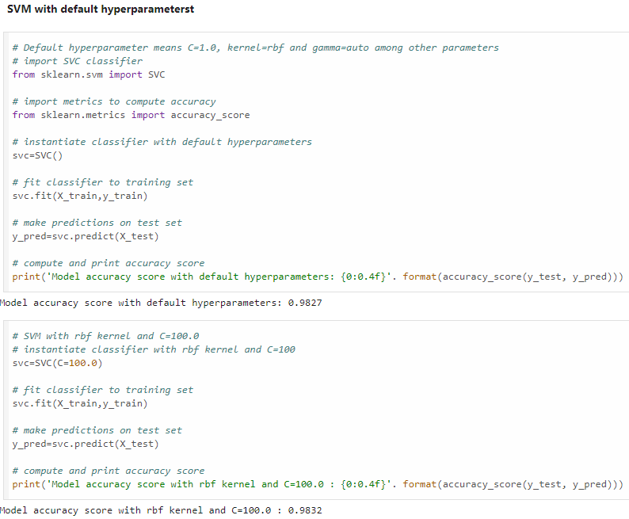



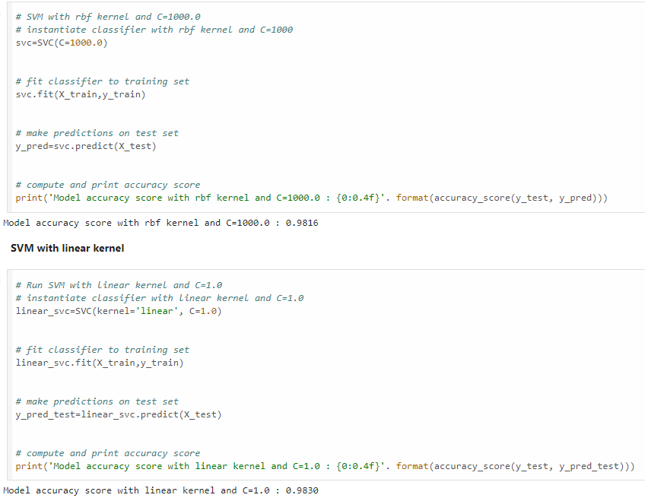

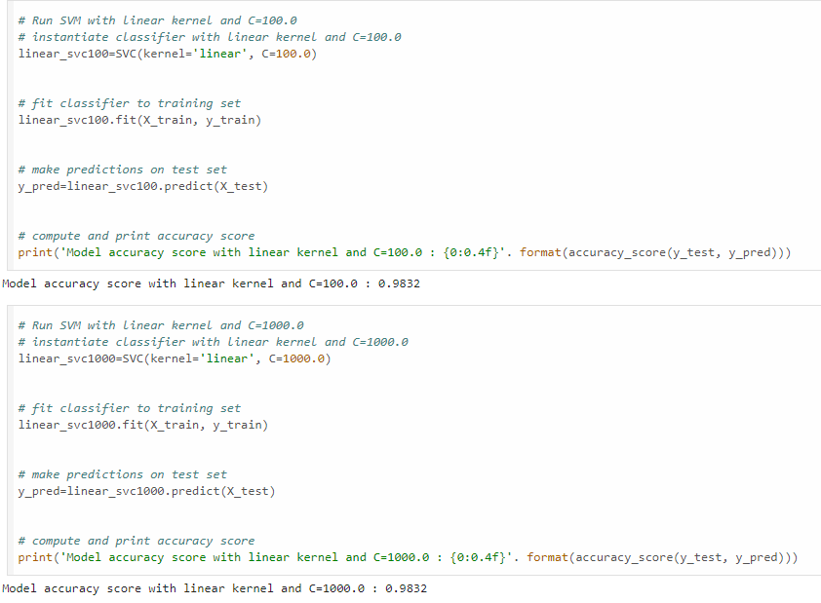



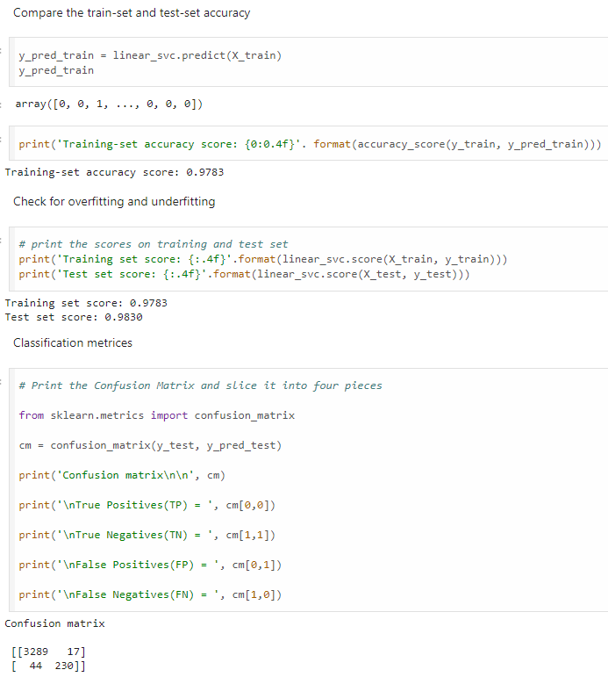

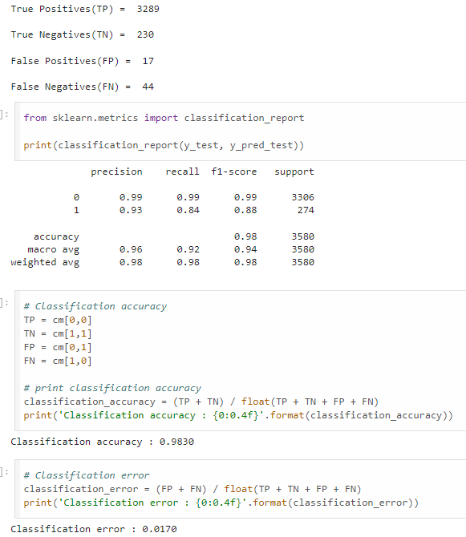

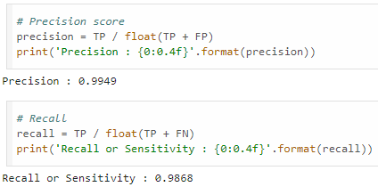

* 1. **Experiment - 8**
     1. **Question:**

**a)** Implement Random forest ensemble method on a given dataset.

**b)** Implement Boosting ensemble method on a given dataset.

* + 1. **Code with Output:**

1. **Random Forest:**

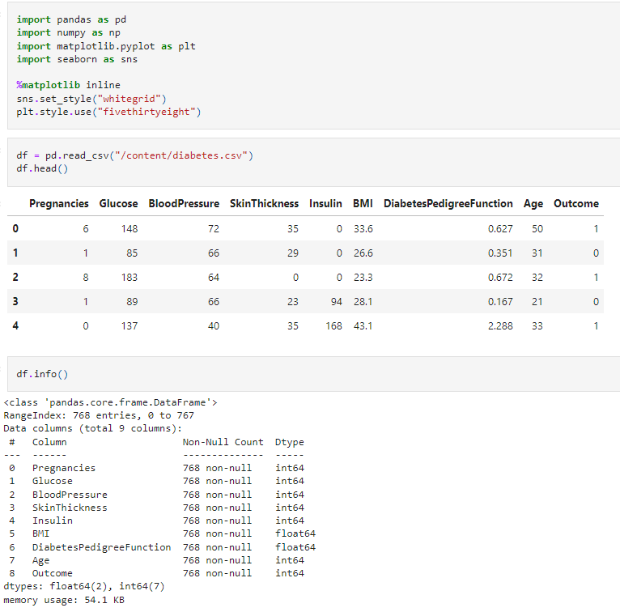

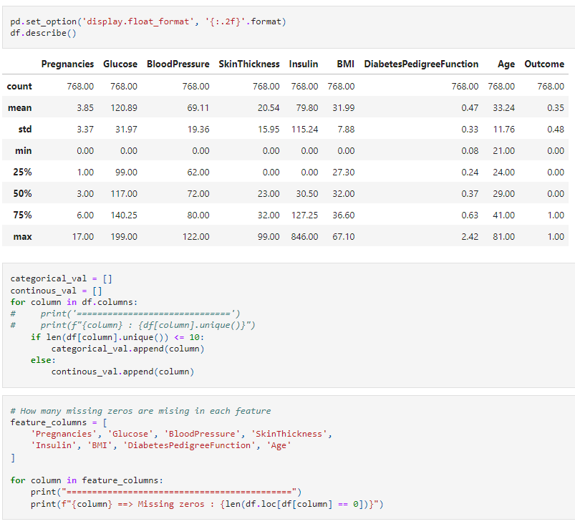



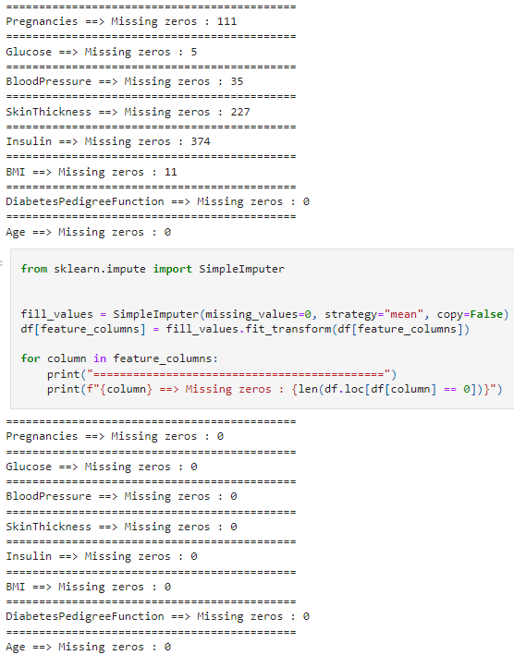

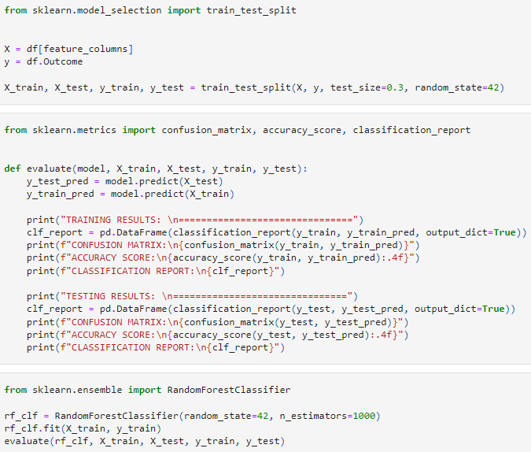

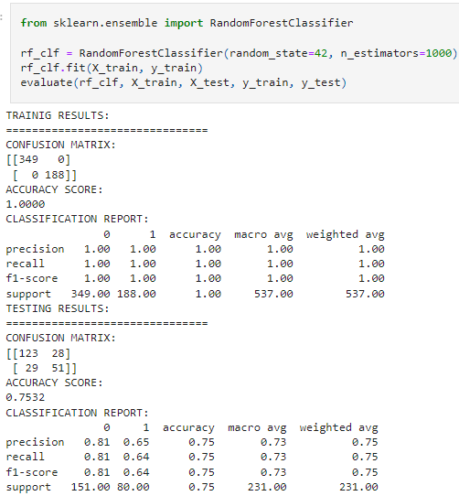

1. **Boosting Ensemble:**

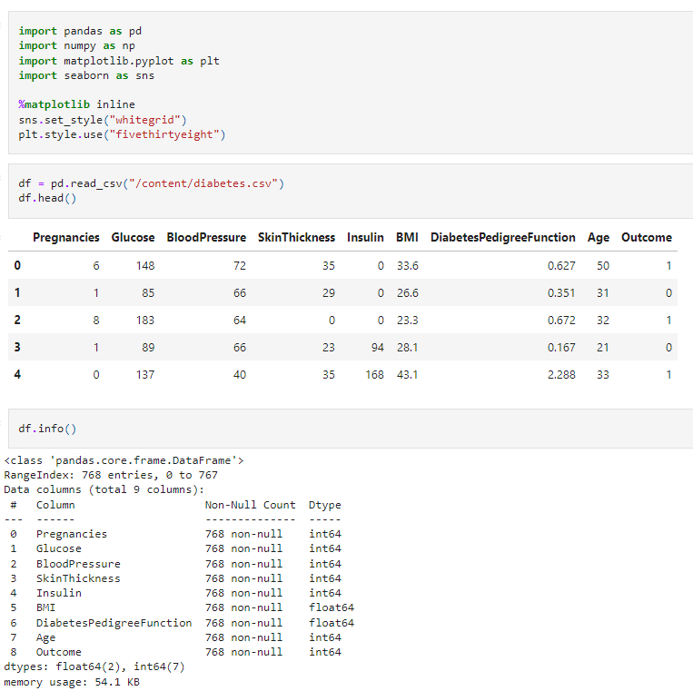

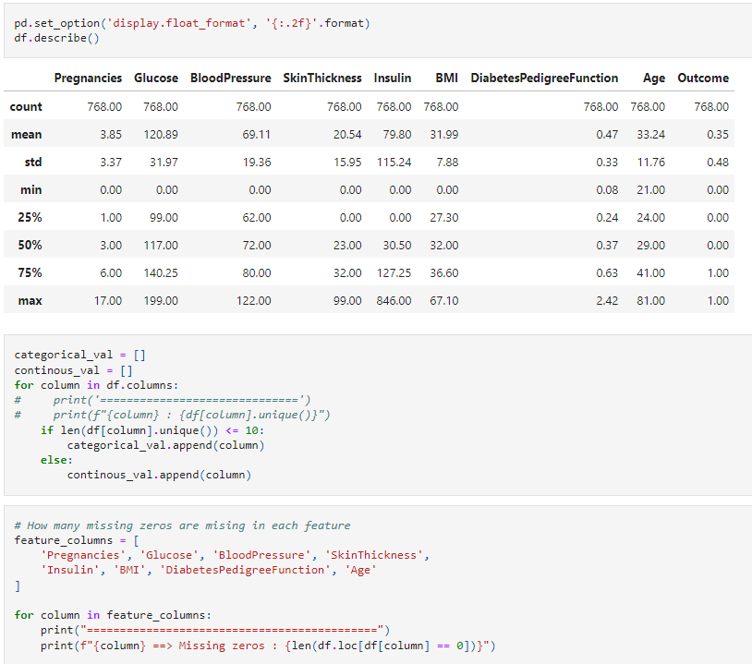



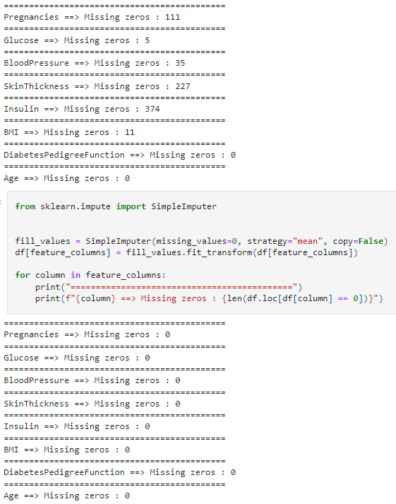

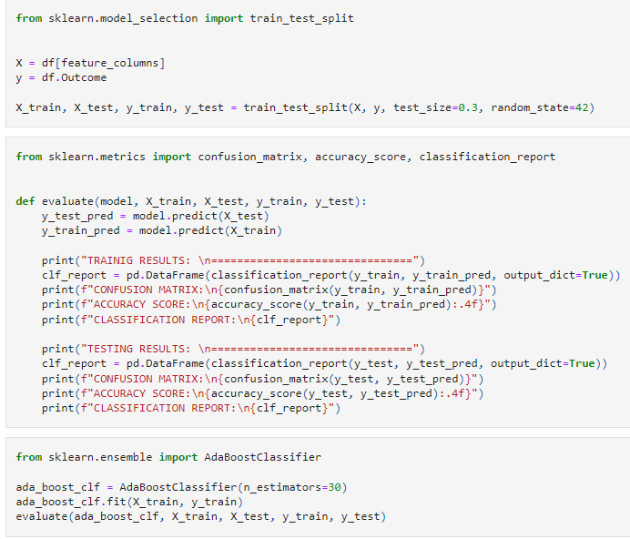

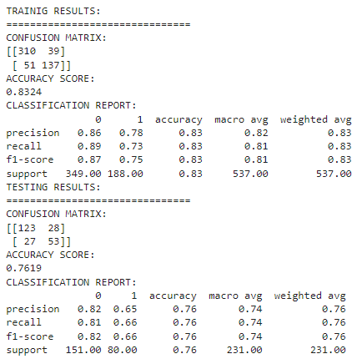

* 1. **Experiment - 9**
     1. **Question:**

Build k-Means algorithm to cluster a set of data stored in a .CSV file.

* + 1. **Code with Output:**

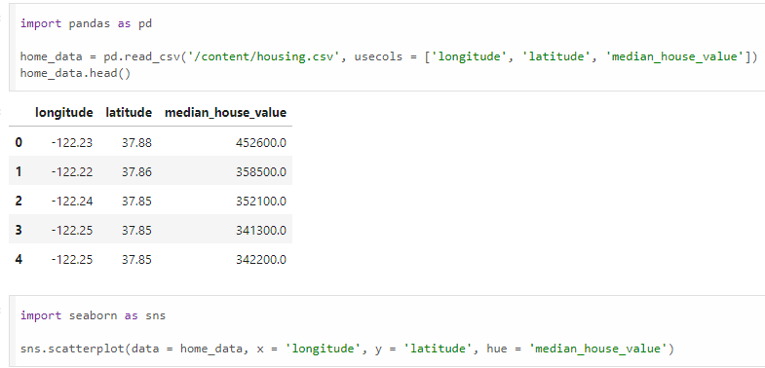

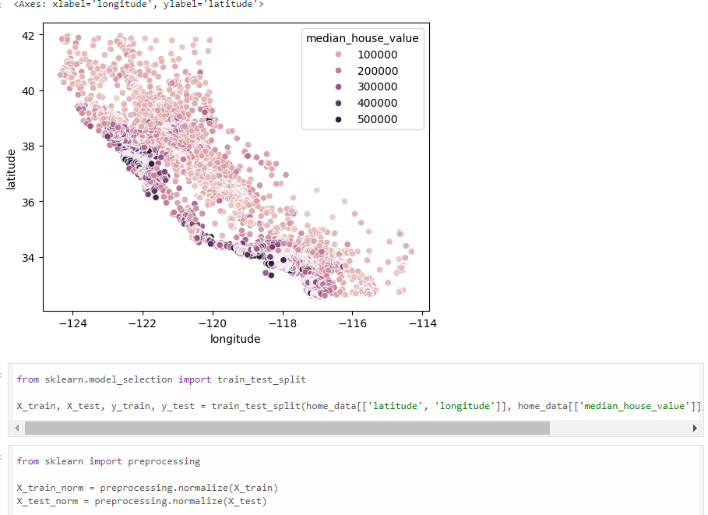

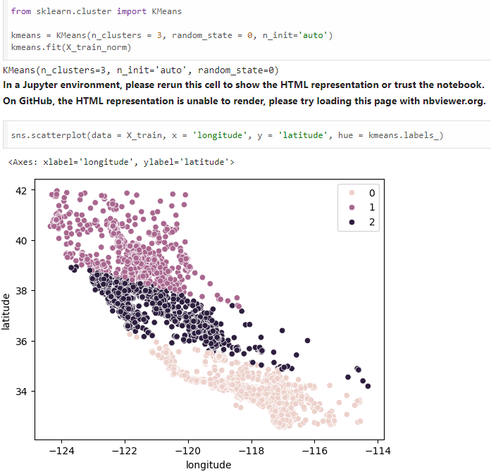

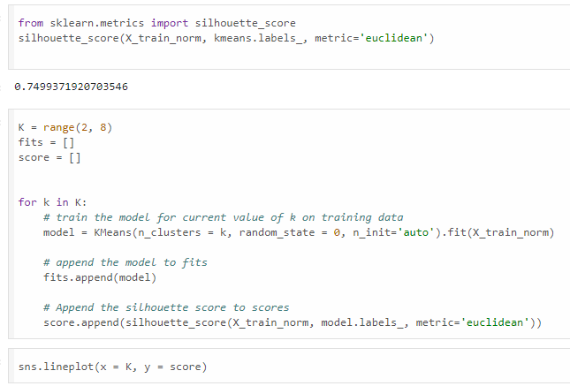

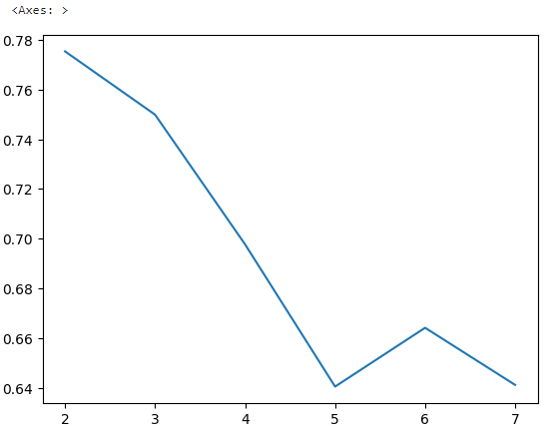

* 1. **Experiment - 10**
     1. **Question:**

Implement Dimensionality reduction using Principle Component Analysis (PCA) method.

* + 1. **Code with Output:**

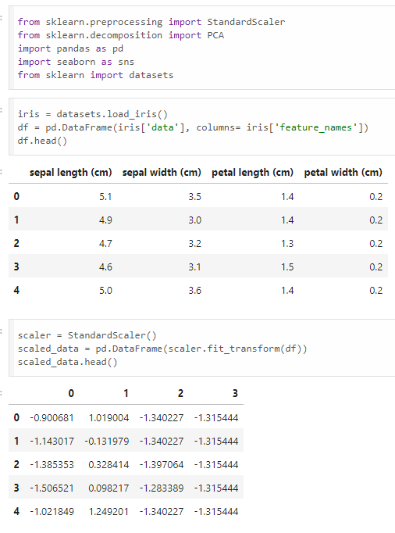

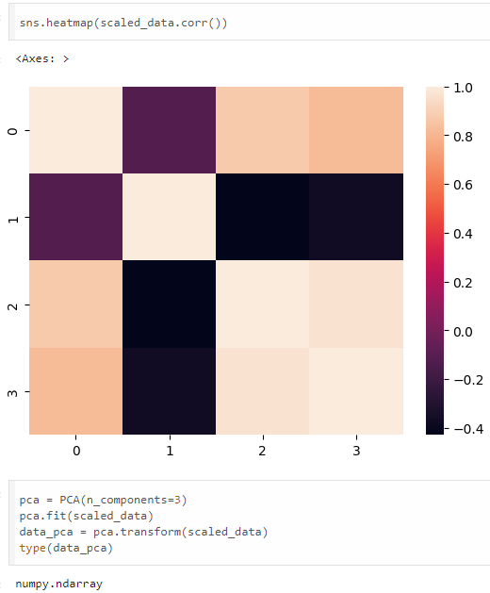

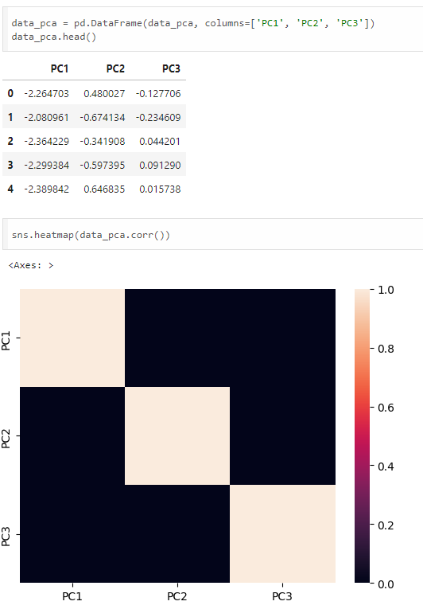

* 1. **Experiment - 11**
     1. **Question:**

Build Artificial Neural Network model with back propagation on a given dataset.

* + 1. **Code with Output:**



